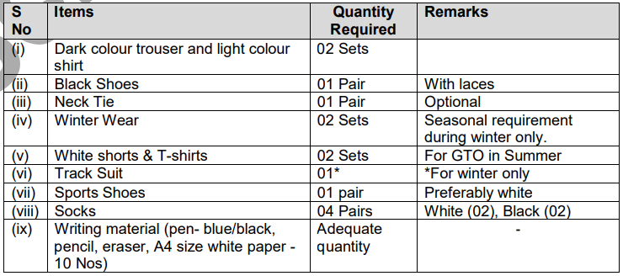

**Appendix ‘B’**

**NO RISK CERTIFICATE**

1. It is certified that Mr ______________ (Name) Roll No ________________ a candidate of

**SSC (Tech)-62**, hereby certify that I have no COVID -19 symptoms. I fully understand that travel to Selection Centre is at my own risk and I or my parents/guardian shall not be entitled to claim any compensation or retest for the same course or any other relief from the Government if I am infected with COVID-19 during my transit or during my stay at Selection Centre North, Jalandhar.

Date : …………………………….. Signature of Candidate

**COUNTERSIGNED**

Signature of Parent / Guardian

Place : …………………………….

Date : ……………………………..

**Appendix ‘C’**

**NO CLAIM/RISK CERTIFICATE**

I father/ guardian of __________________________ (Name of candidate) who is a candidate for

**SSC(T)-62** course in the Army, hereby certify that I fully understand that my son/daughter/ ward will, if required, attend the Service Selection Board Interview with my full and free consent and at my own risk and that I or my son/ daughter/ ward shall not be entitled to claim any compensation or other relief from the government in respect of any injury or disability which my son/ daughter/ ward may sustain in the course of or as the result of any of the tests given to him at the SSB interview, whether due to his own negligence or the negligence of any other person or otherwise.

Place : ______________________ (Signature of Parent/ Guardian)

Date : _____________________ Name _____________________

Address ___________________

**Appendix ‘D’**

**UNDERTAKING CERTIFICATE**

**BY CANDIDATE PRIOR TO UNDERGOING SSB**

I, Roll No _________________________ Name_____________________________

son of ______________________________ am appearing for SSB of SSC(T) - 62 Entry commencing from _________________ to ____________________. I undertake/ certify that all criteria/ eligibility conditions, as mentioned in the Course Notification and Call Up letter are being fulfilled by me. There is no discrepancy in my school & college mark sheets/ certificates, online applications and all other documents as required. If any discrepancy is found in any of my documents or eligibility conditions, at any stage, during or after the SSB, I fully understand that my candidature will be cancelled.

Place: (Signature of the Candidate)

Date:

**Appendix ‘E’**

**CERTIFICATE FOR NOT HAVING DUPLICATE PROFILES/REGISTRATION IDs**

1. I understand that creating duplicate profiles (registration IDs) on **www.joinindianarmy.nic.in**

is not allowed.

2. I hereby certify that I have only one profile (registration ID) on **www.joinindianarmy.nic.in**

whose username is ________________________________.

**OR**

I have more than one profiles (registration IDs) on [**www.joinindianarmy.nic**](http://www.joinindianarmy.nic) in whose user

name are as under:-

(a) ________________________________

(b) ________________________________

3. **For Candidates having more than one Profile/Registration ID.** Having understood that I

can maintain only one profile (Registration ID), I have already requested the authority concerned at

DG Recruiting by email/letter on _______________ to delete my profile(s) (registration IDs) with

following user name (s):-

(a) ________________________________

(b) ________________________________

4. In case the above information submitted by me is found to be false, I understand that all my

current applications are liable to be cancelled at any stage of the selection process.

Date : (Signature of the Candidate)

Name : ___________________

Place:

Course : __________________

Roll No : _________________

