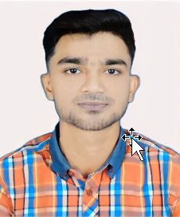 **CURRICULUM VITAE**

**OF**

**Jahid Hasan**

Contact Number: 01633074131

Email: [amranpatwary696@gmail.com](mailto:amranpatwary696@gmail.com)

Address: South Raipur, Raipur, Lakshmipur

Build up challenging and rewarding career in organization that provides structured career advancement within the extent of competitive and dynamic business environment and face challenging opportunities with sincerity, punctuality commitment, self- competency and hard work.

**Career Objective:**

|  |  |
| --- | --- |
| Father’s Name | : Nurul Amin |
| Mother’s Name | : Mahinur Begum |
| Date of Birth | : 10 November 1995 |
| Nationality | : Bangladeshi |
| Religion | : Islam |
| Gender | : Male |
| Marital Status | : Unmarried |
| Blood Group | : B + |
| Permanent Address | : Village- South Raipur, Post Office- South Raipur Police Station- Raipur, District- Lakshmipur |

**Personal Information:**

* Room Attendant
* Driving
* Food Delivery (one year six months) work in Doha, Qatar

**Experience:**

**Education Qualification:**

**Secondary School Certificate (SSC)**

Institute: Bangladesh Open University

Borad: Cumilla

Group: Humanities

Year of Passing: 2021

Grade Point Average: 3.18

**Higher Secondary Certificate (HSC)**

Institute: Bangladesh Open University

Borad: Cumilla

Group: Humanities

Year of Passing: 2023

Grade Point Average: 3.18

|  |  |  |  |
| --- | --- | --- | --- |
|  | Reading | Writing | Speaking |
| Bangla | Fluent | Fluent | Fluent |
| English | Average | Average | Average |

**Language Skill:**

* Microsoft Office
* Data Analysis

**Hard Skill:**

* Sports
* Travelling

**Hobby:**

* Communication
* Teamwork
* Time management
* Leadership

**Soft Skill:**

Jahid Hasan

**Sign Date: 26 January, 2024**