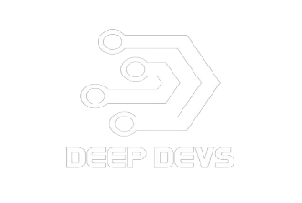

E-Police

Management

System

**PC MOHLALA 201996898**

**SJ LETOABA 201911299**

**NW TSHIVHULA 2019311796**

**Z SEBELA 202000532**

**T TSOTSETSI 219085633**

**K POOE 219056218**

**Chapter 4: System Design Document**

Document Overview

The System Design Document (SDD) explains how the functional and non-functional requirements in the Requirements Document, the preliminary user-oriented functional design in the High-Level Technical Design Concept/Alternatives document, and the preliminary data design in the Logical Data Model (LDM) become more technical system design specifications from which a system can be built. The SDD contains both high-level and detailed system design specifications.

The SDD describes design goals and considerations, provides a high-level overview of the system architecture, and describes the data design associated with the system, as well as the human-machine interface and operational scenarios. The high-level system design is further decomposed into low-level detailed design specifications for each system component, including hardware, internal communications, software, system integrity controls, and external interfaces.

Purpose

In order to give the development team guidance on the architecture of the system to be developed, the SDD documents and tracks the necessary information. Throughout the system development life cycle, design documents are incrementally and iteratively produced based on the unique circumstances of the information technology (IT) project and the system development methodology used to develop the system.

Audience

The intended recipients of this document (SSD) are the project manager, project team, and development team. Some parts of this document, such as the user interface (UI), may be shared with the client/user and other stakeholders whose input/approval is required for the UI.

The following individuals or groups are the intended audience or users for this system design document:

1. Deep Devs Project Management team
2. Deep Devs Development team
3. Deep Devs Information Technology Team
4. Consulting team

Related Documentation

**Test plans**

|  |  |
| --- | --- |
|  |  |
| Test Planning | Actor: not complete  Output: not complete |
| Test Analysis | Actor: not complete  Output: not complete |
| Test Design | Actor: not complete  Output: not complete |
| Test Execution | Actor: not complete  Output: not complete |
| Test Closure | Actor: not complete  Output: not complete |

Document Convention

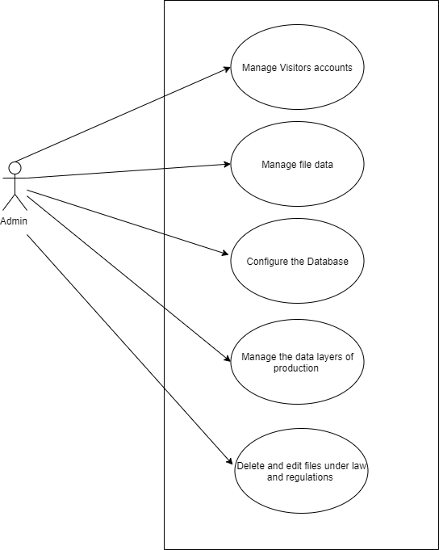

System Overview

Description

|  |
| --- |
| KEY SOFTWARE FEATURES |
| DASHBOARD |
| Manage Account |
|  |
| Reports |
|  |
| Knowledge Centre |
|  |
| Help Desk |
|  |
| KEY SECIRUTY FEATURES |
| Software Security |
|  |

System Architecture

Software architecture description involves principles and practices of modelling and representing architectures. Not complete

Architectural view model

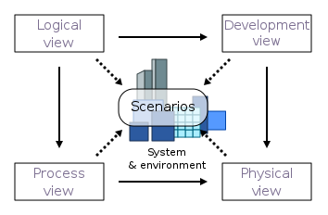

Architectural Activities

A software architect undertake several tasks, working alongside project managers including the development team to accomplish the overall vision of system by producing a fully functional system which achieves a scalable and stable project. Architects are needed in assistance to manage complexity while ensuring adaptability, reduce maintenance cost and provides a solid foundation for the system to be reused. The following are the tasks associated with the software architect:

* Phase 1: Create business case for the system
* Phase 2: Understand requirements: functional and non-functional
* Phase 3: Create and select architecture
* Phase 4: Document and communicate architecture
* Phase 5: Evaluate architecture
* Phase 6: Implement system according to architecture
* Phase 7: Ensure implementation conforms too architecture

Financial Implications

1. Development Costs:

|  |  |
| --- | --- |
| **Type of Cost** | **Total Estimates** |
| Technical Expertise | R15 000.00 |
| Internet Connection | R3 000.00 |
| Hardware costs | R12 000.00 |
| Software testing and quality inspections | R16 000.00 |

1. Unit Costs and Investments:

Deep Devs is in the process of accumulating a total amount of R205 000.00, only R81 000.00 has been granted through a bank loan, which each group member is liable to contribute 10% for loan repayment, including interest rates incurred. This amount will majorly contribute toward setting up the project environment, such as purchasing hardware and software needed - that will be assisting the team to start working on the project and also cover weekly to monthly running costs.

|  |  |
| --- | --- |
| **Cost Per Assets (Unit Cost)** | **Total Estimates** |
| Workstation costs | R17 500.00 |
| Storage Drives | R4 000.00 |
| Backup Drives | R2 950.00 |

1. Operational Costs:
2. Profit System:

Android tools

• Latest version of JDK

• Android SDK

• Apache Ant(Another Neat Toll) – an open source tool that automates aspects of the Android build process

• Gradle – An advanced build toolkit that manages dependencies and allows you to define

custom build logic

Windows Desktop tools

Incomplete

Web Application Architecture

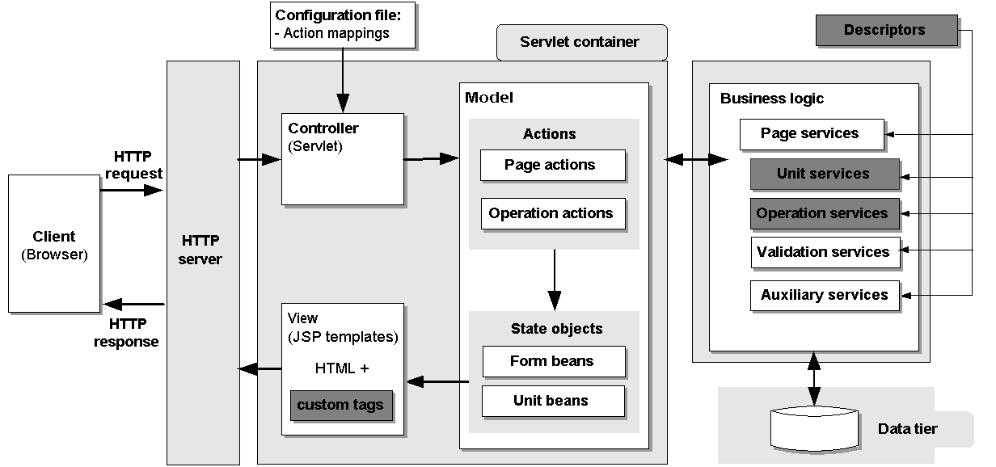

Hardware Architecture

|  |  |
| --- | --- |
| CPU | Intel core 1.60Hz or more |
| Memory | 2GB or more |
| Storage | ? GB |
| Operating System | Microsoft Windows 7/8/8.1/10 (32bit / 64bit) |
| Display |  |

Hardware Design

**Computer Systems**

The e-Police management will run on both android and the web.

**Hardware Components Peripherals**

|  |  |
| --- | --- |
| Input | * Keyboard * Computer mouse * Image scanner |
| Output | * Printer * Display screen |
| Storage device | * Flash drive * Hard disk drive |
| Input/output | * Network interface controller |

**Networks**

|  |  |
| --- | --- |
| Routers |  |
| Switch |  |
| Hub |  |
| Gateway |  |
| Bridge |  |
| Repeater |  |
| Modem |  |

Data and Database/Files

Dataflow Diagram

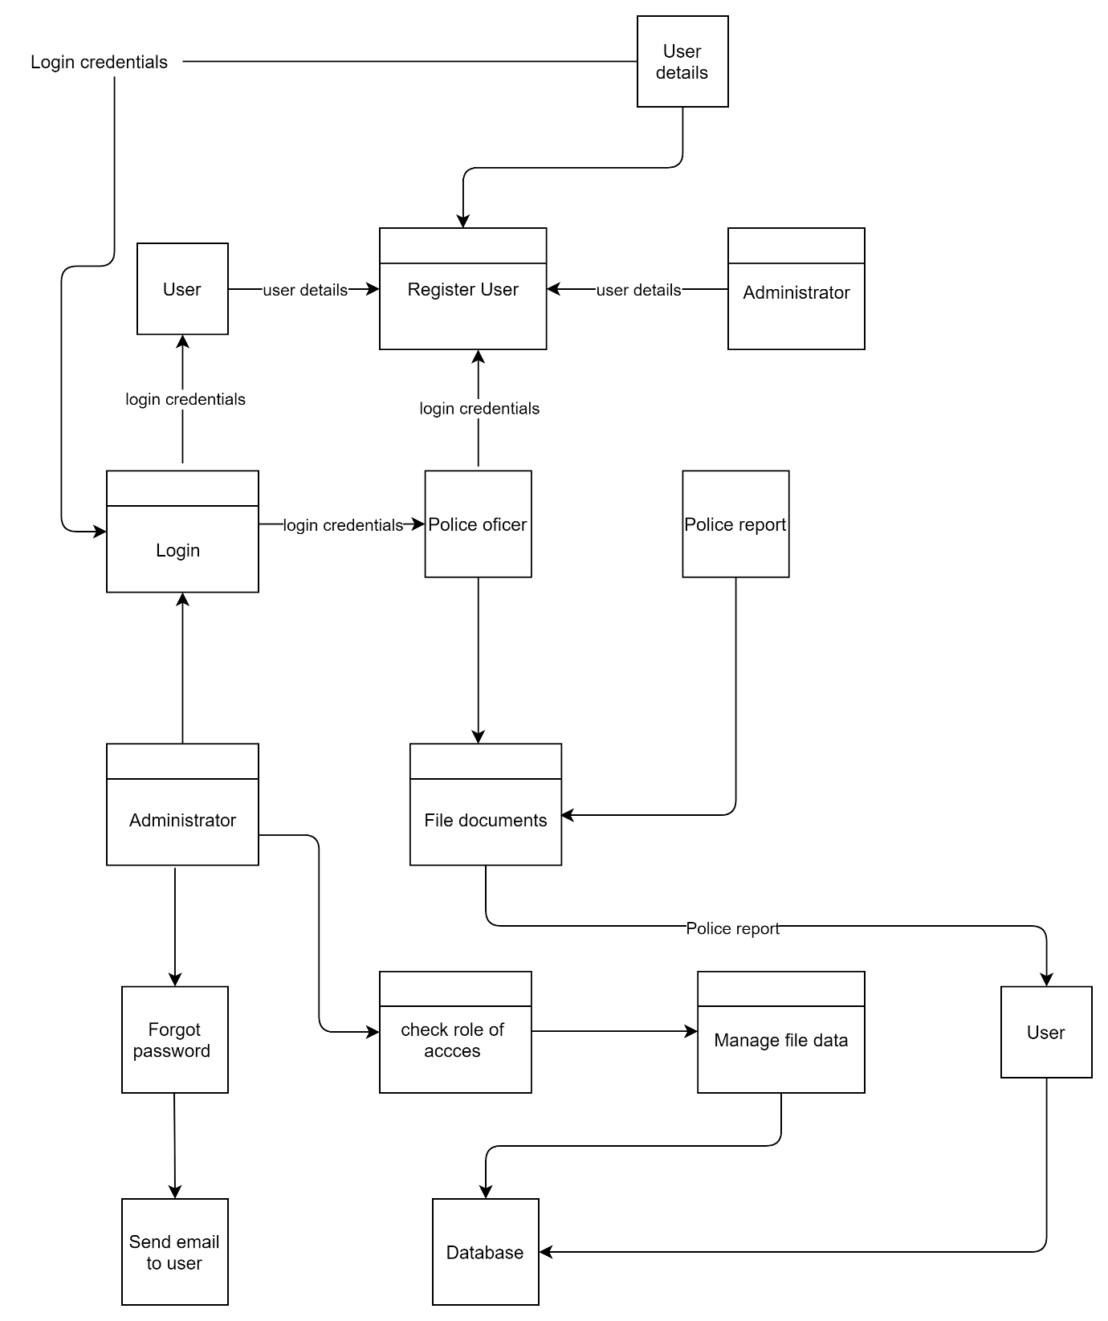

System Design

* **User Experience (UX) – Wireframes**
* **User Interface (UI)**