**Active Record Basics Practical**

* Create Product using new() method:-

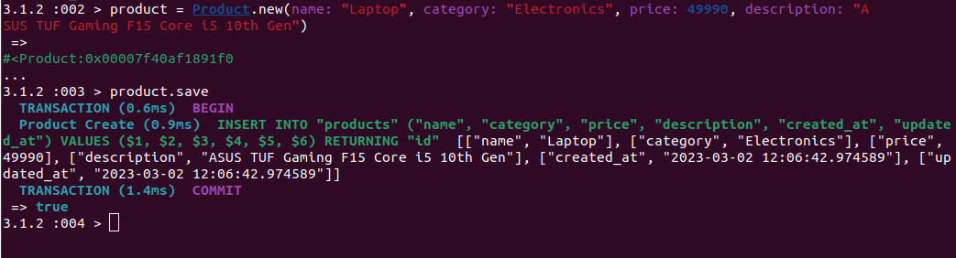

* Create Product using create() method:-

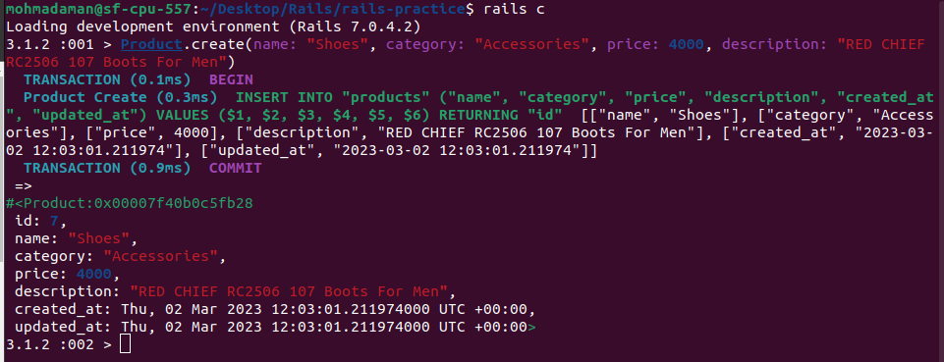

* Read Products using all() method:-

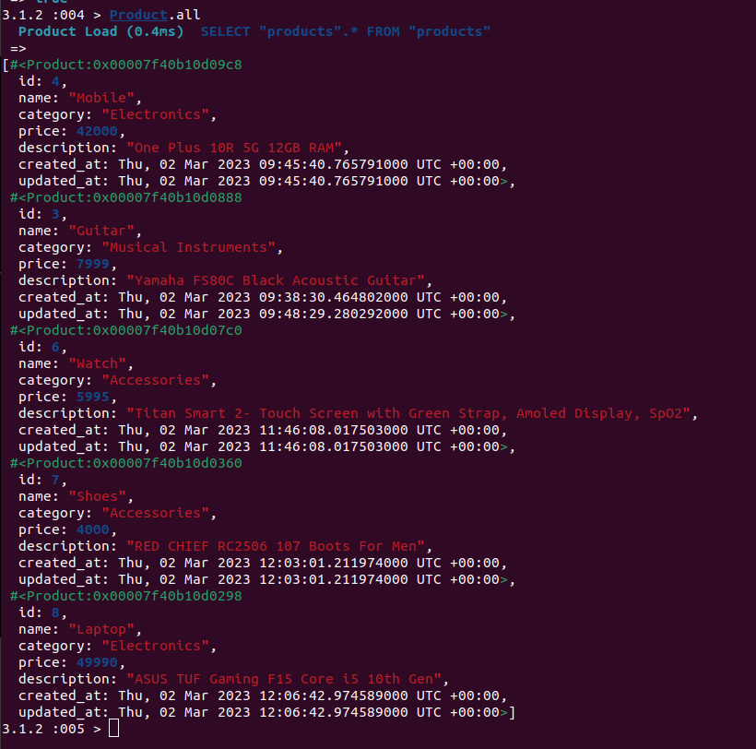

* Read Products using find() method:-

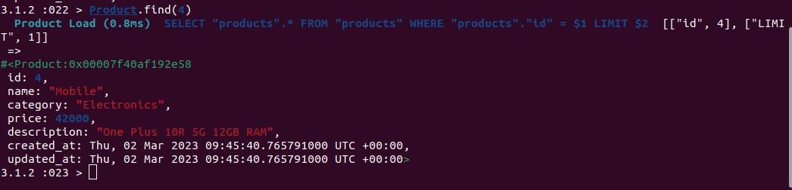

* Read Products using where, first and last method:-

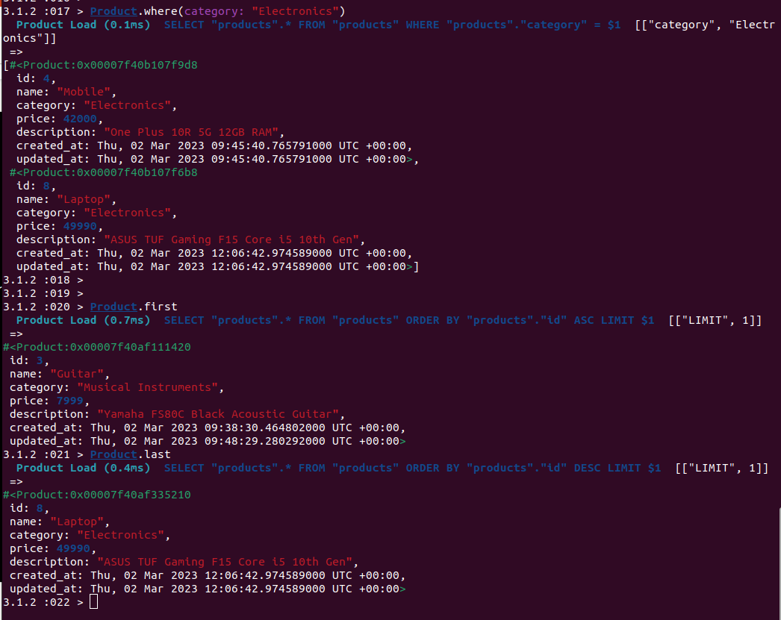

* Update Products using update method:-

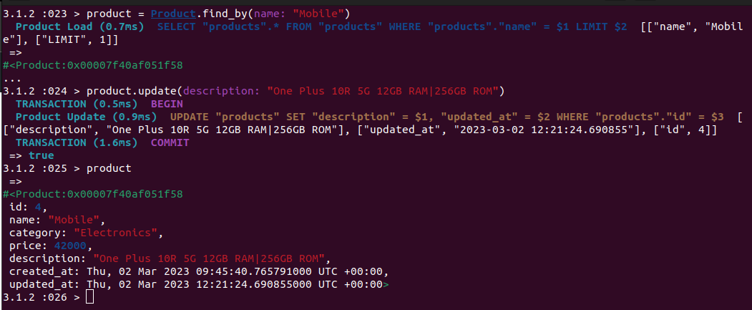

* Update Products using update_all method:-

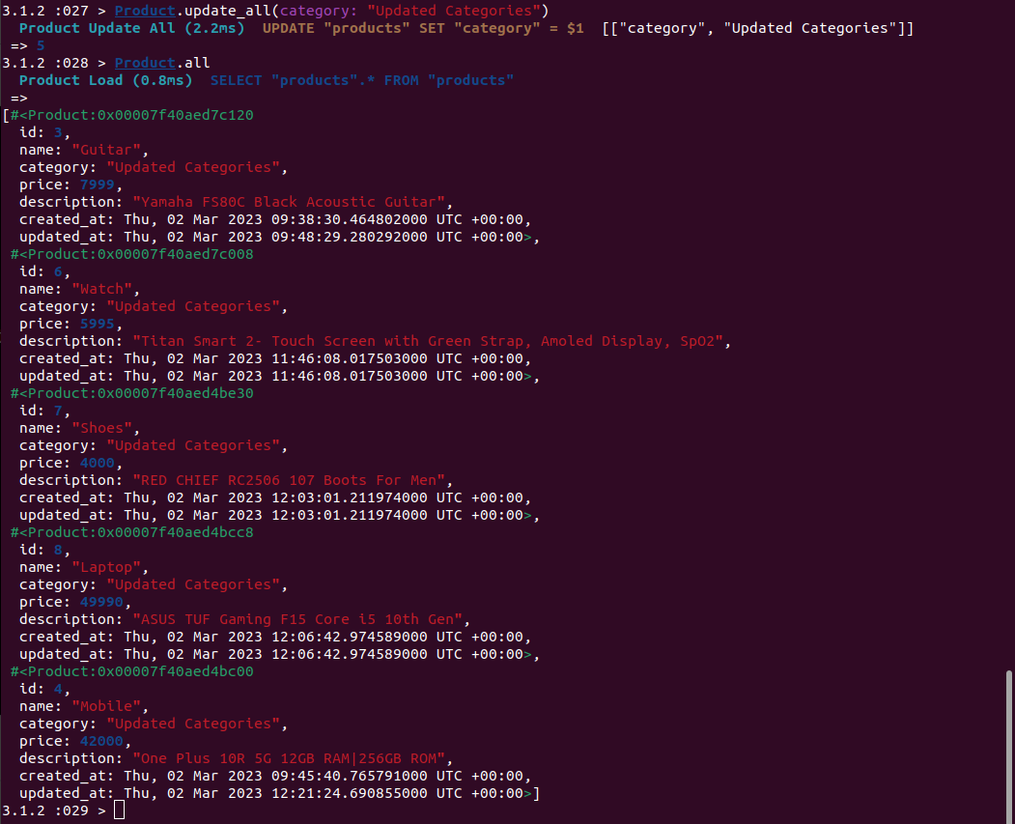

* Delete Products using destroy method:-

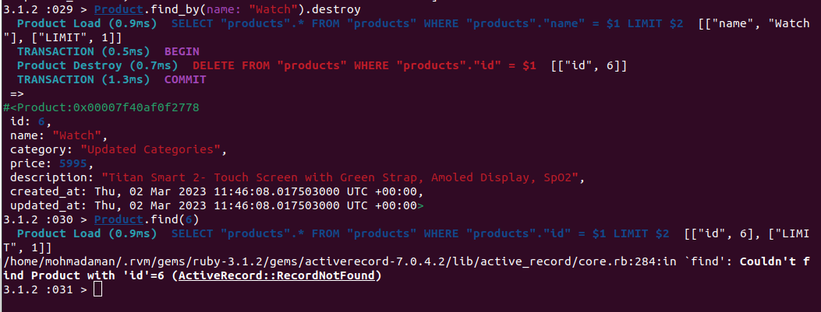

* Update Products using delete method:-

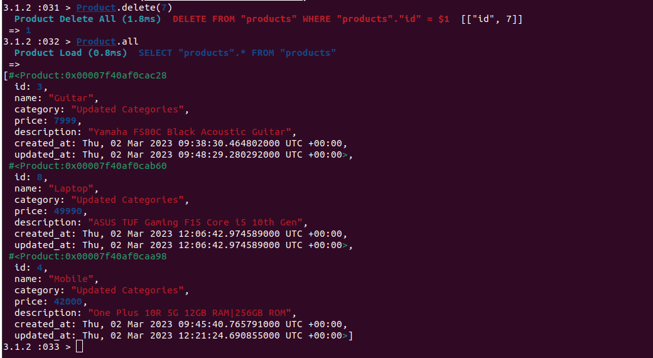

* Update Products using destroy_by method:-

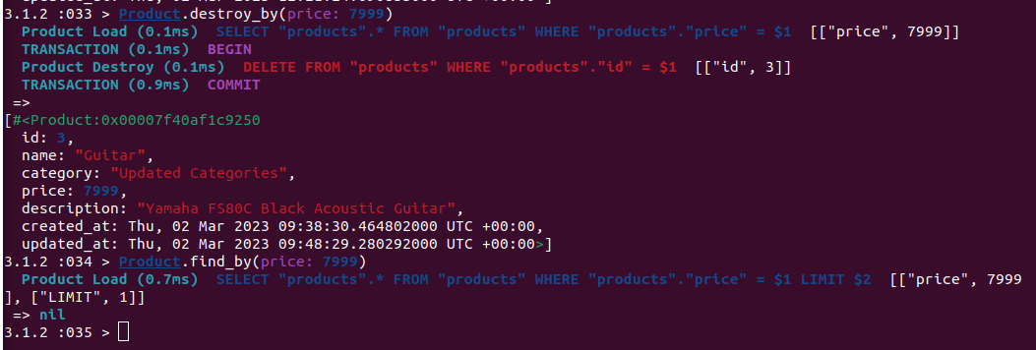

* Update Products using destroy_all method:-

