**Practical-14**

**unscope :-**

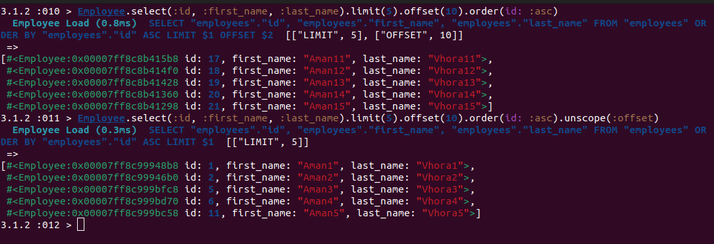

**only :-**

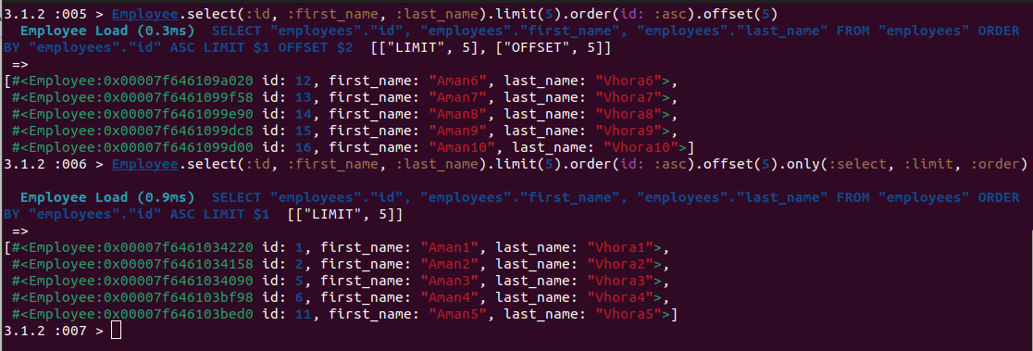

**reselect :-**

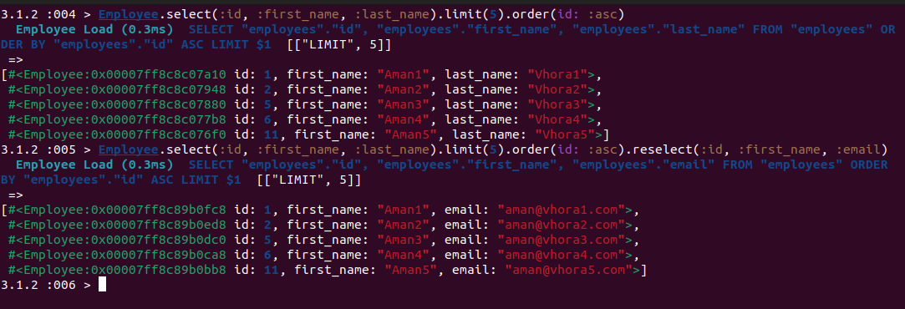

**reorder :-**

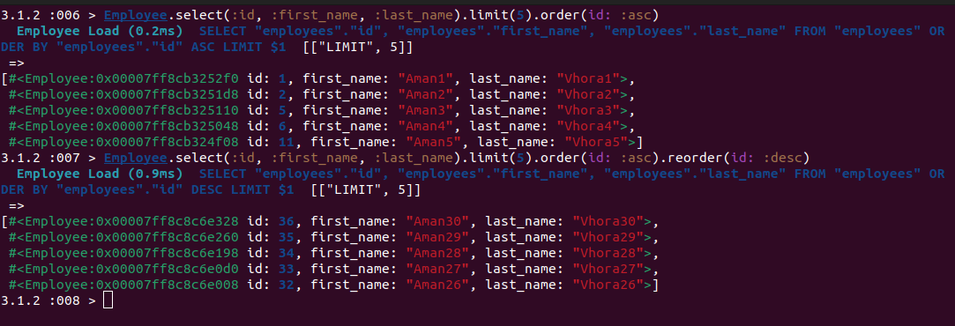

**reverse_order :-**

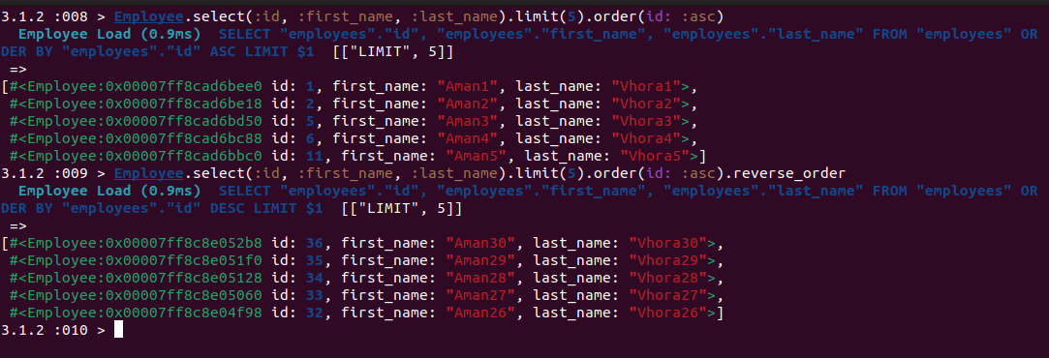

**Practical-15**

**Locking :-**

**-** Before Locking Implementation: -

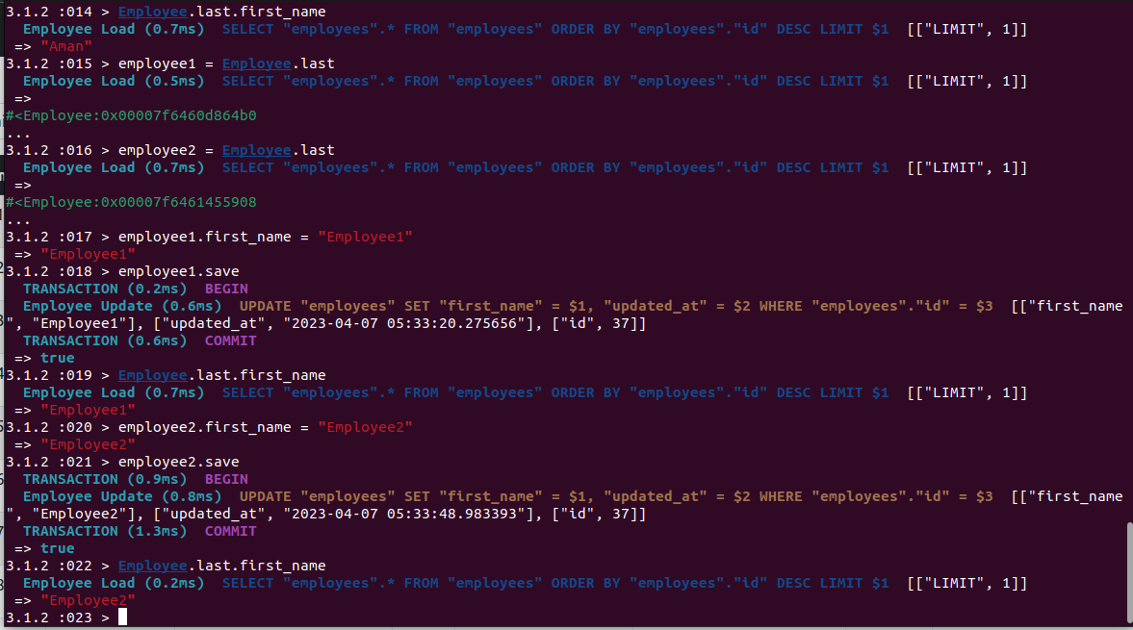

**-** In order to use optimistic locking, the table needs to have a column called lock_version of type integer.

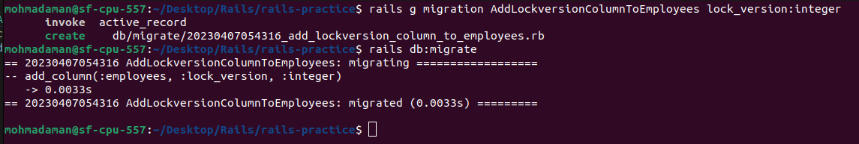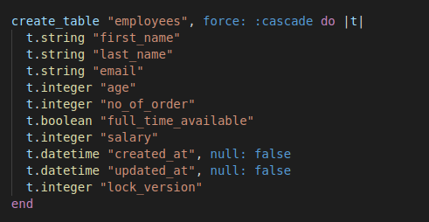

**-** After Locking Implementation: -

