**Name : محمد نجم الدين عبد الفتاح**

**B.N: 814**

**Date : 5/6/2020**

**Topic:** Artificial Intelligence (AI)

**Github link :**

**Github page :**

**Application brief :**

Artificial intelligence is a branch of computer science that attempts to understand the essence of intelligence and produce a new intelligent machine that responds in a manner similar to human intelligence. Research in this area includes robotics, speech recognition, image recognition, Natural language processing and expert systems. Since the birth of artificial intelligence, the theory and technology have become more and more mature, and the application fields have been expanding. It is conceivable that the technological products brought by artificial intelligence in the future will be the “container” of human wisdom. Artificial intelligence can simulate the information process of human consciousness and thinking. Artificial intelligence is not human intelligence, but it can be like human thinking, and it may exceed human intelligence

Applications of artificial intelligence

AI is relevant to any intellectual task. Modern artificial intelligence techniques are pervasiveand are too numerous to list here. Frequently, when a technique reaches mainstream use, it is no longer considered artificial intelligence; this phenomenon is described as the AI effect.

High-profile examples of AI include autonomous vehicles (such as drones and self-driving cars), medical diagnosis, creating art (such as poetry), proving mathematical theorems, playing games (such as Chess or Go), search engines (such as Google search), online assistants (such as Siri), image recognition in photographs, spam filtering, predicting flight delays, prediction of judicial decisions, targeting online advertisements, and energy storage

With social media sites overtaking TV as a source for news for young people and news organizations increasingly reliant on social media platforms for generating distribution, major publishers now use artificial intelligence (AI) technology to post stories more effectively and generate higher volumes of traffic.

AI can also produce Deepfakes, a content-altering technology. ZDNet reports, "It presents something that did not actually occur," Though 88% of Americans believe Deepfakes can cause more harm than good, only 47% of them believe they can be targeted. The boom of election year also opens public discourse to threats of videos of falsified politician media

**Screeshots :**

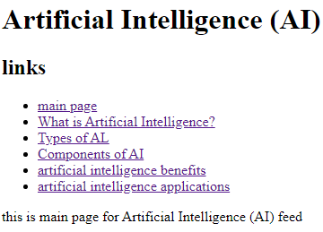

**Screen shot for main page**

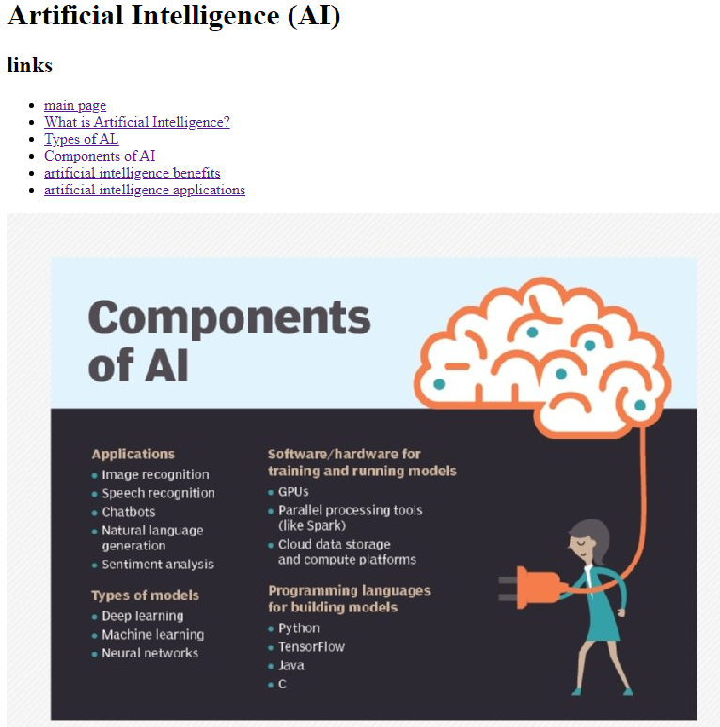

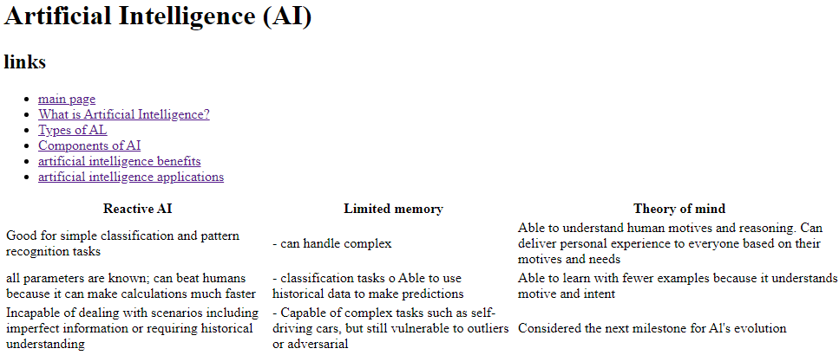

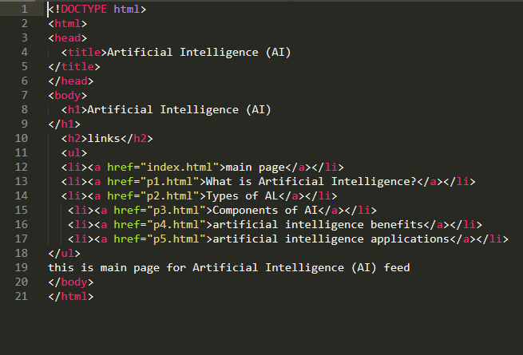

**Screen shot for code**