Table of Contents
1. Introduction 1
3. Main Components and Their Roles 2
4. Design Patterns Used 6
4.1 Singleton (FileManager) 6
4.2 Template Method (ReportGenerator) 8
4.3 Factory Method (ActorFactory) 13
4.4 Decorator (ResidenceInfo) 14
4.5 Proxy (SystemAccessProxy) 16
5. SOLID Principles Applied 19
6. UML Class Diagram 29
Test Plan and Automated Testing 30

1. Introduction
Smart Care is a patient admission management software for hospital patients that automates and simplifies the steps in registering a patient, admitting them, discharging them, tracking their procedures, and producing statistical reports. Each user type Doctor, Nurse, and Administrator has a different set of tasks to perform and also has their own privileges within the system.
2. System Overview and objectives
The objectives of the system are as follows:
- Maintain and store records for all types of people in the hospital: patient, nurse, doctor and administrator.
- Monitor which section and rooms (private, 2 shared, 4 shared) are to be occupied at any given time.
- simplify the workflows associated with admitting and discharging patients from the hospital including room assignment.
- Track each patient's required procedures with the ability for a nurse to indicate when the procedure has been completed.
- Provide statistical reporting for patients, section, rooms, and performed medical procedures with exporting to TXT or XML.
- Implement role based access control so that each user type can perform only those functions that they are authorized by their role to perform.

3. Main Components and Their Roles
The following table summarises every significant class or interface in the system, its type, and its role.

Component | Type | Role in the System
Actor (abstract) | Abstract class | All human entities are defined with a base class, containing shared properties including; id, name, phone number, password, and a reference to a ResidenceInfo decorater. The getResidenceInfo() method offers polymorphic access to the individual's address.
Admin | Concrete class | Has an inheritance relationship with the Actor class. The Actor represents an administrator who has full control over all system functionality: including managing Doctors, Nurses, Administrators, Sections, Rooms, Procedures, as well as producing Reports.
Doctor | Concrete class | Has an inheritance relationship with the Actor class. Represents a Doctor who is able to admit/ discharge patients, prescribe medical procedures, and view the patient's medical history.
Nurse | Concrete class | Has an inheritance relationship with the Actor class. This is a person who is responsible to register new patients, view patient information, view their registered medical procedures, and mark them as complete.
Patient | Concrete class | Has an inheritance relationship with the Actor class. This entity is responsible for maintaining the admission process, has an assigned Doctor, has Section, Room, Admission Dates, and a collection of MedicalProcedure entities..
ResidenceInfo | Interface | Defines a contract in the form of the getInfo() which is used by the Decorator pattern to represent any actor's address.
ResidenceDecorator (abstract) | Abstract decorator | Implements the ResidenceInfo Decorator pattern. Wraps another ResidenceInfo object to form the basis for the Decorator pattern hierarchy.
JordanianInfo | Concrete decorator | Has an inheritance relationship with the ResidenceDecorator class and provides National Number and ID Card Numbers for citizens of Jordan.
NonJordanianInfo | Concrete decorator | Has an inheritance relationship with the ResidenceDecorator class and adds Nationality and Residence Permit Number for non Jordanians.
Section | Entity class | Represents a Hospital Section (for example: Cardiology). Contains an ArrayList of Room objects and provides findAvailableRoom() capability.
Room | Entity class | The Room has a type (PRIVATE / SHARED_2 / SHARED_4) specifying the type of the room as well as the derived capacity of the room. It contains an ArrayList of the patients that are currently admitted into the room.
MedicalProcedure | Entity class | The MedicalProcedure represents a single medical procedure (Blood Test, for example). It has a name, id, and completion status (once marked complete using the markDone() method, can be checked for completion status with the isDone() methods).
DoctorDatabase | Repository class | An ArrayList of Doctors is maintained and provides the following actions: add doctor, remove doctor, and find doctor and call displayAllDoctors() to display all doctors.
NurseDatabase | Repository class | An ArrayList of Nurses is maintained and provides (add / remove)method capabilities and call displayAllNurses() to display all nurses.
PatientDatabase | Repository class | An ArrayList of Patients is maintained and provides all (add / remove) method capabilities and call displayAllPatients() to display all patients.
AdminDatabase | Repository class | An ArrayList of Admins is maintained and provides all (add / remove) method capabilities and call displayAllAdmins() to display Admins.
SectionDatabase | Repository class | An ArrayList of Sections is maintained and provides call to displayAllRooms() and findAvailableRoomInAnySection().
MedicalProcedureDatabase | Repository class | An ArrayList of Medical Procedures is maintained and provides (add / remove )method capabilities and call displayAllProcedures() to display all medical procedures.
ISystemAccess | Interface | adminLogin(), doctorLogin() and nurseLogin() are declared within the SystemContract and are the mechanisms for authenticating all actors accessing the System.
SystemAccess | Concrete class | ISystemAccess is implemented within the SystemAccess as a way to redirect actors back to their respective database.
SystemAccessProxy | Proxy class | ISystemAccess is implemented within the SystemValidation as the mechanism for validating credentials and subsequently redirecting actors back to the SystemAccess for the continuing of system use.
ReportGenerator (abstract) | Abstract class | The generateReport() method is considered a template method and calls the methods writeTitle(), writeSummary(), writeContent() and writeFooter() in that fixed order.
PatientReport | Concrete report | ReportGenerator is extended by Reporting, and the writeContent() of Reporting is overridden to display lists of each patient, along with their times of admission and completed procedures.
RoomReport | Concrete report | ReportGenerator is extended by Reporting, and the writeContent() of Reporting is overridden to display occupancy statistics of each of the rooms.
SectionReport | Concrete report | ReportGenerator is extended by Reporting, and the writeContent() of Reporting is overridden to display a summary of each section and the rooms in that section (by room).
MedicalProcedureReport | Concrete report | An extension of ReportGenerator, implements the writeContent() method in order to list procedures which have been completed (and those which are still pending).
FileManager | Singleton utility | A singleton with a private constructor. Includes methods for saving files to either text or XML format. Will only have 1 instance (of itself) at any one time to prevent issues with concurrent file access.
ActorFactory | Factory utility | Contains a method (createActor(type,...)) which returns the correct subclass of Actor based on the type string that is passed in.
DataInitializer | Initializer | At startup, the application will populate all data tables (for section, room, procedure, and actor) with sample data to show how the system functions for the user.
Main | UI Controller | Holds all menu-related logic (for login, Admin, Doctor and Nurse screens) and the main() method. Uses inline switch case logic only, with a single helper method (addResidence()) using the Decorator Pattern to apply the proper decoration to the object.

4. Design Patterns Used

4.1 Singleton (FileManager)
Programming Problem:
The Problem with these types of Applications is there are too many instances that can be created. With more than one instance of the FileManager, multiple threads will all try to write to the same file causing damaged file data and incomplete data.
Design Pattern Solution:
The Singleton Design Pattern will be employed to enforce the existence of only one instance of FileManager that is found in the Application System. The Class FileManager will provide a static method which is called getInstance(). This method will always return the same instance of the FileManager.
Justification:
Using the Singleton will provide a single, ownership point of file access which will eliminate any conflict between multiple threads trying to write to the same File (the file).

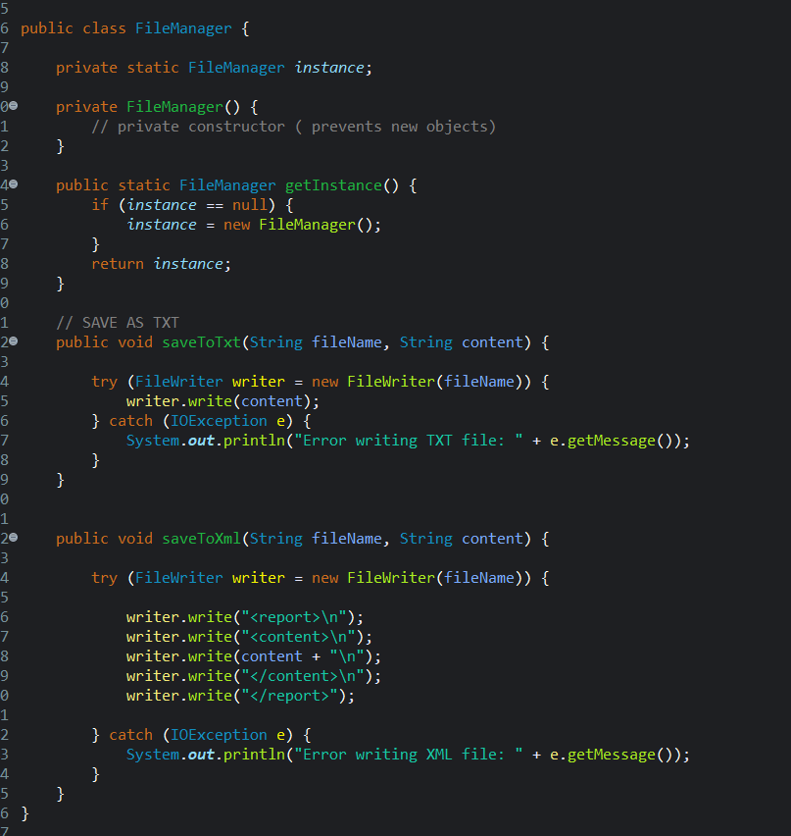

4.2 Template Method (ReportGenerator)
Programming Problem:
There are many types of reports that all share the same structure (title, summary, body, footer). If each report is created by writing the same set of steps to generate the report throughout all report classes, there will be a lot of duplicate code and will make maintenance very difficult.
Design Pattern Solution:
The Template Method design pattern allows a common report structure to be created in a parent class, while allowing each subclass to define only the content of each individual report type created with that structure.
Justification:
The template method design pattern allows for an overall reduction in repetitive code, provides consistent report structure to the users of the various types of reports and will make it easier to create new report types in the future.
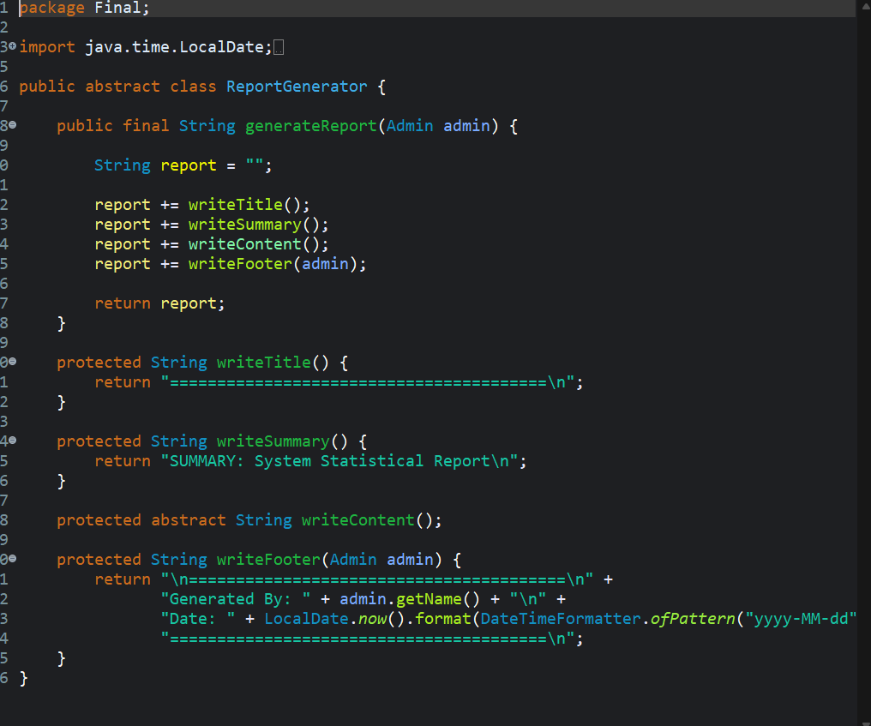

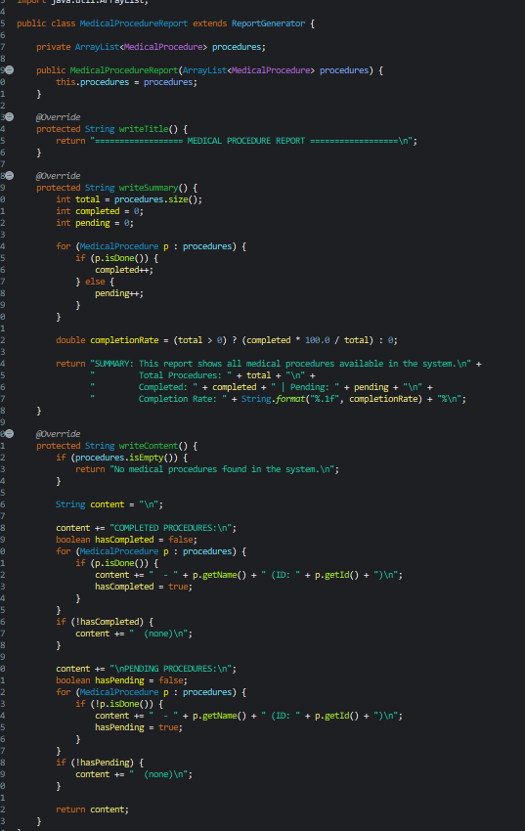
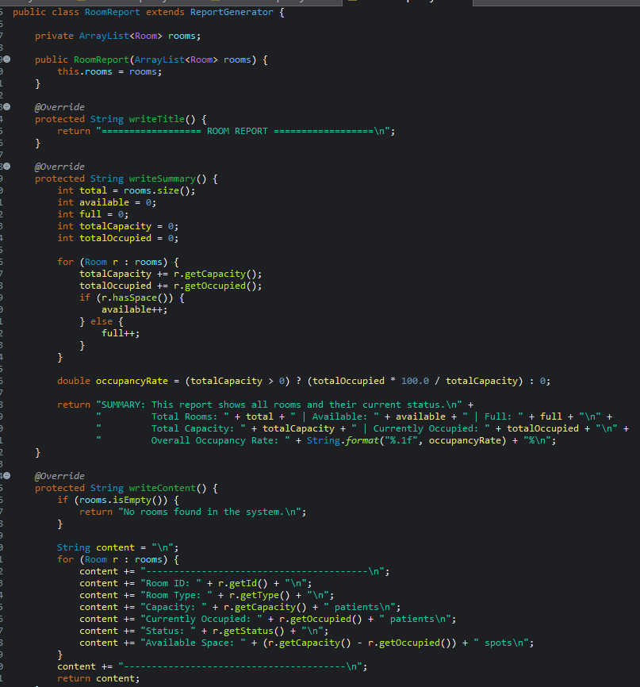
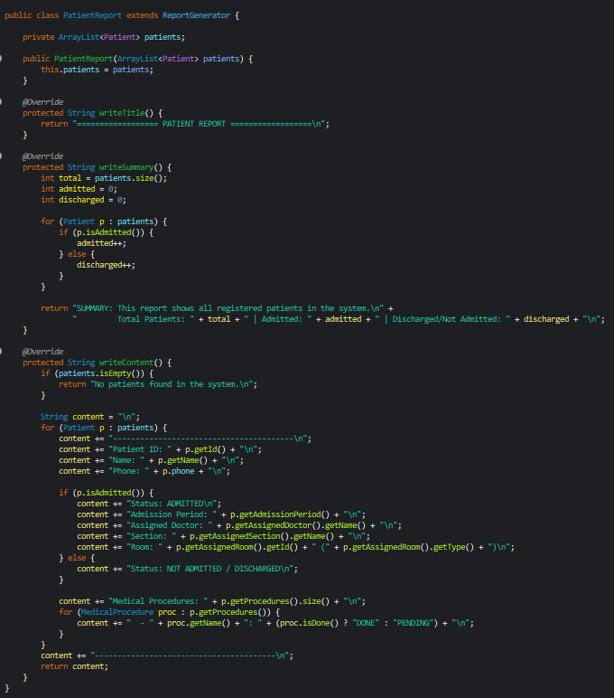
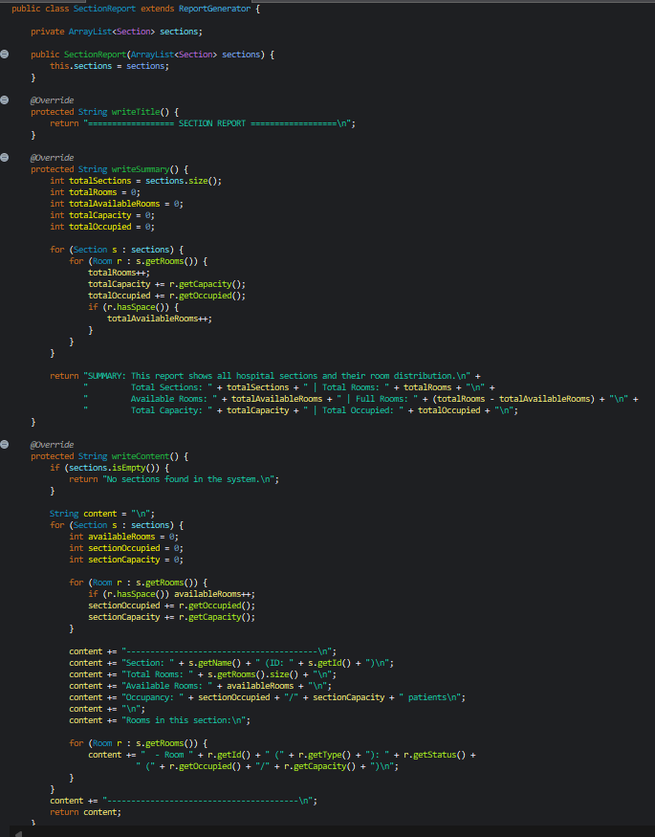

4.3 Factory Method (ActorFactory)
Programming Problem:
The program will allow users to create various types of actors for admin users (Doctor, Nurse, Admin, Patient), depending on their selections. If the program creates actor objects directly in the Main program, it will cause a tight coupling between the user interface and its concrete classes.
Design Pattern Solution:
Implement the Factory Method design pattern to centralize the creation of actors in the ActorFactory and use the ActorFactory's created actor when it needs a specific type of actor.
Justification:
This will enhance the maintainability of the code, simplify creating objects for actors, and allow for new actors to be added with the minimal amount of code modifications necessary.
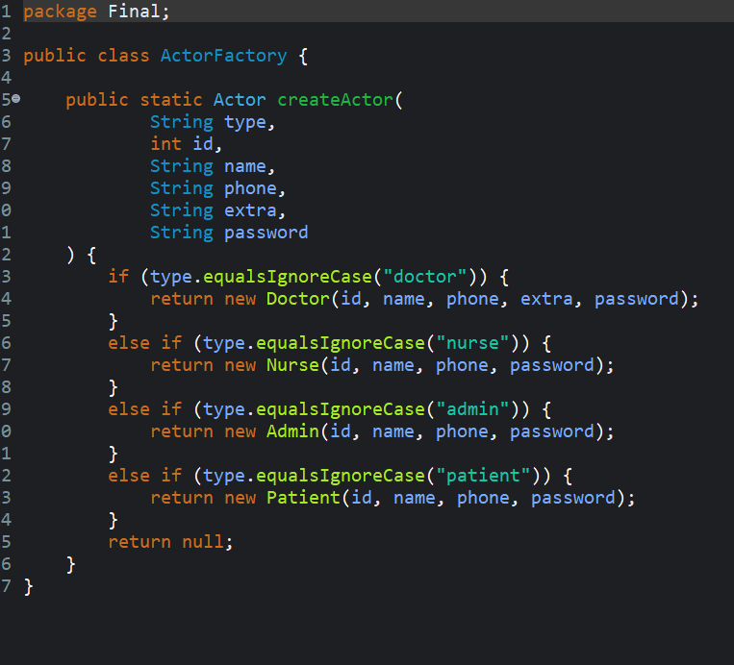

4.4 Decorator (ResidenceInfo)
Programming Problem:
Depending on whether an actor is Jordanian or not, they have residence information that is different. If you simply used inheritance, you would create many duplicated subclasses for each type of actor.
Design Pattern Solution:
The Decorator pattern adds residence information to a base ResidenceInfo object by surrounding the base object with another object with added functionality.
Justification:
The Decorator pattern will avoid class explosion, provide the ability to remain flexible in design, and allow for new types of residence information to be added to the system without modifying existing actor classes.
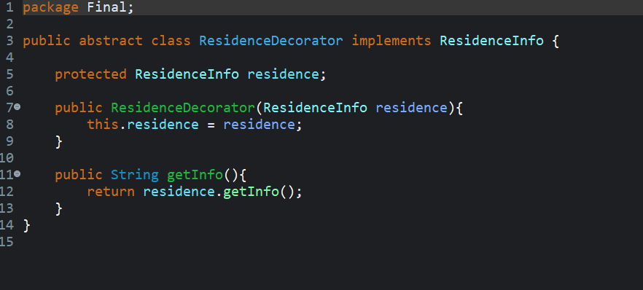
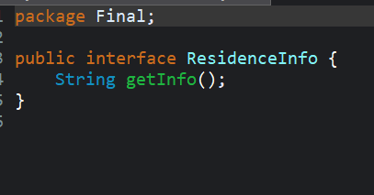
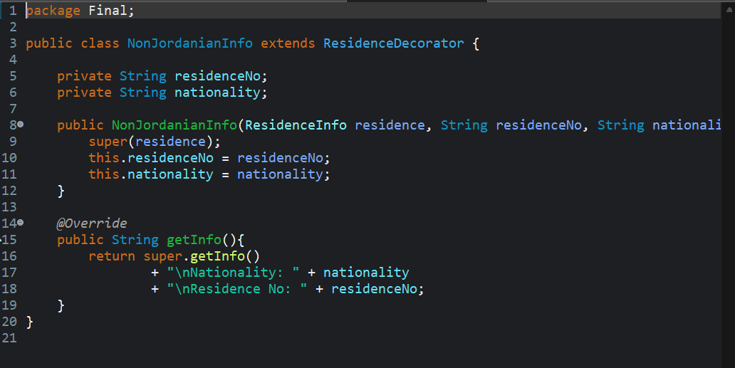
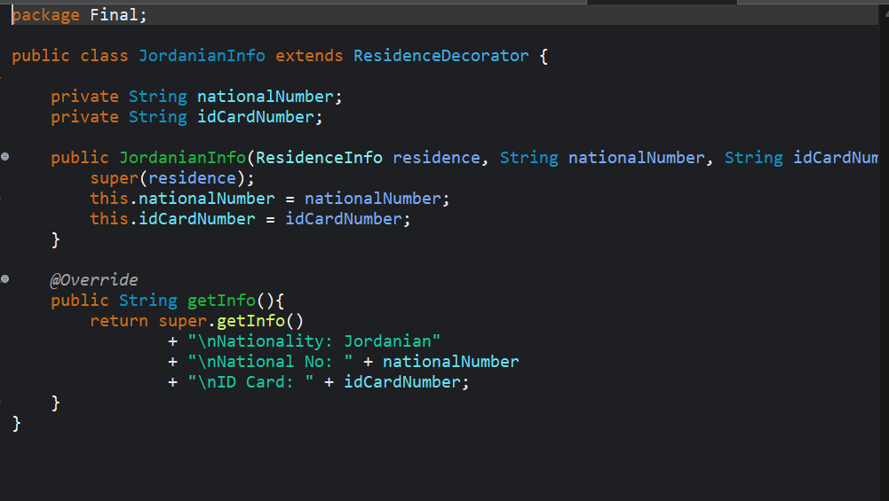

4.5 Proxy (SystemAccessProxy)
Programming Problem:
Developing an application with separate concerns for UI (user-interface) and Security Logic helps eliminate users from being able to log into the system without being properly authenticated. We will accomplish this with a Proxy Design Pattern to separate the Authentication Logic from UI Logic.
Design Pattern Solution:
The Proxy Pattern creates SystemAccessProxy, which validates the user's credentials before giving access to the real System Object.
Justification:
By separating Authentication Logic from User-Interface and Security Logic, you improve upon how the system handles Security. By doing this, you have created a structure to manage/extend the mechanism for Access Control easily.
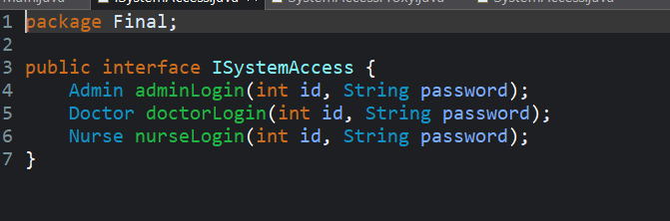
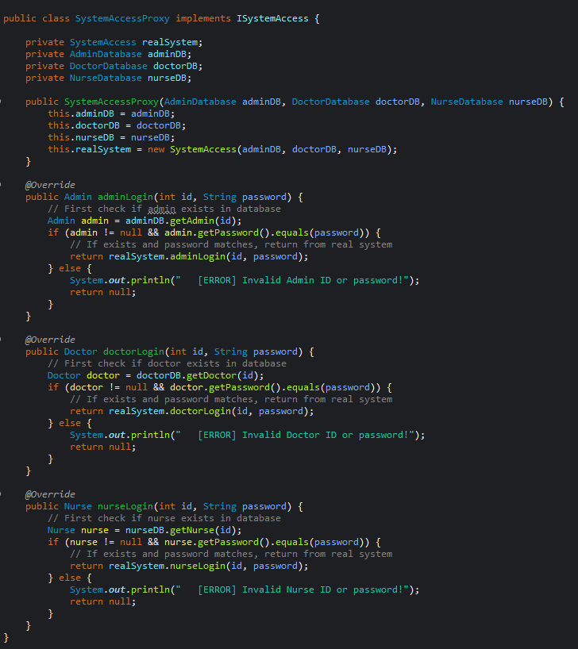
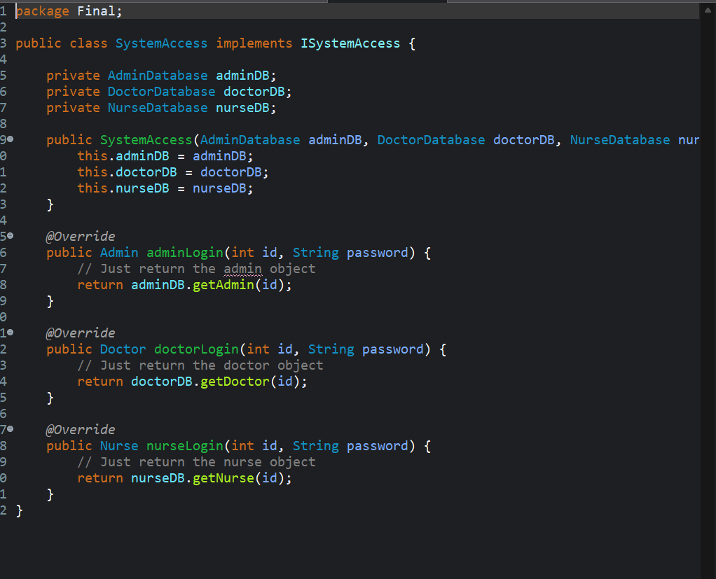

5. SOLID Principles Applied
- Single Responsibility: Each class has one reason to change. The FileManager handles only I/O for files; each database class runs on just one type of entity ReportGenerator formats reports without regard to their contents Main manages only the menus and input.
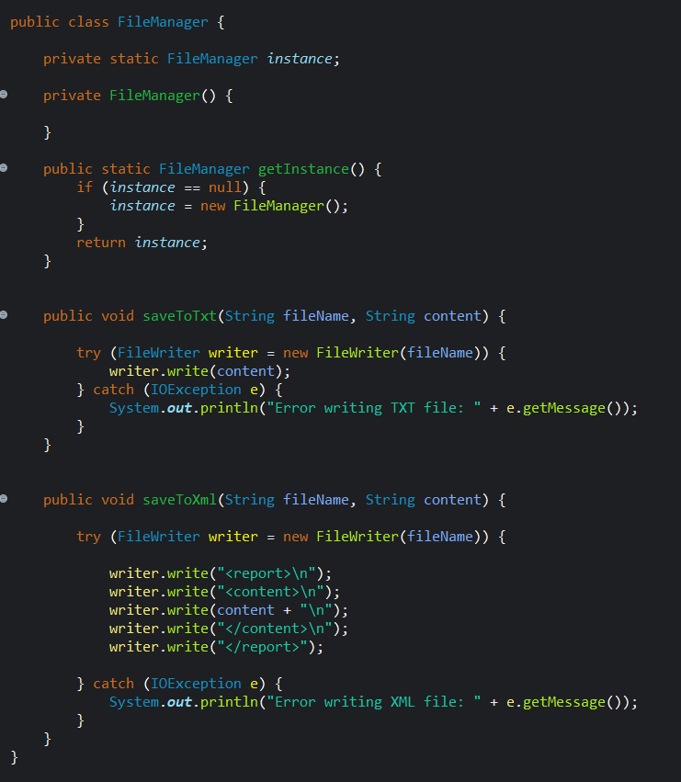
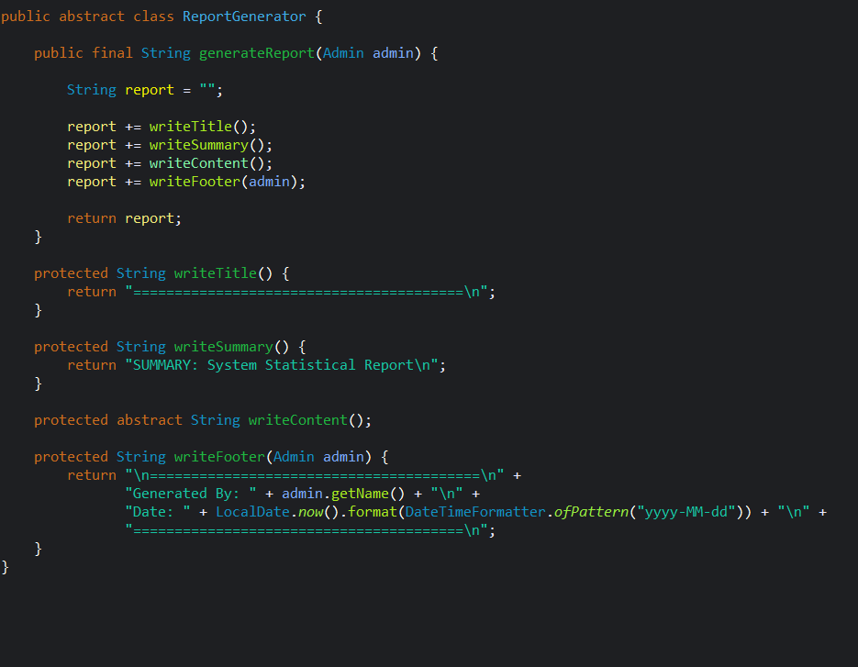
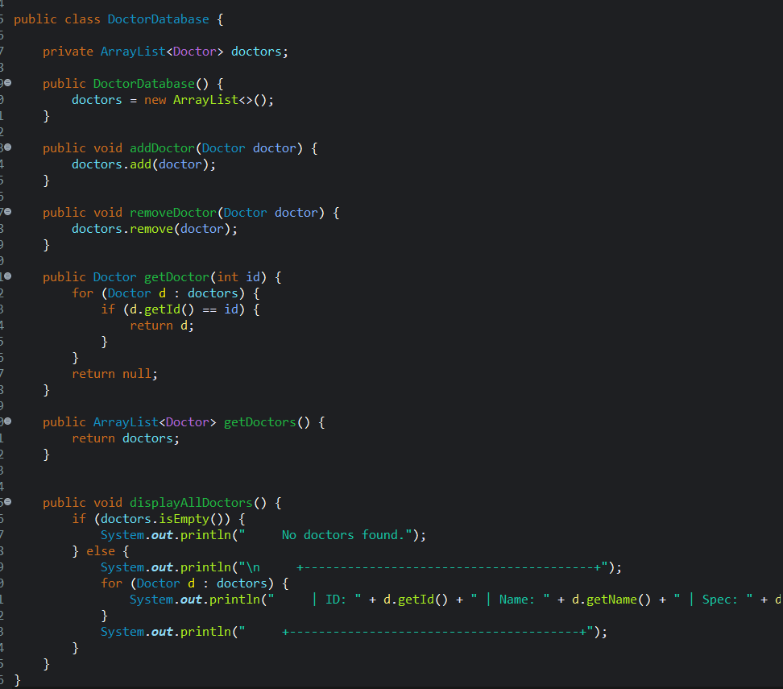

- Open/Closed: New types of reports, residences, or actors can be added by extending current abstractions (ReportGenerator, ResidenceDecorator, Actor) without modifying existing classes.
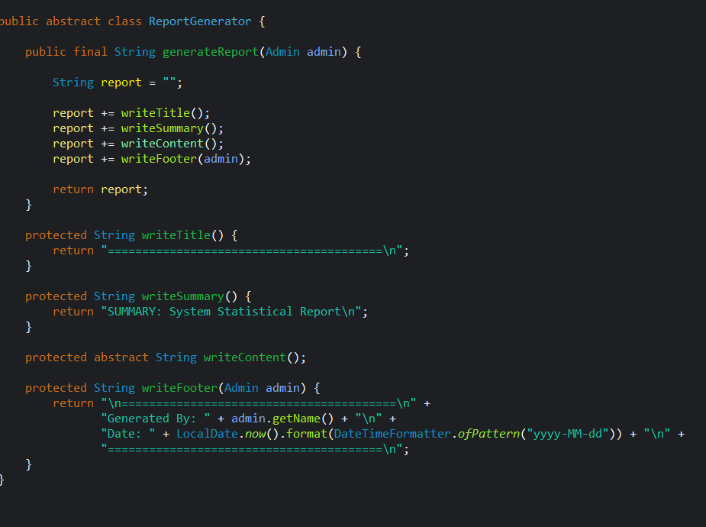
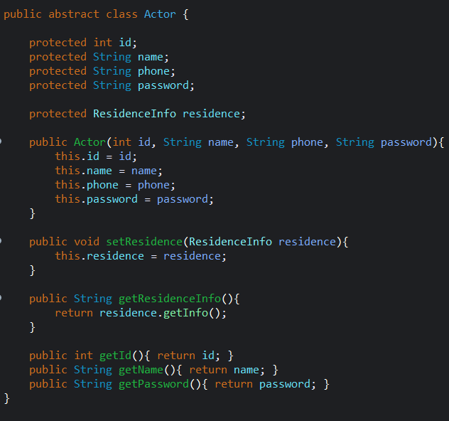

- Liskov Substitution: Any subclass of Actor can be referenced using an Actor reference. Any subclass of ReportGenerator can be used to generate a report from any type of ReportGenerator. SystemAccessProxy is used as a transparent substitute for SystemAccess.

- Interface Segregation: ISystemAccess has only three login methods, and ResidenceInfo has only a getInfo() function. No class will implement methods it does not require.

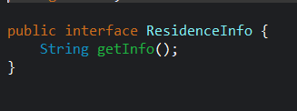

- Dependency Inversion: Main depends on ISystemAccess (interface) and not SystemAccess (concrete). Main's report generation relies on ReportGenerator (abstract class) and not concrete report types.

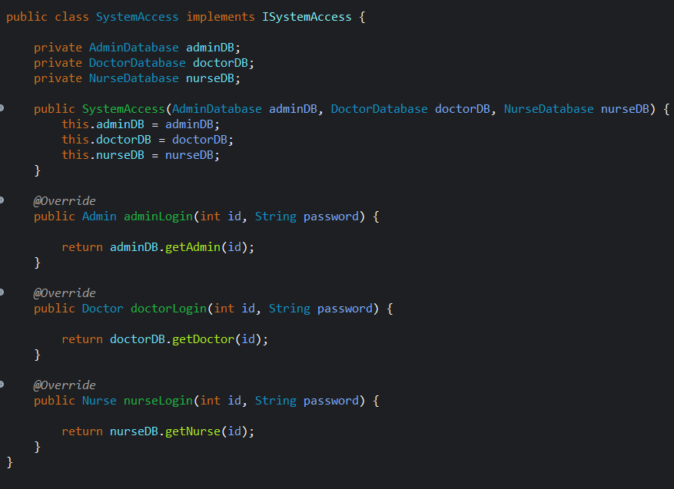

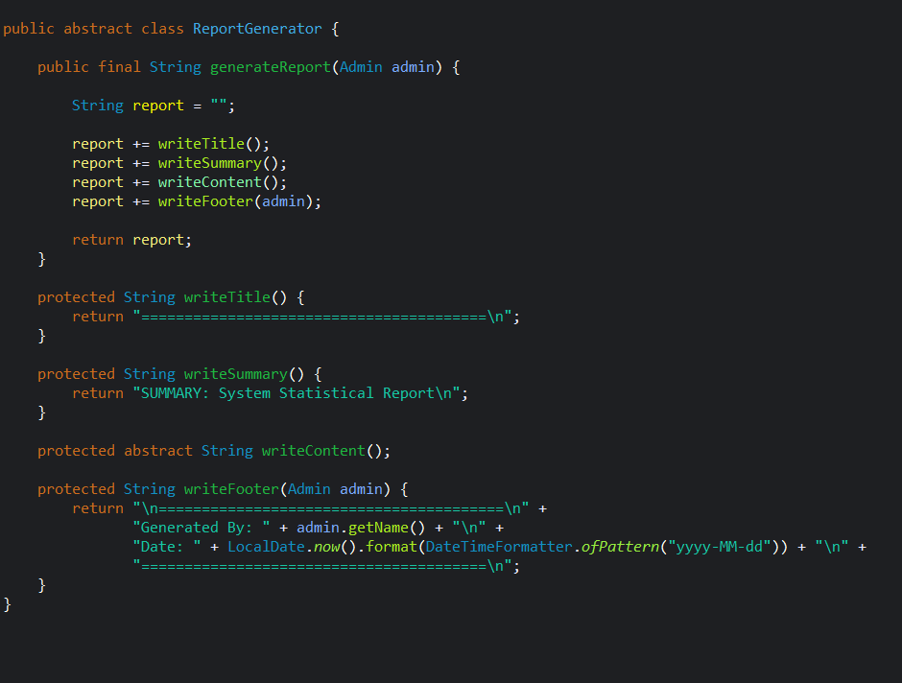
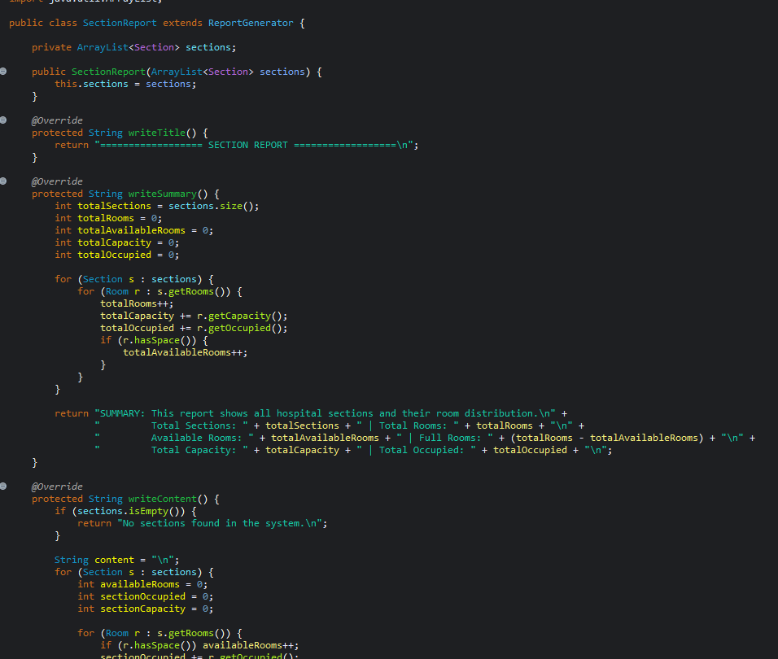

6. UML Class Diagram
The UML class diagram for the Smart Care system is submitted as a separate image file (It shows all classes, interfaces, and abstract classes with their attributes and key methods, connected by the following relationship:

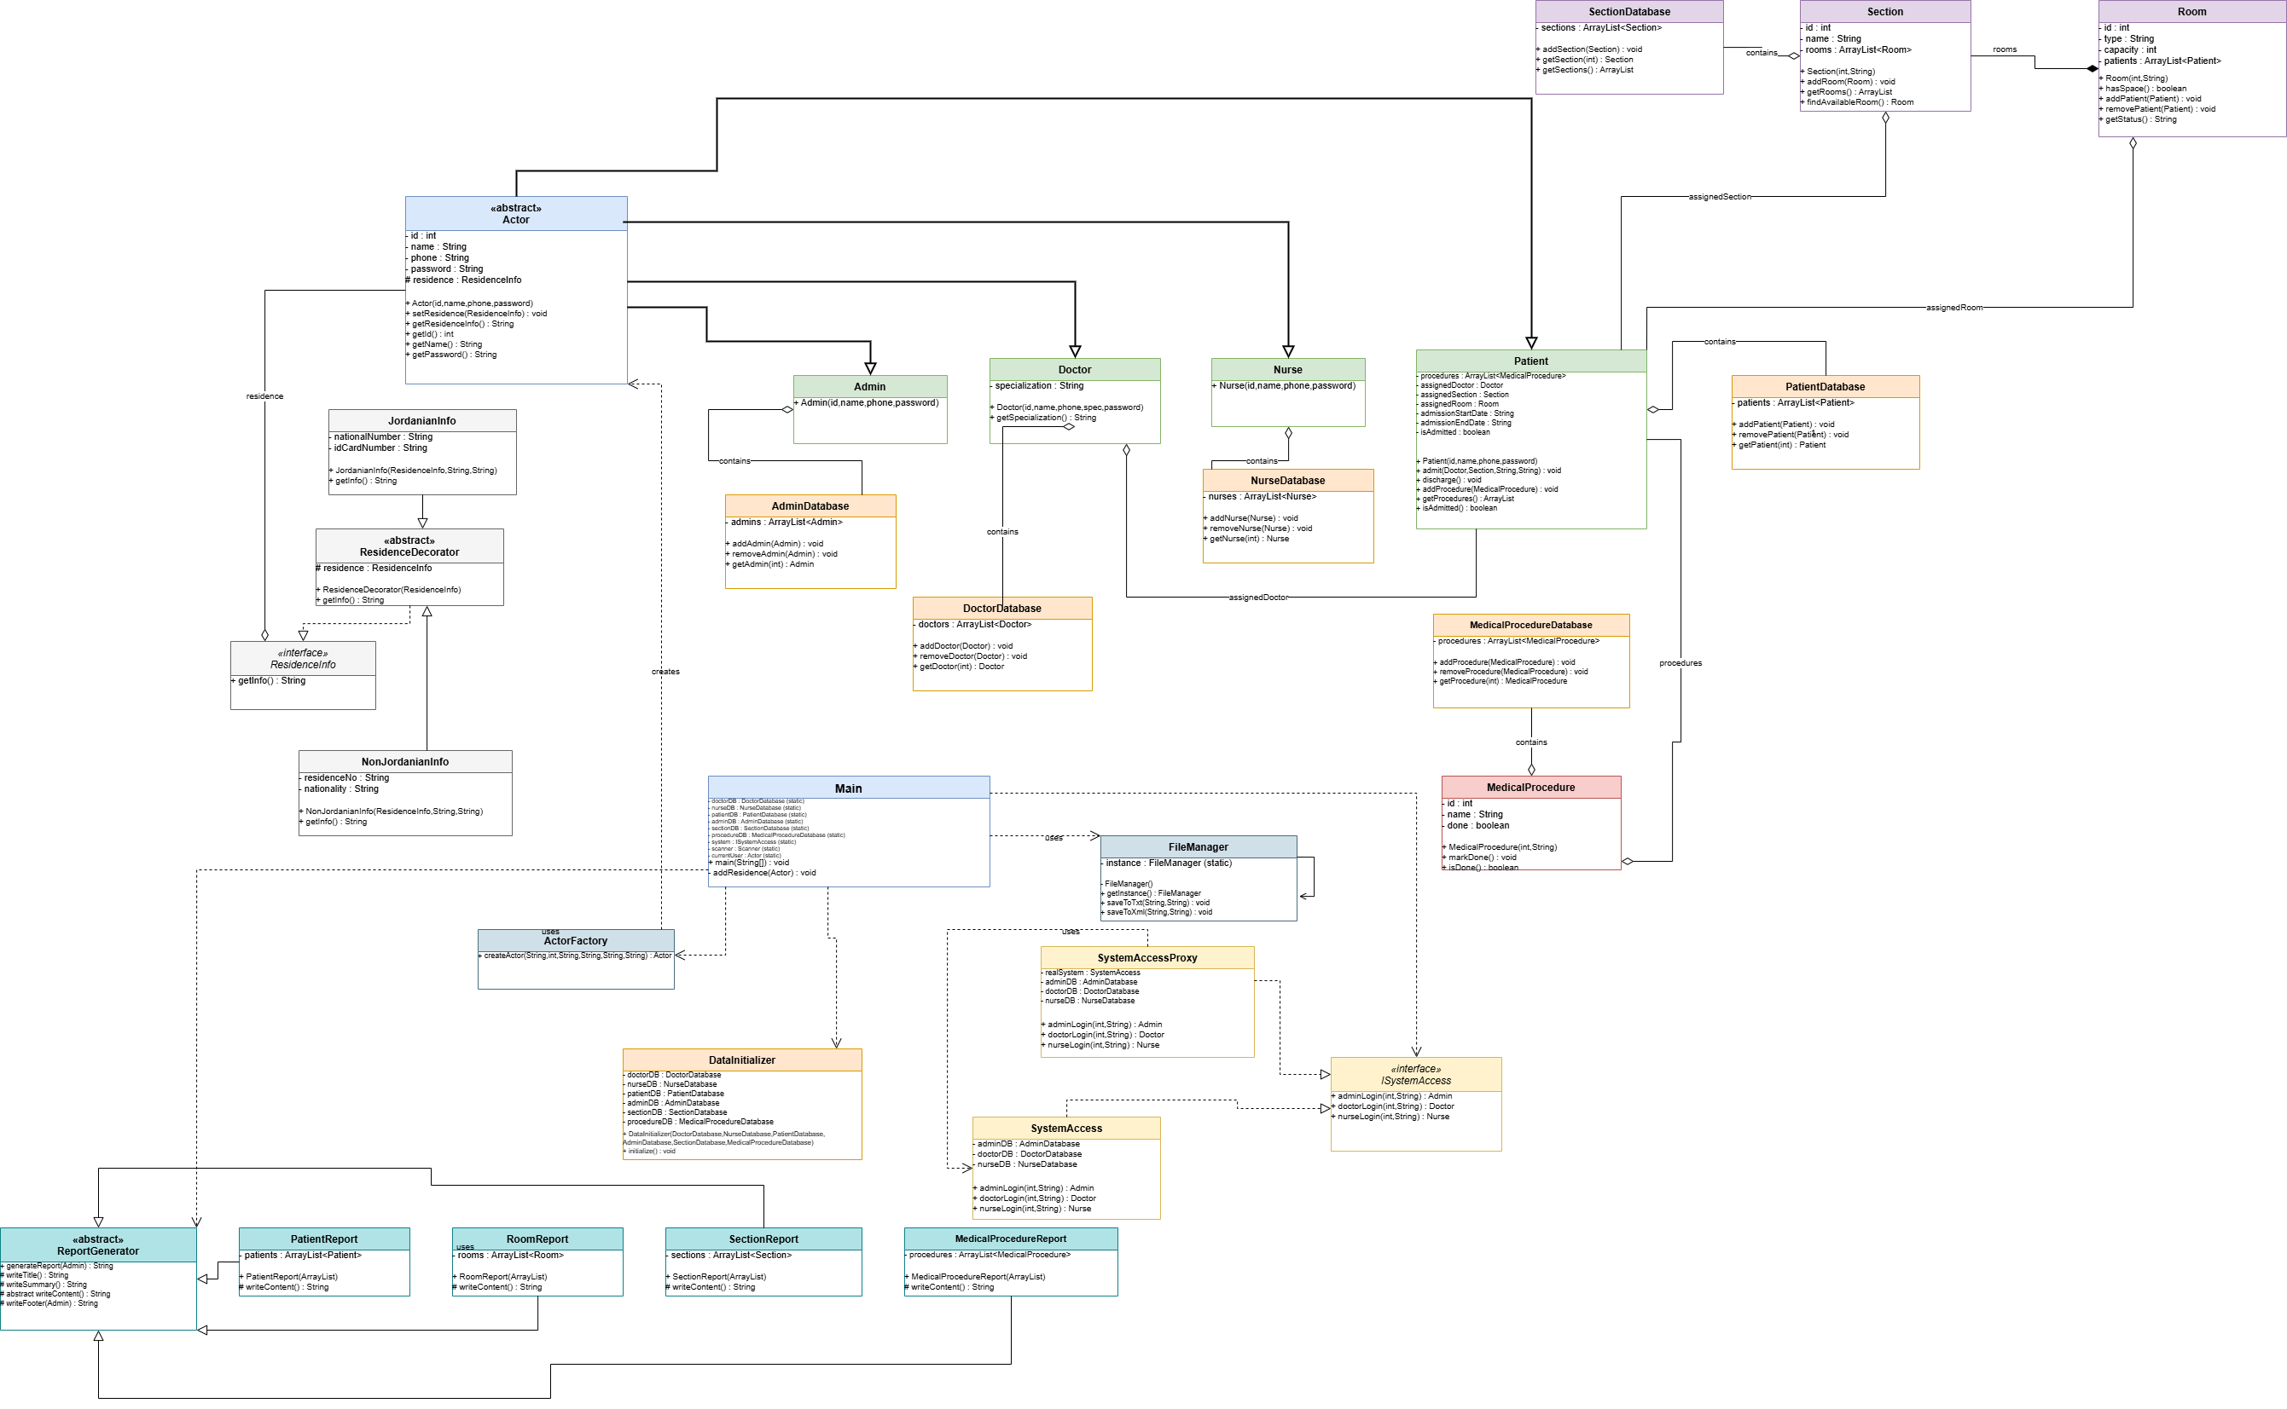

Test Plan and Automated Testing
Introduction
A test plan was created for Hospital Management System to validate critical aspects of the system. The focus of testing was to verify how the system operates when valid and invalid information is used during the transactions being conducted by the users withinther system.
There are three main functionalities of HMS which are intended to be tested:
- The Login Functionality
- Patient Management Functionality
- Medical Procedure Functionality
Each functionality has three test cases that will provide verification of expected results for each.
Once the test plan was complete, it was executed with the use of JUnit 5 Automated Testing Tool.
1. Login Functionality Test Plan
Functionality Targeted
The login functionality allows users to gain access to the HMS only if they enter valid credentials, should the user attempt to log in with invalid credentials, they should not be allowed into the system. Admins, Doctors and Nurses should all be able to log into the system provided they have valid credentials.
Test Cases
Test Case ID | Test Scenario | Input | Expected Result
TC-L1 | Login with valid admin credentials | Admin ID = 1, Password = admin123 | Admin object is returned successfully
TC-L2 | Login with valid doctor credentials | Doctor ID = 100, Password = doc123 | Doctor object is returned successfully
TC-L3 | Login with invalid credentials | Invalid ID and password | System returns null and access is denied

Automated Test Implementation
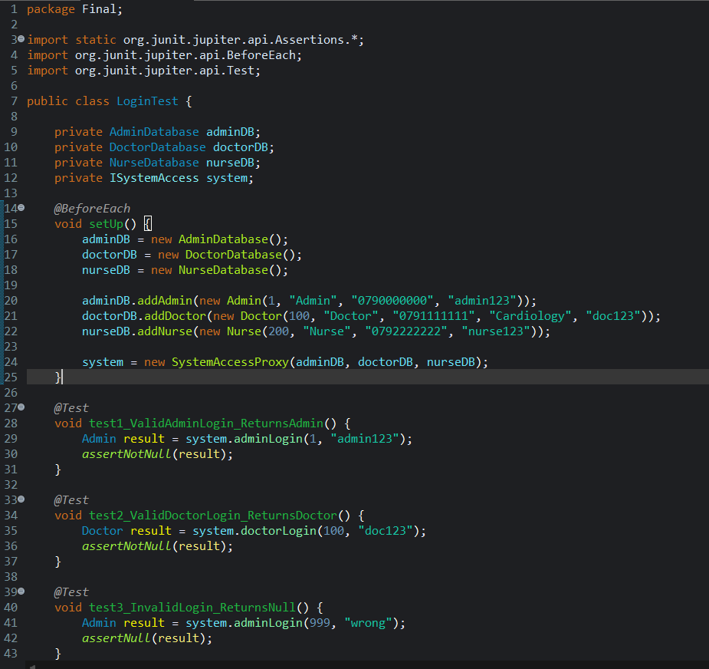

2. Patient Management Functionality Test Plan
Functionality Targeted
The Patient Management functionality is responsible for the accurate and complete storage of patient data and retrieval of patient records. The system should accommodate adding new patients, as well as retrieving already existing patient data.
Test Cases
Test Case ID | Test Scenario | Input | Expected Result
TC-P1 | Add a new patient | Patient object with ID 2000 | Patient is added successfully
TC-P2 | Retrieve existing patient | Patient ID = 1000 | Correct patient object is returned
TC-P3 | Retrieve non-existing patient | Patient ID = 9999 | System returns null

Automated Test Implementation
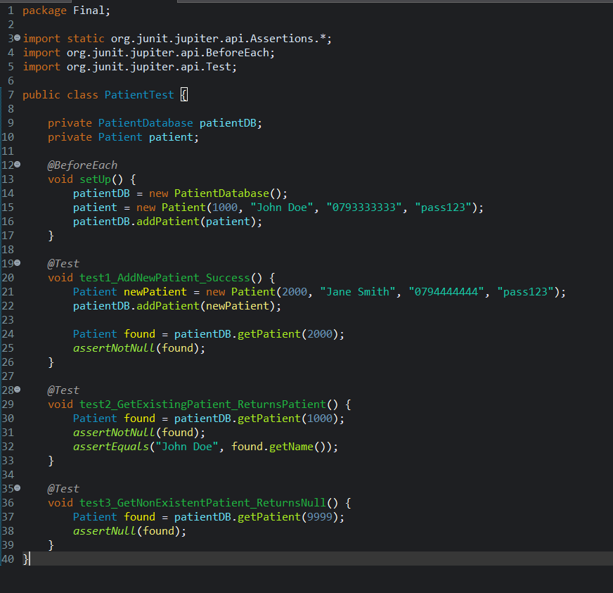

3. Medical Procedure Functionality Test Plan
Functionality Targeted
The Medical Procedure function allows for assigning procedures to patients, as well as completing them; thus, the system should ensure accurate tracking of the procedures to confirm completion status.
Test Cases
Test Case ID | Test Scenario | Input | Expected Result
TC-M1 | Add procedure to patient | Add Blood Test procedure | Procedure count increases
TC-M2 | Mark procedure as completed | Call markDone() | Procedure status becomes true
TC-M3 | Create new procedure | New procedure object | Procedure status is false initially

Automated Test Implementation
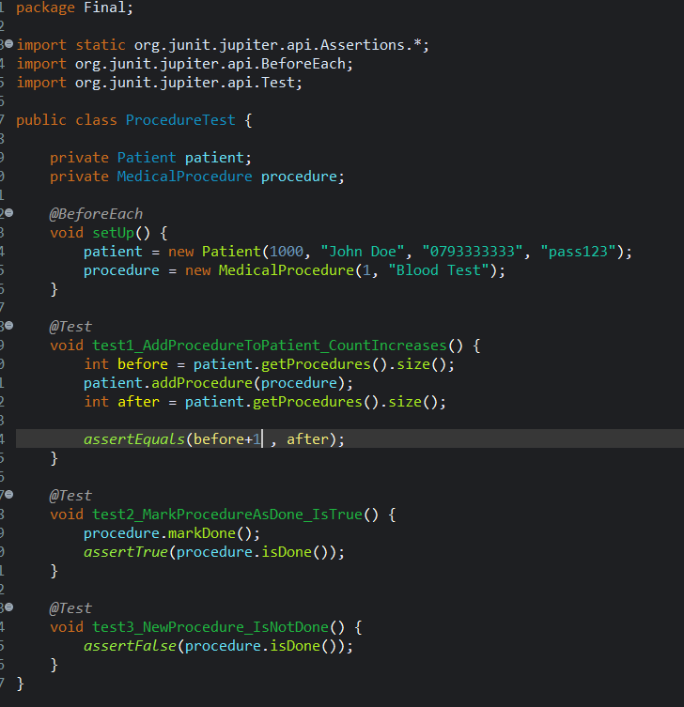

Automated Testing Tool Used
The intended framework for automated testing is JUnit 5, which is for Java automated testing framework.
JUnit was used to for executing the performed test cases to confirm that the system is behaving correctly, and the results are accurate compared to the desired results. The following JUnit features were used:
- @Test : Tests the implementation of a test case.
- @BeforeEach : Used to set up test data prior to executing any test.
- assertNotNull() : Confirms that the specified object exists.
- assertNull() : Confirms that the object or operation does not exist when an invalid operation is executed.
- assertEquals() : Compares the actual result to the expected result.
- assertTrue() and assertFalse() : Used to confirm a boolean condition.

Conclusion
Through the results of the proposed test plan, it was demonstrated that the testing effort has been adequately completed for the following three key business functions in the system:
1. Login functionality
2. Patient management functionality
3. Medical procedure functionality

Each of the individual functionalities was tested through the execution of three different test cases, which included valid (successful) and invalid (unsuccessful) capability testing.
In addition, the implementation of automated testing using JUnit confirmed that the system operates properly and effectively according to the desired results.

