The challneg gaved us unlock pdf file and asked me to crack this file 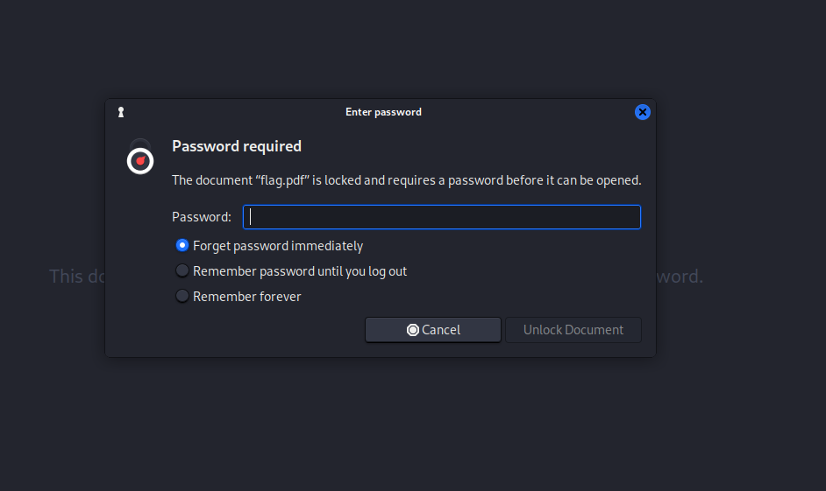

This was easy and straight forward challenge , so first thing I made sure this file is pdf file by file command , now I wanna crack the file so I used pdf2john command and put it in file name hash.txt .then, I used john --wordlist=/usr/share/wordlists/rockyou.txt hash.txt

command john: This is the main command to run John the Ripper ,

john --wordlist=/usr/share/wordlists/rockyou.txt : This specifies the wordlist to be used for the password cracking attempt. The RockYou wordlist is a common list of passwords that were leaked from the RockYou.com website and is often used in password cracking due to its extensive collection of real-world passwords,

hash.txt : file name

when run it I got the password the put it

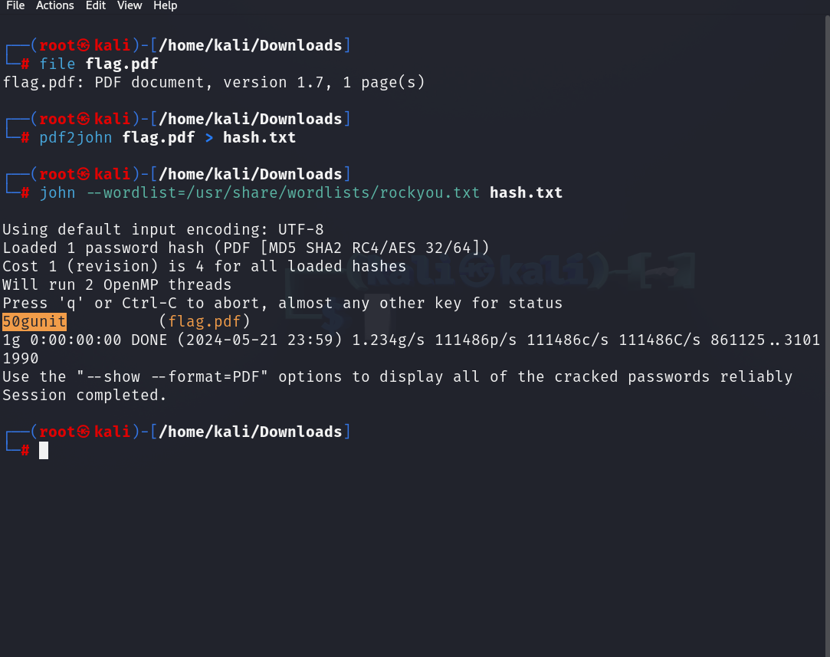

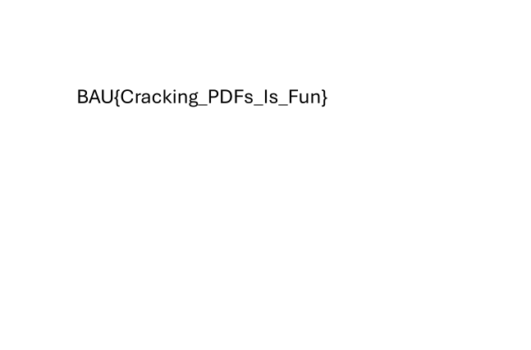

Now you can see the flag .