Practical – 21
Develop a simple MVC web application using PHP for Contact Management with add, search, update, and delete operations (CURD operations with prevention of SQL Injection).
Theory:
MVC-Based Contact Management System in PHP (With CRUD & SQL Injection Prevention)

Introduction
A Contact Management System is a web application used to store and manage contact details such as name, phone number, email, and address.
Using the MVC (Model-View-Controller) architecture in PHP helps in organizing the code efficiently, making the application scalable, maintainable, and secure.

What is MVC Architecture?
MVC is a software design pattern that separates an application into three main components:

Model
  - Handles database operations
  - Contains business logic
  - Interacts with MySQL database

Example tasks:
  - Insert contact
  - Update contact
  - Delete contact
  - Fetch/search contacts

View
  - Responsible for user interface (UI)
  - Displays data to the user
  - Contains HTML, CSS, and minimal PHP

Example:
  - Contact form
  - Contact list display
  - Search results page

Controller
  - Acts as a bridge between Model and View
  - Handles user requests and responses
  - Processes input and calls Model functions

Example:
  - Receives form data
  - Calls model to insert/update/delete
  - Loads appropriate view

Features of Contact Management System
  - Add Contact
    - User enters contact details
    - Data stored in database

Search Contact
    - Search by name/email/phone
    - Displays matching results

Update Contact
    - Modify existing contact details

Delete Contact
    - Remove contact from database

CRUD Operations
CRUD stands for:
Operation Description Create Add new contact Read View/search contacts Update Modify contact Delete Remove contact

Database Design Table: contacts
Field Type Description id INT (PK) Unique ID name VARCHAR Contact name email VARCHAR Email address phone VARCHAR Phone number address TEXT Address

Working of MVC in This Application
  - User submits form (View)
  - Controller receives request
  - Controller calls Model
  - Model interacts with database
  - Data returned to Controller
  - Controller sends data to View
  - View displays result

SQL Injection and Its Prevention What is SQL Injection?
SQL Injection is a security vulnerability where attackers insert malicious SQL code into input fields to manipulate the database.

Example Attack:
' OR '1'='1

Prevention Techniques
- Prepared Statements (Recommended)
Using PDO or MySQLi prepared statements ensures safe execution.
$stmt = $conn->prepare("INSERT INTO contacts (name, email) VALUES (?, ?)");
$stmt->bind_param("ss", $name, $email);
$stmt->execute();

- Input Validation
  - Validate user input
  - Remove unwanted characters
$name = htmlspecialchars($_POST['name']);

- Use Parameterized Queries
  - Avoid direct query concatenation Unsafe:
$query = "SELECT * FROM contacts WHERE name = '$name'"; Safe:
$stmt = $conn->prepare("SELECT * FROM contacts WHERE name = ?");

- Escaping Data

  - Use built-in functions like: mysqli_real_escape_string()

Advantages of MVC Architecture
- Separation of concerns
- Easy maintenance
- Reusable code
- Better security handling
- Scalable for large applications

Conclusion
The MVC-based Contact Management System in PHP provides a structured approach to developing web applications. By implementing CRUD operations and using prepared statements, the system ensures both functionality and security. This architecture improves code organization, reduces redundancy, and protects against SQL Injection attacks.

File name: index.php
<?php
require_once "database_Config.php";
require_once "Contact_Controller.php";

$db = (new Database())->connect();
$controller = new ContactController($db);

// ADD
if (isset($_POST['add'])) {
$controller->add($_POST);
}

// DELETE
if (isset($_POST['delete'])) {
$controller->delete($_POST['id']);
}

// SEARCH or READ
if (isset($_POST['search'])) {
$contacts = $controller->search($_POST['keyword']);
} else {
$contacts = $controller->getAll();
}

include "contact_view.php";
?>
File name: database_config.php
<?php
class Database {
private $host = "localhost";
private $user = "root";
private $pass = "";
private $dbname = "Contact_App";

public function connect() {
$conn = new mysqli($this->host, $this->user, $this->pass, $this->dbname);

if ($conn->connect_error) {
die("Connection Failed");
}

return $conn;
}
}
?>
File name: contact_view.php
<!DOCTYPE html>
<html>
<head>
<title>Contact Manager</title>
</head>
<body>

<h2>Add Contact</h2>
<form method="POST">
<input type="text" name="name" placeholder="Name" required>
<input type="email" name="email" placeholder="Email" required>
<input type="text" name="phone" placeholder="Phone" required>
<button name="add">Add</button>
</form>

<h2>Search</h2>
<form method="POST">
<input type="text" name="keyword">
<button name="search">Search</button>
</form>

<h2>Contact List</h2>

<?php
if (isset($contacts)) {
while ($row = $contacts->fetch_assoc()) {
echo $row['name']." | ".$row['email']." | ".$row['phone'];

echo "
<form method='POST' style='display:inline'>
<input type='hidden' name='id' value='".$row['id']."'>
<button name='delete'>Delete</button>
</form>
<form method='POST' style='display:inline'>
<input type='hidden' name='id' value='".$row['id']."'>
<button name='update'>Update</button>
</form>
<br>";
}
}
?>

</body>
</html>
File name: contact_model.php
<?php
class Contact {
private $conn;

public function __construct($db) {
$this->conn = $db;
}

// ADD
public function create($name, $email, $phone) {
$stmt = $this->conn->prepare("INSERT INTO contacts(name,email,phone) VALUES(?,?,?)");
$stmt->bind_param("sss", $name, $email, $phone);
return $stmt->execute();
}

// READ (All)
public function read() {
return $this->conn->query("SELECT * FROM contacts");
}

// SEARCH
public function search($keyword) {
$stmt = $this->conn->prepare("SELECT * FROM contacts WHERE name LIKE ?");
$search = "%".$keyword."%";
$stmt->bind_param("s", $search);
$stmt->execute();
return $stmt->get_result();
}

// UPDATE
public function update($id, $name, $email, $phone) {
$stmt = $this->conn->prepare("UPDATE contacts SET name=?, email=?, phone=? WHERE id=?");
$stmt->bind_param("sssi", $name, $email, $phone, $id);
return $stmt->execute();
}

// DELETE
public function delete($id) {
$stmt = $this->conn->prepare("DELETE FROM contacts WHERE id=?");
$stmt->bind_param("i", $id);
return $stmt->execute();
}
}
?>
File name: Contact_controller.php
<?php
require_once "Contact_model.php";

class ContactController {
private $model;

public function __construct($db) {
$this->model = new Contact($db);
}

public function add($data) {
return $this->model->create($data['name'], $data['email'], $data['phone']);
}

public function getAll() {
return $this->model->read();
}

public function search($keyword) {
return $this->model->search($keyword);
}

public function update($data) {
return $this->model->update($data['id'], $data['name'], $data['email'], $data['phone']);
}

public function delete($id) {
return $this->model->delete($id);
}
}
?>

Output
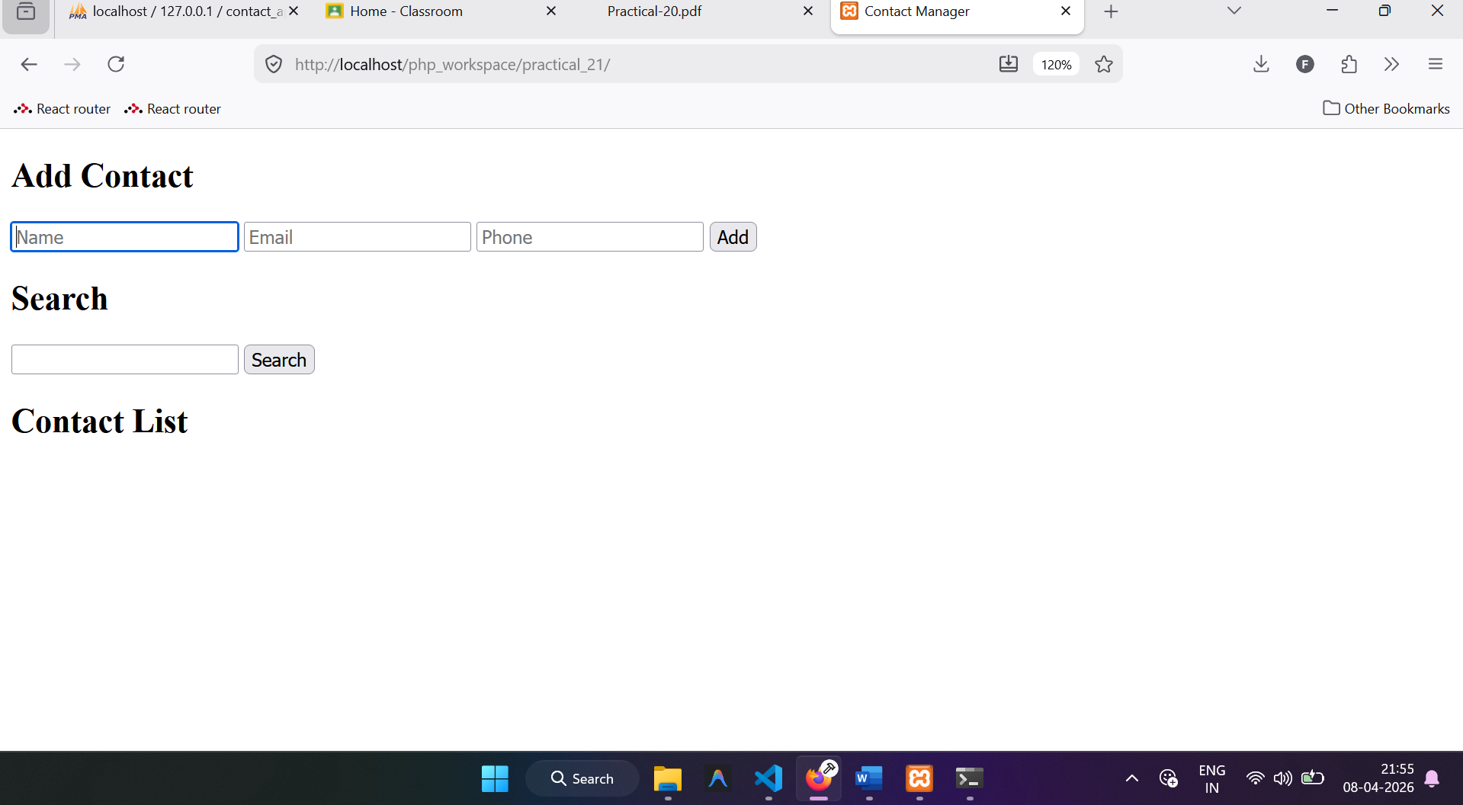
Inserting one record
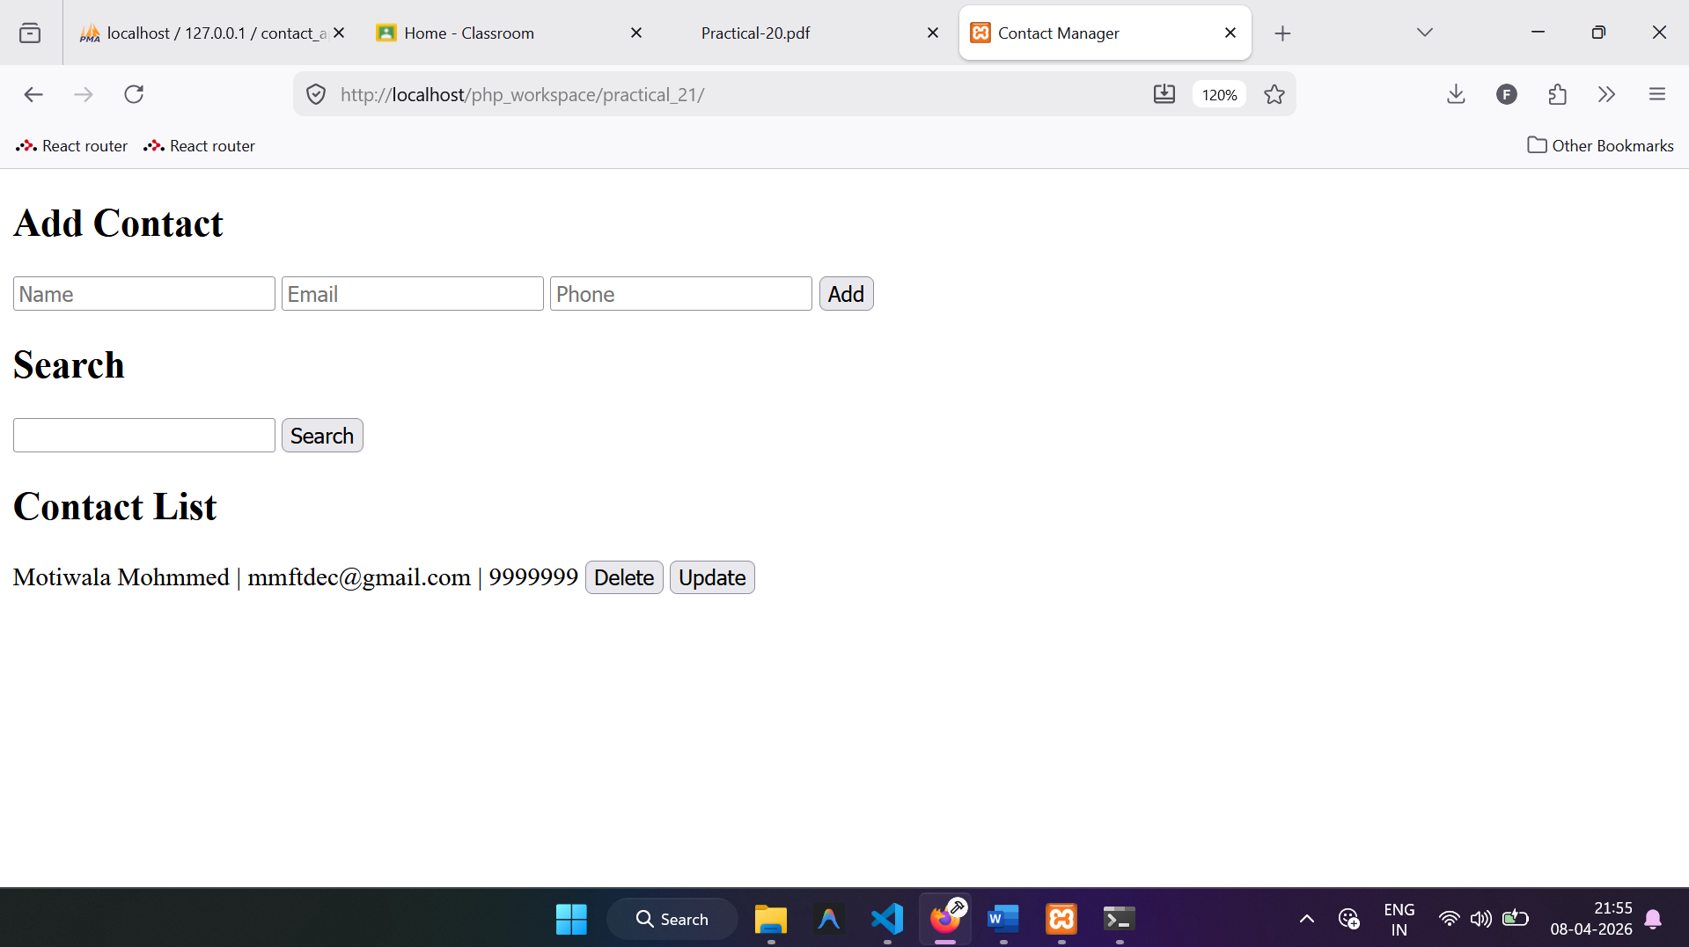
After inserting the 5 records
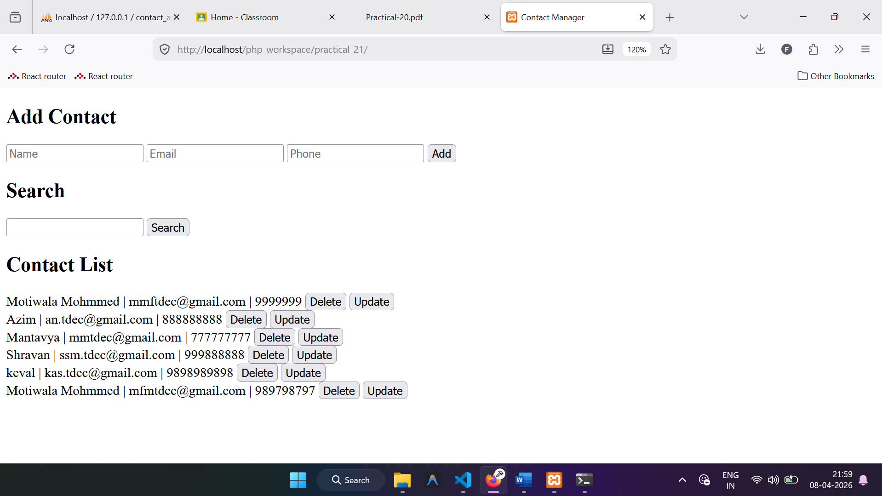
After searching by name

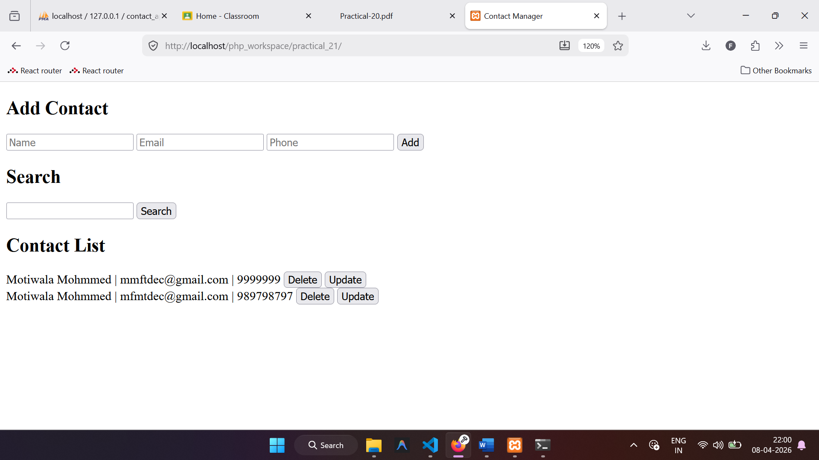
Deletting the record
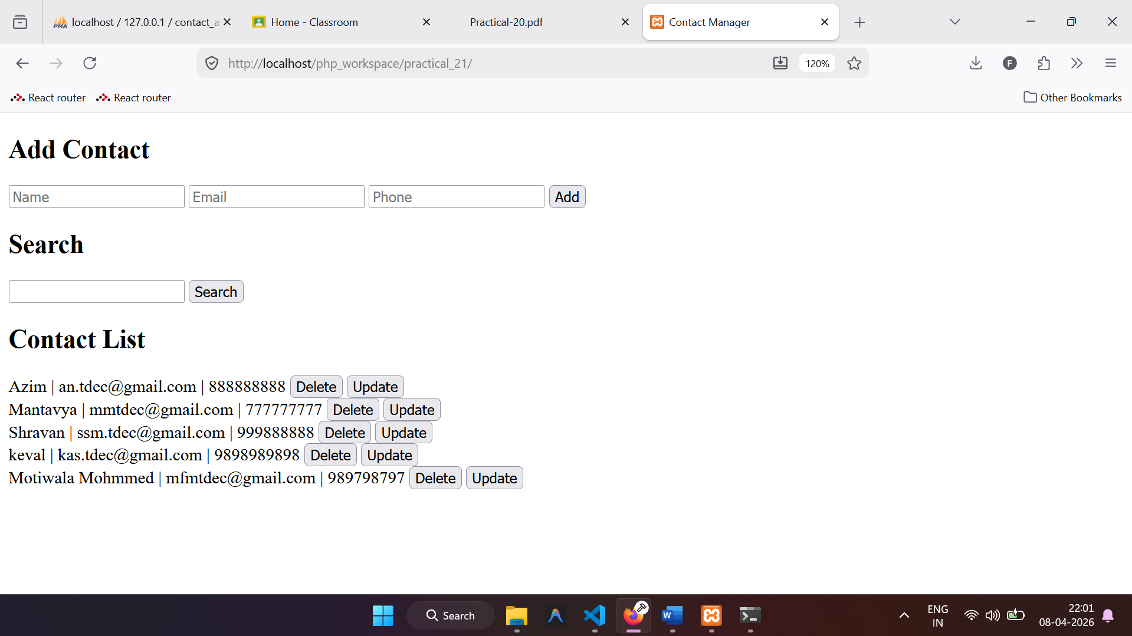
Update the contact information
