Practical – 22
Aim build the todo app using the AI like chatGPT, gemini
File name: db.php
<?php
$host = "localhost";
$user = "root";
$password = "";
$database = "todo_app";
$conn = new mysqli($host, $user, $password, $database);
if ($conn->connect_error) {
die("Connection failed: " . $conn->connect_error);
}
?>
File name: index.php
<?php
include 'db.php';
// ADD TASK
if (isset($_POST['add'])) {
$title = $_POST['title'];
$priority = $_POST['priority'];
$deadline = $_POST['deadline'];

$sql = "INSERT INTO tasks (title, priority, deadline)
VALUES ('$title', '$priority', '$deadline')";
$conn->query($sql);
}// DELETE TASK
if (isset($_GET['delete'])) {
$id = $_GET['delete'];
$conn->query("DELETE FROM tasks WHERE id=$id");
// MARK AS COMPLETED
if (isset($_GET['complete'])) {
$id = $_GET['complete'];
$conn->query("UPDATE tasks SET status='Completed' WHERE id=$id");
}
// FETCH SINGLE TASK FOR EDIT
$editData = null;
if (isset($_GET['edit'])) {
$id = $_GET['edit'];
$resultEdit = $conn->query("SELECT * FROM tasks WHERE id=$id");
$editData = $resultEdit->fetch_assoc();
}
// UPDATE TASK
if (isset($_POST['update'])) {
$id = $_POST['id'];
$title = $_POST['title'];
$priority = $_POST['priority'];
$deadline = $_POST['deadline'];
$sql = "UPDATE tasks
SET title='$title', priority='$priority', deadline='$deadline'
WHERE id=$id";
$conn->query($sql);
// Reset edit mode
header("Location: index.php");
}
// FETCH TASKS
$result = $conn->query("SELECT * FROM tasks ORDER BY deadline ASC");
?>
<!DOCTYPE html>
<html>
<head>
<title>Student To-Do List</title>
</head>
<body>

<h2><?php echo $editData ? "Edit Task" : "Add Task"; ?></h2>
<form method="POST">
<input type="hidden" name="id" value="<?php echo $editData['id'] ?? ''; ?>">
Task:
<input type="text" name="title"
value="<?php echo $editData['title'] ?? ''; ?>" required><br><br>
Priority:
<select name="priority">
<option <?php if(($editData['priority'] ?? '')=='Low') echo 'selected'; ?>>Low</option>
<option <?php if(($editData['priority'] ?? '')=='Medium') echo 'selected'; ?>>Medium</option>
<option <?php if(($editData['priority'] ?? '')=='High') echo 'selected'; ?>>High</option>
</select><br><br>
Deadline:
<input type="date" name="deadline"
value="<?php echo $editData['deadline'] ?? ''; ?>" required><br><br>
<?php if ($editData) { ?>
<button type="submit" name="update">Update Task</button>
<?php } else { ?>
<button type="submit" name="add">Add Task</button>
<?php } ?>
</form>
<hr>
<h2>Task List</h2>
<table border="1" cellpadding="10">
<tr>
<th>ID</th>
<th>Task</th>
<th>Priority</th>
<th>Deadline</th>
<th>Status</th>
<th>Actions</th>
</tr>
<?php while($row = $result->fetch_assoc()) { ?>
<tr>
<td><?php echo $row['id']; ?></td>
<td><?php echo $row['title']; ?></td>
<td><?php echo $row['priority']; ?></td>
<td><?php echo $row['deadline']; ?></td>
<td><?php echo $row['status']; ?></td>
<td>
<a href="?edit=<?php echo $row['id']; ?>">Edit</a>
<a href="?delete=<?php echo $row['id']; ?>">Delete</a> |
<?php if ($row['status'] == 'Pending') { ?>
<a href="?complete=<?php echo $row['id']; ?>">Mark Done</a>
<?php } ?>
</td>
</tr>
<?php } ?>
</table>
</body>
</html>

Output
- Home page
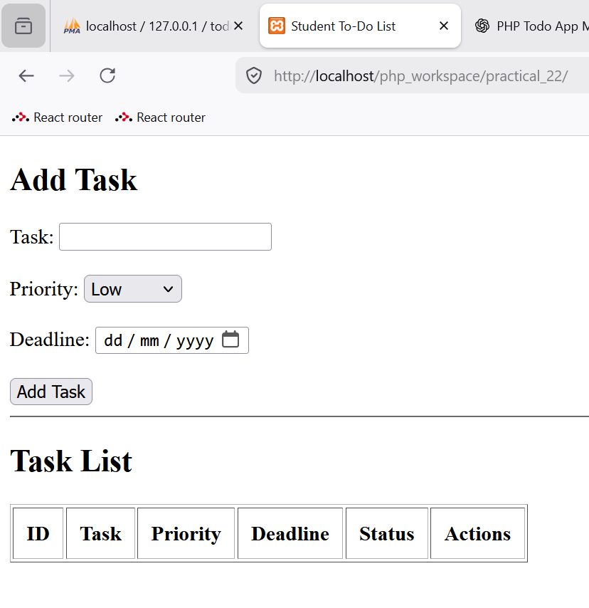
- Adding 5 tasks
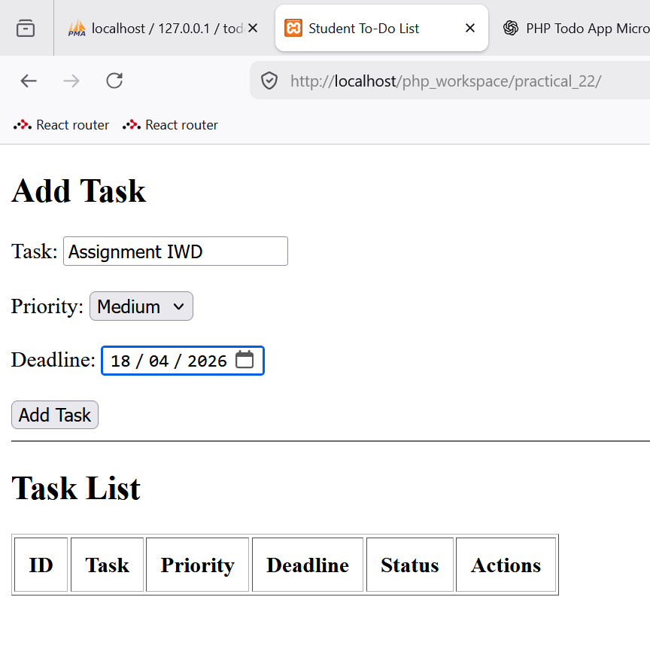
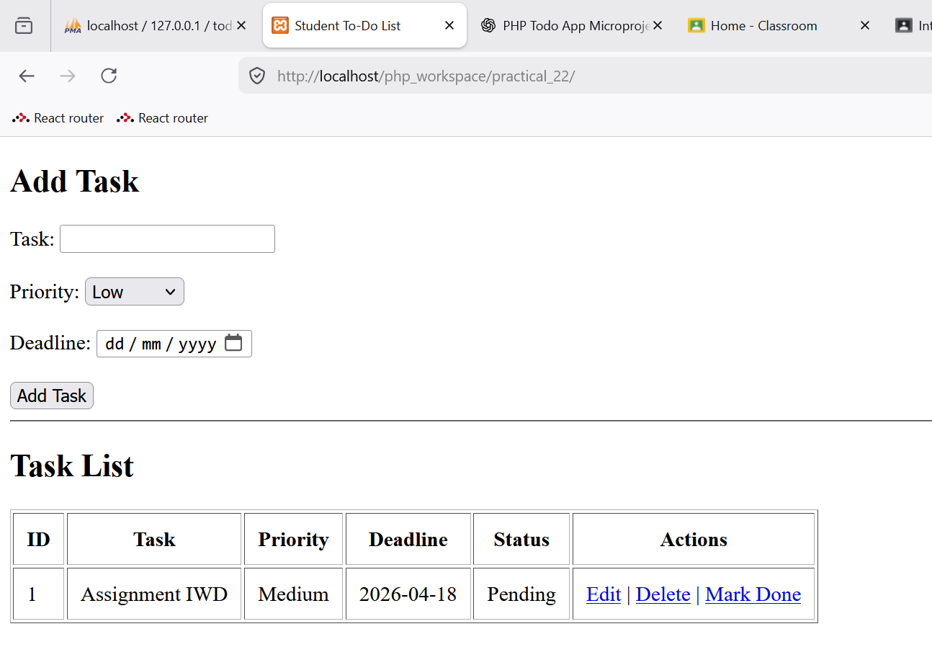
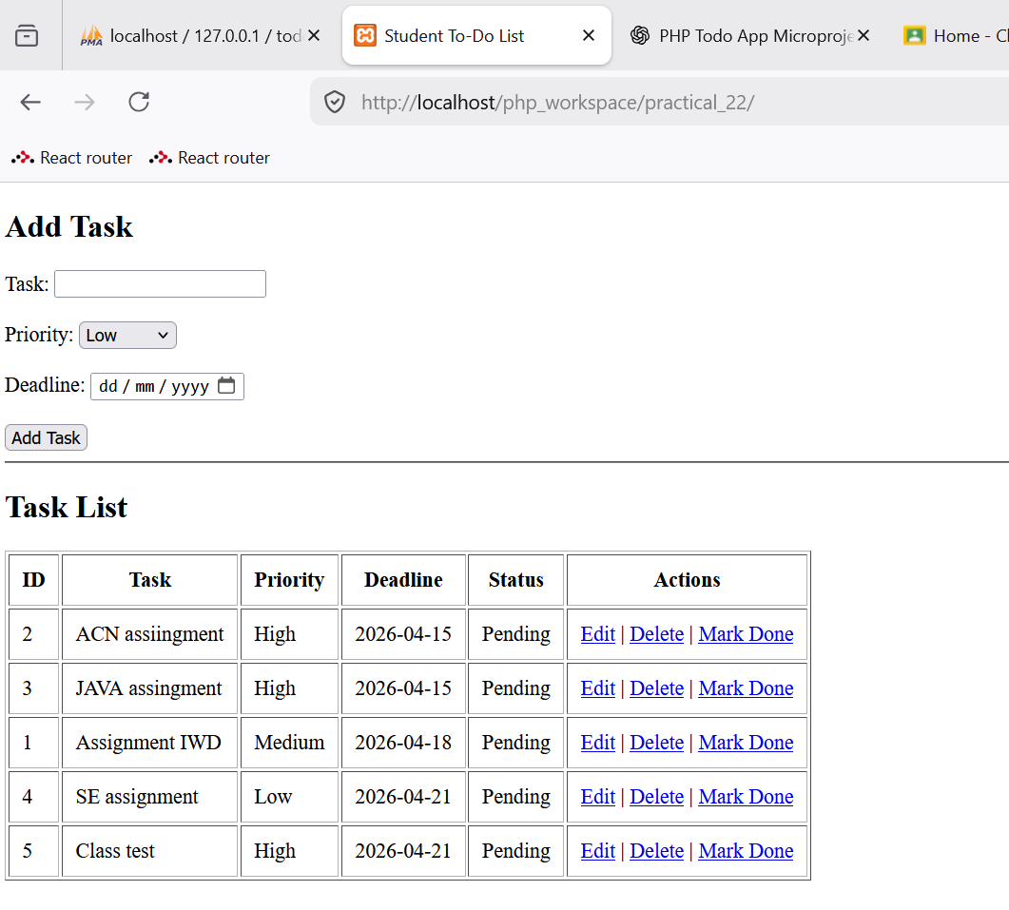
- Editing the task id 2
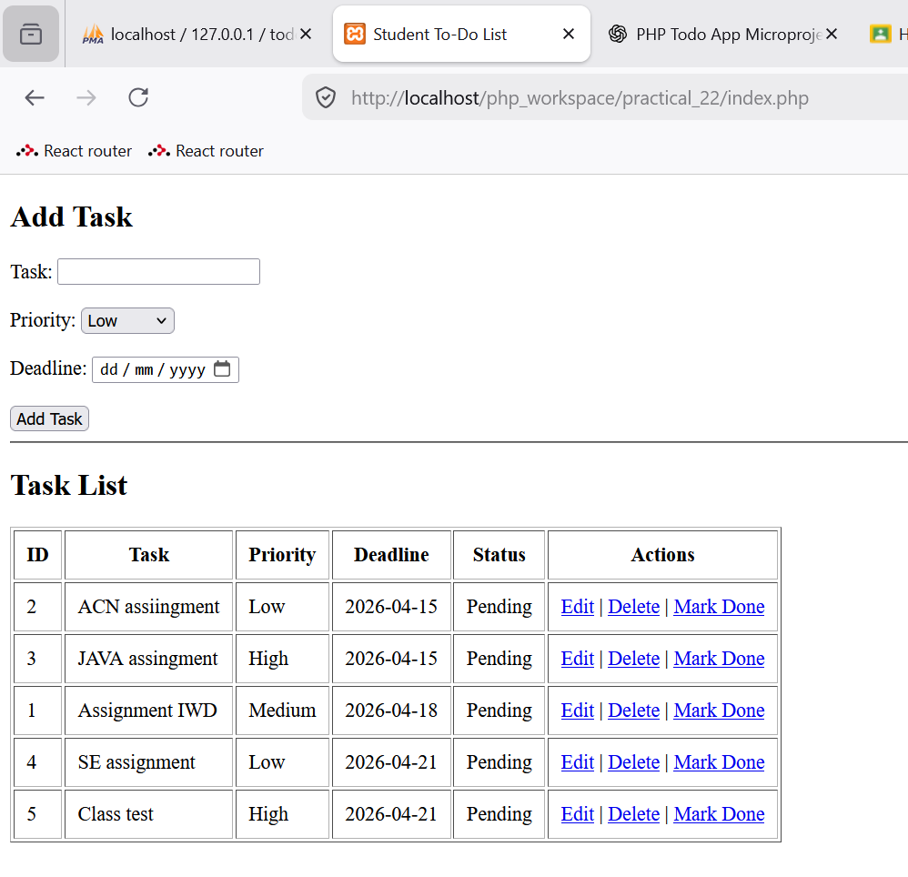
- Deleting the task id – 5
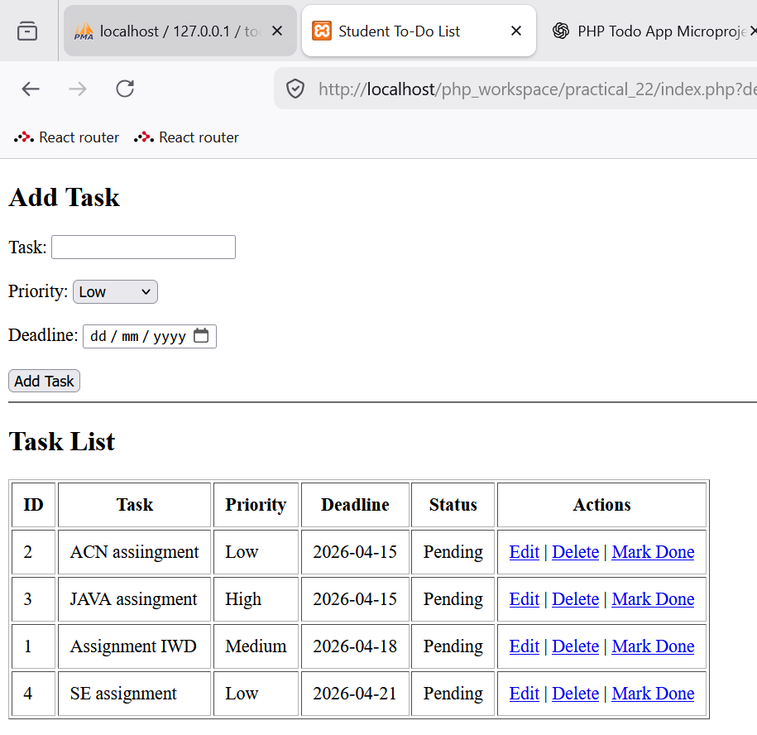

- Marking the task as done
