Practical – 23
Aim: create the inventory-management system and host it
Strucutre
inventory-app/
│
├── config/
│ └── db.php
│
├── models/
│ └── Product.php
│
├── controllers/
│ └── ProductController.php
│
├── UI/
│ └── index.php
File name: db.php
<?php
$conn = new mysqli("localhost", "root", "", "inventory_app");

if ($conn->connect_error) {
die("Connection failed: " . $conn->connect_error);
}
?>
File name: Product.php
<?php
class Product {
private $conn;

public function __construct($db) {
$this->conn = $db;
}

public function getAll() {
return $this->conn->query("SELECT * FROM products ORDER BY created_at DESC");
}

public function add($name, $category, $quantity, $price) {
$stmt = $this->conn->prepare(
"INSERT INTO products (name, category, quantity, price) VALUES (?, ?, ?, ?)"
);
$stmt->bind_param("ssid", $name, $category, $quantity, $price);
return $stmt->execute();
}

public function delete($id) {
$stmt = $this->conn->prepare("DELETE FROM products WHERE id=?");
$stmt->bind_param("i", $id);
return $stmt->execute();
}

public function update($id, $name, $category, $quantity, $price) {
$stmt = $this->conn->prepare(
"UPDATE products SET name=?, category=?, quantity=?, price=? WHERE id=?"
);
$stmt->bind_param("ssidi", $name, $category, $quantity, $price, $id);
return $stmt->execute();
}

public function getById($id) {
$stmt = $this->conn->prepare("SELECT * FROM products WHERE id=?");
$stmt->bind_param("i", $id);
$stmt->execute();
return $stmt->get_result()->fetch_assoc();
}
}
?>
File name: ProductController.php
<?php
require_once "../config/db.php";
require_once "../models/Product.php";

$product = new Product($conn);

// ADD
if (isset($_POST['add'])) {
$product->add(
$_POST['name'],
$_POST['category'],
$_POST['quantity'],
$_POST['price']
);
header("Location: ../public/index.php");
}

// DELETE
if (isset($_GET['delete'])) {
$product->delete($_GET['delete']);
header("Location: ../public/index.php");
}

// UPDATE
if (isset($_POST['update'])) {
$product->update(
$_POST['id'],
$_POST['name'],
$_POST['category'],
$_POST['quantity'],
$_POST['price']
);
header("Location: ../public/index.php");
}
?>
File name: index.php
<?php
require_once "../config/db.php";
require_once "../models/Product.php";

$product = new Product($conn);
$data = $product->getAll();

$editData = null;
if (isset($_GET['edit'])) {
$editData = $product->getById($_GET['edit']);
}
?>

<!DOCTYPE html>
<html>
<head>
<title>Inventory Management</title>
</head>
<body>

<h2><?php echo $editData ? "Edit Product" : "Add Product"; ?></h2>

<form method="POST" action="../controllers/ProductController.php">
<input type="hidden" name="id" value="<?php echo $editData['id'] ?? ''; ?>">

Name: <input type="text" name="name" value="<?php echo $editData['name'] ?? ''; ?>" required><br><br>
Category: <input type="text" name="category" value="<?php echo $editData['category'] ?? ''; ?>"><br><br>
Quantity: <input type="number" name="quantity" value="<?php echo $editData['quantity'] ?? 0; ?>" required><br><br>
Price: <input type="number" step="0.01" name="price" value="<?php echo $editData['price'] ?? ''; ?>" required><br><br>

<?php if ($editData) { ?>
<button type="submit" name="update">Update</button>
<?php } else { ?>
<button type="submit" name="add">Add</button>
<?php } ?>
</form>

<hr>

<h2>Inventory</h2>

<table border="1" cellpadding="10">
<tr>
<th>ID</th>
<th>Name</th>
<th>Category</th>
<th>Qty</th>
<th>Price</th>
<th>Actions</th>
</tr>

<?php while($row = $data->fetch_assoc()) { ?>
<tr>
<td><?php echo $row['id']; ?></td>
<td><?php echo $row['name']; ?></td>
<td><?php echo $row['category']; ?></td>
<td><?php echo $row['quantity']; ?></td>
<td><?php echo $row['price']; ?></td>
<td>
<a href="?edit=<?php echo $row['id']; ?>">Edit</a> |
<a href="../controllers/ProductController.php?delete=<?php echo $row['id']; ?>">Delete</a>
</td>
</tr>
<?php } ?>

</table>

</body>
</html>
Output
- Home page
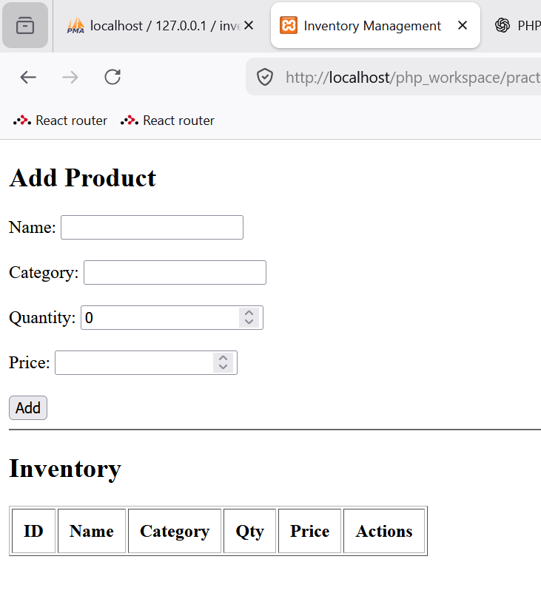
- Adding products
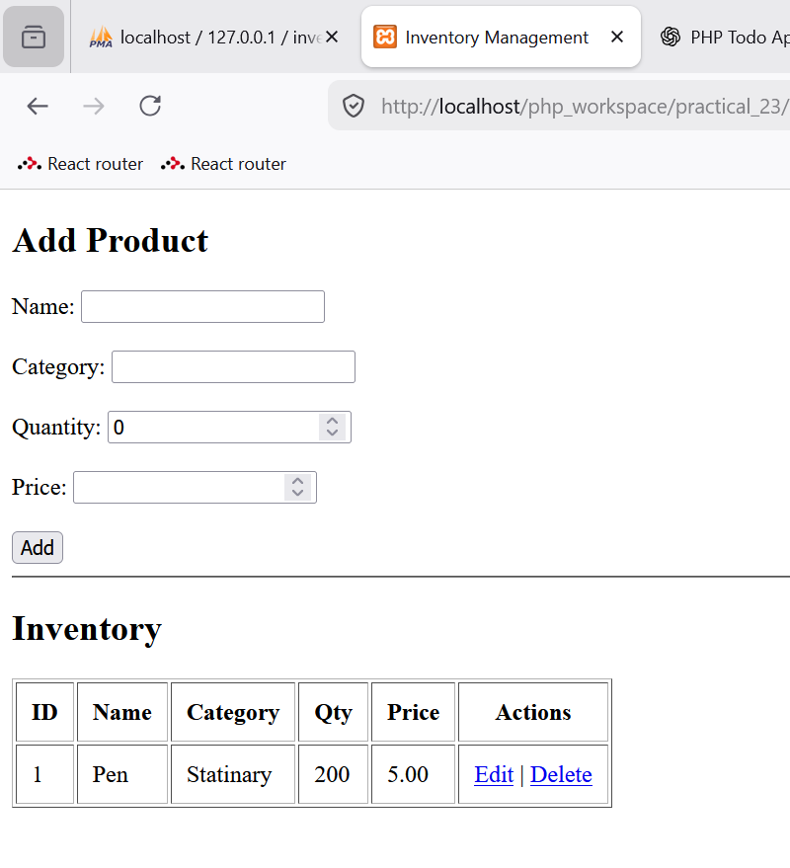
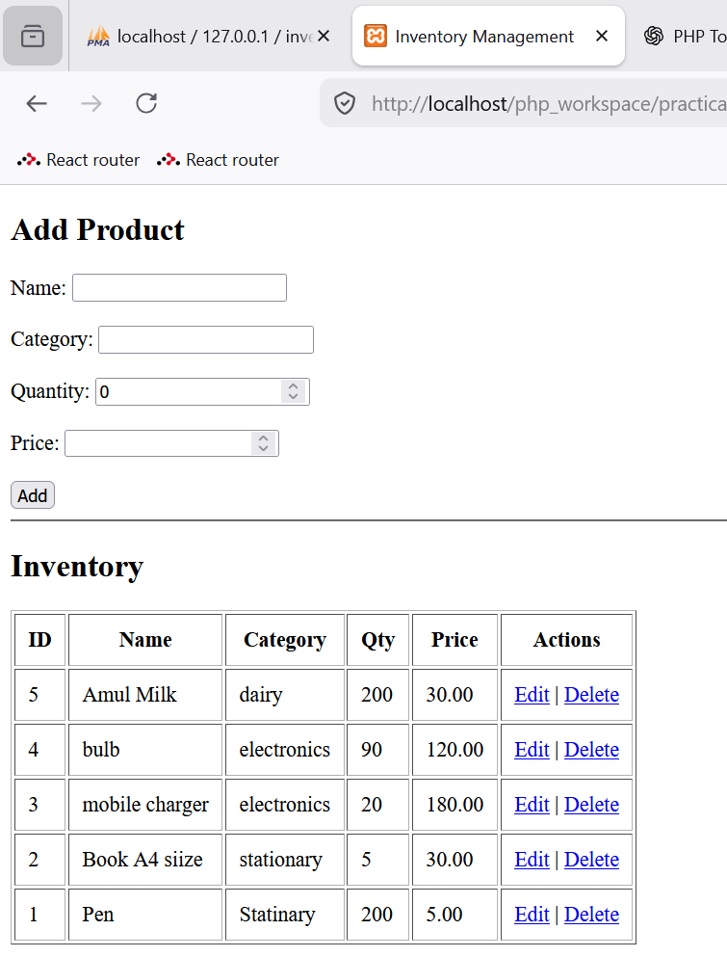

- Editing/Updating the product for Amul milk
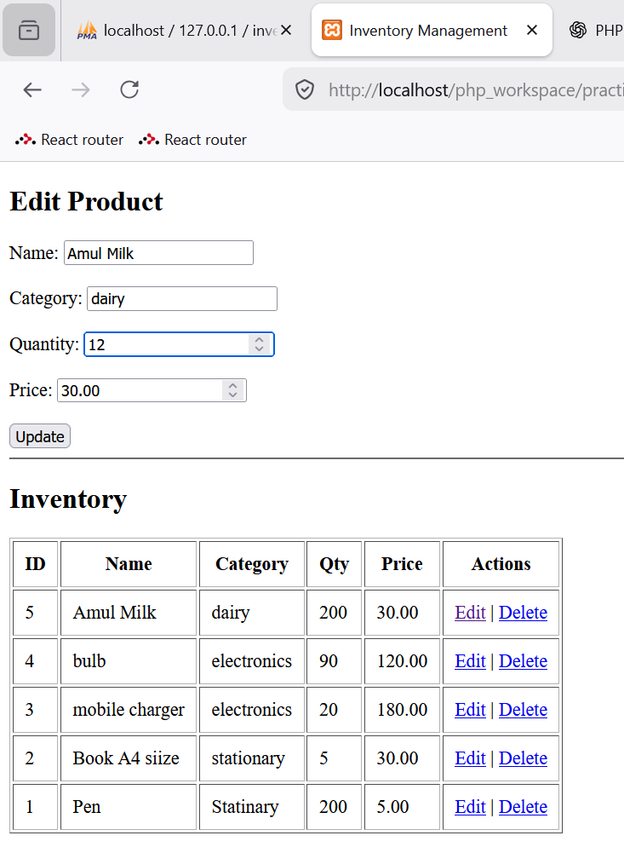
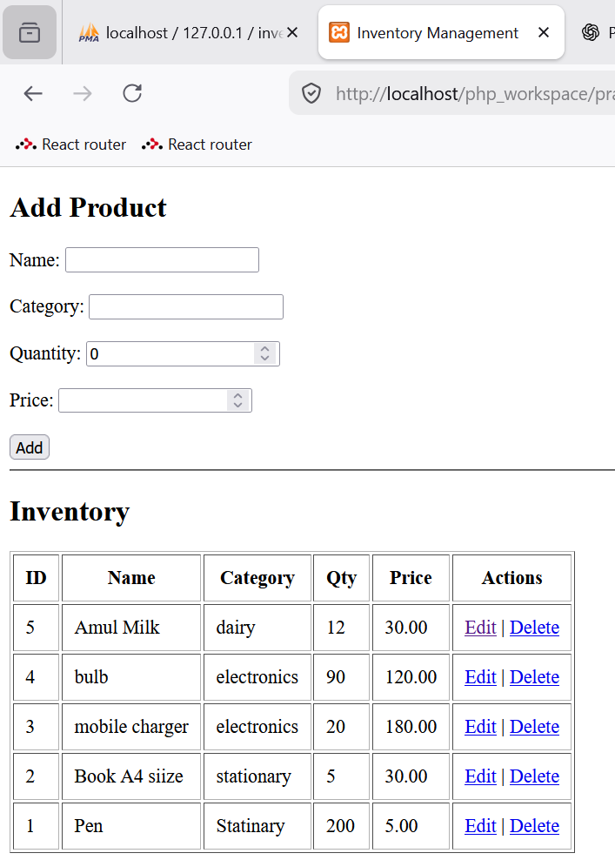

- Deleted the product Amul milk
