Practical – 20

Develop a simple Blog web application that allows users to create, read, update, and delete blogs (CURD operations).
Theory:
Create (Insert Blog): Create a new blog post by filling out a form that includes fields such as: Title
Content
Author (optional) Date
The data entered is sent to the server and stored in the database using an SQL INSERT query.

Read (Display Blogs): All blog posts are retrieved from the database and displayed on a web page. This is done using an SQL SELECT query.
List of all blogs Individual blog view

Update (Edit Blog): Users can modify an existing blog post. The application: Fetches existing data from the database
Displays it in an editable form
Updates the database using an SQL UPDATE query

Delete (Remove Blog): Users can delete a blog post by selecting a deleted option. The application removes the selected record using an SQL DELETE query.

Project Structure
└── 📁practical_20
└── 📁pages
├── add.html
├── delete.html
├── index.html
├── add_blogs.php
├── check_connection.php
├── create_table.php
├── delete_blogs.php
├── readme.md
└── view_blogs.php

File name: add.html

<!DOCTYPE html>

<html lang="en">

<head>

<meta charset="UTF-8">

<meta name="viewport" content="width=device-width, initial-scale=1.0">

<title>Blogs | Add</title>

</head>

<body>

<h1>Fill the form to add Blogs</h1>

<form action="../add_blogs.php" method="post">

<!-- for blog id -->

<label for="id">Enter blog id : </label>

<input type="text" name="id" required>

<br>

<br>

<!-- for Blog title -->

<label for="title">Enter title for blog : </label>

<input type="text" name="title" required>

<br>

<br>

<!-- for content -->

<label for="content">Enter blog content</label>

<textarea name="content" rows="4" cols="50" placeholder="Enter your blog content"></textarea>

<br>

<br>

<!-- submit button -->

<input type="submit" value="press to add blog" name="submit">

</form>

</body>

</html>

File name: delete.html

<!DOCTYPE html>

<html lang="en">

<head>

<meta charset="UTF-8">

<meta name="viewport" content="width=device-width, initial-scale=1.0">

<title>Blogs | delete</title>

</head>

<body>

<h1>Fill the form to delete the blogs</h1>

<form action="../delete_blogs.php" method="post">

<!-- blog id -->

<label for="id">Enter blog id : </label>

<input type="text" name="id" required>

<br>

<br>

<input type="submit" value="press to delete blog" name="submit">

</form>

</body>

</html>

File name:Index.html

<!DOCTYPE html>

<html lang="en">

<head>

<meta charset="UTF-8">

<meta name="viewport" content="width=device-width, initial-scale=1.0">

<title>Blogs | Home</title>

</head>

<body>

<h1>Blogs Platform</h1>

<a href="add.html">add blogs</a><br>

<br>

<a href="update.html">update blogs</a><br>

<br>

<a href="delete.html">Delete Blogs</a><br>

<br>

<a href="../view_blogs.php">view Blogs</a><br>

<br>

<p><b>1. Add : </b> click <code>add</code> to add blogs</p>

<p><b>2. Delete : </b> click <code>delete</code> blogs</p>

<p><b>3. Update : </b> click <code>update</code> blogs</p>

</body>

</html>

File name: add_blogs.php

<?php

include "check_connection.php";

if($_SERVER["REQUEST_METHOD"] == "POST"){

// fetch the blogs title and content

$id = $_POST["id"];

$title = strtoupper($_POST["title"]);

$content = strtolower($_POST["content"]);

$INSERT_QUERY = "INSERT INTO blogs

(id, title, content) VALUES ('$id', '$title', '$content')";

if (mysqli_query($conn, $INSERT_QUERY)) {

echo "Blog added successfully!";

exit;

} else {

echo "Error adding blog: " . mysqli_error($conn);

}

}

?>

File Name: check_connection.php

<?php

$servername = "localhost";

$username = "root";

$password = "";

$db = "blog_db";

// Step 1: connect WITHOUT database

$conn = mysqli_connect($servername, $username, $password);

// Check connection

if (!$conn) {

die("Connection failed: " . mysqli_connect_error());

}

// Step 2: create database

$sql = "CREATE DATABASE IF NOT EXISTS $db";

if (!mysqli_query($conn, $sql)) {

die("Error creating database: " . mysqli_error($conn));

}

// Step 3: connect to the database

$conn = mysqli_connect($servername, $username, $password, $db);

if (!$conn) {

die("Connection failed: " . mysqli_connect_error());

}

// Close connection

// mysqli_close($conn);

?>

File name: create_table.php

<?php

include "check_connection.php";

// create the table in the DB if not exists

$TABLE_QUERY = "create table if not exists Blogs(

id int AUTO_INCREMENT PRIMARY KEY,

title varchar(50),

content text(350)

)";

if(mysqli_query($conn, $TABLE_QUERY)){

echo "<br>Table created Successfully !";

}

else{

echo "ERROR : ".mysqli_error($conn);

}

mysqli_close($conn);

?>

Delete_blogs.php

<?php

include "check_connection.php";

if($_SERVER['REQUEST_METHOD'] == 'POST') {

// fetch the blog etails from the user form

$id = $_POST['id'];

// delete query

$DELETE_QUERY = "DELETE FROM blogs WHERE id = '$id'";

if (mysqli_query($conn, $DELETE_QUERY)) {

echo "Blog deleted successfully!";

echo "<br>";

echo "<a href = 'view_blogs.php'>view blogs</a>";

exit;

} else {

echo "Error deleting blog: " . mysqli_error($conn);

}

}

?>

File name: view_blogs.php

<?php

include "check_connection.php";

?>

<!DOCTYPE html>

<html lang="en">

<head>

<meta charset="UTF-8">

<meta name="viewport" content="width=device-width, initial-scale=1.0">

<title>Blogs | View</title>

<style>

table {

width: 80%;

border-collapse: collapse;

margin: 20px 0;

}

table, th, td {

border: 1px solid black;

}

th, td {

padding: 10px;

text-align: left;

}

th {

background-color: #f2f2f2;

}

</style>

</head>

<body>

<h1>All Blogs</h1>

<a href="pages/index.html">Back to Home</a><br><br>

<?php

// Fetch all blogs

$SELECT_QUERY = "SELECT id, title, content FROM blogs";

$result = mysqli_query($conn, $SELECT_QUERY);

if (mysqli_num_rows($result) > 0) {

echo "<table>";

echo "<tr>";

echo "<th>ID</th>";

echo "<th>Title</th>";

echo "<th>Content</th>";

echo "</tr>";

while($row = mysqli_fetch_assoc($result)) {

echo "<tr>";

echo "<td>" . $row["id"] . "</td>";

echo "<td>" . htmlspecialchars($row["title"]) . "</td>";

echo "<td>" . nl2br(htmlspecialchars($row["content"])) . "</td>";

echo "</tr>";

}

echo "</table>";

} else {

echo "<p>No blogs found in the database.</p>";

}

?>

</body>

</html>

Output

Main page (Home page)

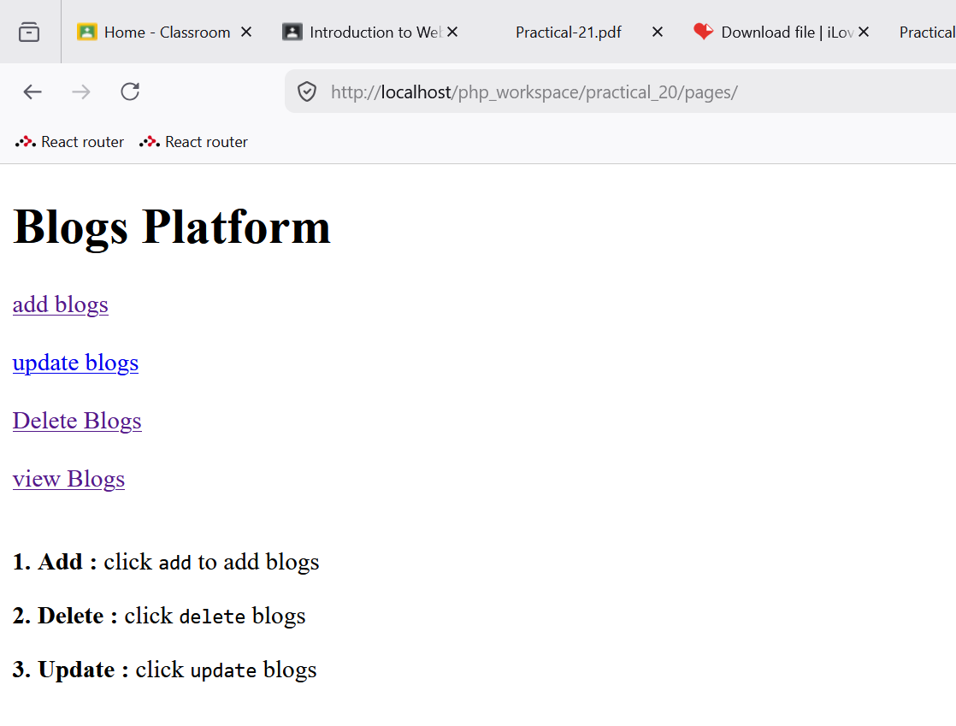

Add blogs

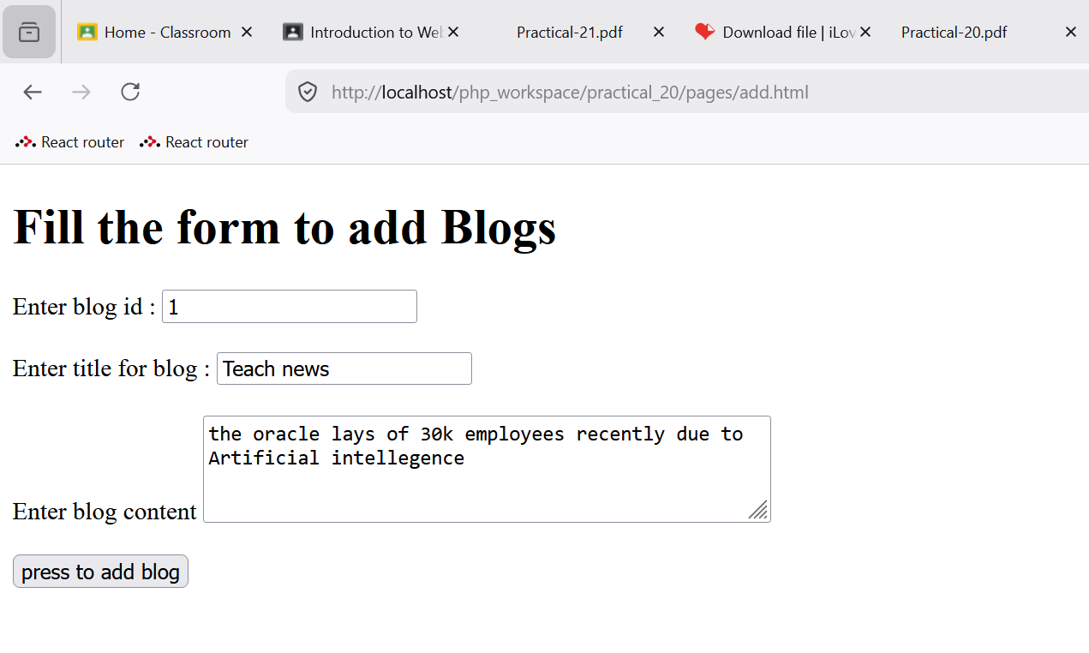

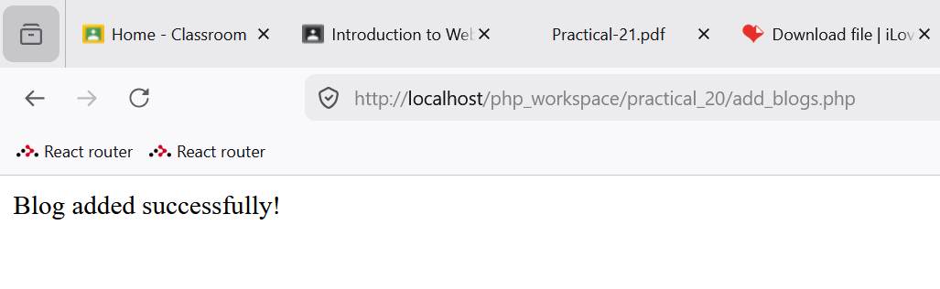

View blogs

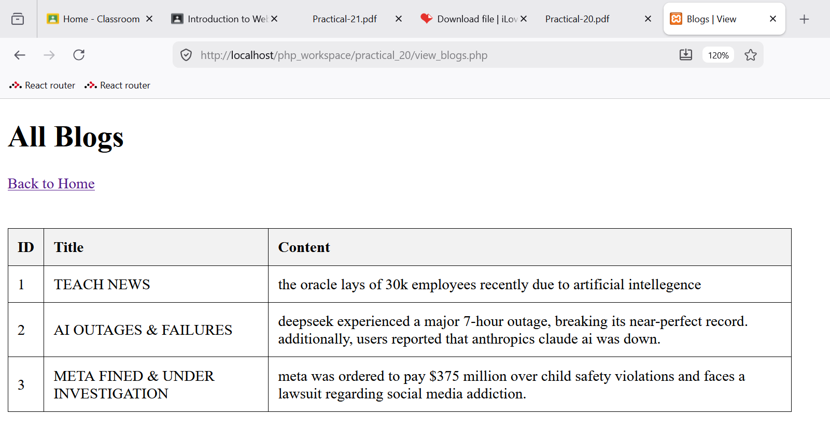

Update the blogs

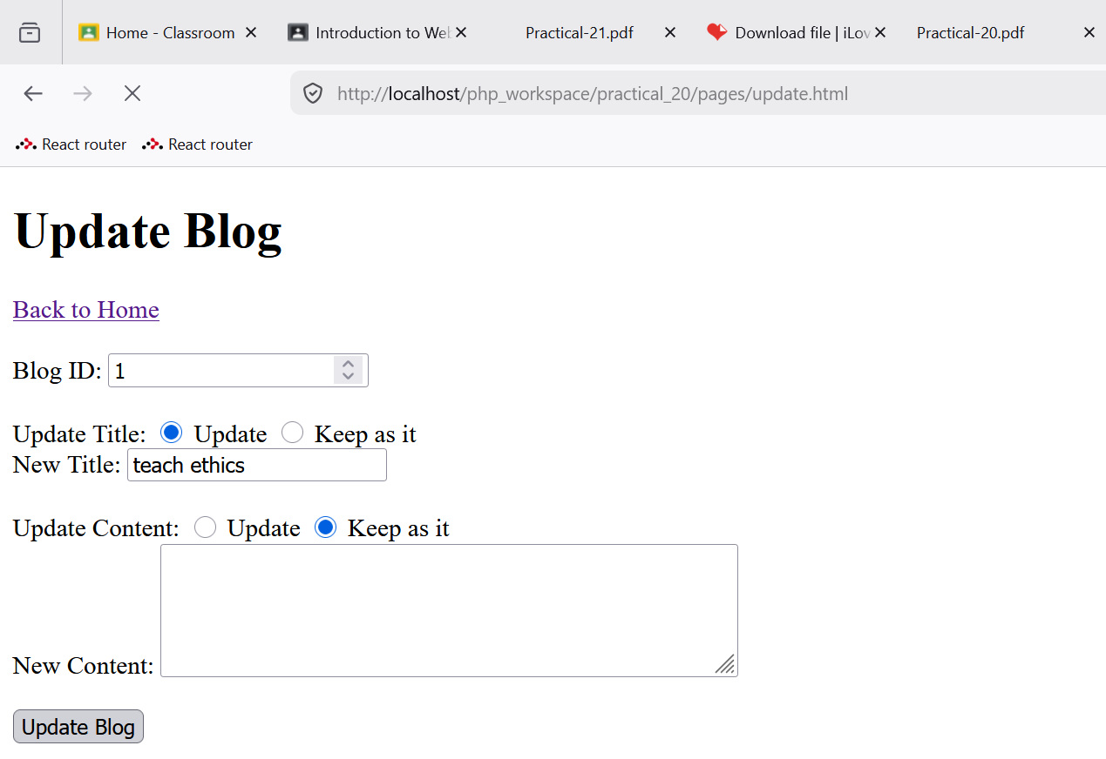

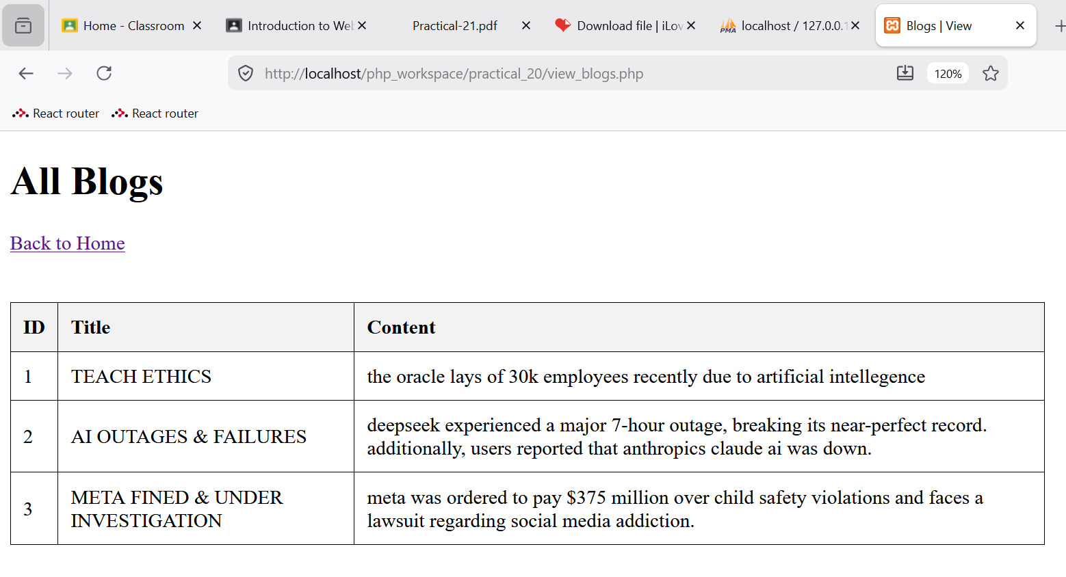

Delete the blog

