Practical – 20
Develop a simple Blog web application that allows users to create, read, update, and delete blogs (CURD operations).
Theory:
Create (Insert Blog): Create a new blog post by filling out a form that includes fields such as: Title
Content
Author (optional) Date
The data entered is sent to the server and stored in the database using an SQL INSERT query.

Read (Display Blogs): All blog posts are retrieved from the database and displayed on a web page. This is done using an SQL SELECT query.
List of all blogs Individual blog view

Update (Edit Blog): Users can modify an existing blog post. The application: Fetches existing data from the database
Displays it in an editable form
Updates the database using an SQL UPDATE query

Delete (Remove Blog): Users can delete a blog post by selecting a deleted option. The application removes the selected record using an SQL DELETE query.

File name: index.php
<?php
require_once "database_Config.php";
require_once "Contact_Controller.php";

$db = (new Database())->connect();
$controller = new ContactController($db);

// ADD
if (isset($_POST['add'])) {
$controller->add($_POST);
}

// DELETE
if (isset($_POST['delete'])) {
$controller->delete($_POST['id']);
}

// SEARCH or READ
if (isset($_POST['search'])) {
$contacts = $controller->search($_POST['keyword']);
} else {
$contacts = $controller->getAll();
}

include "contact_view.php";
?>
File name: database_config.php
<?php
class Database {
private $host = "localhost";
private $user = "root";
private $pass = "";
private $dbname = "Contact_App";

public function connect() {
$conn = new mysqli($this->host, $this->user, $this->pass, $this->dbname);

if ($conn->connect_error) {
die("Connection Failed");
}

return $conn;
}
}
?>
File name: contact_view.php
<!DOCTYPE html>
<html>
<head>
<title>Contact Manager</title>
</head>
<body>

<h2>Add Contact</h2>
<form method="POST">
<input type="text" name="name" placeholder="Name" required>
<input type="email" name="email" placeholder="Email" required>
<input type="text" name="phone" placeholder="Phone" required>
<button name="add">Add</button>
</form>

<h2>Search</h2>
<form method="POST">
<input type="text" name="keyword">
<button name="search">Search</button>
</form>

<h2>Contact List</h2>

<?php
if (isset($contacts)) {
while ($row = $contacts->fetch_assoc()) {
echo $row['name']." | ".$row['email']." | ".$row['phone'];

echo "
<form method='POST' style='display:inline'>
<input type='hidden' name='id' value='".$row['id']."'>
<button name='delete'>Delete</button>
</form>
<form method='POST' style='display:inline'>
<input type='hidden' name='id' value='".$row['id']."'>
<button name='update'>Update</button>
</form>
<br>";
}
}
?>

</body>
</html>
File name: contact_model.php
<?php
class Contact {
private $conn;

public function __construct($db) {
$this->conn = $db;
}

// ADD
public function create($name, $email, $phone) {
$stmt = $this->conn->prepare("INSERT INTO contacts(name,email,phone) VALUES(?,?,?)");
$stmt->bind_param("sss", $name, $email, $phone);
return $stmt->execute();
}

// READ (All)
public function read() {
return $this->conn->query("SELECT * FROM contacts");
}

// SEARCH
public function search($keyword) {
$stmt = $this->conn->prepare("SELECT * FROM contacts WHERE name LIKE ?");
$search = "%".$keyword."%";
$stmt->bind_param("s", $search);
$stmt->execute();
return $stmt->get_result();
}

// UPDATE
public function update($id, $name, $email, $phone) {
$stmt = $this->conn->prepare("UPDATE contacts SET name=?, email=?, phone=? WHERE id=?");
$stmt->bind_param("sssi", $name, $email, $phone, $id);
return $stmt->execute();
}

// DELETE
public function delete($id) {
$stmt = $this->conn->prepare("DELETE FROM contacts WHERE id=?");
$stmt->bind_param("i", $id);
return $stmt->execute();
}
}
?>
File name: Contact_controller.php
<?php
require_once "Contact_model.php";

class ContactController {
private $model;

public function __construct($db) {
$this->model = new Contact($db);
}

public function add($data) {
return $this->model->create($data['name'], $data['email'], $data['phone']);
}

public function getAll() {
return $this->model->read();
}

public function search($keyword) {
return $this->model->search($keyword);
}

public function update($data) {
return $this->model->update($data['id'], $data['name'], $data['email'], $data['phone']);
}

public function delete($id) {
return $this->model->delete($id);
}
}
?>
Output
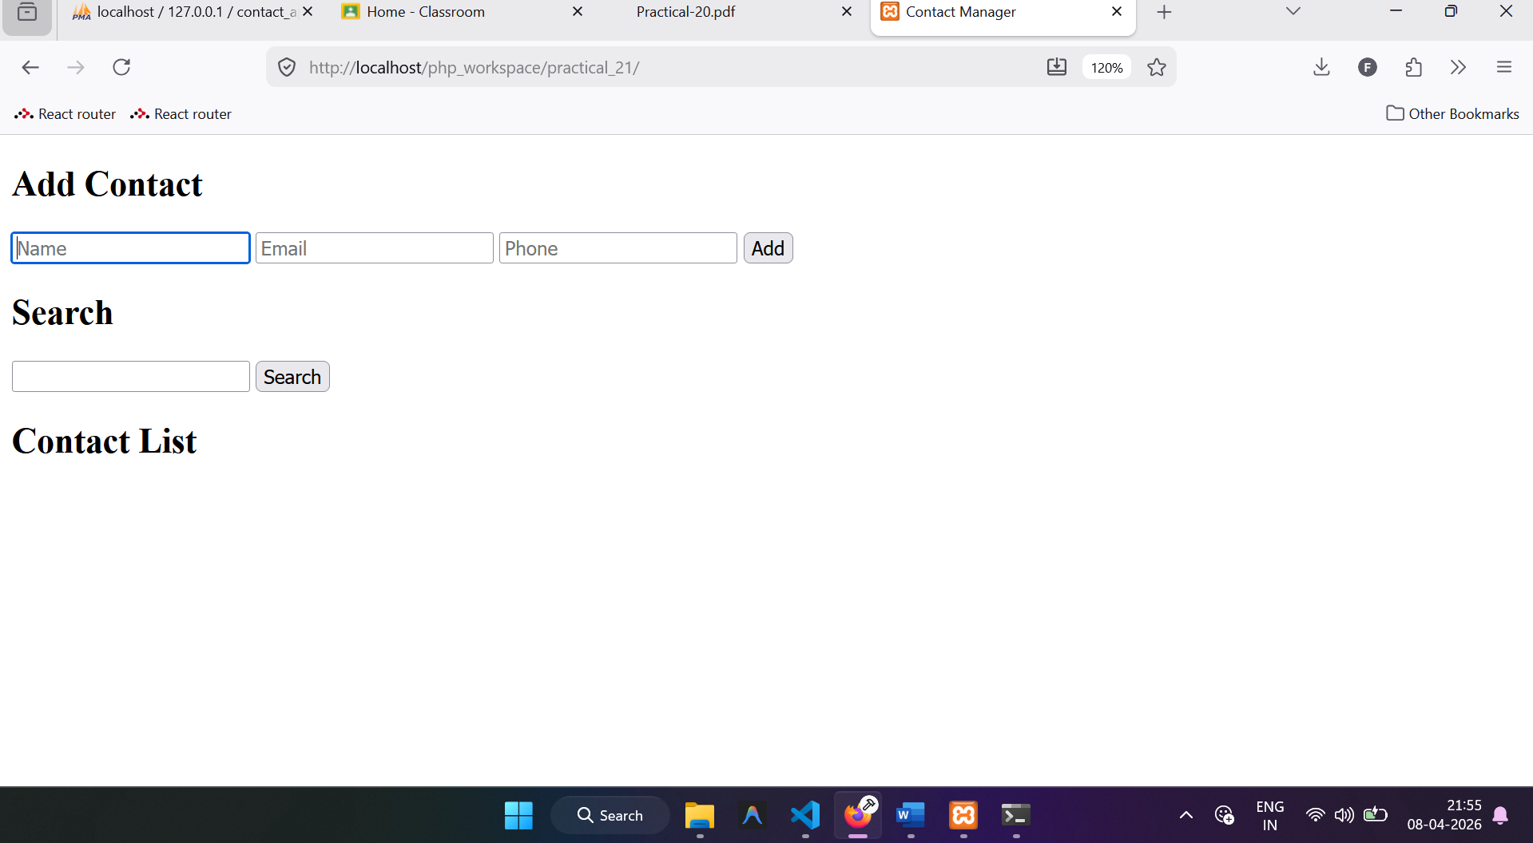
Inserting one record
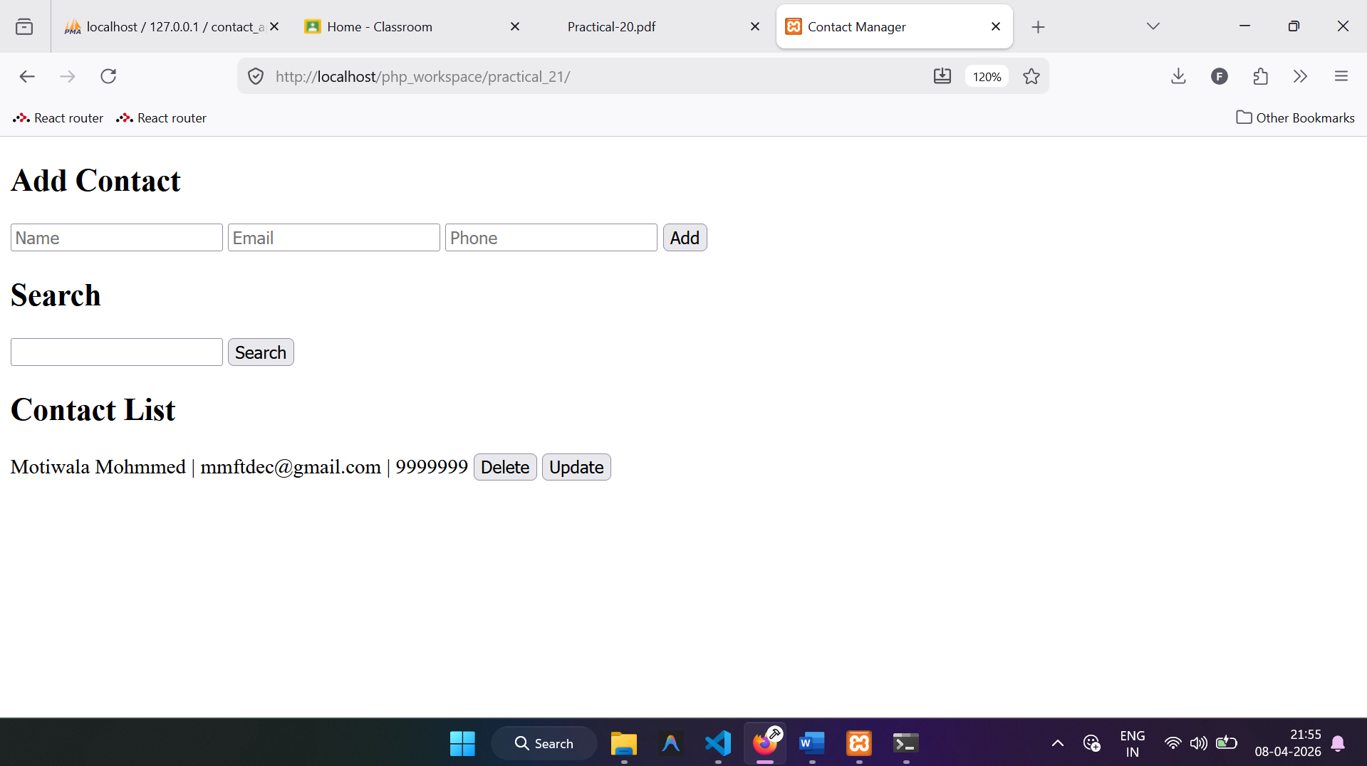
After inserting the 5 records
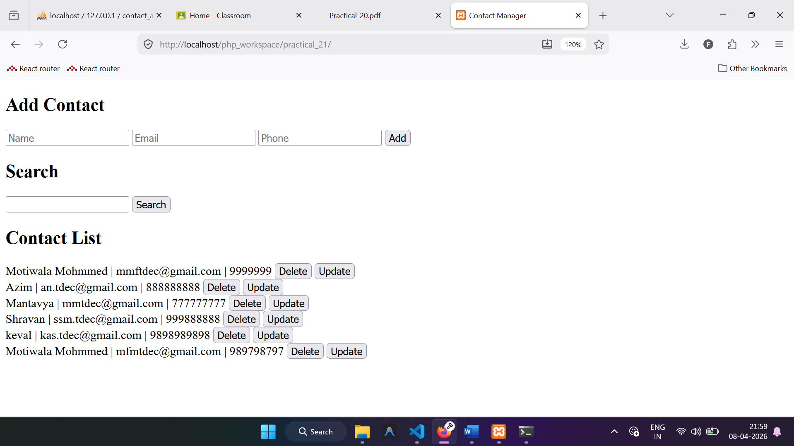
After searching by name

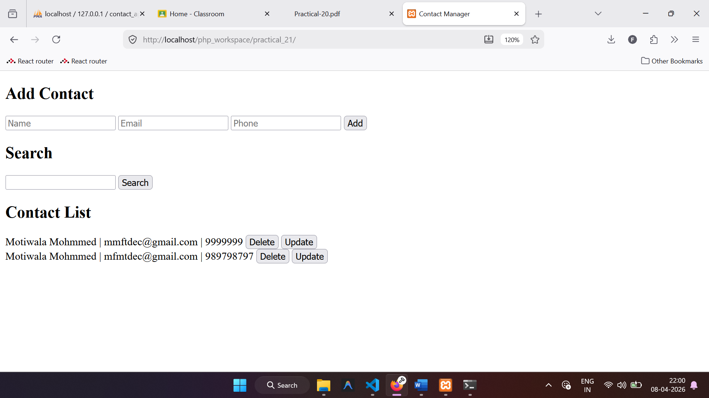
Deletting the record
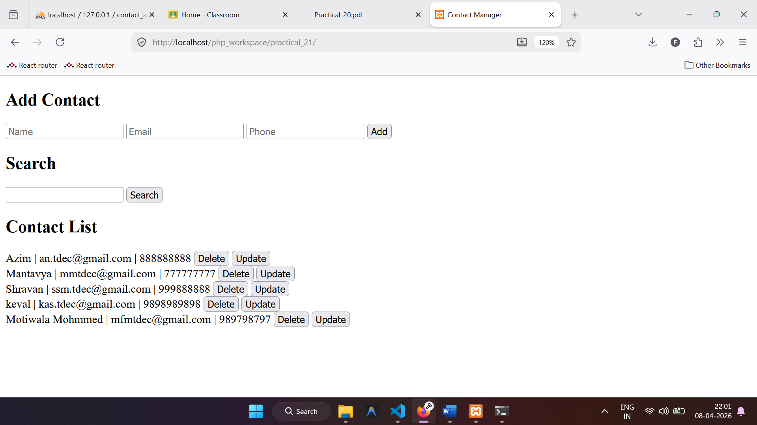
Update the contact information
