Practical – 11
AIM :- Develop a PHP web application to display a user registration form and show data filled out by the user after submission.
Theory:
PHP - A Simple HTML Form

The PHP superglobals $_GET and $_POST are used to collect form-data.
The example below displays a simple HTML form with two input fields and a submit button: HTML form with method = POST
<html><body>
<form action="welcome.php" method="post"> Name: <input type="text" name="name"><br> E-mail: <input type="text" name="email"><br>
<input type="submit">
</form></body></html>
When a user fills out the form above and clicks the submit button, the form data is sent for processing to a PHP file named "welcome.php". The form data is sent with the HTTP POST method.
To display the submitted data you could simply echo all the variables. The "welcome.php" looks like this:
<html>
<body>
Welcome <?php echo $_POST["name"]; ?><br>
Your email address is: <?php echo $_POST["email"]; ?>
</body>
</html>

The output could be something like this:

Welcome John
Your email address is john.doe@example.com
The same result could also be achieved using the HTTP GET method:
<form action="welcome_get.php" method="get">

INPUT :- using GET method File :- { pr 11_1.php }

<!DOCTYPE html>
<html lang="en">
<head>
<meta charset="UTF-8">
<meta name="viewport" content="width=device-width, initial-scale=1.0">
<title>Document</title>
</head>
<body>
<form method="get">
<label for="name">name:</label>
<input type="text" name="name"><br><br>
<label for="email">email:<label>
<input type="email" name="email"><br><br>
<label for="contect">contect:</label>
<input type="number" name="contect"><br><br>

Gender:
<input type="radio" name="gender" <?php if (isset($gender) && $gender=="male") echo "checked";?>
value="male">Male
<input type="radio" name="gender" <?php if (isset($gender) && $gender=="female") echo "checked";?>
value="female">Female <br>
<p>Select your favorite Hobby:</p>
<input type="radio" id="Cricket" name="hobby" value="red">
<label for="Cricket">Cricket</label><br>
<input type="radio" id="blue" name="hobby" value="blue">
<label for="blue">Blue</label><br>
<input type="radio" id="green" name="hobby" value="green">

<label for="green">Green</label><br>
<input type="submit" name="submit"value="submit"><br><br>
</from>

<?php if(isset($_GET["submit"])){
$name = $_GET["name"];
$email = $_GET["email"];
$contect = $_GET["contect"];
$gender = $_GET["gender"];

if (isset($_GET["gender"])) {
$genderErr = "Gender is required";
} else {
$gender = $_GET["gender"];
}
echo "Name : $name <br>"; echo "Email : $email <br>"; echo "Contenct : $contect <br>"; echo "Gender : $gender <br>" ;
}
?>
</body>
</html>

OUTPUT :-

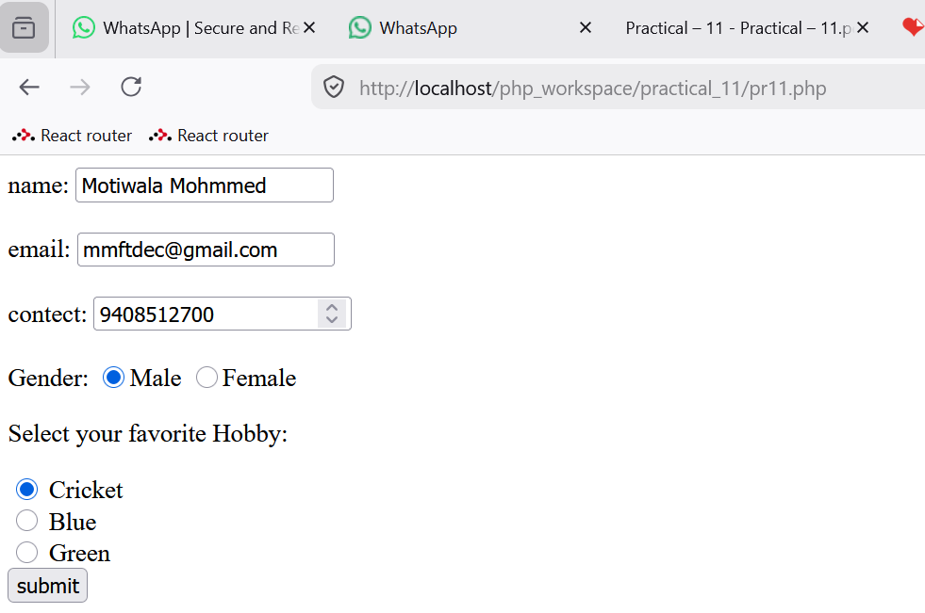
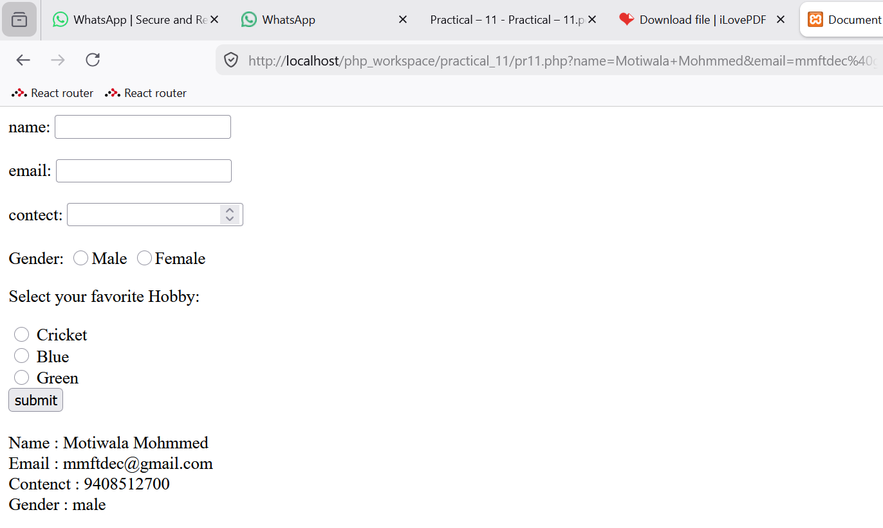

INPUT :- Using POST method File :- { pr 11_2.php }
<!DOCTYPE html>
<html lang="en">
<head>
<meta charset="UTF-8">
<meta name="viewport" content="width=device-width, initial-scale=1.0">
<title>Document</title>
</head>
<body>
<form method="post">
<label for="name">name:</label>
<input type="text" name="name"><br><br>
<label for="email">email:<label>
<input type="email" name="email"><br><br>
<label for="contect">contect:</label>
<input type="number" name="contect"><br><br>

Gender:
<input type="radio" name="gender" <?php if (isset($gender) && $gender=="male") echo "checked";?>
value="male">Male
<input type="radio" name="gender" <?php if (isset($gender) && $gender=="female") echo "checked";?>
value="female">Female <br>
<p>Select your favorite Hobby:</p>
<input type="radio" id="Cricket" name="hobby" value="red">

<label for="Cricket">Cricket</label><br>
<input type="radio" id="gaming" name="hobby" value="gaming">
<label for="gaming">Gaming</label><br>
<input type="radio" id="hockey" name="hobby" value="hockey">
<label for="hockey">Hockey</label><br>
<input type="submit" name="submit"value="submit"><br><br>
</from>
<?php if(isset($_POST["submit"])){
$name = $_POST["name"];
$email = $_POST["email"];
$contect = $_POST["contect"];
$gender = $_POST["gender"];

if (isset($_POST["gender"])) {
$genderErr = "Gender is required";
} else {
$gender = $_POST["gender"];
}
echo "Name : $name <br>"; echo "Email : $email <br>"; echo "Contenct : $contect <br>"; echo "Gender : $gender <br>" ;
}
?>
</body>
</html>

OUTPUT :-



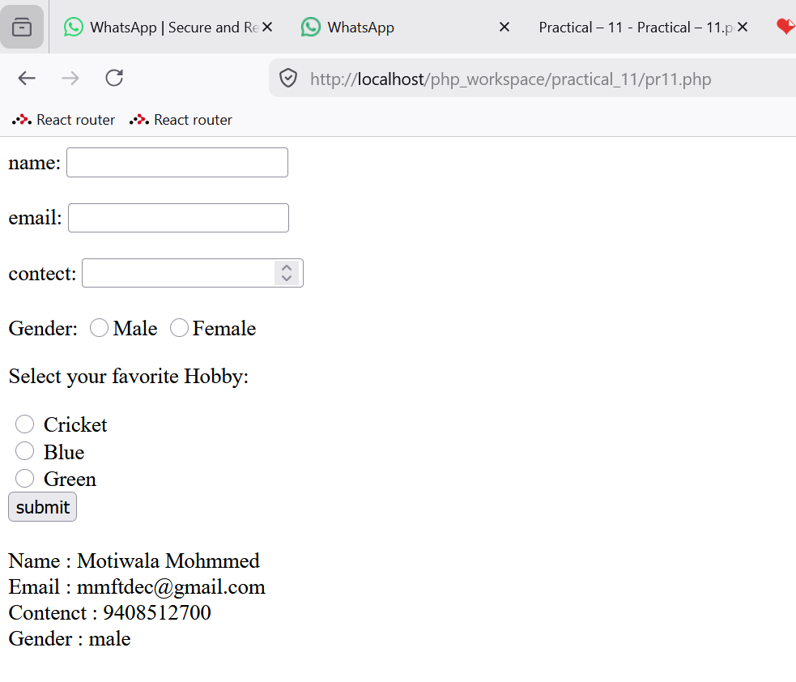

INPUT :- using GET method 1 File :- { pr 11_1.php }
<!DOCTYPE html>
<html lang="en">
<head>
<meta charset="UTF-8">
<meta name="viewport" content="width=device-width, initial-scale=1.0">
<title>Document</title>
</head>
<body>
<form method="get" action="pr 11_3.php">
<label for="name">name:</label>
<input type="text" name="name"><br><br>
<label for="email">email:<label>
<input type="email" name="email"><br><br>
<label for="contect">contect:</label>
<input type="number" name="contect"><br><br>

Gender:
<input type="radio" name="gender" <?php if (isset($gender) && $gender=="male") echo "checked";?>
value="male">Male
<input type="radio" name="gender" <?php if (isset($gender) && $gender=="female") echo "checked";?>
value="female">Female <br>
<p>Select your favorite Hobby:</p>
<input type="radio" id="Cricket" name="hobby" value="Cricket">
<label for="Cricket">Cricket</label><br>
<input type="radio" id="gaming" name="hobby" value="gaming">
<label for="gaming">Gaming</label><br>
<input type="radio" id="hockey" name="hobby" value="hockey">
<label for="hockey">Hockey</label><br>
<input type="submit" name="submit"value="submit"><br><br>
</from>

</body>

</html>

2 File :- { pr 11_3.php }
<?php if(isset($_GET["submit"])){
$name = $_GET["name"];
$email = $_GET["email"];
$contect = $_GET["contect"];
$gender = $_GET["gender"];
$hobby = $_GET["hobby"];

if (isset($_GET["gender"])) {
$genderErr = "Gender is required";
} else {
$gender = $_GET["gender"];
}
echo "Name : $name <br>"; echo "Email : $email <br>"; echo "Contenct : $contect <br>"; echo "Gender : $gender <br>" ; echo "Favorite Hobby : $hobby";
}
?>

OUTPUT :-
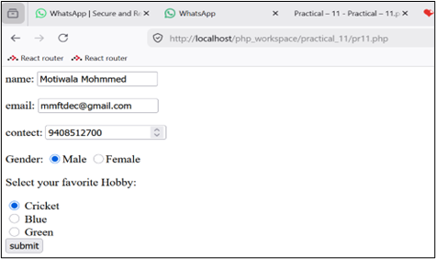

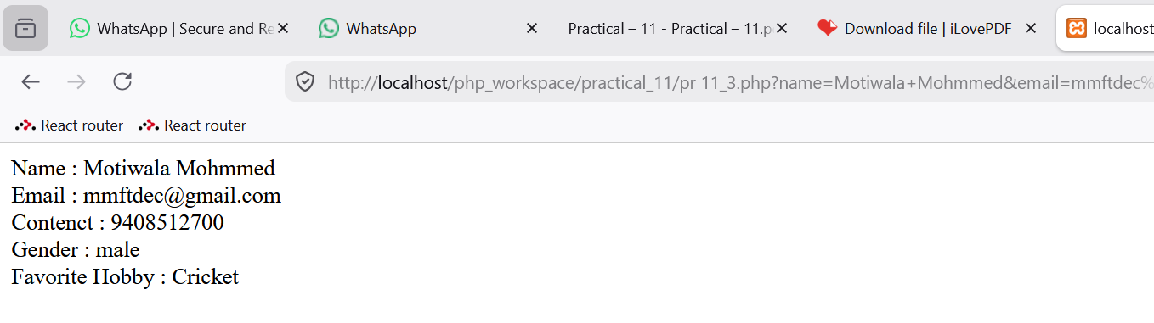

INPUT :- using POST method 1 File :- { pr 11_2.php }

<!DOCTYPE html>
<html lang="en">
<head>
<meta charset="UTF-8">
<meta name="viewport" content="width=device-width, initial-scale=1.0">
<title>Document</title>
</head>
<body>
<form method="post" action="pr 11_4.php">
<label for="name">name:</label>
<input type="text" name="name"><br><br>
<label for="email">email:<label>
<input type="email" name="email"><br><br>
<label for="contect">contect:</label>
<input type="number" name="contect"><br><br>

Gender:
<input type="radio" name="gender" <?php if (isset($gender) && $gender=="male") echo "checked";?>
value="male">Male
<input type="radio" name="gender" <?php if (isset($gender) && $gender=="female") echo "checked";?>
value="female">Female <br>
<p>Select your favorite Hobby:</p>

<input type="radio" id="Cricket" name="hobby" value="Cricket">
<label for="Cricket">Cricket</label><br>
<input type="radio" id="gaming" name="hobby" value="gaming">
<label for="gaming">Gaming</label><br>
<input type="radio" id="hockey" name="hobby" value="hockey">
<label for="hockey">Hockey</label><br>
<input type="submit" name="submit"value="submit"><br><br>
</from>

</body>
</html>

2 File :- { pr 11_4.php }
<?php if(isset($_POST["submit"])){
$name = $_POST["name"];
$email = $_POST["email"];
$contect = $_POST["contect"];
$gender = $_POST["gender"];
$hobby = $_POST["hobby"];

if (isset($_POST["gender"])) {
$genderErr = "Gender is required";
} else {
$gender = $_POST["gender"];
}
echo "Name : $name <br>"; echo "Email : $email <br>"; echo "Contenct : $contect <br>"; echo "Gender : $gender <br>" ; echo "Favorite Hobby : $hobby";
}
?>

OUTPUT :-
