Practical – 15
Develop a simple PHP web application for newsletter subscription and send a confirmation email. (Plain & HTML email).
Theory:

PHP Mail Introduction
The mail() function allows you to send emails directly from a script.

Requirements
For the mail functions to be available, PHP requires an installed and working email system. The program to be used is defined by the configuration settings in the php.ini file.

Installation
The mail functions are part of the PHP core. There is no installation needed to use these functions. We have to import some file in order to use function as shown in below example.

Example:
<?php
use PHPMailer\PHPMailer\PHPMailer; require 'src/PHPMailer.php';
require 'src/Exception.php'; require 'src/SMTP.php';
$mail = new PHPMailer(true);
$name = $_POST['name'];
$em = $_POST['email']; try{
$mail -> isSMTP();
$mail -> Host = 'SMTP.gmail.com';
$mail -> SMTPAuth = true;
$mail -> Username = ‘Your Email ID’;
$mail -> Password = 'qjhp deth krru diih';
$mail -> SMTPSecure = 'tls';
$mail -> Port = '587';
$mail -> setFrom("Your Email ID","Administrator");
$mail -> addAddress($em,$name);
$mail->isHTML(false); // IMPORTANT → Plain text
$mail->Subject = "Subscription Confirmed";
$mail->Body = "Hello $name,\nThank you for subscribing.\nRegards Admin";
$mail->send();
echo "Plain Text Email Sent Successfully"; echo "HTML Email Sent Successfully";
}
catch (Exception $e) {
echo "Error: {$mail->ErrorInfo}";
}?>

File Name : Index.php
<!DOCTYPE html>
<html lang="en">
<head>
<meta charset="UTF-8">
<meta name="viewport" content="width=device-width, initial-scale=1.0">
<title>Document</title>
</head>
<body>
<form method="POST" action="send.php">
<label>Enter Recipient Email ID : </label>
<br>
<input type="email" name="email">
<br><br>
<label>Enter Email Subject : </label>
<input type="text" name="subject" id="">
<br>
<label>Enter Email Message : </label>
<input type="text" name="message">
<br><br>

<br>
<br><br>
<input type="submit" value="SEND" name = "send">
</form>
</body>
</html>

File Name: send.php
<?php
//Import PHPMailer classes into the global namespace
use PHPMailer\PHPMailer\PHPMailer;
use PHPMailer\PHPMailer\SMTP;
use PHPMailer\PHPMailer\Exception;

// Load PHPMailer classes manually (since vendor/autoload.php doesn't exist)
require 'phpmailer/src/Exception.php';
require 'phpmailer/src/PHPMailer.php';
require 'phpmailer/src/SMTP.php';

if (isset($_POST['send'])) {
// Collect form data from index.php
$recipient_email = $_POST['email'];
$subject = $_POST['subject'];
$message = $_POST['message'];

//Create an instance; passing `true` enables exceptions
$mail = new PHPMailer(true);

try {
//Server settings
$mail->SMTPDebug = SMTP::DEBUG_SERVER; // Enable verbose debug output for diagnosing authentication error
$mail->isSMTP(); // Send using SMTP
$mail->Host = 'smtp.gmail.com'; // Set the SMTP server to send through
$mail->SMTPAuth = true; // Enable SMTP authentication
$mail->Username = 'furqaan.devspace2007@gmail.com'; // SMTP username
$mail->Password = 'gxji zgzm ekcg tkly'; // SMTP password (as requested)
$mail->SMTPSecure = PHPMailer::ENCRYPTION_SMTPS; // Enable implicit TLS encryption
$mail->Port = 465; // TCP port to connect to

//Recipients
$mail->setFrom('furqaan.devspace2007@gmail.com', 'Furqaan');
$mail->addAddress($recipient_email); // Add a recipient from form data

//Content
$mail->isHTML(true); // Set email format to HTML
$mail->Subject = $subject;
$mail->Body = $message;
$mail->AltBody = strip_tags($message); // Plain text version of message

$mail->send();
echo "<script>alert('Message has been sent'); window.location.href='index.php';</script>";
} catch (Exception $e) {
echo "Message could not be sent. Mailer Error: {$mail->ErrorInfo}";
}
} else {
// Redirect to index.php if accessed directly
header("Location: index.php");
exit();
}
Output
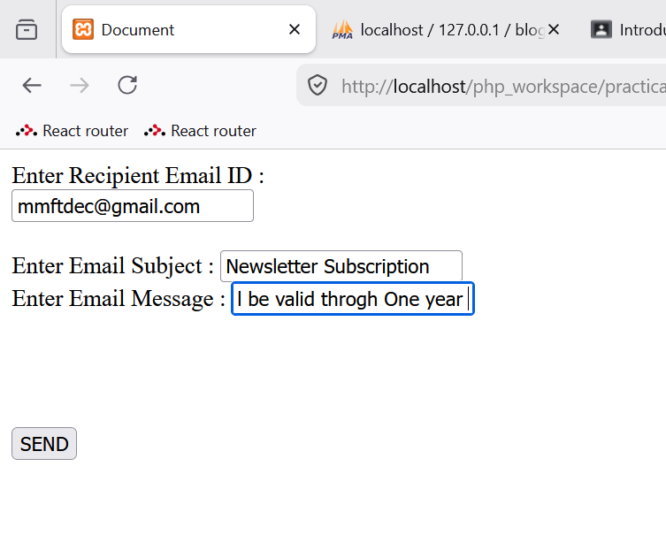
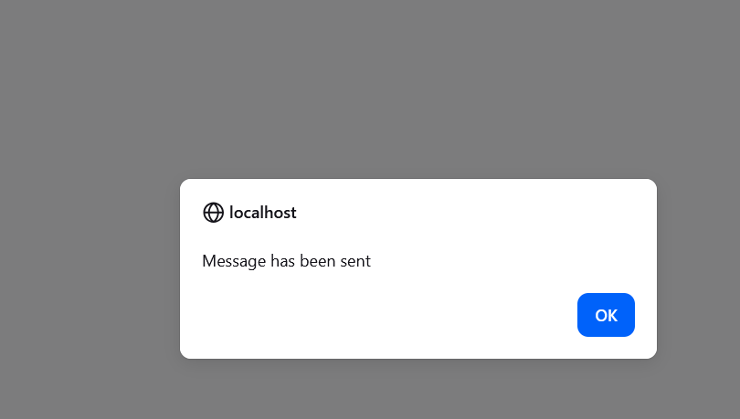

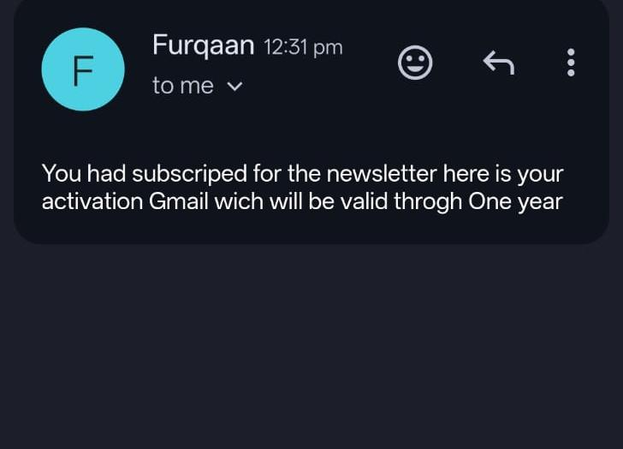

PHP HTML EMAIL

Filename : index.html
<!DOCTYPE html>
<html lang="en">

<head>
<meta charset="UTF-8">
<meta name="viewport" content="width=device-width, initial-scale=1.0">
<title>Newsletter Subscription</title>
<style>
body {
font-family: sans-serif;
display: flex;
justify-content: center;
padding-top: 50px;
background-color: #eef2ff;
}

.card {
background: #ffffff;
padding: 2rem;
border-radius: 8px;
box-shadow: 0 4px 6px rgba(0, 0, 0, 0.1);
width: 300px;
}

h2 {
margin-top: 0;
color: #4f46e5;
}

input {
width: 100%;
padding: 10px;
margin: 10px 0;
border: 1px solid #c7d2fe;
border-radius: 4px;
box-sizing: border-box;
}

button {
width: 100%;
padding: 10px;
background-color: #4f46e5;
color: white;
border: none;
border-radius: 4px;
cursor: pointer;
font-size: 16px;
}

button:hover {
background-color: #4338ca;
}
</style>
</head>

<body>

<div class="card">
<h2>Subscribe</h2>
<form action="send-email.php" method="POST">
<label for="name1">Full Name</label>
<input type="text" name="name1" id="name1" placeholder="Enter your name" required>

<label for="email1">Email Address</label>
<input type="email" name="email1" id="email1" placeholder="Enter your email" required>

<button type="submit">Send Confirmation</button>
</form>
</div>

</body>

</html>
Filename: send-email.php
<?php
// 1. Namespaces MUST stay at the very top use PHPMailer\PHPMailer\PHPMailer;
use PHPMailer\PHPMailer\Exception; use PHPMailer\PHPMailer\SMTP;

// 2. The order of these requires is critical require 'src/Exception.php';
require 'src/PHPMailer.php'; require 'src/SMTP.php';

$mail = new PHPMailer(true);
// ... rest of your code ...

try {
// Server settings
// $mail->SMTPDebug = SMTP::DEBUG_SERVER; // Uncomment this line to see detailed error logs
$mail->isSMTP();
$mail->Host = 'smtp.gmail.com';
$mail->SMTPAuth = true;
$mail->Username = 'mmftdec@gmail.com';
$mail->Password = 'gxji zgzm ekcg tkly'; // Ensure this is a valid App Password
$mail->SMTPSecure = PHPMailer::ENCRYPTION_STARTTLS;
$mail->Port = 587;

// Check if POST data exists to avoid "Undefined Index" errors
$name = isset($_POST['name1']) ? $_POST['name1'] : 'Subscriber';
$email = isset($_POST['email1']) ? $_POST['email1'] : '';

if (empty($email)) {
throw new Exception("Email address is required.");
}

// Recipients
$mail->setFrom('mmftdec@gmail.com', 'Admin');
$mail->addAddress($email, $name);

// Content
$mail->isHTML(true);

$mail->Subject = "Subscription Confirmed";
$mail->Body = "
<h2 style='color:green'>Welcome " . htmlspecialchars($name) . "!</h2>
<p>Thank you for subscribing to our newsletter.</p>
<hr>
<b>Regards,</b><br>Admin";

$mail->AltBody = "Hello $name, Thank you for subscribing.";

$mail->send();
echo "HTML Email Sent Successfully";
} catch (Exception $e) {
echo "Message could not be sent. Mailer Error: {$mail->ErrorInfo}";
}
?>

Output
