PROJECT REPORT
Deploying an Angular Application
Using Docker and Docker Compose
Development container with Angular CLI and production deployment with Nginx

Project | Project 2: Angular Docker Deployment
Submitted by | Kisna
Course / Subject | DevOps Laboratory
Environment | macOS, VS Code, Docker Desktop
Date | 22 July 2026

A reproducible containerized workflow for development and production

Abstract
This project demonstrates how an Angular application can be containerized for two distinct environments. The development workflow uses a Node.js image, Angular's development server, a bind mount, and port 4200 to support rapid iteration. The production workflow uses a multi-stage Dockerfile: Node.js compiles the Angular source into static assets, and an Nginx image serves the optimized output on port 80. Docker Compose provides repeatable commands for building, starting, inspecting, and stopping both environments. The supplied screenshots verify successful image builds, running containers, published ports, browser access, and graceful shutdown.
Outcome Both development and production containers were built successfully, and the Angular application was accessible at http://localhost:4200 and http://localhost respectively.

Contents
1. Introduction
2. Objectives
3. Tools and Technologies
4. Project Structure and Configuration
5. Deployment Architecture
6. Implementation Evidence and Screenshot Analysis
7. Docker Commands Explained
8. Results, Warnings, and Troubleshooting
9. Conclusion
10. Viva Questions and Answers
11. References

1. Introduction
Containerization packages an application together with its runtime, dependencies, and execution instructions. For an Angular project, development and production have different requirements. Development prioritizes live editing and fast feedback, whereas production prioritizes small images, deterministic builds, and efficient static-file delivery.
This project implements both workflows using separate Dockerfiles and Docker Compose configurations. The development container executes the Angular development server. The production container performs a multi-stage build and serves the generated browser files through Nginx.

2. Objectives
- Create and run an Angular application inside a Docker container.
- Provide a development configuration with source-code mounting and port 4200.
- Create a production-ready multi-stage image using Node.js and Nginx.
- Use Docker Compose to make builds and lifecycle commands repeatable.
- Validate container status, image creation, port mappings, browser access, and shutdown behavior.
- Document the complete process with screenshots and explanations.

3. Tools and Technologies
Tool / Technology | Role in the Project | Observed Configuration
Angular CLI | Creates and builds the Angular application. | Application name: angular-docker
Node.js | Installs dependencies and runs/builds Angular. | Node 22 / Node 22 Alpine
Docker | Builds immutable images and runs isolated containers. | Docker Desktop on macOS
Docker Compose | Defines and manages development and production services. | Separate development and production YAML files
Nginx | Serves the compiled Angular static assets. | nginx:alpine, container port 80
VS Code | Edits and inspects project configuration files. | Explorer, editor, and integrated terminal

4. Project Structure and Configuration
The project separates development and production behavior into four primary configuration files:
- Dockerfile.dev - starts the Angular development server inside a Node.js container.
- Dockerfile - builds the Angular application and copies the generated files into Nginx.
- docker-compose.yml - development service, bind mount, environment setting, and port 4200.
- docker-compose.prod.yml - production service and host-to-container port 80 mapping.

4.1 Development Dockerfile
FROM node:22.22.3
WORKDIR /app
COPY package*.json ./
RUN npm install
COPY . .
EXPOSE 4200
CMD ["npm", "start"]
The development image installs dependencies, copies the project, exposes Angular's development port, and executes the project's start script.

4.2 Production Dockerfile
# Build stage
FROM node:22-alpine AS build
WORKDIR /app
COPY package*.json ./
RUN npm install
COPY . .
RUN npm run build -- --configuration production
# Production stage
FROM nginx:alpine
COPY --from=build /app/dist/angular-docker/browser /usr/share/nginx/html
COPY nginx.conf /etc/nginx/conf.d/default.conf
EXPOSE 80
CMD ["nginx", "-g", "daemon off;"]
The build tools remain in the temporary Node.js stage. Only Nginx and the compiled static files are retained in the final runtime image.

4.3 Development Compose File
services:
angular-app:
build:
context: .
dockerfile: Dockerfile.dev
ports:
- "4200:4200"
environment:
- NG_ALLOWED_HOSTS=localhost
volumes:
- .:/app
- /app/node_modules

4.4 Production Compose File
services:
angular-prod:
build:
context: .
dockerfile: Dockerfile
ports:
- "80:80"
Compose compatibility The screenshot contains `version: "3.8"`. Current Docker Compose treats this key as obsolete, so it can be safely removed.

5. Deployment Architecture
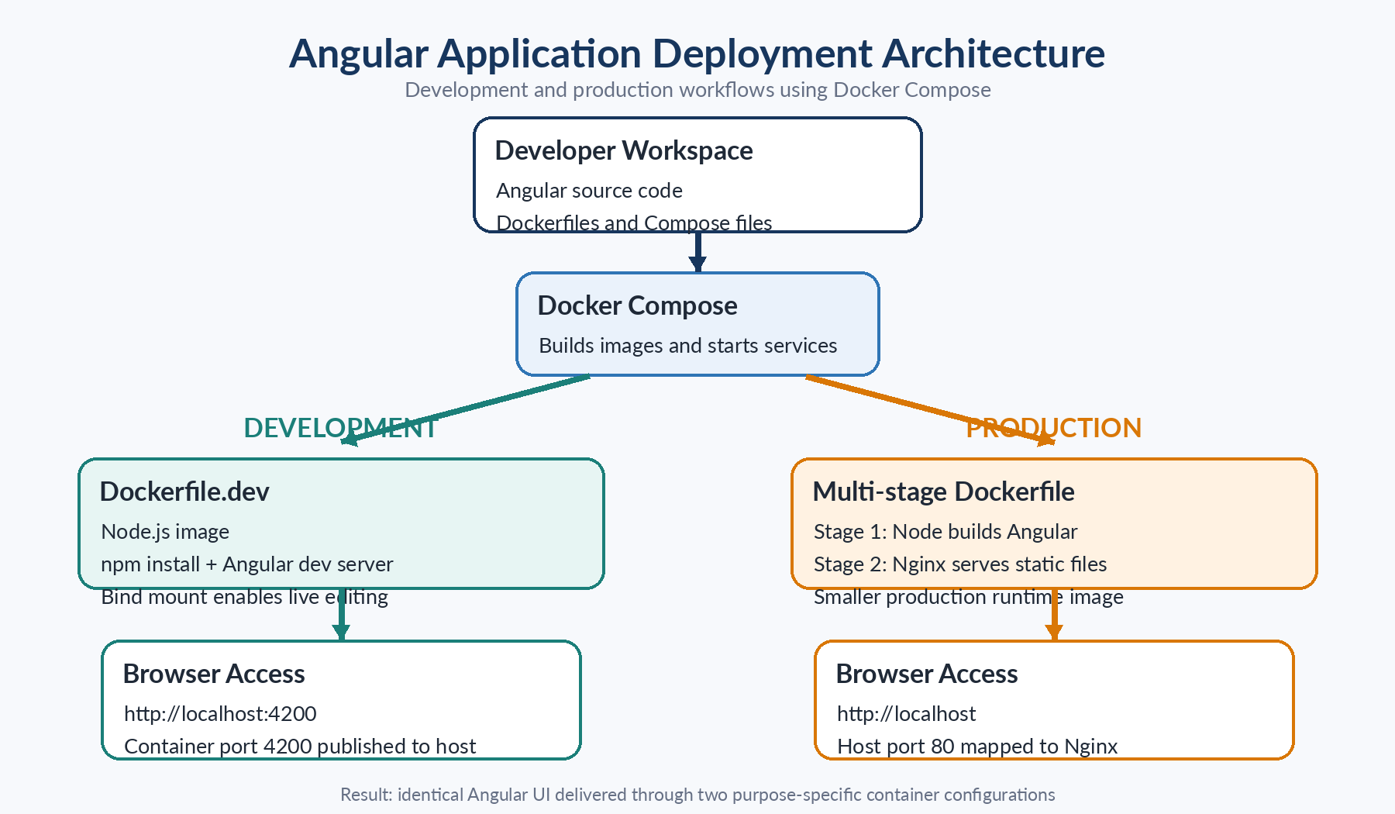
Figure 1. Development and production deployment architecture
Explanation: Docker Compose selects the appropriate Dockerfile. Development runs the Angular server in Node.js on port 4200, while production compiles static assets and serves them through Nginx on port 80.
The two workflows use the same Angular source code but optimize for different operational goals:
Aspect | Development | Production
Runtime | Node.js + Angular development server | Nginx static web server
Port | 4200 | 80
Source updates | Bind-mounted for rapid iteration | Rebuilt into immutable assets
Image design | Single-stage, development focused | Multi-stage, smaller runtime
Primary purpose | Local development and testing | Deployment and delivery

6. Implementation Evidence and Screenshot Analysis
The following figures document the configuration, execution, validation, and shutdown of the project. Each screenshot is paired with an explanation of the evidence it provides.
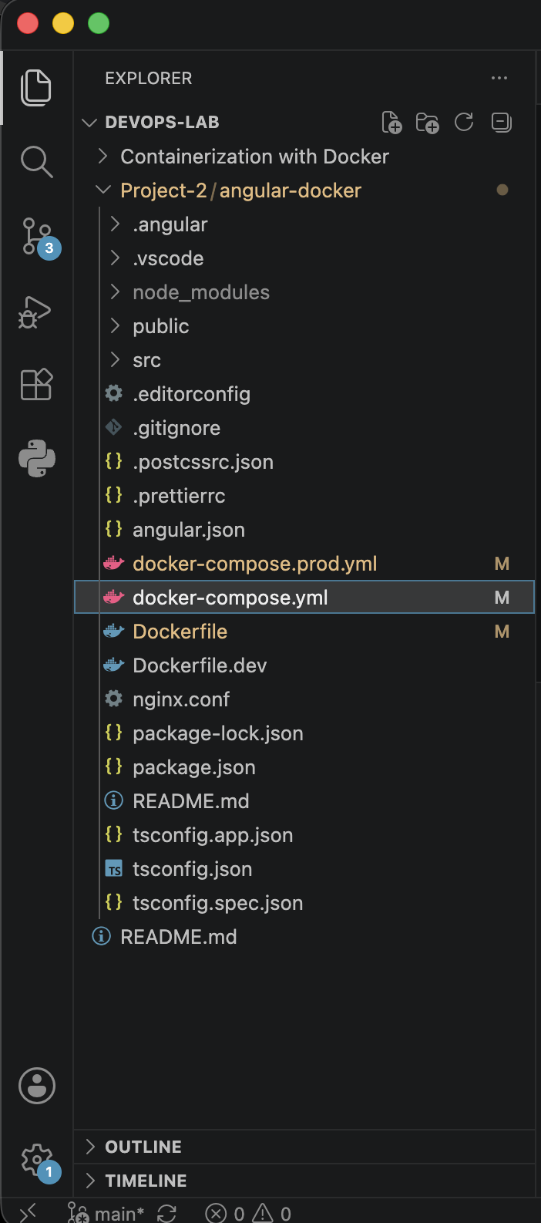
Figure 2. Angular project structure in VS Code
Explanation: The Explorer shows the Angular source folders and all required Docker configuration files: Dockerfile, Dockerfile.dev, docker-compose.yml, docker-compose.prod.yml, nginx.conf, package files, and TypeScript configuration files.

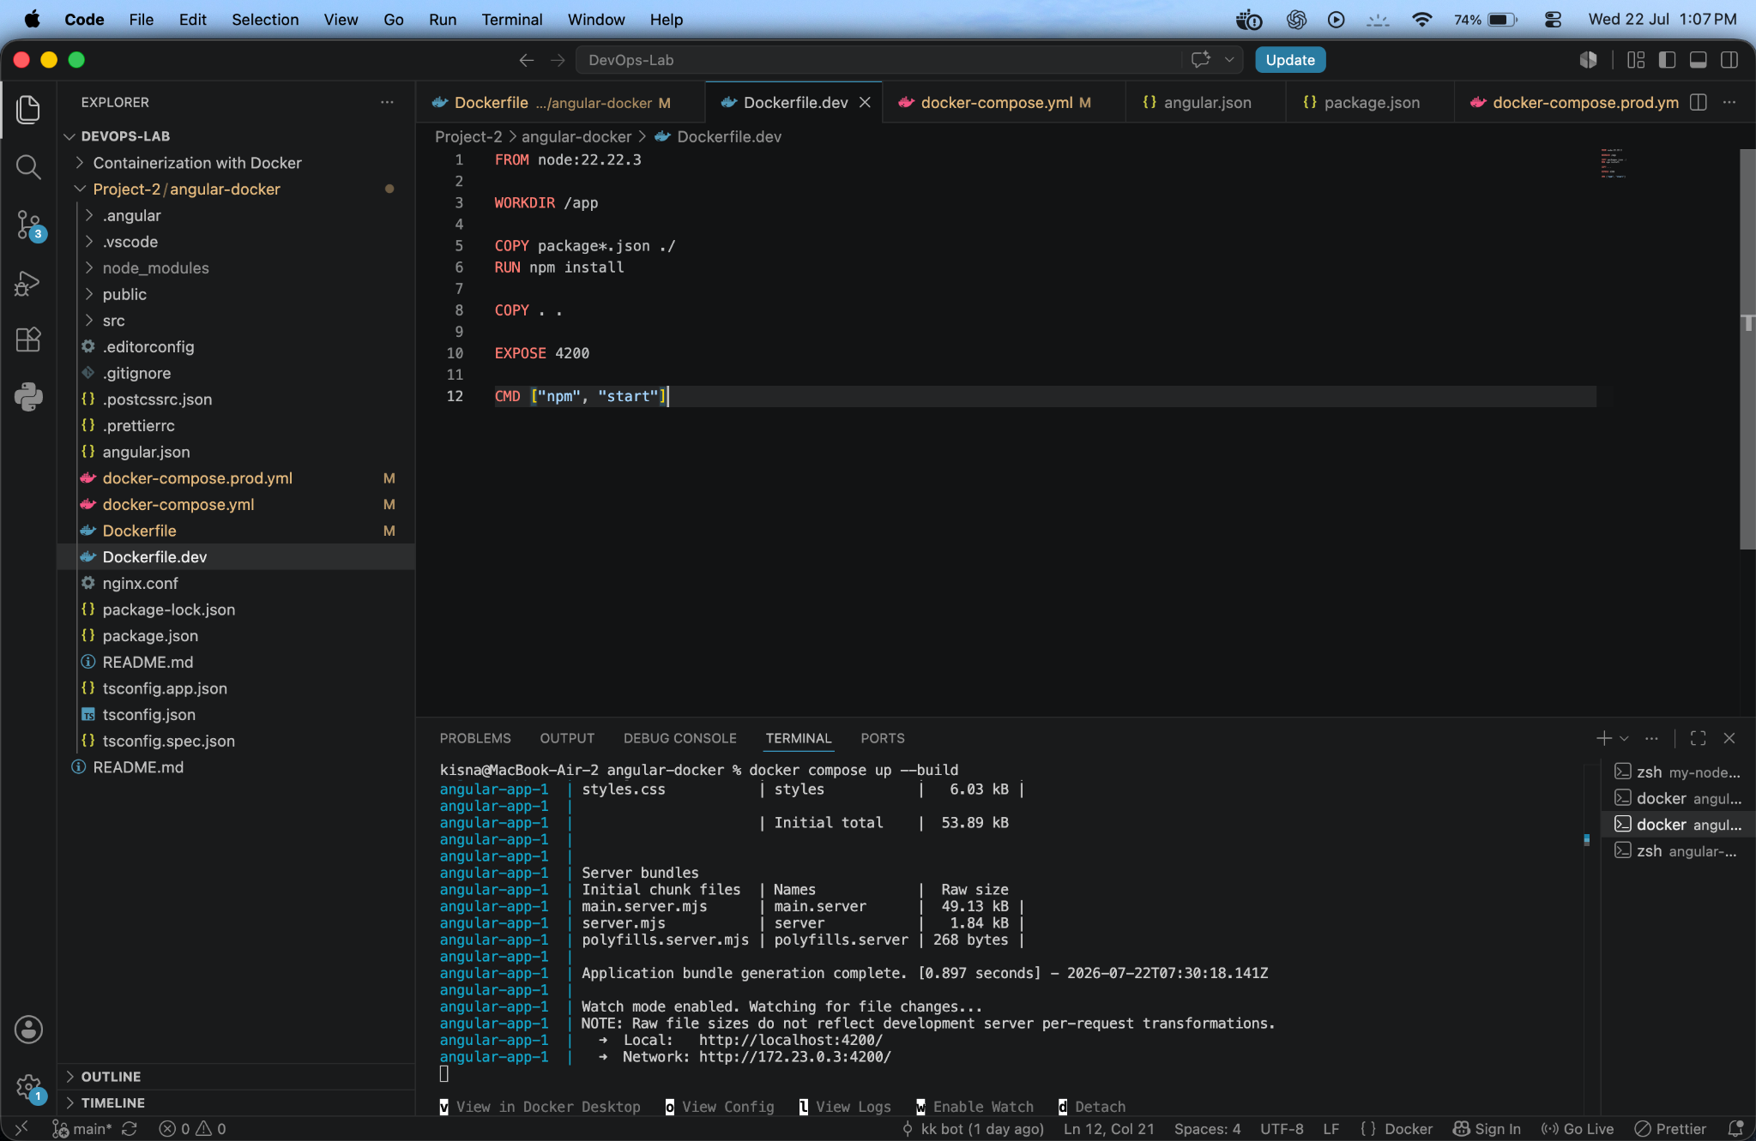
Figure 3. Development Dockerfile
Explanation: The development Dockerfile uses Node.js, sets /app as the working directory, installs npm dependencies, copies the application, exposes port 4200, and starts the Angular application.

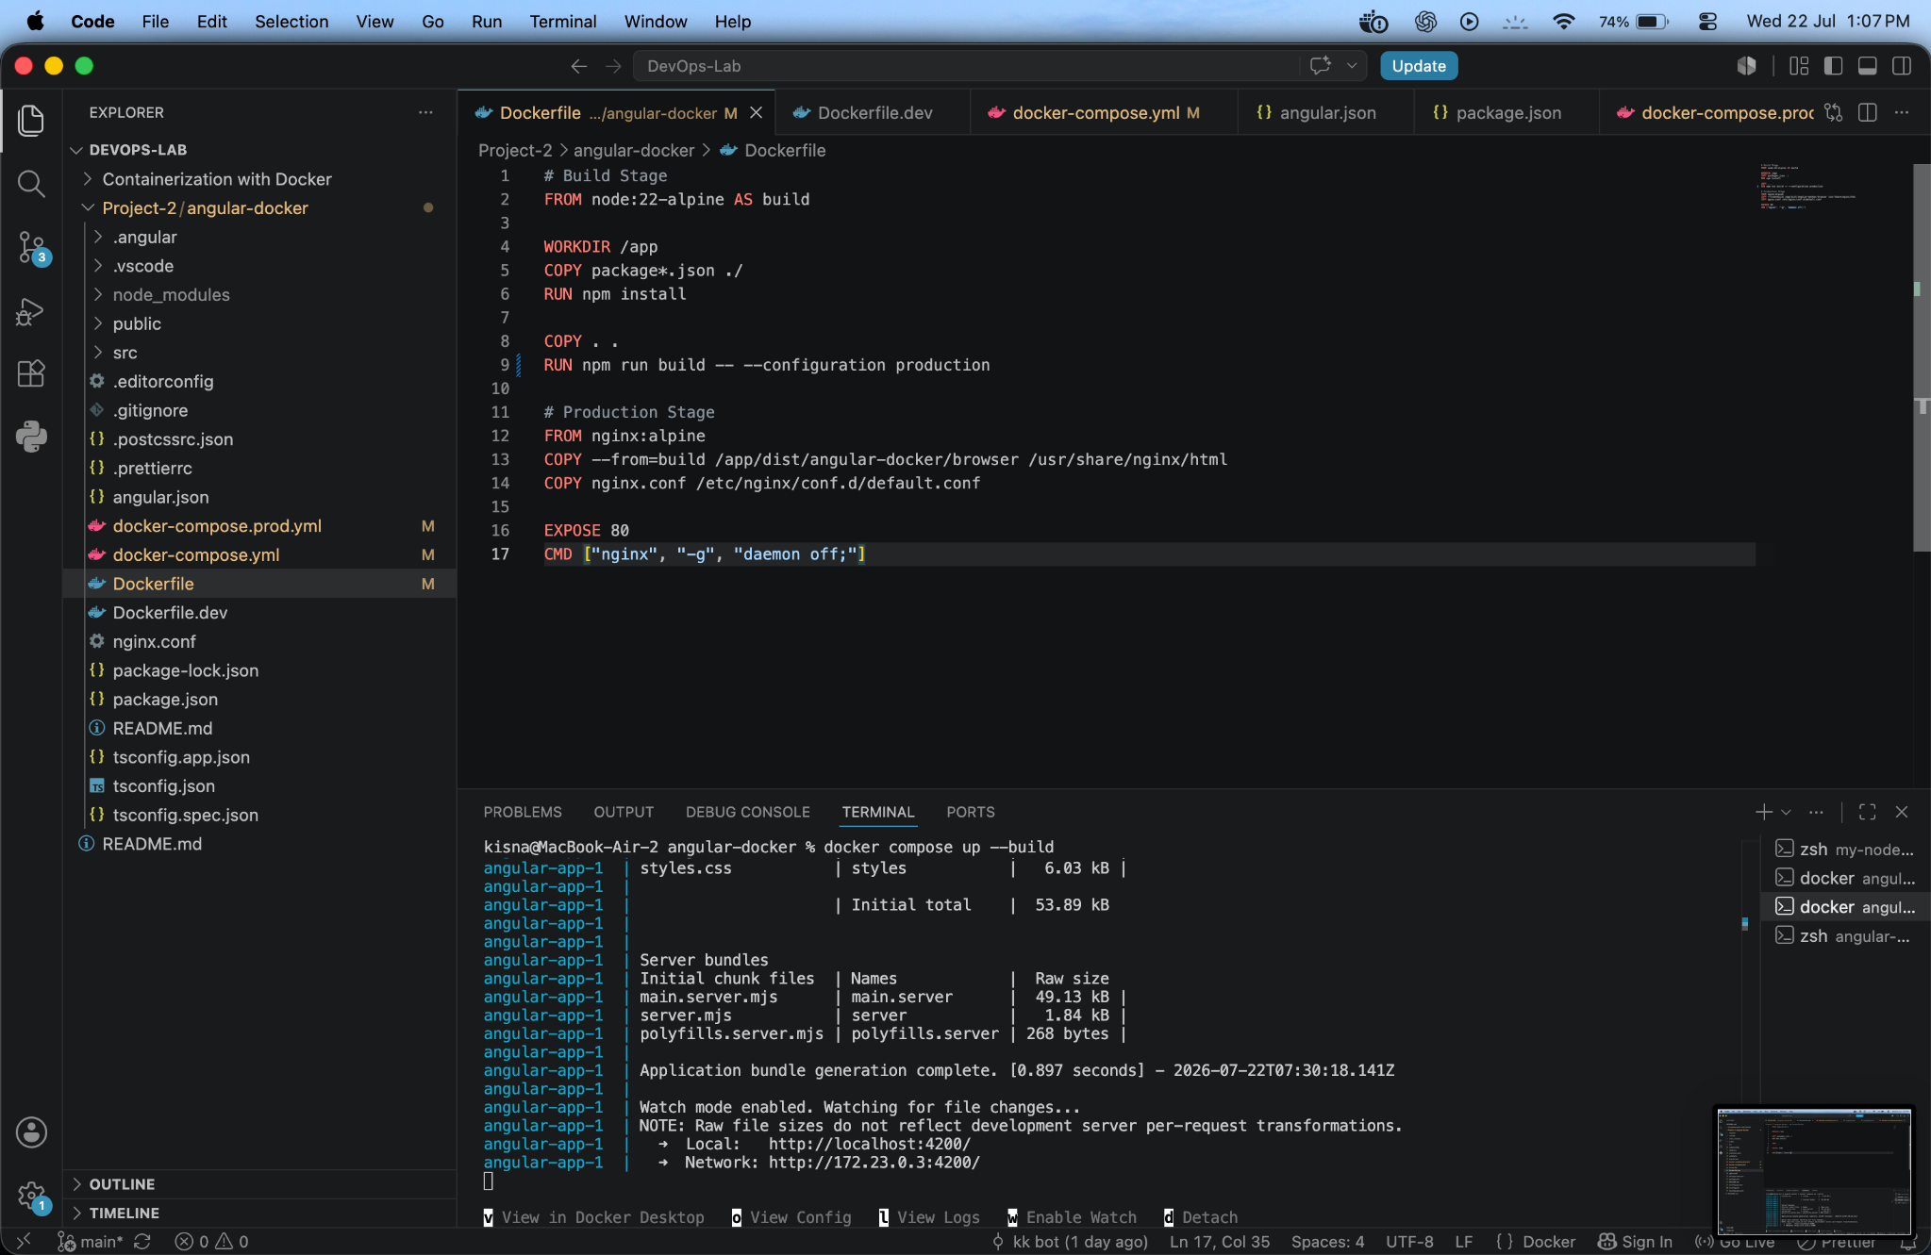
Figure 4. Multi-stage production Dockerfile
Explanation: The first stage builds the Angular application with Node.js. The second stage uses Nginx Alpine, copies the browser build into the Nginx document root, exposes port 80, and keeps Nginx in the foreground.

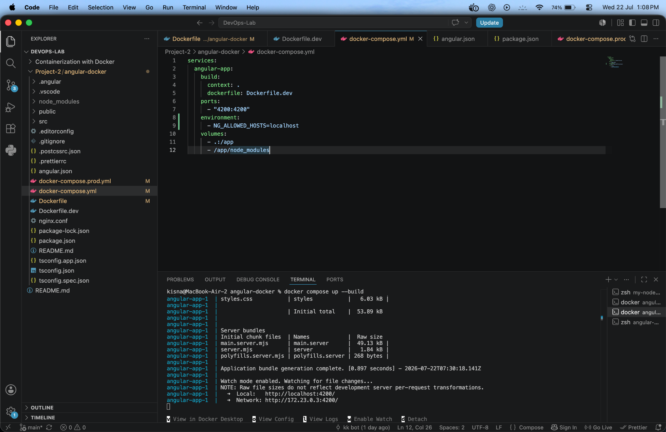
Figure 5. Development Docker Compose configuration
Explanation: The development service builds from Dockerfile.dev, maps host port 4200 to container port 4200, passes the allowed-host setting, mounts the project directory, and protects container-installed node_modules with an anonymous volume.

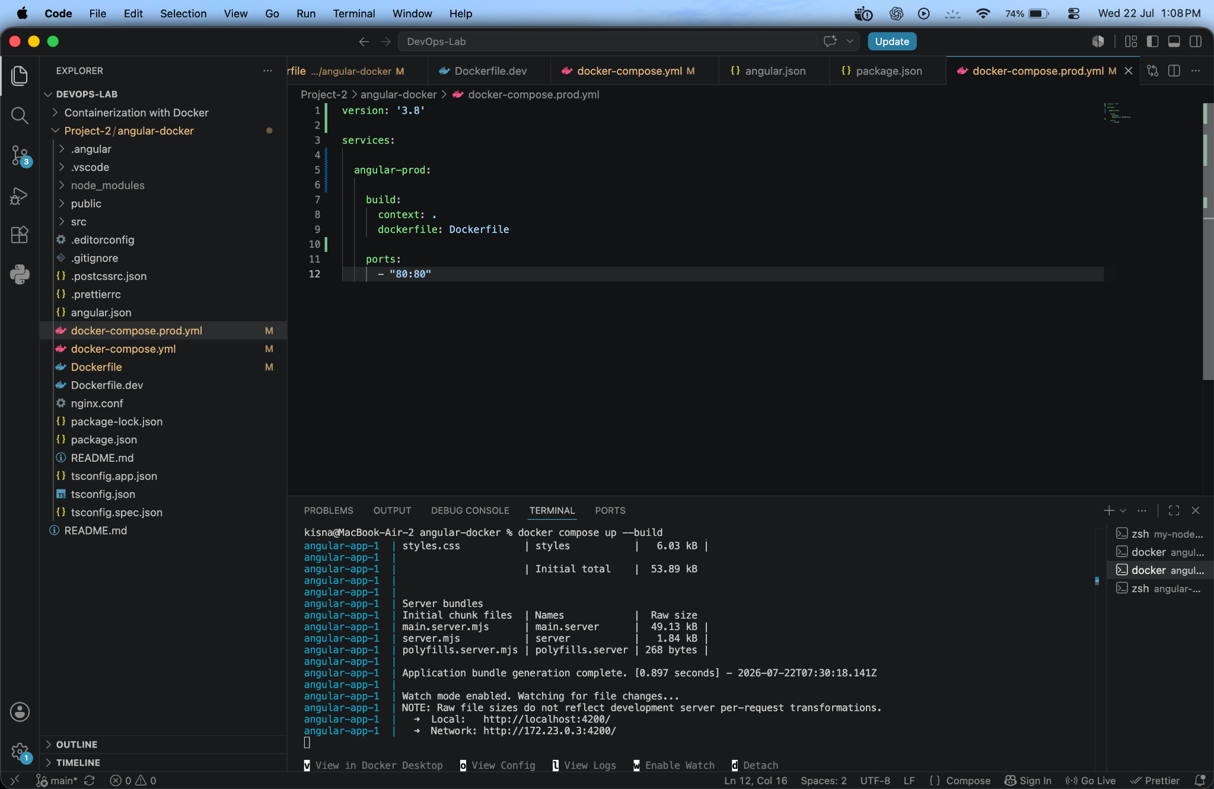
Figure 6. Production Docker Compose configuration
Explanation: The production service builds from the multi-stage Dockerfile and publishes Nginx through host port 80. The displayed version key causes only an informational deprecation warning.

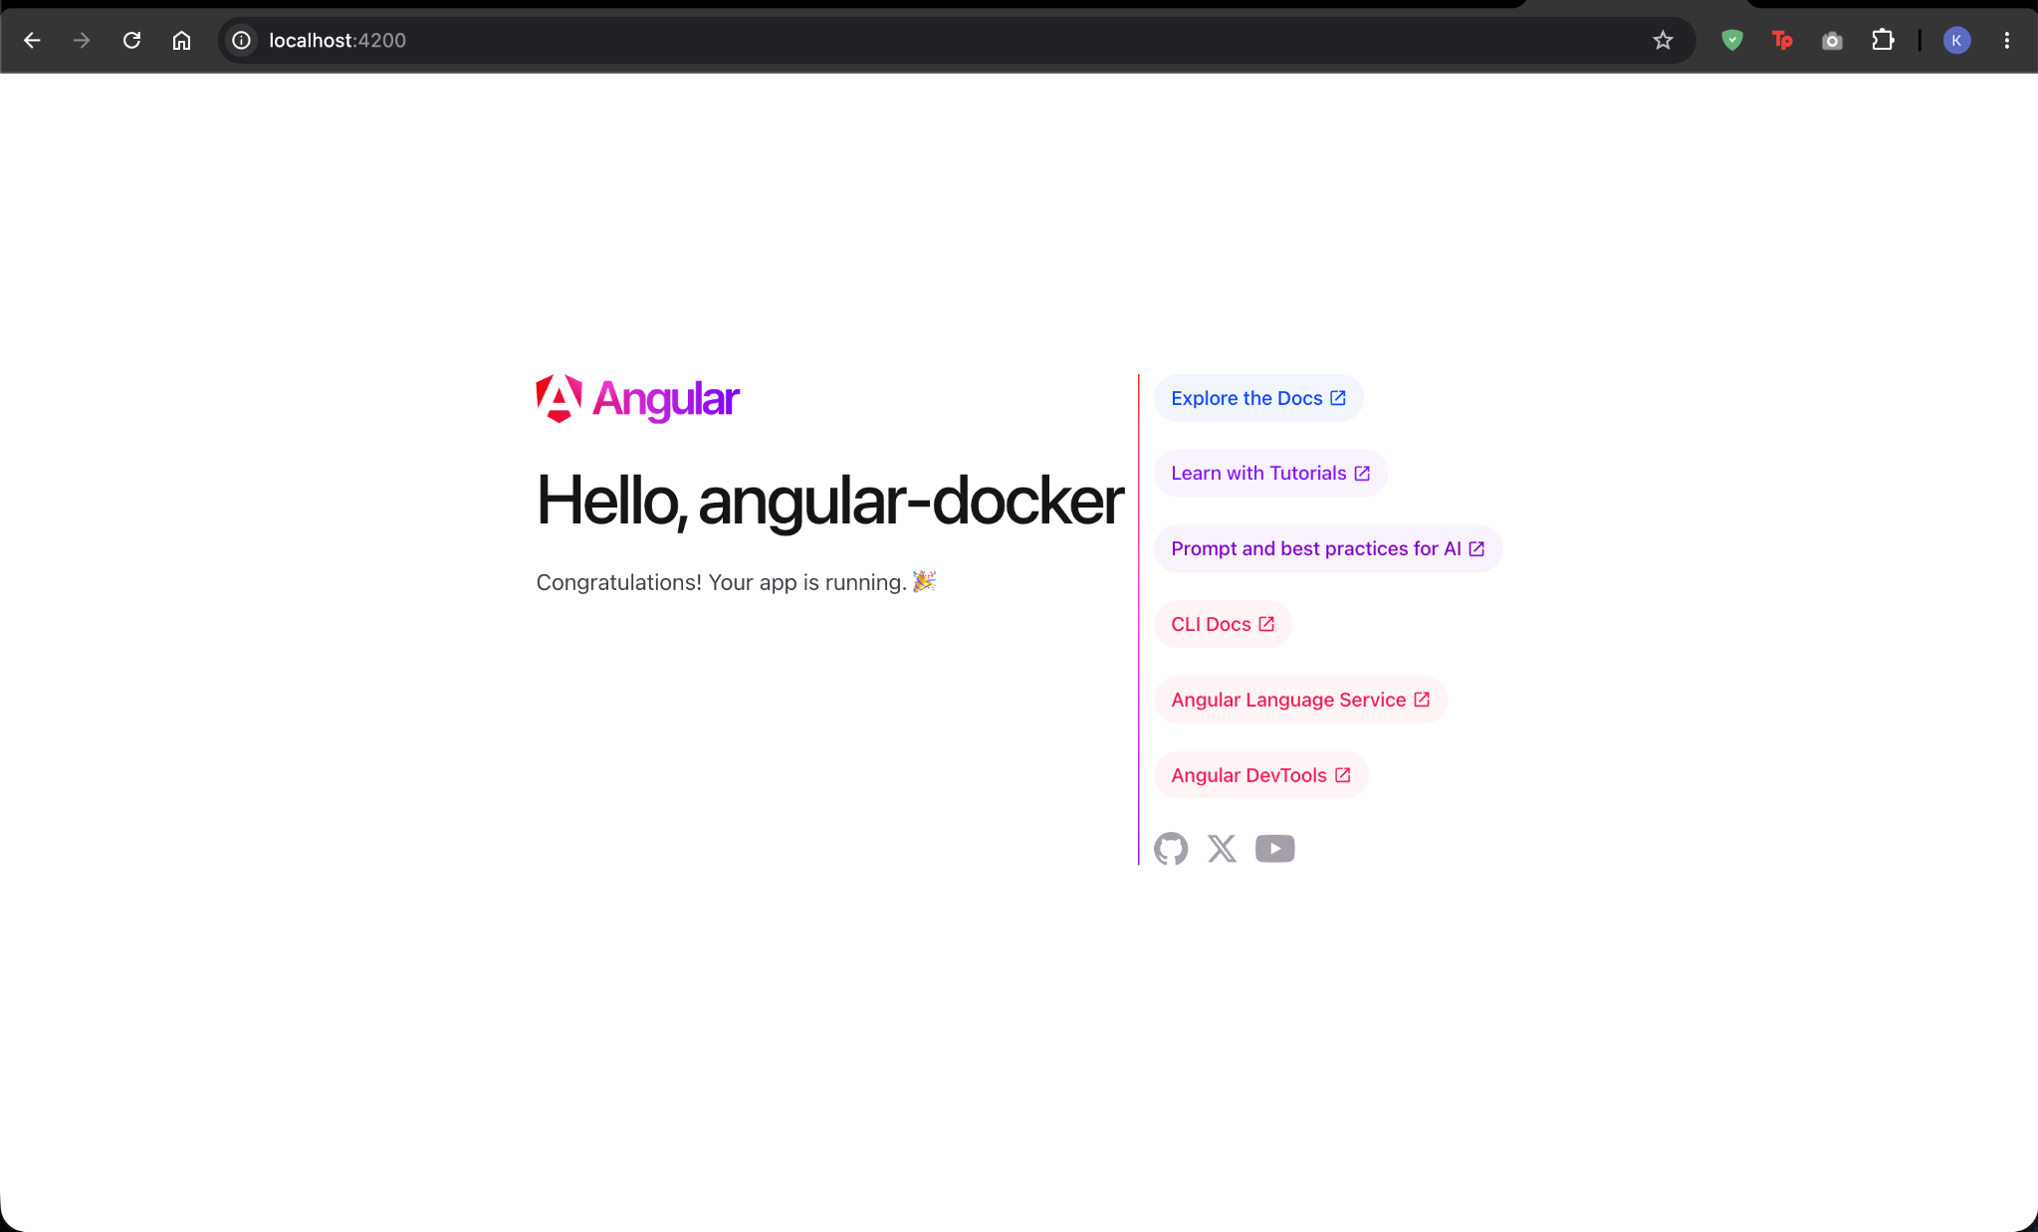
Figure 7. Angular development application on port 4200
Explanation: The browser successfully loads the Angular starter page from localhost:4200, proving that the development container is running and the port mapping is correct.

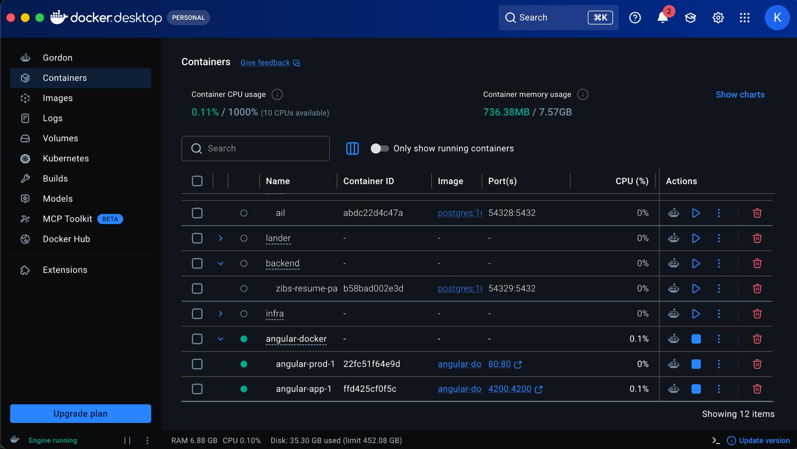
Figure 8. Running Angular containers in Docker Desktop
Explanation: Docker Desktop shows the angular-docker Compose project and its running development and production containers. The published ports 4200:4200 and 80:80 are visible.

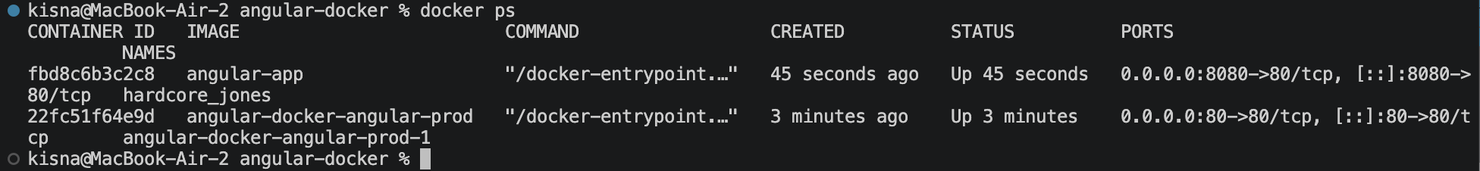
Figure 9. Running containers verified with docker ps
Explanation: The terminal lists the running Angular images, container status, and host-to-container port mappings. This confirms that Docker has published the required ports.

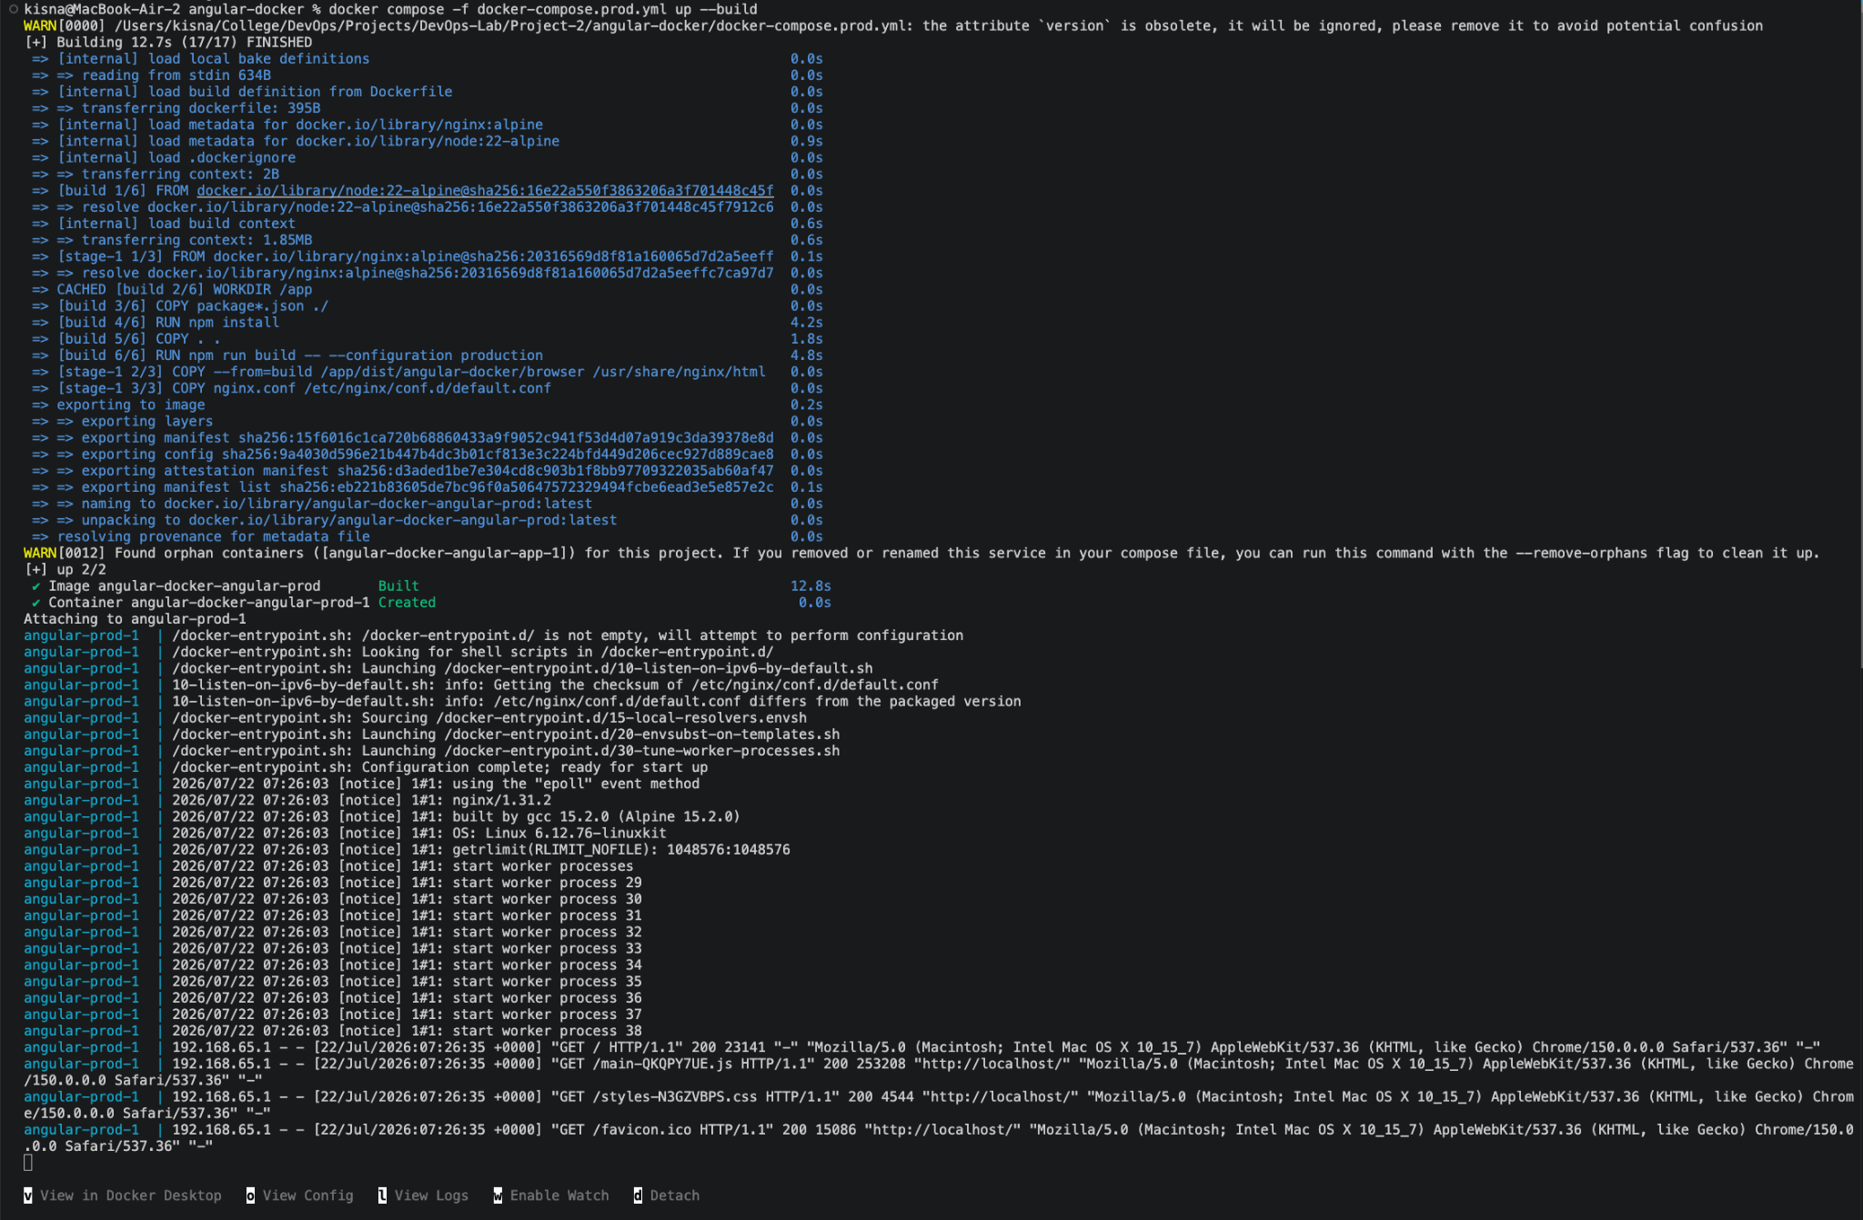
Figure 10. Production image build and Nginx startup
Explanation: The production Compose command completes the Node.js build stage, copies the Angular browser output into Nginx, creates the container, starts Nginx workers, and records successful HTTP 200 responses.

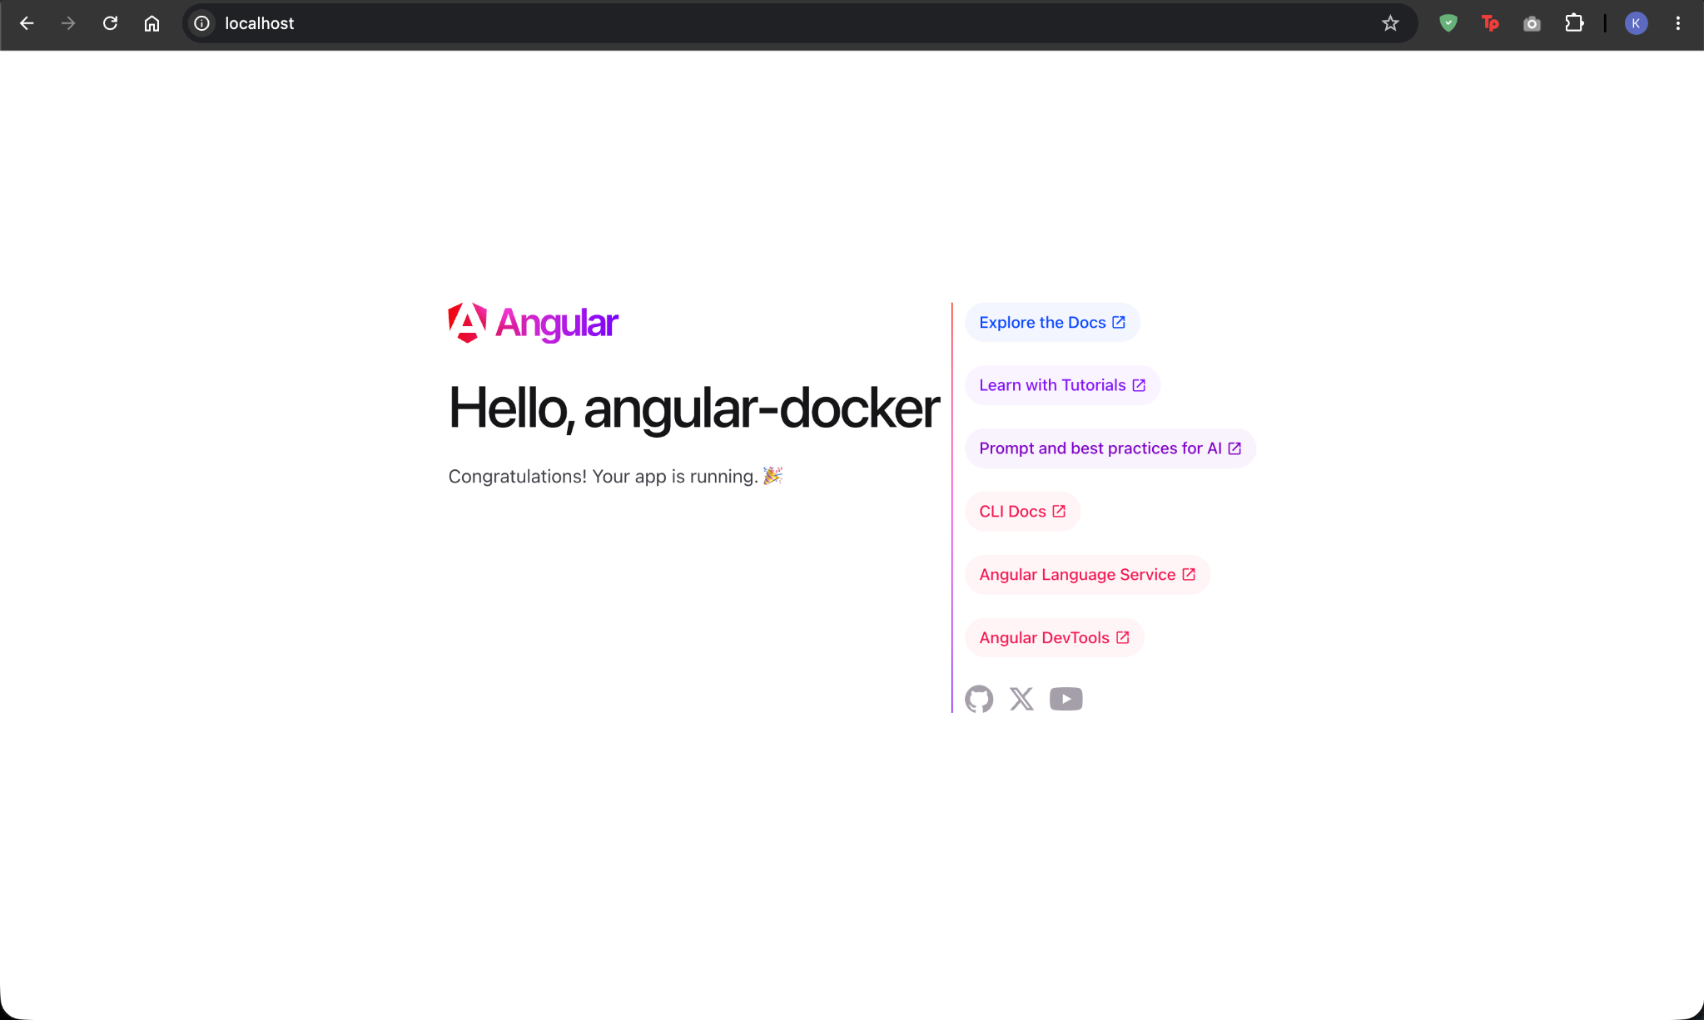
Figure 11. Production Angular application served by Nginx
Explanation: The Angular application loads at http://localhost without an explicit port because the production service is published on the standard HTTP port 80.

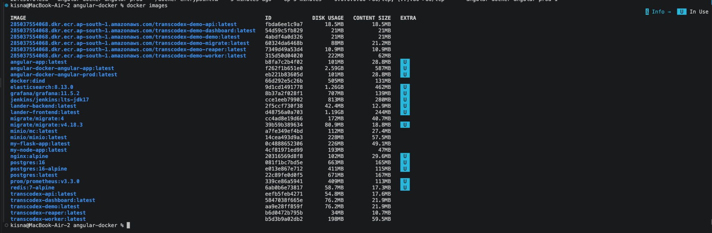
Figure 12. Docker images available on the host
Explanation: The docker images command lists the created Angular development and production images alongside the base Node.js and Nginx images used by the project.

Figure 13. Docker Compose service status
Explanation: docker compose ps displays both Compose services, their images, running state, creation time, and published ports.

Figure 14. Stopping development and production services
Explanation: The development container is removed first, but the shared project network remains while the production container is attached. After the production Compose configuration is stopped, the remaining container and network are removed.

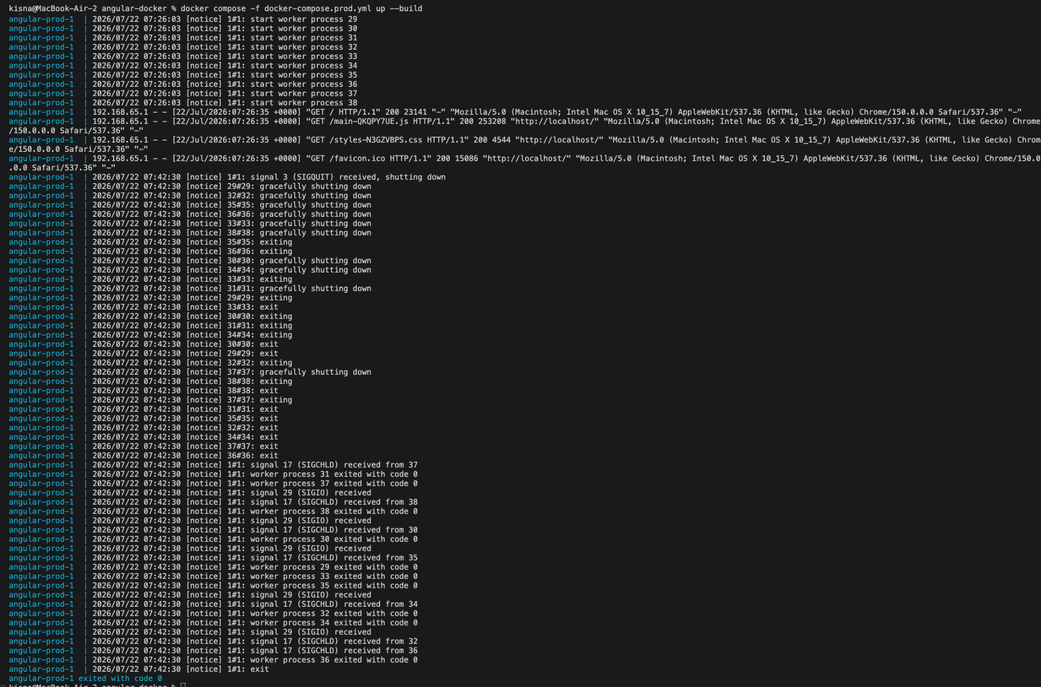
Figure 15. Graceful Nginx shutdown logs
Explanation: After the stop command, Nginx receives termination signals, gracefully shuts down its worker processes, and exits with code 0. This is normal container lifecycle behavior.

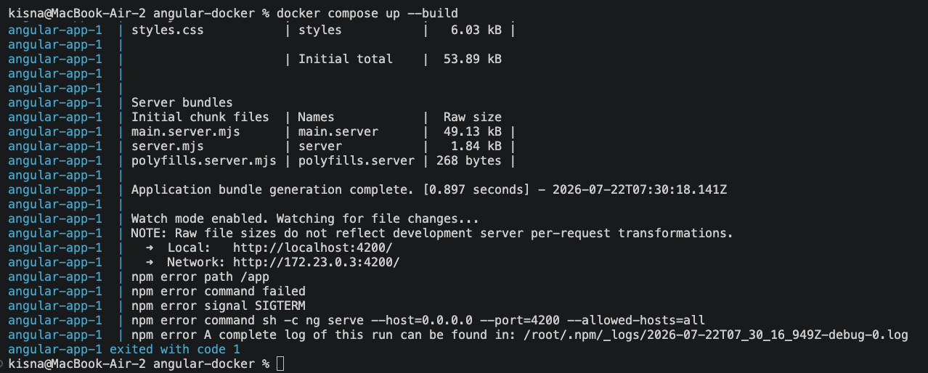
Figure 16. Angular development process terminated during shutdown
Explanation: The Angular development process reports SIGTERM and exits after the container is stopped. The message represents an intentional termination signal rather than an Angular compilation failure.

7. Docker Commands Explained
The project uses the following commands in sequence. Each command is shown with its practical purpose and expected behavior.
ng new angular-docker-app
Creates a new Angular workspace and application, generates the source structure, and installs the initial npm dependencies.
docker compose up --build
Reads docker-compose.yml, rebuilds the development image when required, creates the service container and network, starts Angular, and attaches the terminal to the service logs.
docker compose down
Stops and removes the development service containers and removes the Compose network when no other containers are still using it.
docker compose -f docker-compose.prod.yml up --build
Uses the production Compose file, performs the multi-stage Docker build, creates the Nginx-based service, publishes port 80, starts the container, and attaches to logs.
docker compose -f docker-compose.prod.yml down
Stops and removes the production service and its Compose-managed resources.
docker ps
Lists running containers with container IDs, images, commands, uptime, published ports, and names.
docker images
Lists locally available images, image identifiers, disk usage, content size, and whether an image is currently in use.
docker compose ps
Shows the status of services that belong to the current Compose project, including service name, state, and published ports.
Ctrl + C
Sends an interrupt to the foreground Compose process. Docker forwards a termination signal to the container process so it can shut down gracefully.
docker compose up --build --remove-orphans
Optional cleanup form that starts the selected Compose services and removes containers created by older service definitions that are no longer present.

8. Results, Warnings, and Troubleshooting

8.1 Verified Results
- The development image was built and the Angular development server started successfully.
- The application was reachable at http://localhost:4200.
- The production multi-stage image was built successfully.
- Nginx served the compiled Angular application at http://localhost.
- Docker Desktop, docker ps, and docker compose ps confirmed running containers and correct port mappings.
- Both services were removed successfully and Nginx completed a graceful shutdown.

8.2 Observed Warnings
Observation | Meaning | Recommended Action
`version` attribute is obsolete | Modern Docker Compose ignores the top-level version field. | Remove `version: "3.8"` from docker-compose.prod.yml.
Orphan container warning | A container from another or older Compose service definition exists in the same project. | Run Compose with `--remove-orphans` after verifying that the orphan is no longer needed.
Network resource is still in use | Another container remains connected to the Compose network. | Stop the remaining Compose service before expecting the network to be removed.
npm SIGTERM after shutdown | Docker intentionally stopped the Angular development process. | Treat it as expected unless it occurs without a stop/restart operation.

8.3 Production Improvement Recommendations
- Use `npm ci` instead of `npm install` in container builds when package-lock.json is committed, because it provides deterministic dependency installation.
- Add a `.dockerignore` file to exclude node_modules, Git metadata, local build output, editor files, and other unnecessary context.
- Pin base-image versions or digests according to the project's maintenance policy and update them deliberately.
- Run the final Nginx image with an appropriate health check in environments that support orchestration.
- Keep development and production Compose projects isolated when they should not share a network or project name.
- Validate the Angular output directory after framework upgrades because the generated path can depend on the Angular builder configuration.

9. Conclusion
The project successfully demonstrates a complete Angular containerization workflow. Development uses Node.js, Angular's live development server, source mounting, and port 4200. Production uses a multi-stage build to keep compilation dependencies out of the runtime image and serves the final static application through Nginx on port 80. Docker Compose makes both workflows repeatable and provides consistent lifecycle management. The collected evidence confirms successful builds, correct networking, browser accessibility, image creation, service status, and controlled shutdown.

10. Viva Questions and Answers
Q. What is containerization?
A. Containerization packages an application and its required runtime dependencies into an isolated, reproducible unit called a container.
Q. Why use Docker for an Angular application?
A. Docker creates a consistent environment across machines, simplifies dependency management, and makes development and deployment commands repeatable.
Q. Why are separate Dockerfiles used for development and production?
A. Development needs live editing and the Angular development server, while production needs optimized static assets and a lightweight web server.
Q. What does `WORKDIR /app` do?
A. It creates or selects /app as the working directory for subsequent Dockerfile instructions and for the container process.
Q. Why copy package files before the remaining source code?
A. Docker can reuse the cached dependency-install layer when application source files change but package metadata does not.
Q. What does `EXPOSE 4200` mean?
A. It documents that the containerized application listens on port 4200. Publishing to the host still requires a `ports` mapping or `-p` option.
Q. What is the difference between EXPOSE and ports in Compose?
A. EXPOSE documents the container port; Compose `ports` publishes and maps a host port to that container port.
Q. Why is `--host=0.0.0.0` commonly required for Angular in Docker?
A. A server bound only to 127.0.0.1 inside the container cannot accept connections through Docker networking. Binding to 0.0.0.0 listens on all container interfaces.
Q. What is a bind mount?
A. A bind mount maps a host file or directory into the container. In development it allows code edits on the host to be visible inside the container.
Q. Why is `/app/node_modules` declared as a separate volume?
A. It prevents the host bind mount from replacing the container-installed node_modules directory.
Q. What is a multi-stage Docker build?
A. It uses multiple FROM stages so build tools can be used temporarily while only selected artifacts are copied into the smaller final image.
Q. Why use Nginx for production?
A. Angular production output is static. Nginx efficiently serves static files and does not require the Angular development server or Node.js build toolchain.
Q. Why must Nginx run with `daemon off;`?
A. A container stays alive while its main process remains in the foreground. This option prevents Nginx from detaching into the background.
Q. What does `docker compose up --build` do?
A. It rebuilds required images, creates Compose resources, starts services, and attaches to their output.
Q. What does `docker compose down` remove?
A. It stops and removes Compose containers and normally removes the Compose network. Volumes are retained unless explicitly requested for removal.
Q. What information does `docker ps` provide?
A. It shows currently running containers, their images, commands, status, port mappings, and names.
Q. Why did Docker report an orphan container?
A. A container associated with the same Compose project existed but its service was not present in the selected Compose file.
Q. Why was the network initially still in use?
A. Another running container remained connected to that network, so Docker could not remove it yet.
Q. Is an npm SIGTERM message always an error?
A. No. During a deliberate container stop, SIGTERM is the normal signal used to request process termination.
Q. What is the final difference between the two URLs?
A. Development is published on localhost:4200. Production uses HTTP port 80, so the browser can use localhost without specifying a port.

11. References
- Angular Documentation - Angular CLI, build configuration, and development server.
- Docker Documentation - Dockerfile reference, image builds, containers, and port publishing.
- Docker Compose Documentation - Compose file specification and service lifecycle commands.
- Nginx Documentation - Static file serving and foreground process configuration.
Submission note All screenshots supplied for the project have been inserted in the report and captioned according to the operation shown.

