Frontend Inventory System - Final Documentation

# 1. Project Overview

The Frontend Inventory System is a web application built with React and TailwindCSS. It provides CRUD functionality for managing inventory items. The system allows users to add, edit, delete, and view inventory records, ensuring smooth stock management and easy tracking.

# 2. Features

• Add new inventory items

• View all inventory in a table format

• Edit existing inventory records

• Delete inventory items

• Responsive UI built with TailwindCSS

• Integration with backend API for real-time updates

# 3. Technology Stack

• Frontend: React, TailwindCSS

• Backend: Node.js, Express.js

• Database: MongoDB

• Tools: Git, GitHub, Postman, VS Code

# 5. Postman Collection

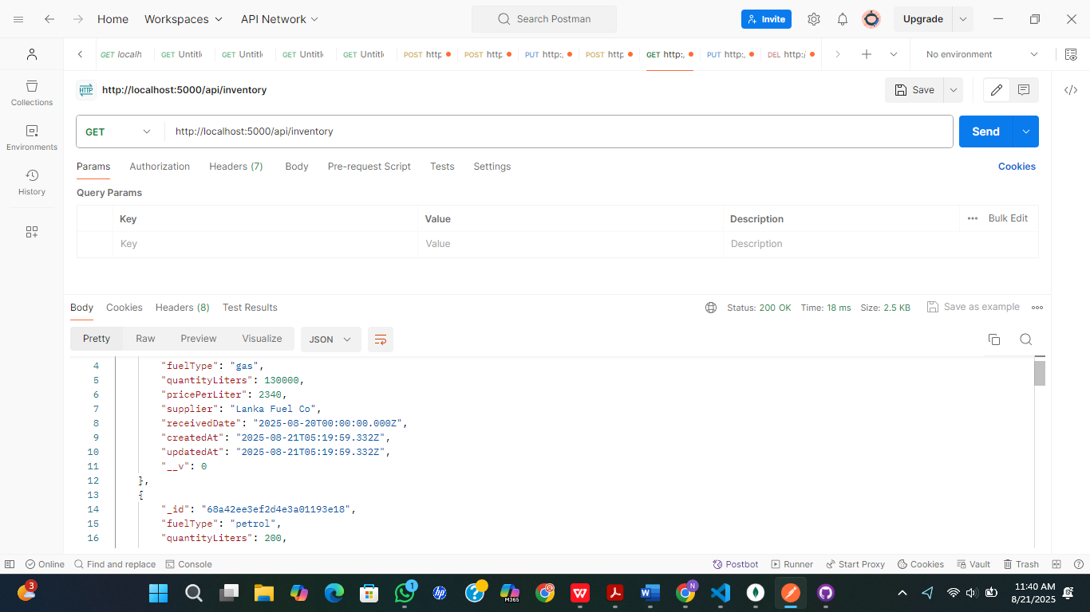

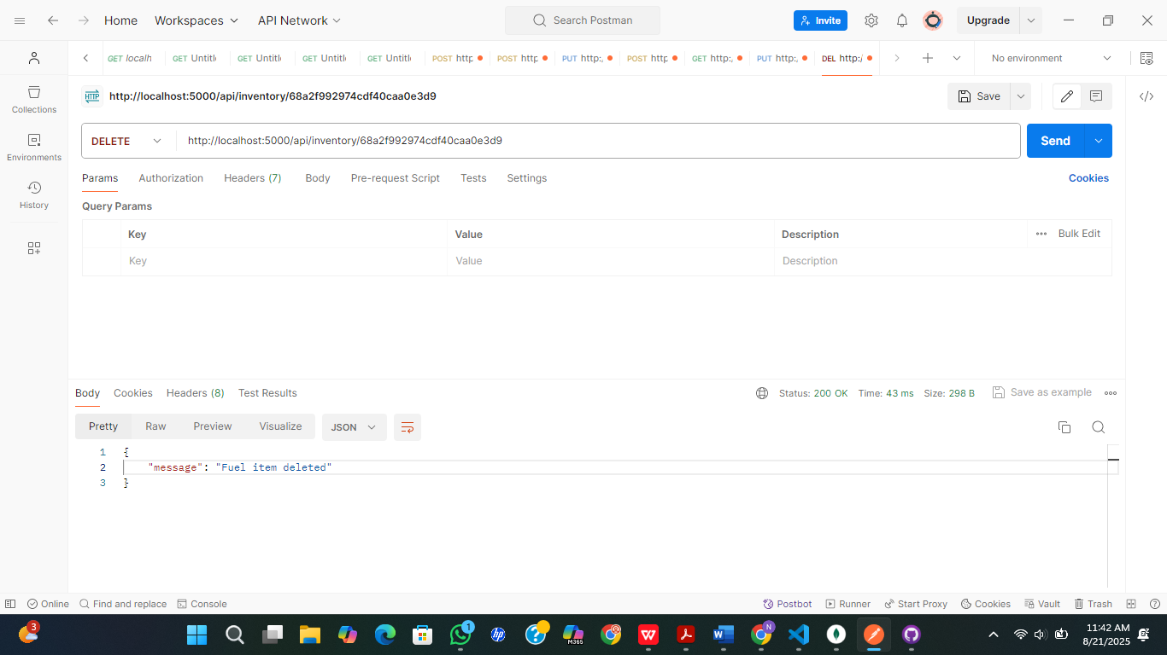

# 6. Deployment & Run Instructions

The steps below are to run the project locally:

### Backend

1. Clone the repo:  
 git clone https://github.com/Mohotti5353/backend-inventory-system.git

2. Install dependencies:  
 cd backend-inventory-system  
 npm install

3. Start the backend server:  
 npm run dev  
 Runs at http://localhost:5000

### Frontend

1. Clone the repo:  
 git clone https://github.com/Mohotti5353/frontend-inventory-system.git

2. Install dependencies:  
 cd frontend-inventory-system  
 npm install

3. Start the frontend:  
 npm run dev  
 Runs at http://localhost:5173

# 7. Screenshots

