1. Array Lists



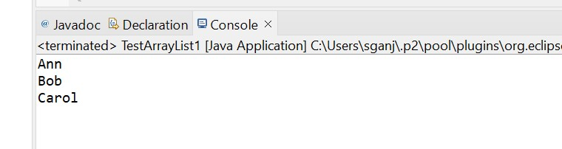

b)

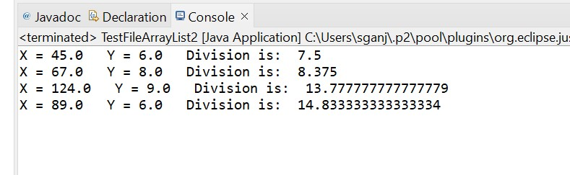

2. Linked List:

a)

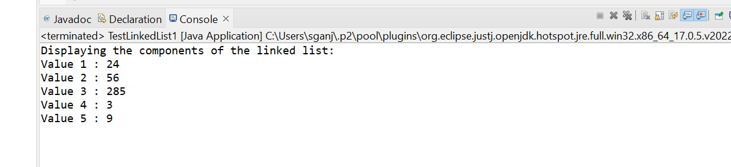

b)

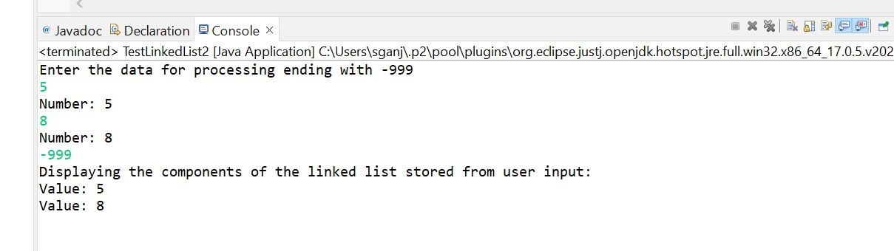

c)

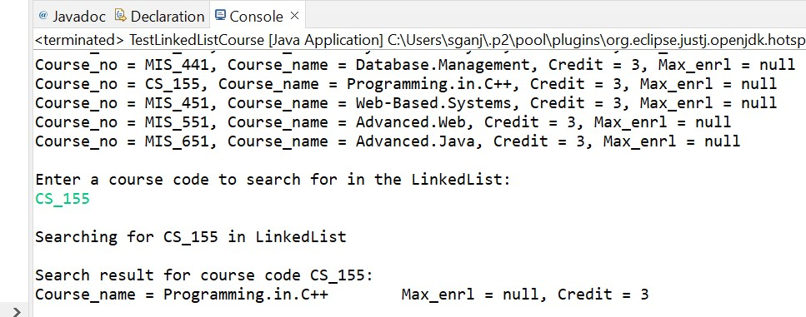

3. Application of Linked List: Storing records of Course.in File

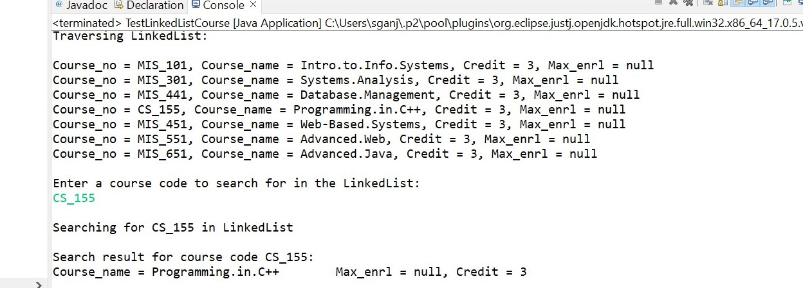

4. Linked List Project: ProjectThreeLinkedList

