1. Stack Data Structure: Create a project named LinkedStackProject

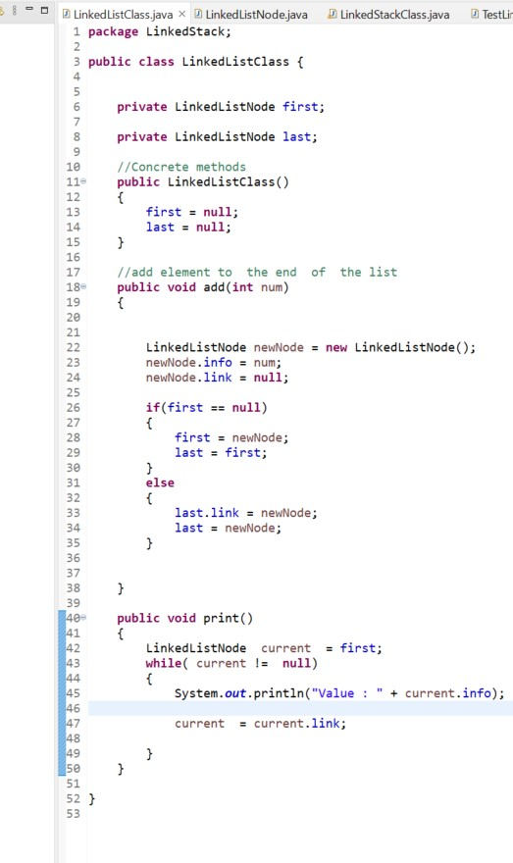

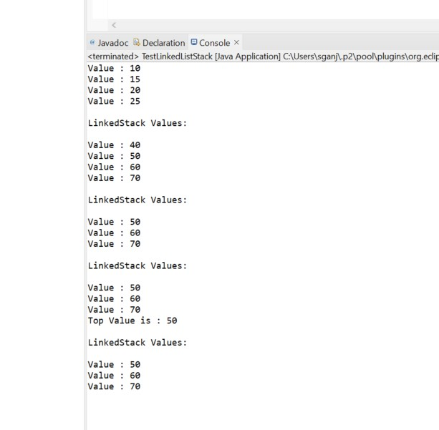

1. Queue Data Structure: Create a Project named QueueProject

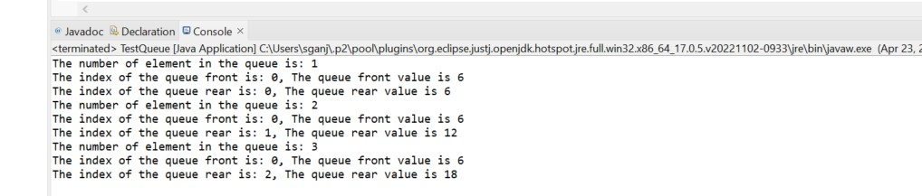

1. Stack List for Payroll records

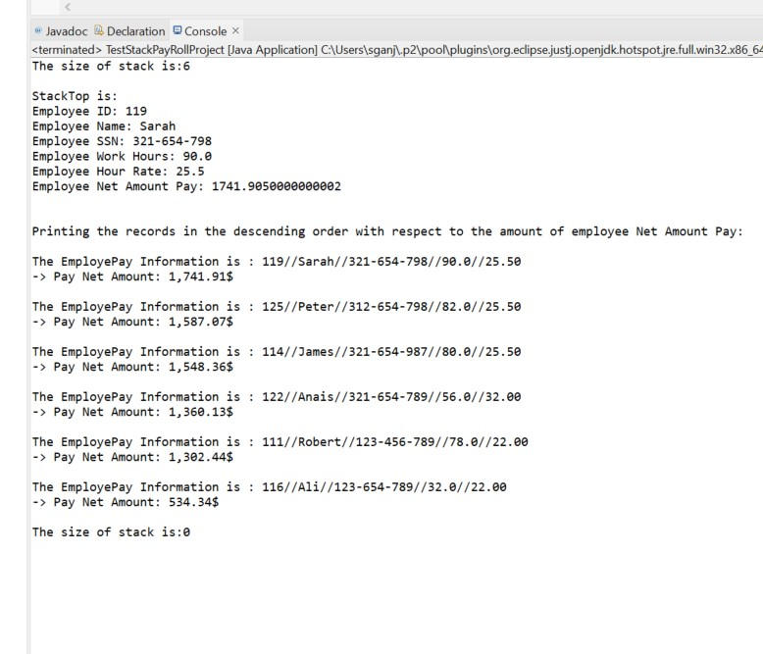

1. Queue with two lines

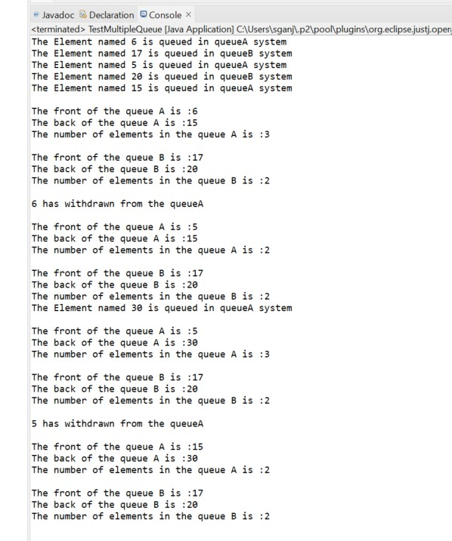

1. Building Binary Tree class

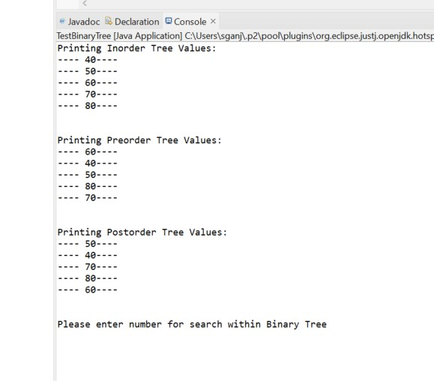

1. Binary Tree for Course records

