

**وظيفة برمجة الشبكات**

**إعداد الطالب:**

**محسن علي**

**إشراف:**

**الدكتور المهندس:**

**مهند عيسى**

**Syrian Arab Republic**

**Lattakia**

**Tishreen University**

**Department of Communication and electrical engineering**

**5 th , Network Programming : Homework No1**

**الجمهورية العربية السورية**

**وزارة التعليم العالي والبحث العلمي**

**جامعة تشرين**

**كلية الهمك**

**قسم هندسة الاتصالات والالكترونيات**

**السنة الخامسة**

**Question 1: Python Basics?**

A-If you have two lists, L1=[‘HTTP’,’HTTPS’,’FTP’,’DNS’] L2=[80,443,21,53], convert it to generate this dictionary d={‘HTTP’:80,’HTTPS’:443,’FTP’:21,’DNS’:53 }

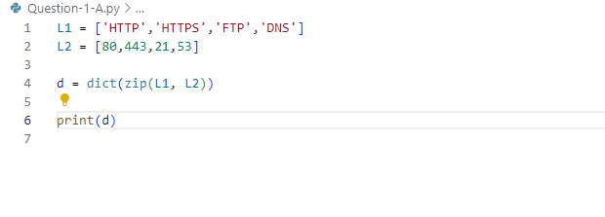



استخدمت التابع dict() لبناء القاموس d تم تمرير التابع zip() كبارمتر داخل التابع وذلك لمقابلة قيم القائمتين حسب الفهارس، ومن ثم عن طريق الباني dict() حولنا النتيجة لقاموس.

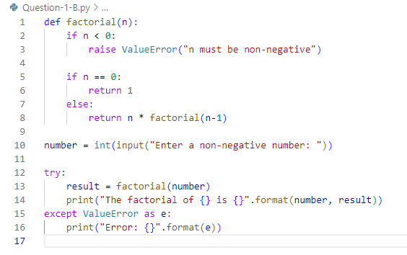B- Write a Python program that calculates the factorial of a given number entered by user.

تم بناء التابع factorial() لحساب عاملي العدد

المدخل ثم باستخدام مفهوم العودية تم حساب العاملي وباستخدام بنية try- except تم معالجة الاستثناء الحاصل في حال إدخال عدد سالب.

C- L=[‘Network’ , ’Bio’ , ’Programming’, ‘Physics’ , ‘Music’] In this exercise, you will implement a Python program that reads the items of the previous list and identifies the items that starts with ‘B’ letter, then print it on screen. Tips: using loop, ‘len ()’ , startswith() methods.

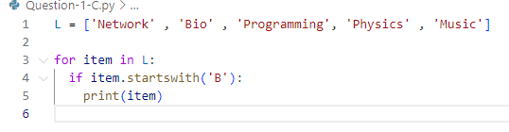



قمت بتعريف القائمة L وباستخدام الحلقة for قمنا بالمرور على عناصر القائمة واختبار بواسطة الميثود startswith() الكلمات التي تبدأ ب B.

D: Using Dictionary comprehension, Generate this dictionary d={0:1,1:2,2:3,3:4,4:5,5:6,6:7,7:8,8:9,9:10,10:11}

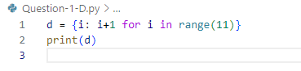



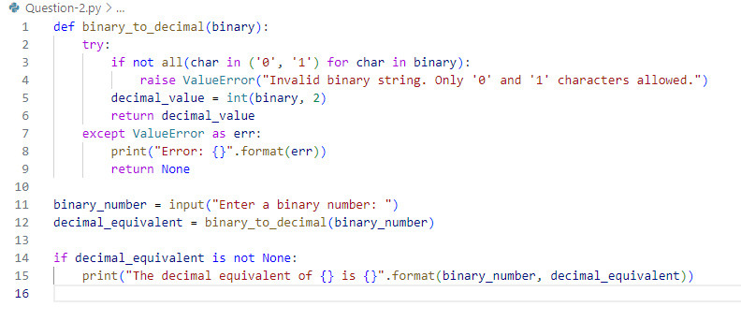Question 2: Convert from Binary to Decimal Write a Python program that converts a Binary number into its equivalent Decimal number. The program should start reading the binary number from the user. Then the decimal equivalent number must be calculated. Finally, the program must display the equivalent decimal number on the screen. Tips: solve input errors.



Question 3: Working with Files” Quiz Program” Type python quiz program that takes a text or json or csv file as input for (20 (Questions, Answers)). It asks the questions and finally computes and prints user results and store user name and result in separate file csv or json file.

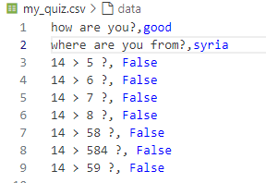

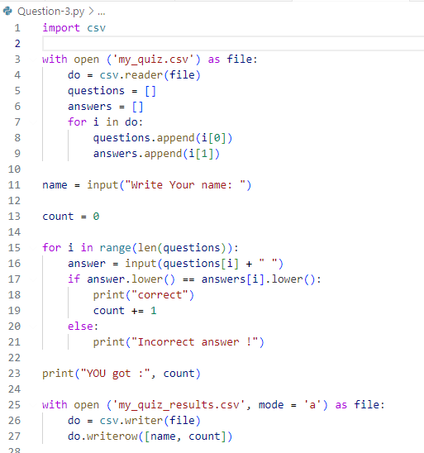

Question 4: Object-Oriented Programming - Bank Class Define a class BankAccount with the following attributes and methods: Attributes: account_number (string), account_holder (string), balance (float, initialized to 0.0) Methods:deposit(amount), withdraw(amount) , get_balance() - Create an instance of BankAccount, - Perform a deposit of $1000, - Perform a withdrawal of $500. - Print the current balance after each operation. - Define a subclass SavingsAccount that inherits from BankAccount and adds interest_rate Attribute and apply_interest() method that Applies interest to the balance based on the interest rate. And Override print() method to print the current balance and rate. - Create an instance of SavingsAccount , and call apply_interest() and print() functions.

