Appendix
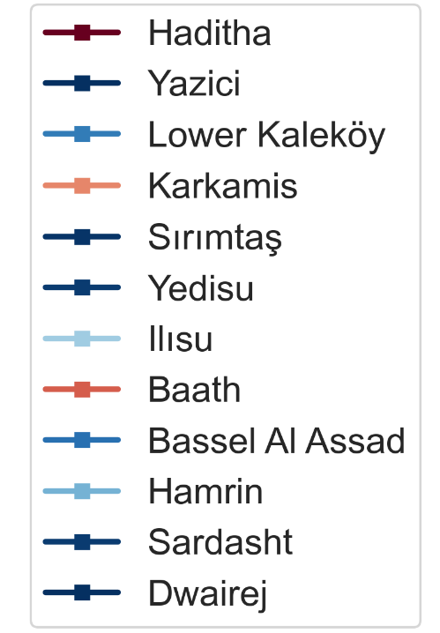
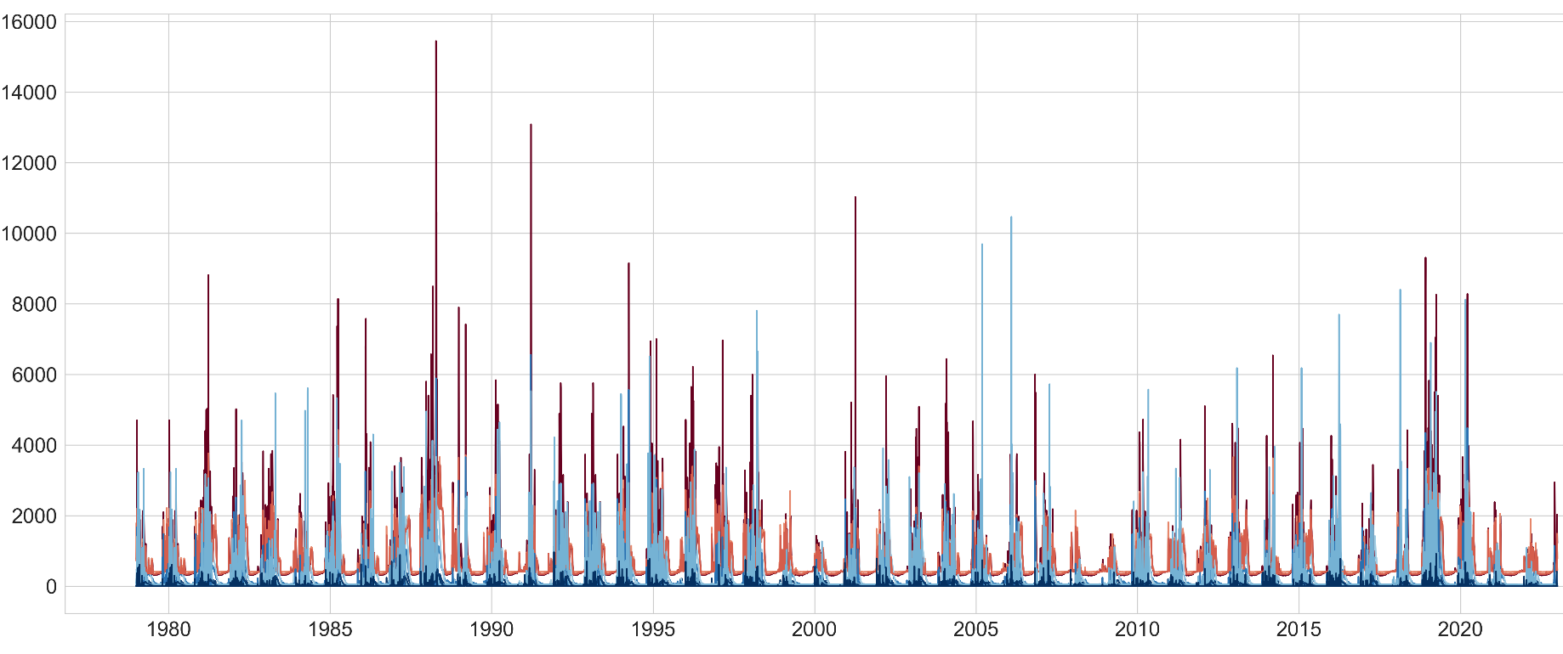
Extended Fig. 1. Daily discharge (m³/s) and of sampled proximal points from 1979 to 2022.
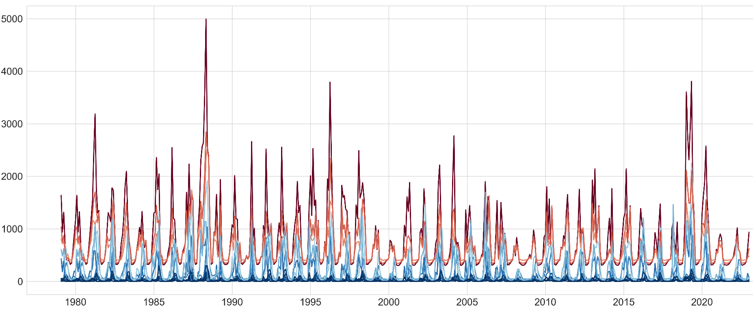
Extended Fig. 2. Monthly discharge (m³/s) and of sampled proximal points from 1979 to 2022.
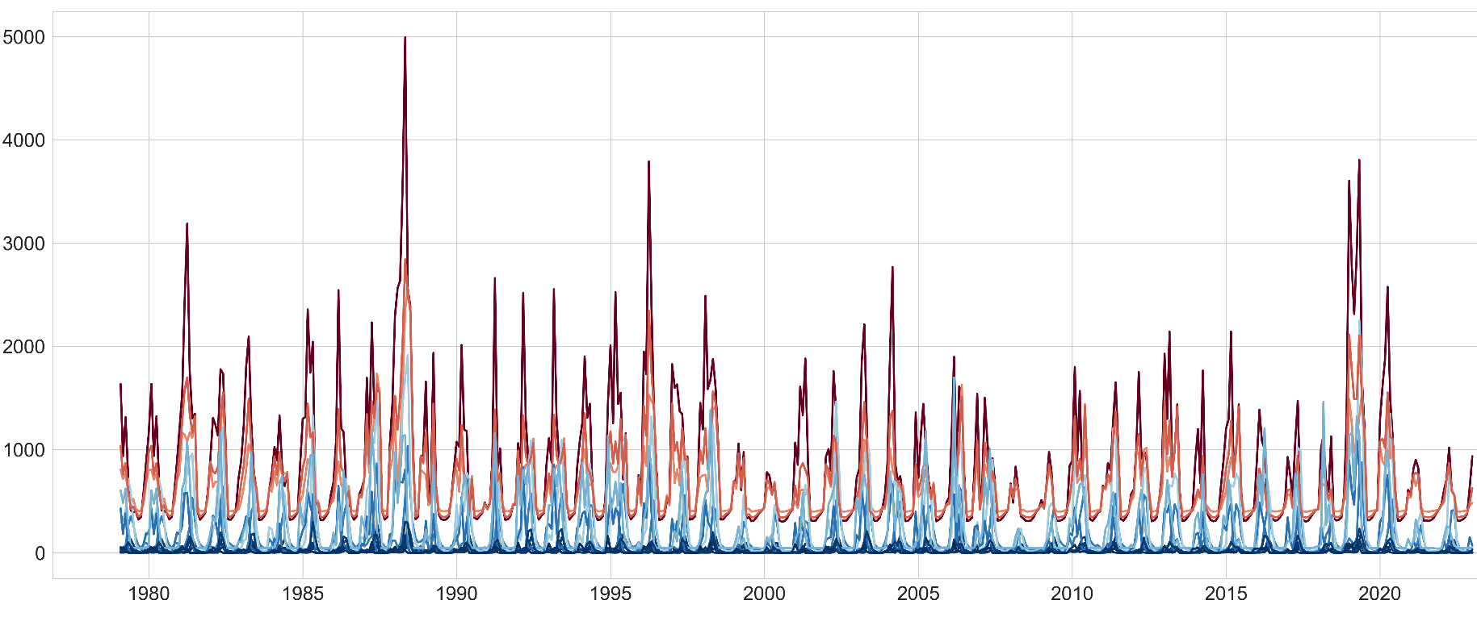
Extended Fig. 3. Seasonal discharge (m³/s) and of sampled proximal points from 1979 to 2022.
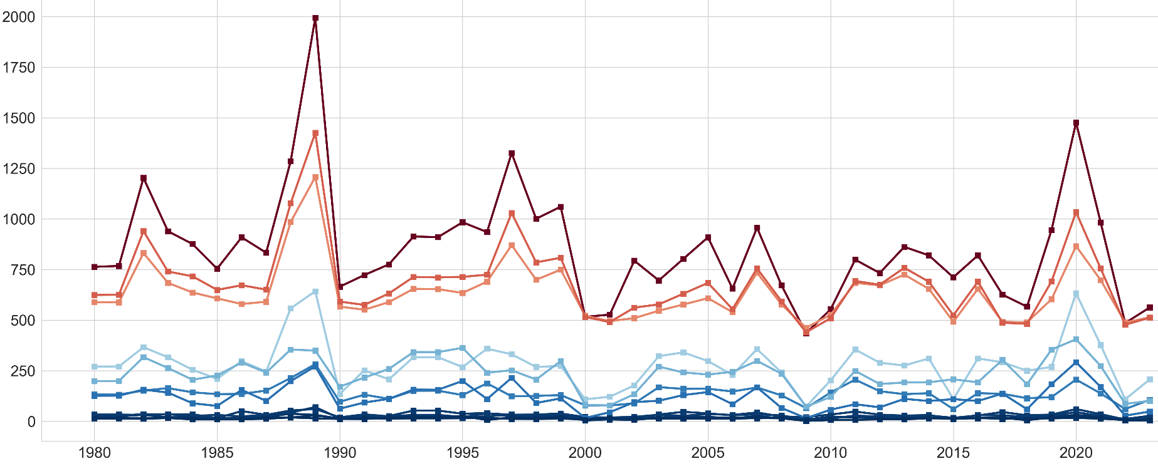
Extended Fig. 4. Annual discharge (m³/s) and of sampled proximal points from 1979 to 2022.

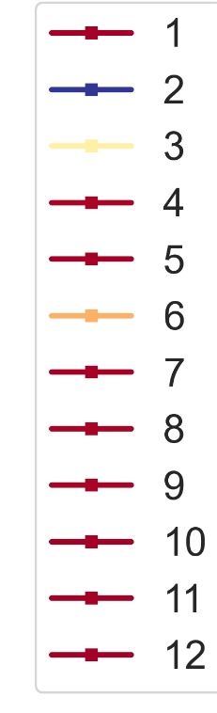
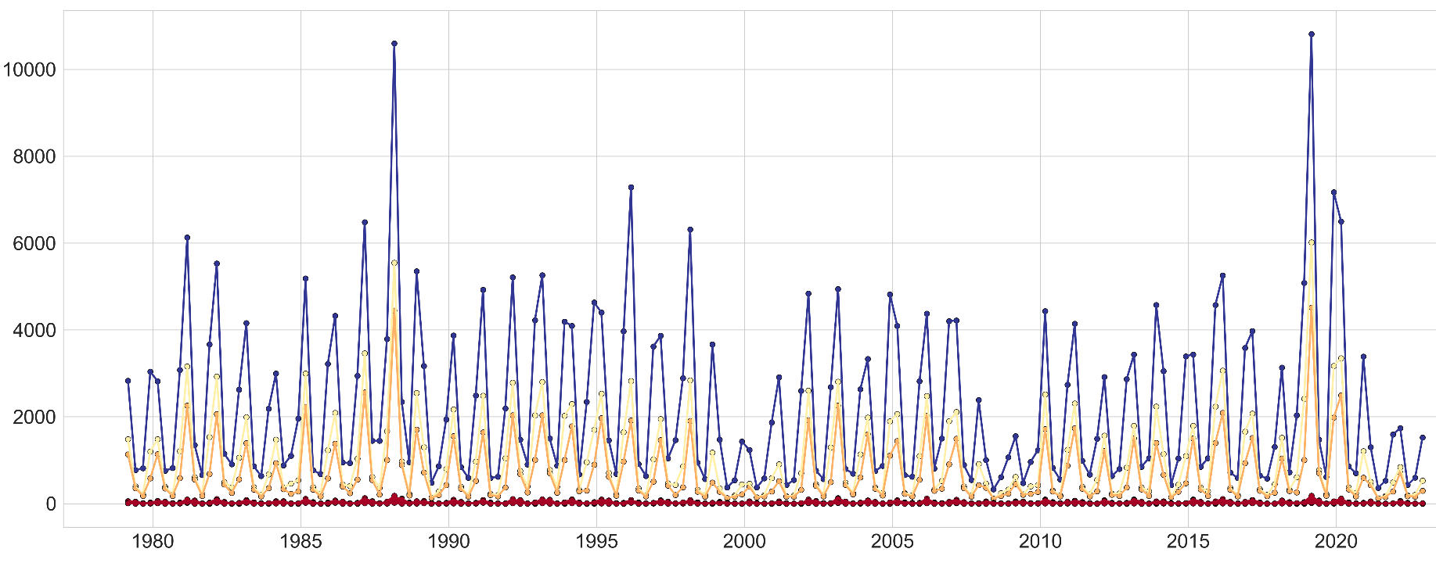
Extended Fig. 5. Daily discharge (m³/s) and of sampled distal points from 1979 to 2022.
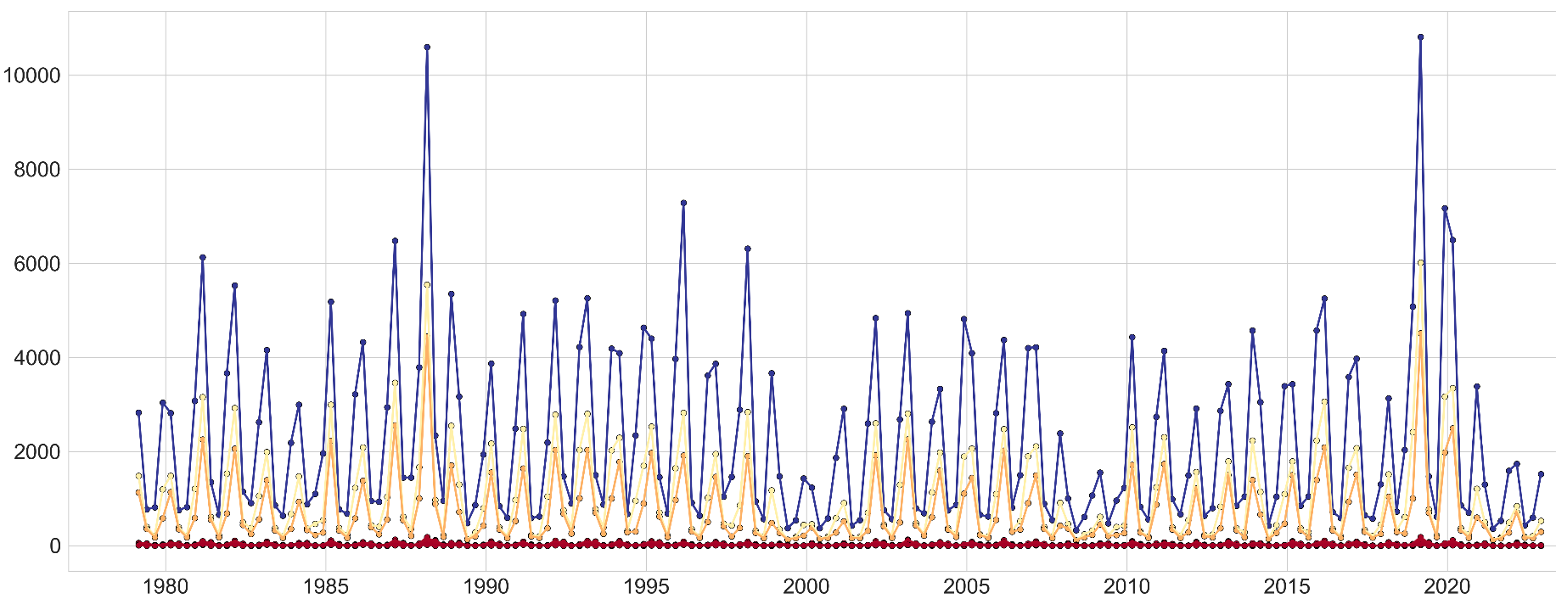
Extended Fig. 6. Monthly discharge (m³/s) and of sampled distal points from 1979 to 2022.
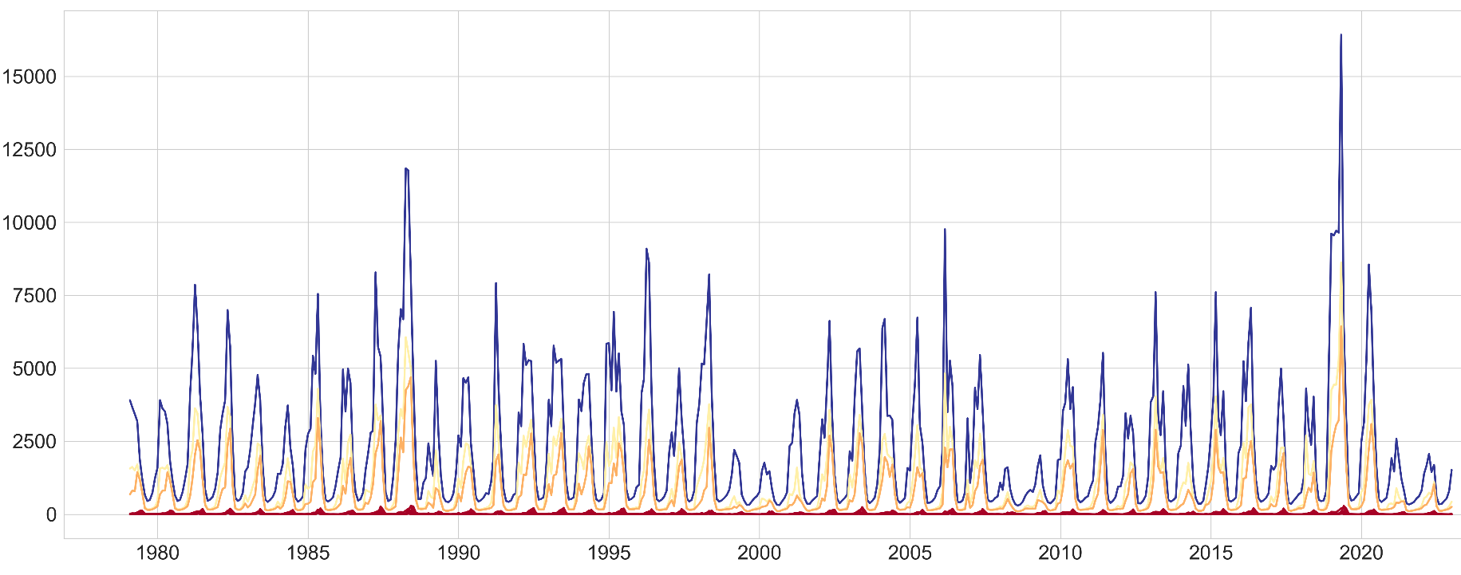
Extended Fig. 7. Seasonal discharge (m³/s) and of sampled distal points from 1979 to 2022.

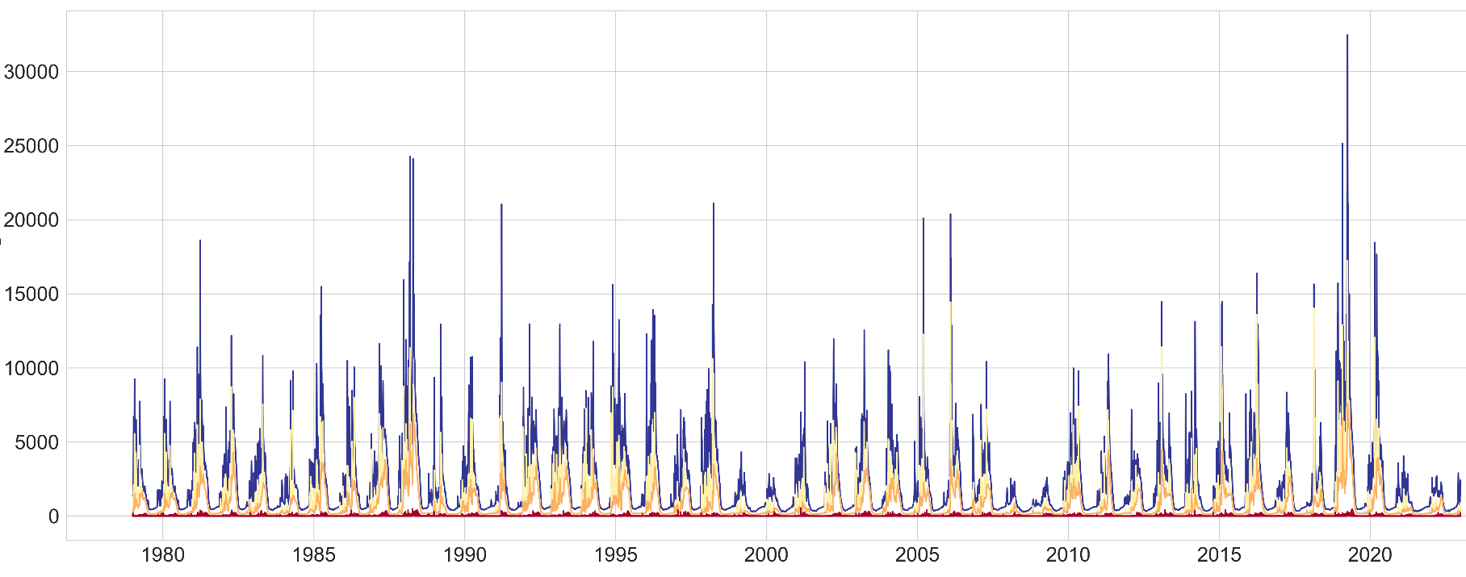
Extended Fig. 8. Annual discharge (m³/s) and of sampled distal points from 1979 to 2022.

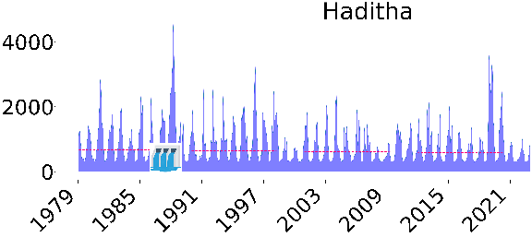 | 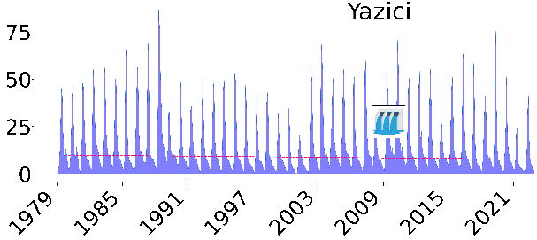 | 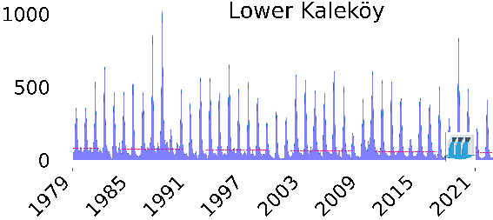
Trend= decreasing, Slope= -0.2147 | Trend= decreasing, Slope= -0.2147 | Trend= decreasing, Slope= -0.2147
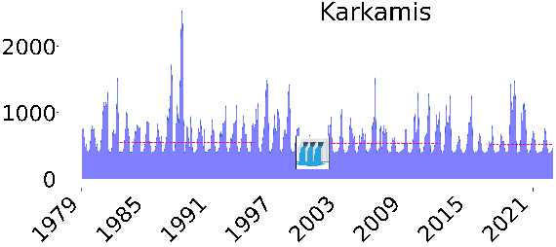 | 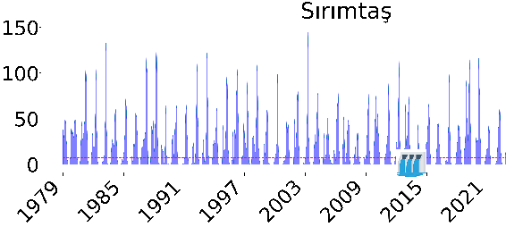 | 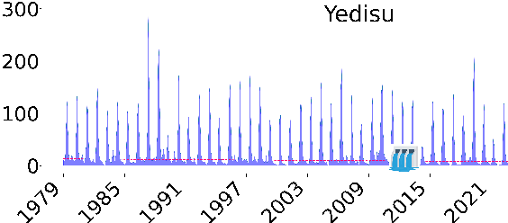
Trend= decreasing, Slope= -0.2147 | Trend= decreasing, Slope= -0.2147 | Trend= decreasing, Slope= -0.2147
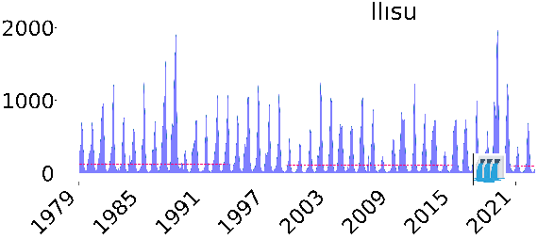 | 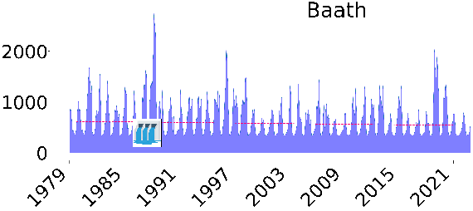 | 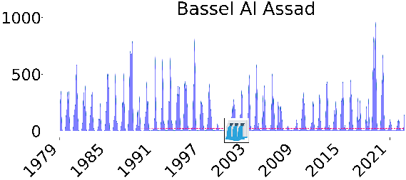
Trend= decreasing, Slope= -0.2147 | Trend= decreasing, Slope= -0.2147 | Trend= decreasing, Slope= -0.2147
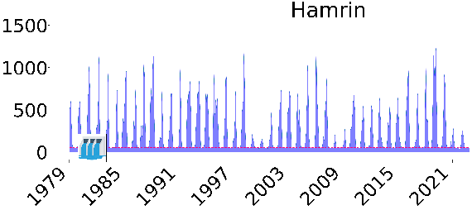 | 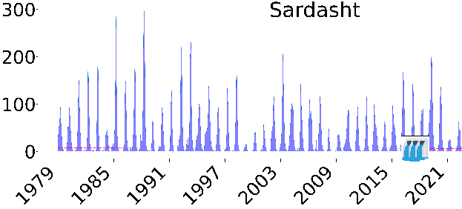 | 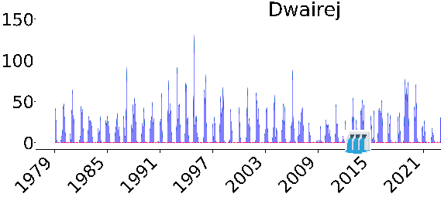
Trend= decreasing, Slope= -0.2147 | Trend= decreasing, Slope= -0.2147 | Trend= decreasing, Slope= -0.2147
Extended Fig. 9. The monthly discharge trend of the proximal points during 1979 to 2022 using Mann–Kendall test. For sampled points with trend, two parameters including Trend (increasing or decreasing) and slope were presented.

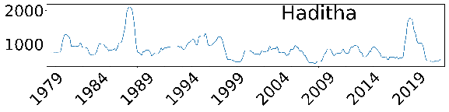 | 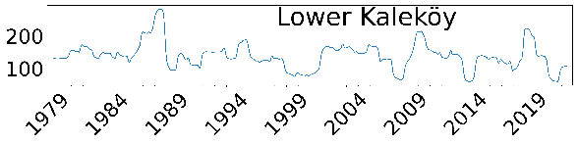 | 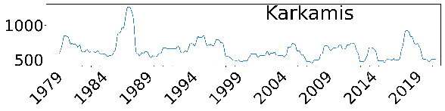
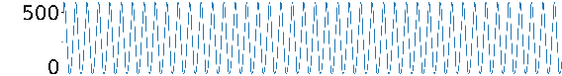 | 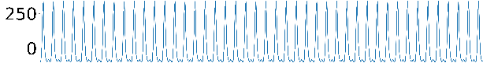 | 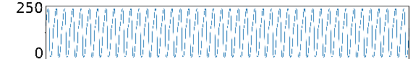
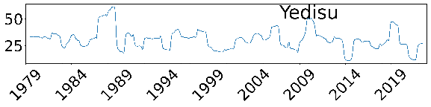 | 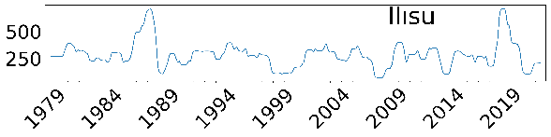 | 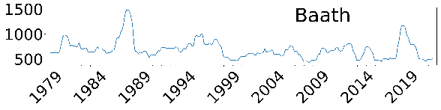
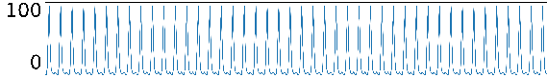 | 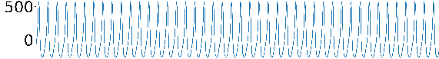 | 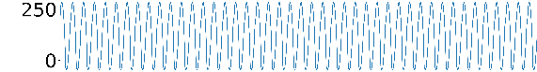
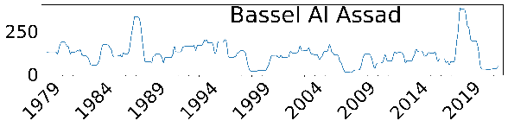 | 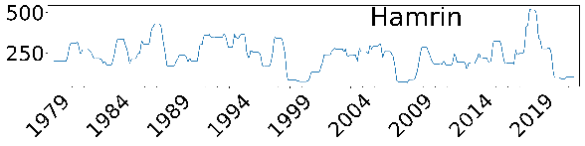
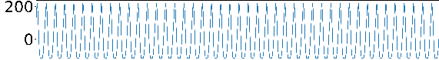 | 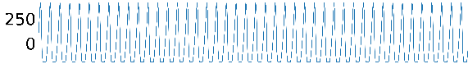
Extended Fig. 10. Trend and seasonality components of monthly discharge trending for proximal points with trend.

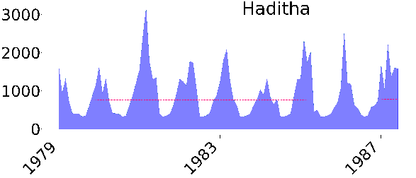 | 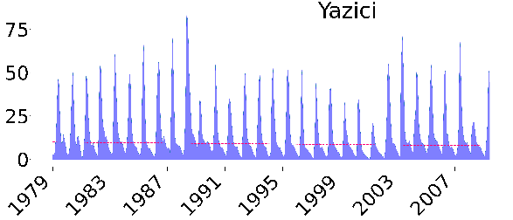 | 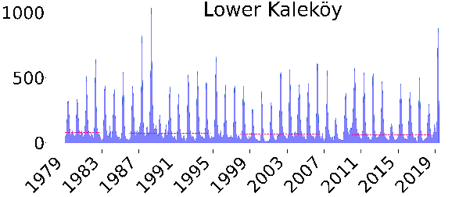
No trend | No trend | Trend= decreasing, Slope= -0.0419
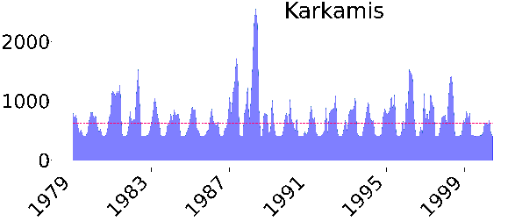 | 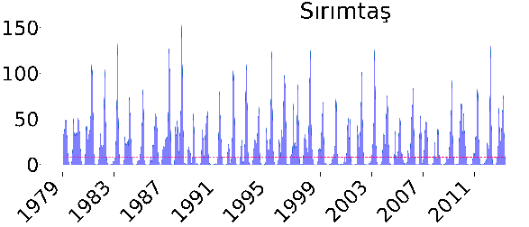 | 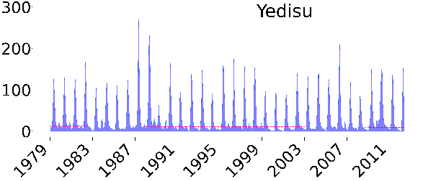
No trend | No trend | No trend
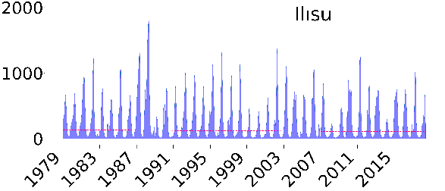 | 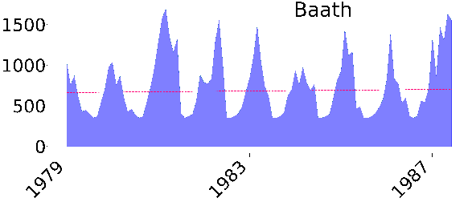 | 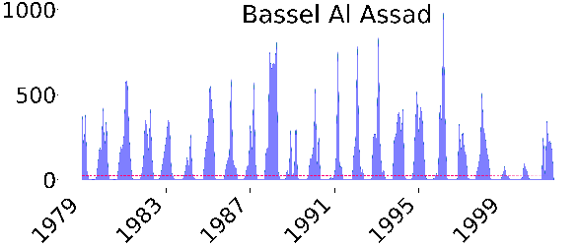
Trend= decreasing, Slope= -0.060 | No trend | No trend
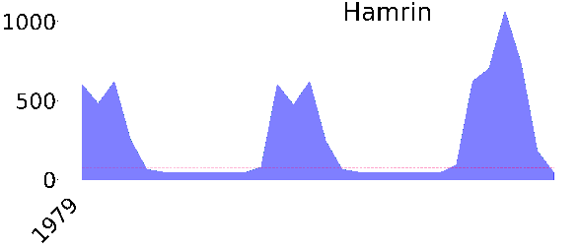 | 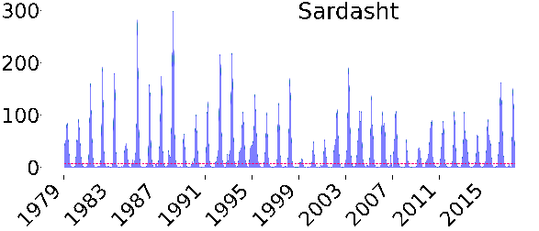 | 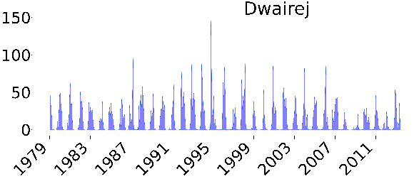
No trend | No trend | No trend
Extended Fig. 11. The monthly discharge trend of the proximal points during 1979 to the year of dam construction.

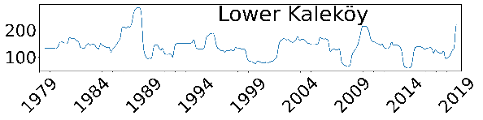 | 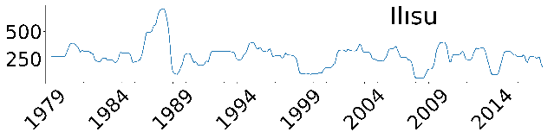
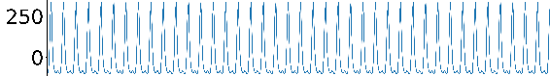 | 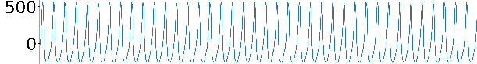
Extended Fig. 12. Trend and seasonality components of monthly discharge trending for proximal points with trend during 1979 to the year of dam construction

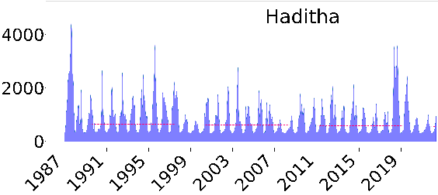 | 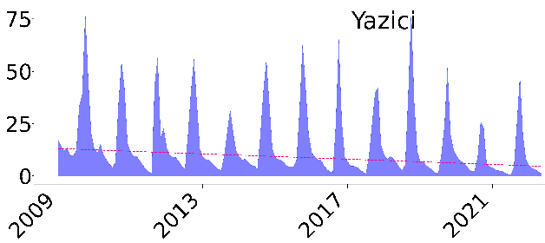 | 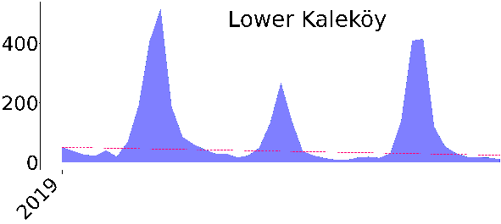
Trend= decreasing, Slope= -0.2234 | Trend= decreasing, Slope= -0.0525 | No trend
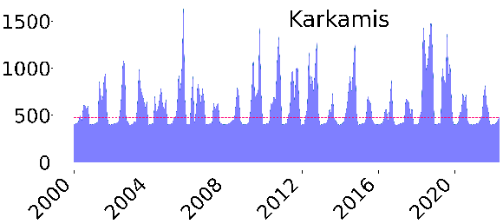 | 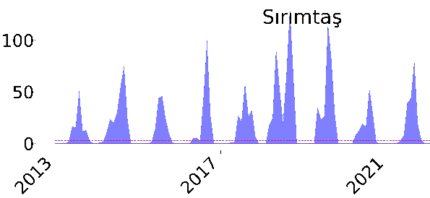 | 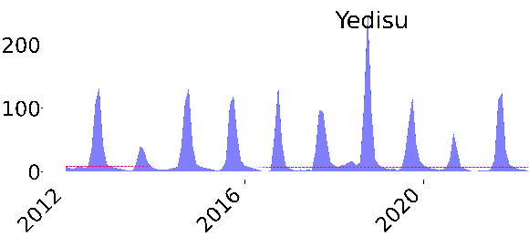
No trend | No trend | No trend
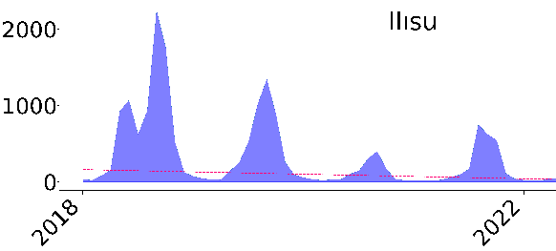 | 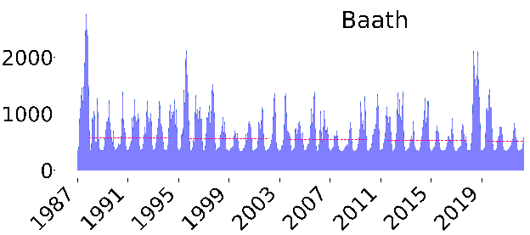 | 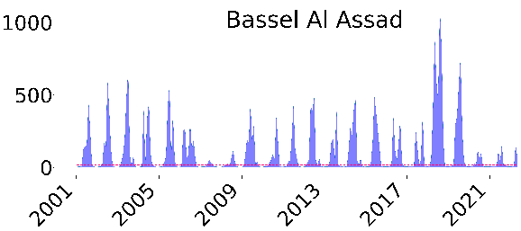
Trend= decreasing, slope= -2.5034 | Trend= decreasing, slope= -0.1591 | No trend
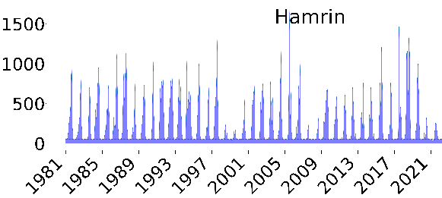 | 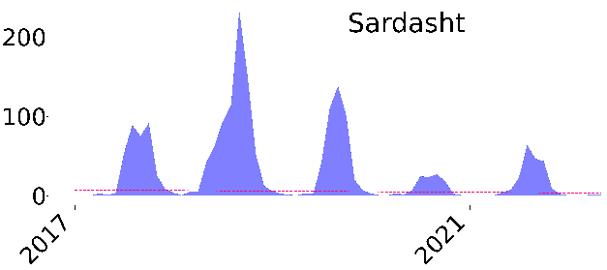 | 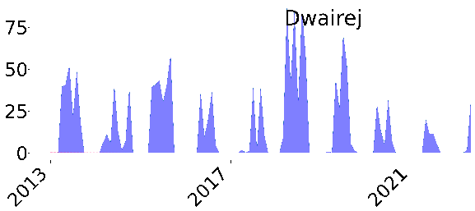
Trend= decreasing, Slope= -0.00108 | No trend | No trend
Extended Fig. 13. The monthly discharge trend of the proximal points during the year of dam construction to 2022.

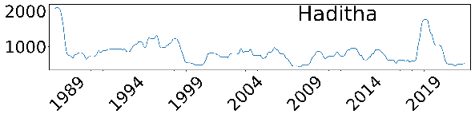 | 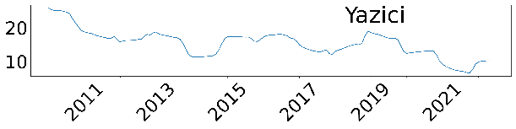 | 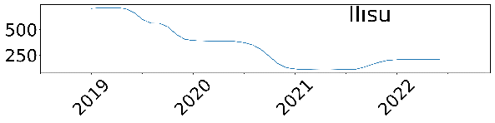
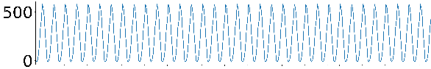 | 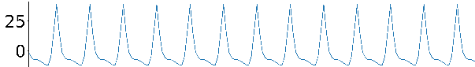 | 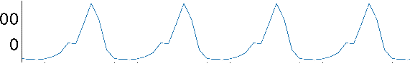
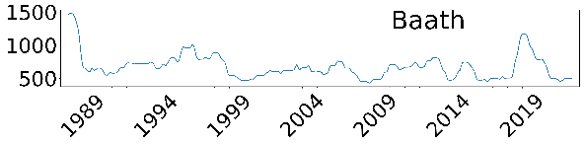 | 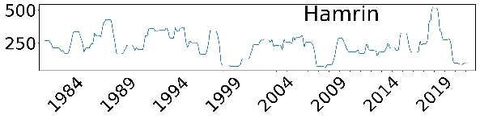
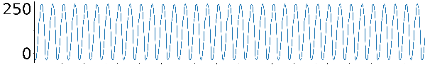 | 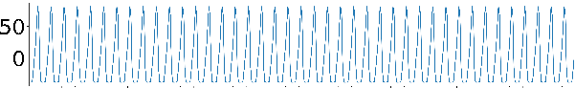
Extended Fig. 14. Trend and seasonality components of monthly discharge trending for proximal points with trend within the year of dam construction to 2022.

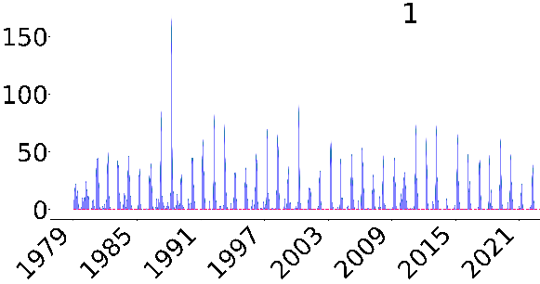 | 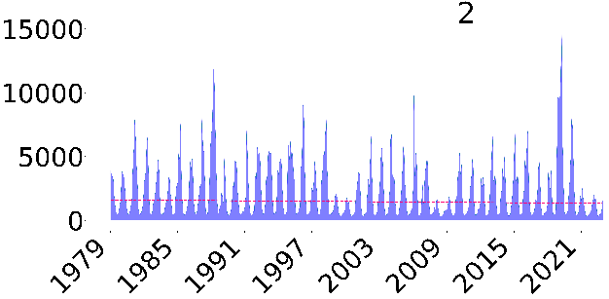 | 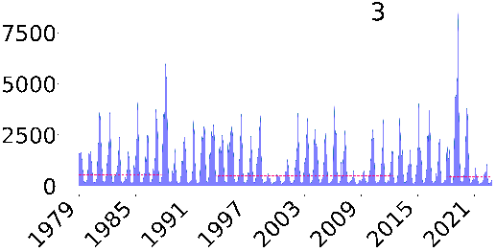
Trend= decreasing, Slope= -0.0002 | Trend= decreasing, Slope= -0.5163 | Trend= decreasing, Slope= -0.1591
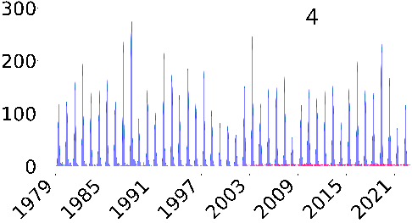 | 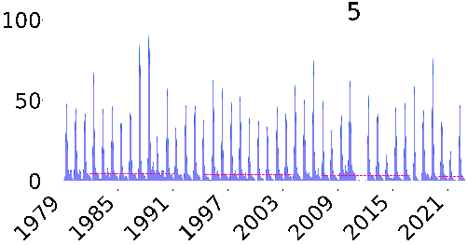 | 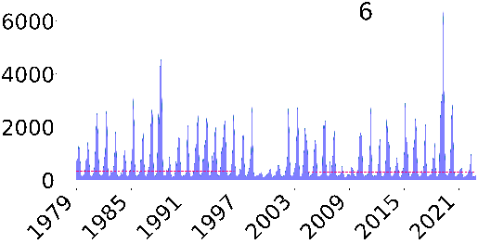
No trend | Trend= decreasing, Slope= -0.0037 | Trend= decreasing, Slope= -0.0863
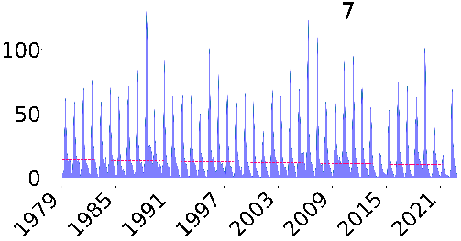 | 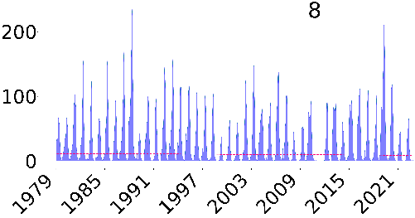 | 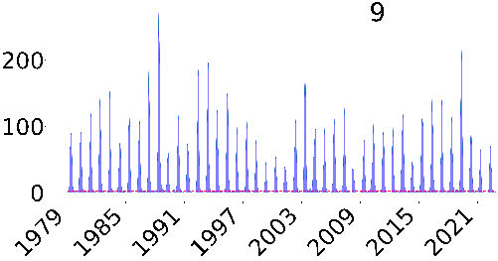
Trend= decreasing, Slope= -0.0077 | Trend= decreasing, Slope= -0. 0053 | No trend
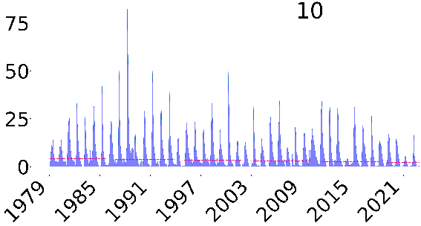 | 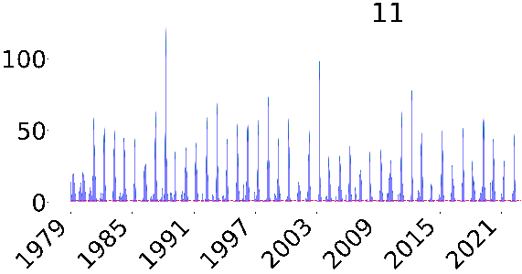 | 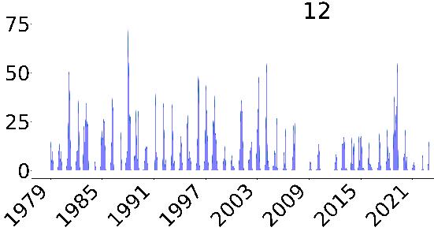
Trend= decreasing, Slope= -0.0039 | Trend= decreasing, Slope= -0.0001 | Trend= decreasing, Slope= -0.0001
Extended Fig. 15. The monthly discharge trend of the distal points during 1979 to 2022.

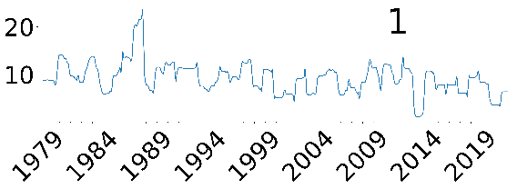 | 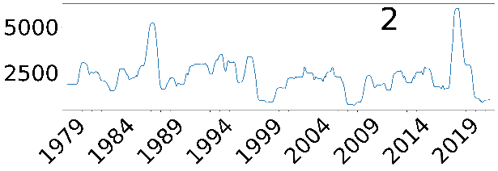 | 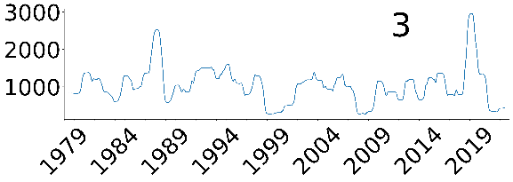
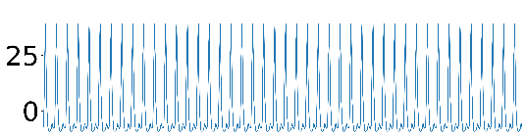 | 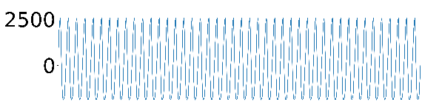 | 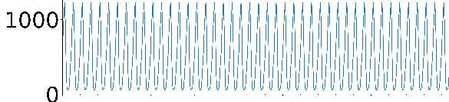
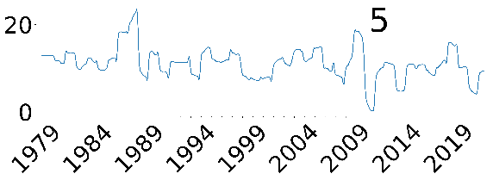 | 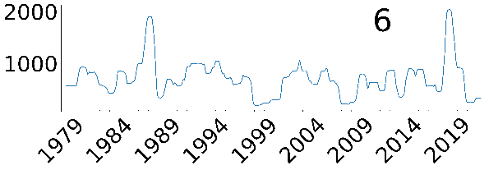 | 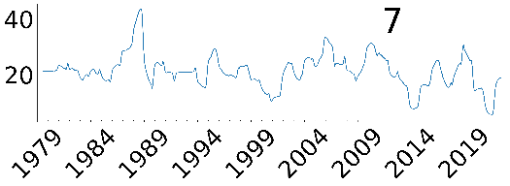
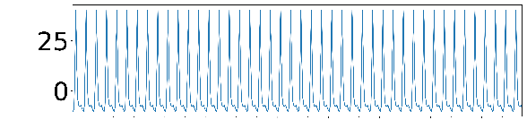 | 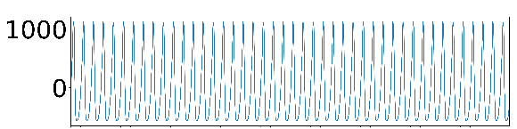 | 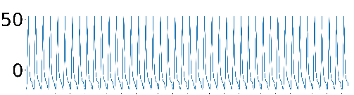
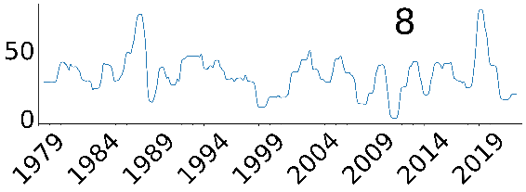 | 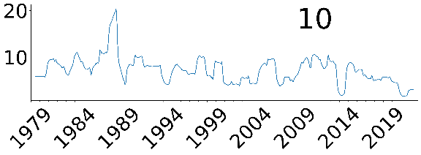 | 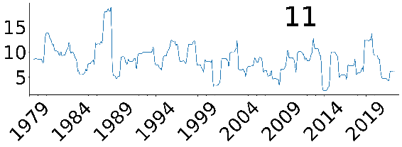
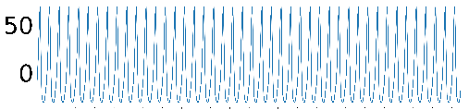 | 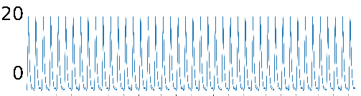 | 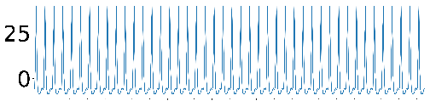
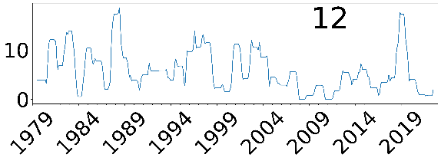
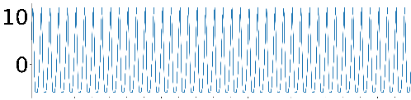
Extended Fig. 16. Trend and seasonality components of monthly discharge trending for distal points with trend within 1979 to 2022.
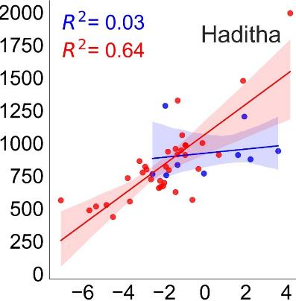 | 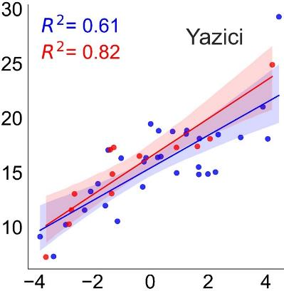 | 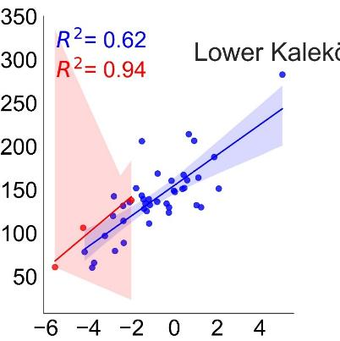
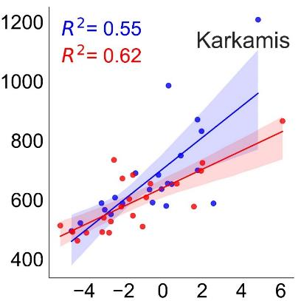 | 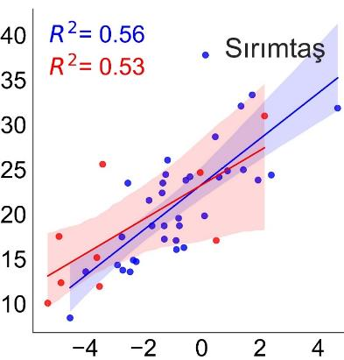 | 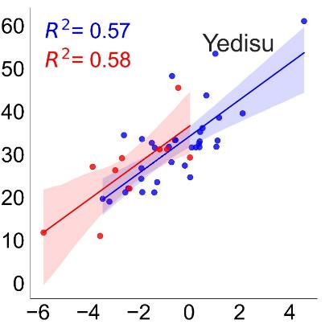
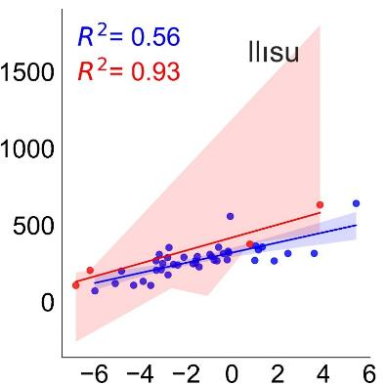 | 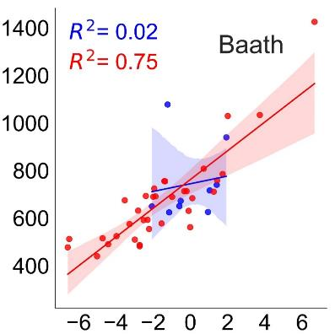 | 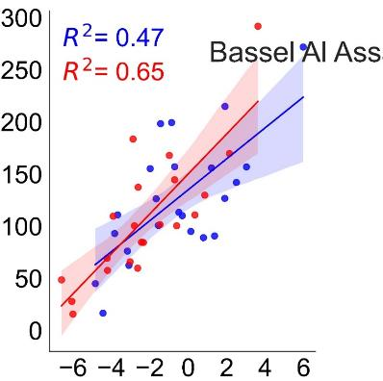
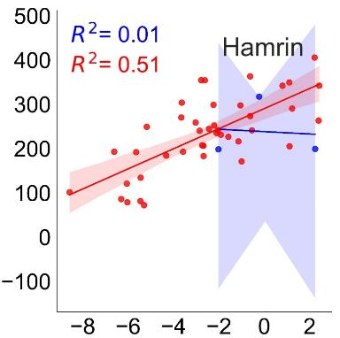 | 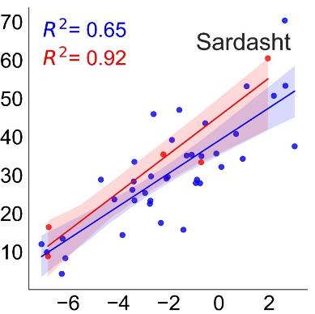 | 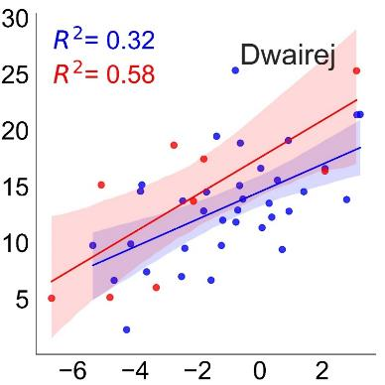
Extended Fig. 17. The scatter plots showing the correlation between annual discharge and PDSI of proximal points during 1979 to the year of dam construction (blue) and the year of dam construction to 2022 (red). X-axis and y- axis values show the annual PDSI and discharge, respectively.

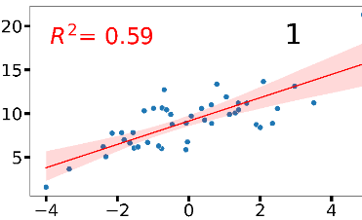 | 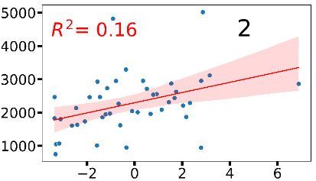 | 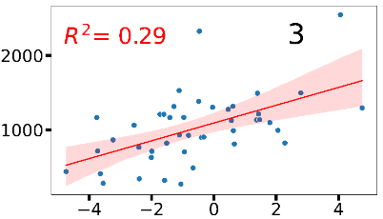
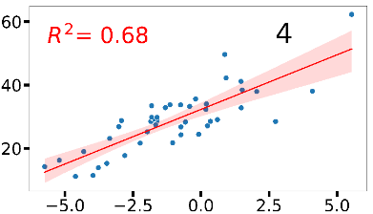 | 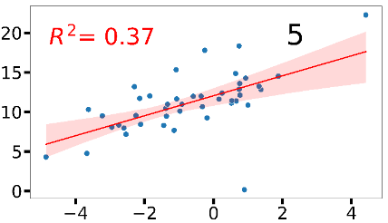 | 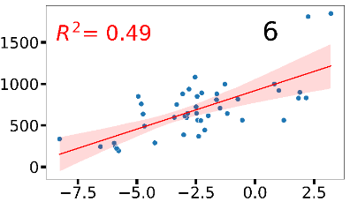
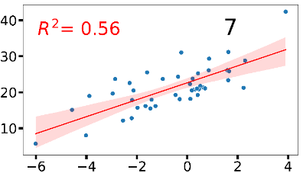 | 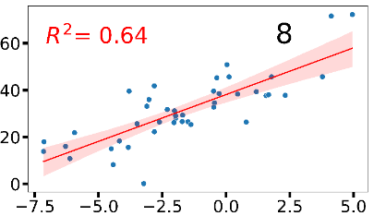 | 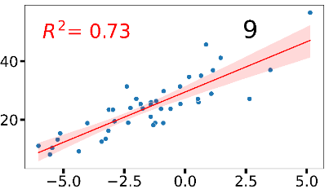
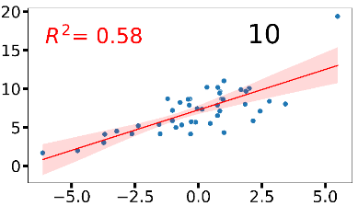 | 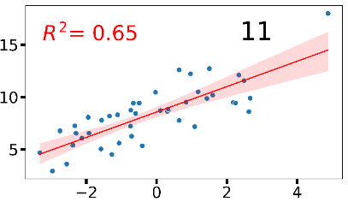 | 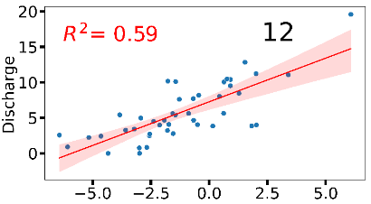
Extended Fig. 18. The scatter plots showing the correlation between annual discharge and PDSI of the distal points during 1979 to 2022.

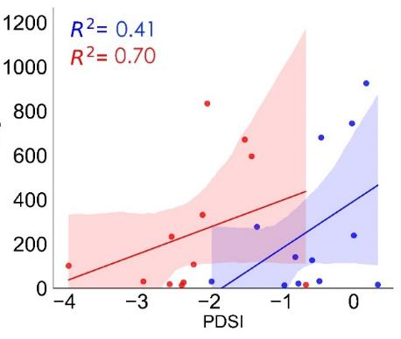 | 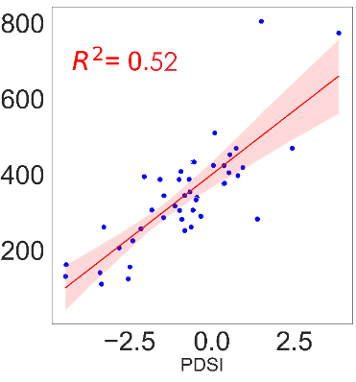
Extended Fig. 19. Correlation between average annual discharge and PDSI of the proximal points before (blue) and after (red) dam construction (right) and distal ones during 1979 to 2022 (left). The relationship is stronger in proximal points (R² = 0.56) than in distal ones (R² = 0.52), with a higher correlation after dam construction than before.

