COMP20050 Documentation

Team: yet_itCompiles
Assignment: Assignment 2
ScrumMaster: Mohsen Qaysi

Sprint Backlog
Task | Owner | Estimate | Due | Done?
Class Design | Yongzhen Ren | 4 days | 20/02/15
Function Implementation

Class Diagram

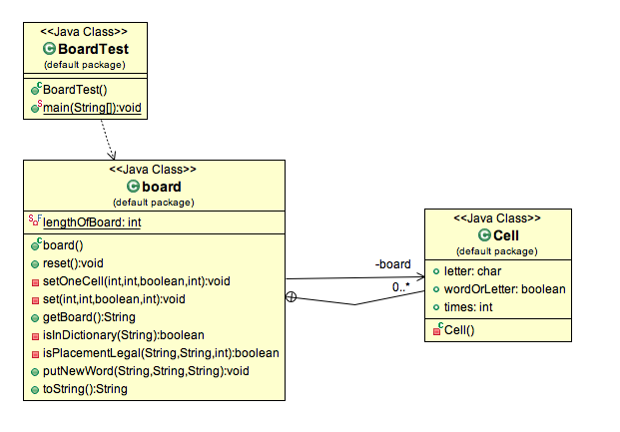

Functions
reset()
Creates a new board with positions on the board set to blank, ready for input.

setOneCell( int, int, boolean, int)
Uses the private cell class to set a single position on the board.

set( int, int, boolean, int)
Uses the setOneCell method to set a value in a given position. According to the position of one cell, set the same value for all four symmetric positions on the board.

getBoard()
Creates the board visually in the console.

isInDictionary()
Will check if the word entered by the user is a legal word based on the words contained in either an array or file.

isPlacementLegal()
This method will check if the user enters a word correctly, either horizontally or vertically but not diagonally.

putNewWord()
If isWordDictionary and isPlacementLegal return true, then the word can be placed on the board. If either return false, the user cannot place the word on the board.

toString()
Stores the current tile positions

Test Plan
Feature | Owner | Pass?
Class Testing

Review & Retrospective Summary
Problem | Resolution | Lesson

