Data Science

[Company name] | [Company address]

Access

Name

2021

**Q: What is the problem statement?**

**A:** The problem is that we have text files in which multiple tweets of Bitcoin stored. So first we need to do sentiment analysis on each tweet and create sentiment of each tweet. After that we need build Machine Learning models.

**Q: what major techniques have been selected?**

**A:** The major techniques which we are using right now are following below

* Vader Sentiment Analysis (For sentiment prediction)
* Random Forest Classifier (For ML prediction)
* Support Vector Machine Classifier (For ML prediction)
* Logistic Regression Classifier (For ML prediction)
* Neural Networks Classifier (LSTM networks)

**Q: what is technique you selected and extended?**

**A:** The major technique which I used and extended is using LSTM neural networks. As LSTM neural networks have long and short term memory and learn in sequence.

**Q: what dataset are used for your experiments?**

**A:** The dataset which I used is Bitcoin dataset from Kaggle. A very good dataset and the link is given below

<https://www.kaggle.com/datasets/kaushiksuresh147/bitcoin-tweets>

**Q: what are the major results?**

**A:** For results I used Precision, Recall and F1 metrics. The classification report of all the models are given below

**Random Forest:**

precision recall f1-score support

0 0.91 0.84 0.87 2214

1 0.76 0.96 0.84 1987

2 0.94 0.54 0.69 800

accuracy 0.84 5001

macro avg 0.87 0.78 0.80 5001

weighted avg 0.85 0.84 0.83 5001

**SVM:**

precision recall f1-score support

0 0.89 0.89 0.89 2214

1 0.80 0.94 0.87 1987

2 0.93 0.56 0.70 800

accuracy 0.86 5001

macro avg 0.88 0.80 0.82 5001

weighted avg 0.86 0.86 0.85 5001

**LR:**

precision recall f1-score support

0 0.88 0.88 0.88 2214

1 0.81 0.91 0.86 1987

2 0.87 0.57 0.69 800

accuracy 0.85 5001

macro avg 0.85 0.79 0.81 5001

weighted avg 0.85 0.85 0.84 5001

**Neural Network:**

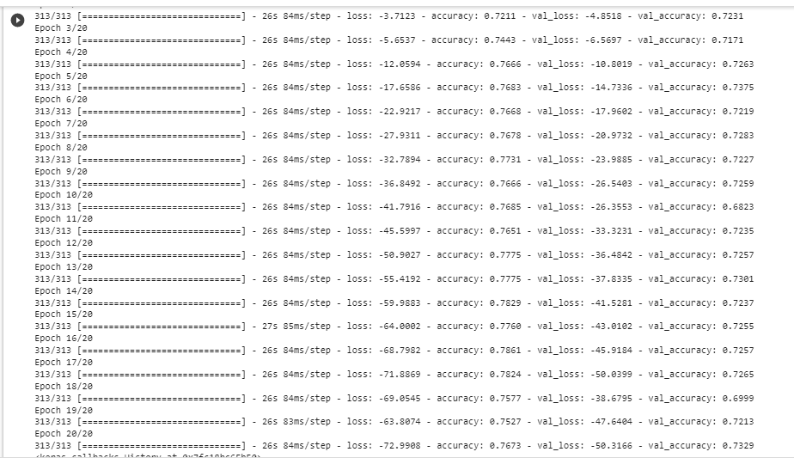

**All steps are formulas are in code notebook and the major Data structures which I used are**

* **List**
* **Dictionary**

**The python version which I used is 3.8.**