

**Program: ESE 4009**

**INSTRUCTOR:** Prof**.** Mike Aleshams

# Group 2

|  |  |  |
| --- | --- | --- |
| Student Name | Student ID | Signature* |
| Jaswinder Singh | C0747193 | JS |
| Bibin Babu | C0749104 | BB |
| Mohpreet Sidhu | C0749072 | MS |

*\*By signing above, you attest that you have contributed to this submission and confirm that all work you have contributed to this submission is your own work. Any suspicion of copying or plagiarism in this work will result in an investigation of Academic Misconduct and may result in a “0” on the work, an “F” in the course, or possibly more severe penalties.*

**Project Proposal**

**Project Title:** Patient Monitoring and Control System using Internet of Things

**Description of the latest similar system:**

Patient Monitoring System is an Arduino based Patient monitoring system. In this System, Sensors are connected with the Arduino and Ethernet Shield. The Program is typed on the IDE. The Arduino connected to the computer using the USB cable. The Ethernet shield is ensured that it is connected using an Ethernet cable to a LAN. The Program to Control various sensors first compiled and verified and uploaded to Arduino. The output can be checked on the monitor by using the IP address.

In This System, These Hardware components are used: - Arduino UNO, Pulse Rate Sensor, LM35, Sensor MQ2, LCD 16X2.

All these Sensors will collect the data from the patient and then will be analyzed by the system, which will later send to the server by WIFI using an internet connection. Doctors can check the data anywhere using a browser and internet connection.

**Limitations of the latest similar system:**

1. Only collect the data when the command is given.
2. There is no Notification while something went wrong.
3. Arduino UNO is used, while BeagleBone series is much better.

**Final Solution:**

* **Block Diagram**

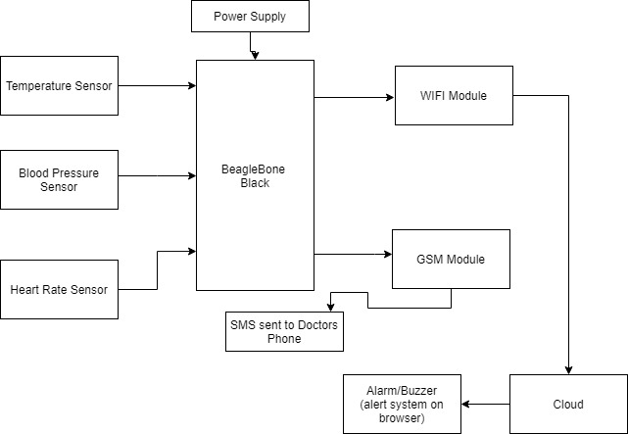

* **Features**
* Use of BeagleBone Black as the master of the system, TP Link version as WIFI dongle.
* Use of DS18B20 as Temperature sensor, Arterial blood pressure sensor, MIKEROE-200 as heart Rate sensor.
* ThingSpeak for data cloud data storage which keeps updated data.
* UART serial communication for GSM module and IEEE 802.11 set protocol for WIFI dongle.
* Use of preemptive scheduler operation to remove the problem of hang or slow down, tick rate for accuracy, fixed task priority using Rate monotonic scheduling.
* **Hardware and Software Requirement**

(Main Hardware Requirements)

* BeagleBone Black
* Keebox W150NN or D-link DW
* MIKEROE-200
* DS18B20- Temperature Sensor
* Arterial Blood Pressure sensor
* GSM Module
* 5V Adapter
* Jumper Wires

(Software Requirements)

* Debian for BeagleBone
* Bash script
* Embedded C
* EasyEDA
* MATLAB
* ThingSpeak Cloud storage.
* **Milestones (Deliverables and Time Schedule)**

|  |  |  |  |
| --- | --- | --- | --- |
| **Task Name** | **Start Date** | **End Date** | **Person-in-charge** |
| Finalizing and Getting the Hardware components | June 17 ,2020 | June 29,2020 | Mohpreet |
| Testing each Hardware parts | June 30, 2020 | July 5, 2020 | Mohpreet |
| Design the Hardware Schematic | June 30, 2020 | July 10,2020 | Bibin |
| Interfacing Temperature Sensor with BeagleBone Black | July 6,2020 | July 12,2020 | Mohpreet |
| Interfacing Heart Rate Sensor with BeagleBone Black | July 13, 2020 | July 19, 2020 | Bibin |
| Interfacing Blood Pressure Sensor with BeagleBone Black | July 20, 2020 | July 26, 2020 | Jaswinder |
| Interfacing WIFI Module with BeagleBone Black | July 27, 2020 | August 2, 2020 | Jaswinder |
| Interfacing GSM module with BeagleBone Black | August 3,2020 | August 10, 2020 | Jaswinder |
| Interfacing ThingSpeak cloud with BeagleBone Black | August 11, 2020 | August 17, 2020 | Bibin |
| Finalizing the code and debugging | August 11, 2020 | August 21, 2020 | Jaswinder |
| Final Report |  | August 28 |  |

* **References:**

1. Patient Monitoring and Control System using Internet of Thing (V. Vikram Gnanaraj, P.Ranjana, P. Thenmozhi ) (April-2019)

<https://www.ijitee.org/wp-content/uploads/papers/v8i6s3/F10220486S319.pdf>

1. Beaglebone black Key components (April-2020)

<https://www.elinux.org/Beagleboard:BeagleBoneBlack#WIFI_Adapters>

1. Remote Monitoring of Patients using Beaglebone Black(Surakshith K C, Nagashree K T) ( March 2015)

<https://www.ijert.org/research/remote-monitoring-of-patients-using-beaglebone-black-IJERTCONV3IS19105.pdf>

**Instructor’s Remarks:**