# **MARKETING COMPAIGN ANALYSIS**

# PROBLEM

Campaign’s isn’t targeted efficiently to achieve goals

Sales are way lower than expected

# How to solve Problem

First, I checked if this campaign was Indeed successful or not?

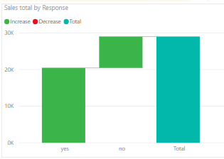

Also, the initials core facts defined:

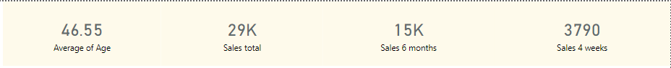

Response Rate:

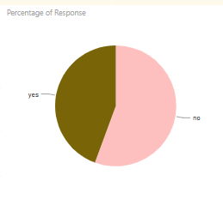

The Response I believe can be enhanced to make it better as for the stats stand at 44.4% of Yes!

## FINDING STRONG POINTS:

I tried to see which population group responded best to the Best to the campaign that is from where we made most of our Sales

We checked Sales Generated By Age TimeLine

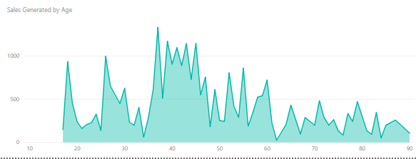

From the graph above we can clearly see the consistent high sales generated are from age group 35 to 48

Where is strong Age Group is from 25 to 61, We can also say that Age group 25 to 35 has potential that the marketing group can tap as seen by the spike between 25-30

SALES REPORT BY AREA AND RESPONSE

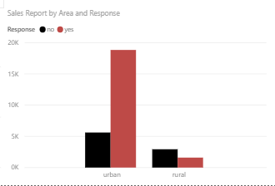

We can see that the Marketing Campaign was successful in Urban Areas and failed in the Rural

RESPONSE BY Email

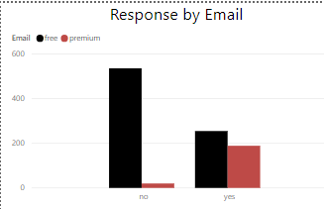

Premium Email Holders responded far better with 90% success rate

ANOVA TEST 1

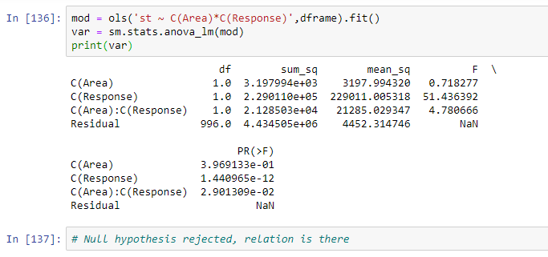

ANOVA TEST 2

