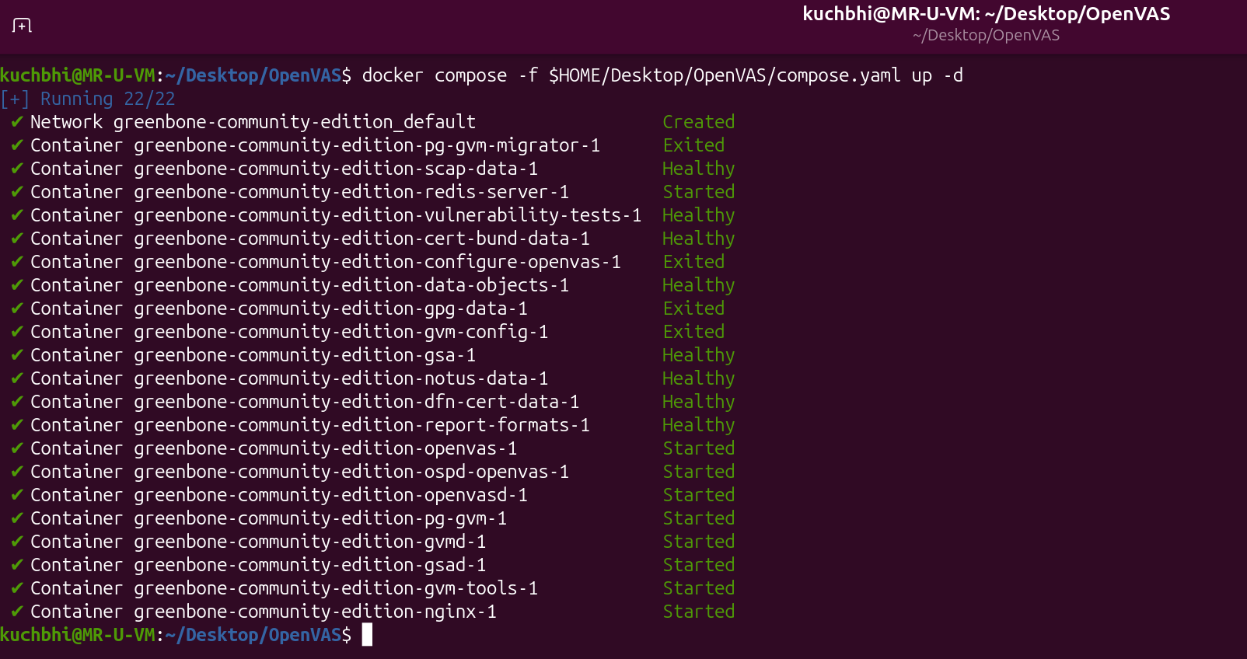
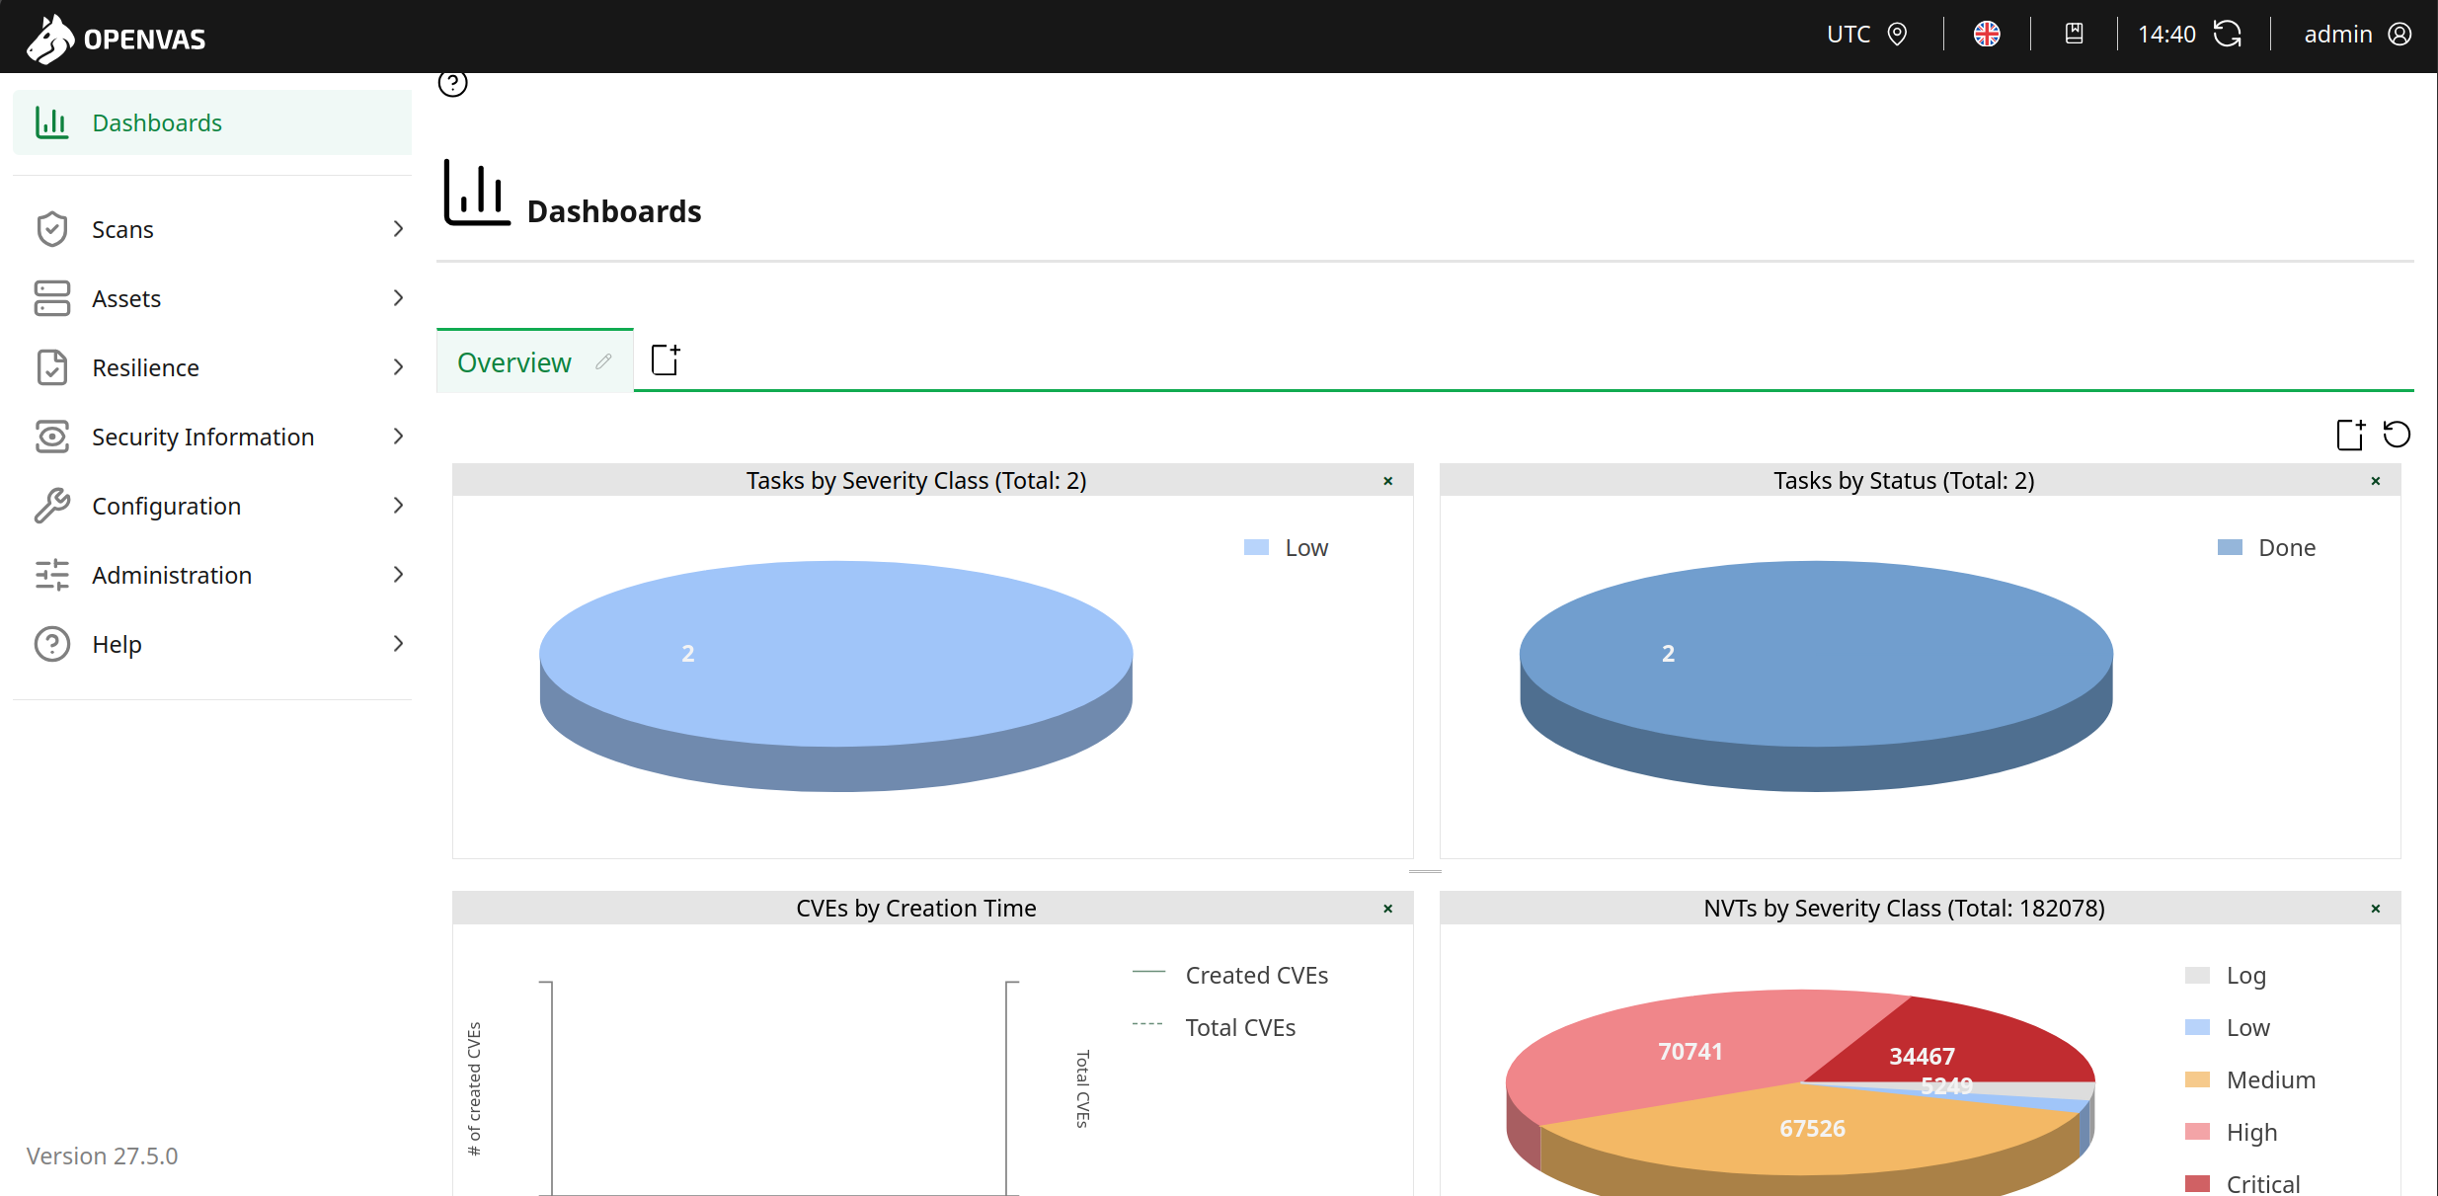
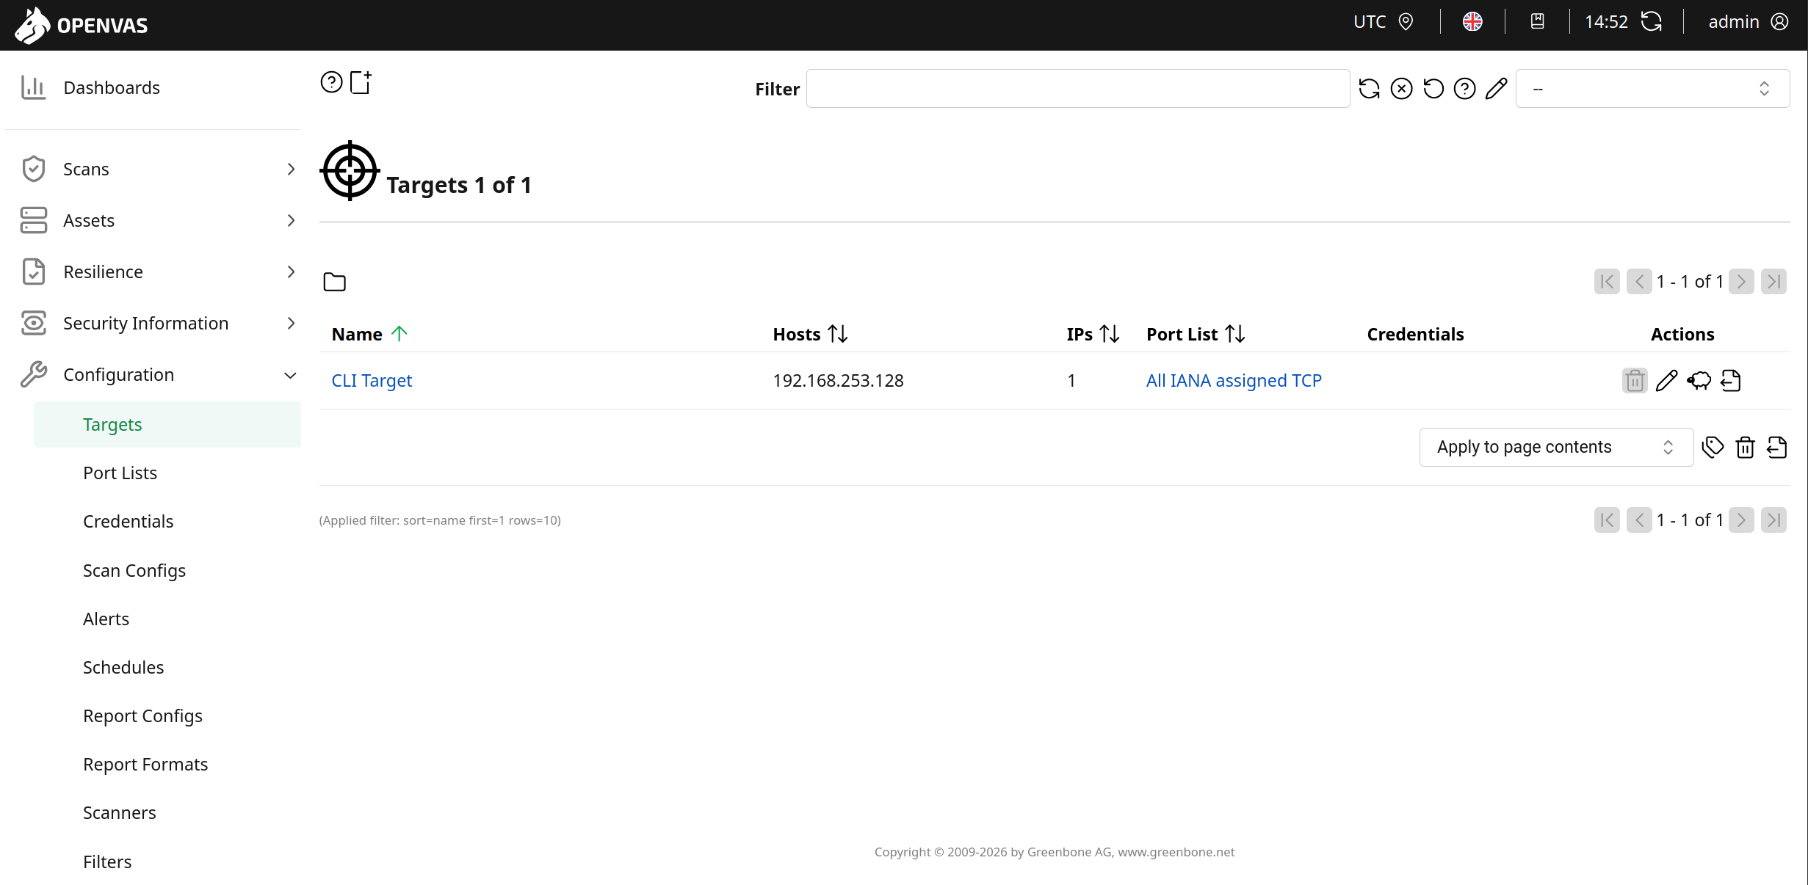
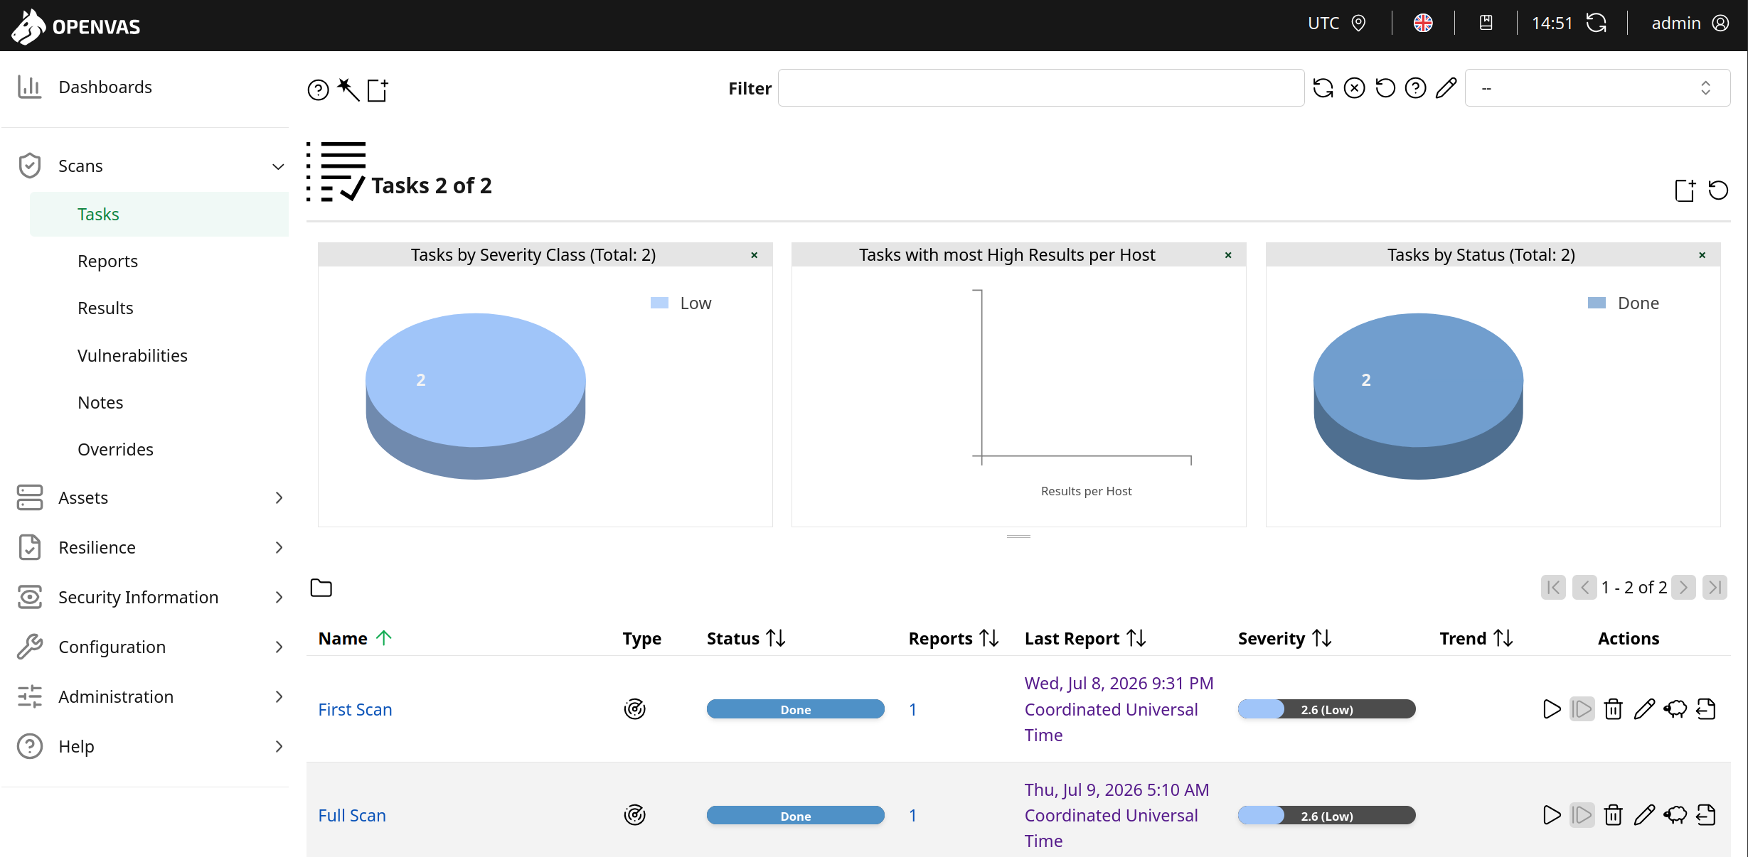
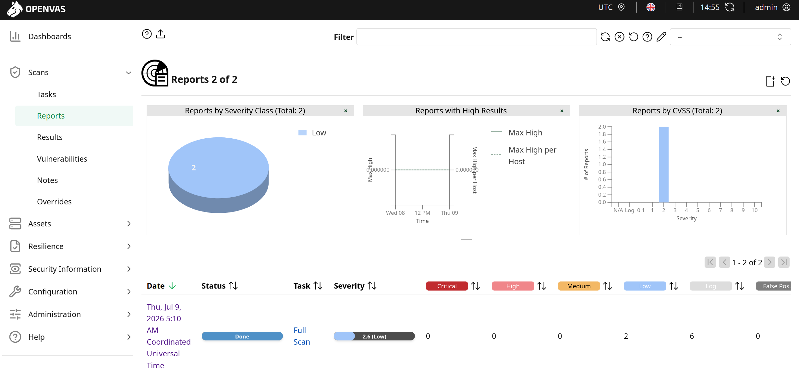
Technical Task Report: Network Vulnerability Assessment using OpenVAS
Task Objective: Research, deploy, configure, and execute an open-source vulnerability assessment tool within a virtual lab environment.
1. Tool Selection & Architecture
For this task, OpenVAS (Open Vulnerability Assessment System)—the core component of the Greenbone Community Edition—was selected. It is a full-featured vulnerability scanner providing a comprehensive feed of Network Vulnerability Tests (NVTs).
To ensure a clean, portable, and modern deployment, the tool was deployed using Docker Compose inside an Ubuntu Virtual Machine configured with a NAT network adapter. This architecture provides complete containment, ensuring all scanning traffic remains strictly isolated inside the virtual lab environment.
2. Phase-by-Phase Implementation
Phase 1: Container Deployment and Database Synchronization
The environment was initialized using a multi-container Docker Compose setup. Because a vulnerability scanner relies entirely on its signature database, a full synchronization of security feeds was executed.
- Monitored Component: gvmd (Greenbone Vulnerability Manager daemon).
- Feeds Synchronized: SCAP (Security Content Automation Protocol) data, CERT data, and NVT signatures spanning from historic records up to current 2026 vulnerabilities.
- Database Verification: The initialization successfully concluded after verifying the local database updated and indexed 182,078 unique Vulnerability Tests (VTs).
Phase 2: Automation & Interaction via Greenbone Management Protocol (GMP)
To demonstrate technical proficiency in cybersecurity automation, the scanner was controlled programmatically via the command-line interface using gvm-cli over the raw XML-based Greenbone Management Protocol (GMP).
The pipeline was executed using the following structured XML workflows:
- Target Identification: A specific host asset target was generated for the local VM endpoint (192.168.253.128) linked to the universal IANA TCP/UDP port list identifier (33d0cd82-57c6-11e1-8ed1-406186ea4fc5).
- Task Creation: A scanning task titled "My First AI Scan" was registered, binding the target to the highly thorough Full and fast scan configuration (daba56c8-73ec-11df-a475-002264764cea).
- Execution & Monitoring: The task was successfully initialized into a Running state, with progress monitored programmatically until status resolution reached Done.
- Data Extraction: The raw, unstructured vulnerability data stream was exported directly from the container architecture into a local file named real_openvas_report.xml for subsequent parsing and triage automation.
Phase 3: Dashboard Management & Scoping Analysis
In addition to programmatic command-line manipulation, the Greenbone Security Assistant (GSA) web dashboard was accessed locally via [http://127.0.0.1:9392](http://127.0.0.1:9392) using verified administrative credentials.
During the testing pipeline, two distinct scoping methodologies were evaluated:
- System Discovery: A lightweight network mapping scan configuration restricted to host pings, active port discovery, and OS fingerprinting without vulnerability checking.
- Full and Fast: A comprehensive vulnerability assessment configuration that actively correlates discovered open services against the local database of known exploits and flaws.
3. Vulnerability Scan Assessment & Findings
The target machine (192.168.253.128) was subjected to the complete Full and Fast security profile. Because the VM operates behind a local NAT boundary, the security exposure was confined entirely to the target operating system's baseline network stack configuration.
The scanner concluded with a Low Risk severity threshold, identifying two distinct security configuration flaws:
Vulnerability Detected | Protocol / Layer | Severity | QoD (Quality of Detection) | Exploitation Risk Summary
TCP Timestamps Information Disclosure | general/tcp | 2.6 (Low) | 80% | Explores system uptime data via remote TCP handshakes, allowing potential attackers to infer patch-reboot schedules.
ICMP Timestamp Reply Information Disclosure | general/icmp | 2.1 (Low) | 80% | The system responds to ICMP type 13 requests, leaking exact system clock configuration data across the local link.
Remediation Recommendations
- TCP Timestamps: Modify the Linux kernel parameters by appending net.ipv4.tcp_timestamps = 0 to /etc/sysctl.conf to disable explicit timestamp transmission.
- ICMP Timestamps: Configure local network packet filters (iptables / nftables) to systematically drop ICMP type 13 and type 14 (timestamp request/reply) messages.
4. Conclusion & Next Steps
This task successfully demonstrated an end-to-end vulnerability management cycle, proving competence in deployment, CLI-based automation via XML APIs, manual dashboard control, and analytical triage of resulting security posture reports.
The next phase of this implementation involves feeding the structured XML report output into a custom Python parsing framework to automatically parse out high-risk threats, modeling a real-world automated SOC Analyst triage pipeline.

