|  |  |  |
| --- | --- | --- |
| **Chapter** | **Contents Name** | **Page No.** |
| **1.1** | **Introduction** | **1** |
| **1.2** | Prolog | **1** |
| **1.3** | Structure of prolog | **1** |
| **1.4** | Facts | **1** |
| **1.5** | Database | **1** |
| **1.6** | **Background Study** | **2** |
| **1.7** | Objective | **2** |
| **1.8** | Prolog Description | **2** |
| **1.9** | Screen Shots | **3-4** |
| **1.10** | **Codes** | **5-9** |
| **1.11** | **Limitation** | **9** |
| **1.12** | **Future works and expansion** | **9** |
| **1.13** | **Conclusion** | **9** |
| **1.14** | **References** | **9** |

List of Figures

|  |  |  |
| --- | --- | --- |
| Figure No. | Figure Name | Page No. |
| 1. | Figure of output 1 | 4 |
| 2 | Figure of output 2 | 5 |

**Chapter 1**

1.1 **Introduction:** This is the project based on prolog programming language which is well- known to develop artificial intelligent software. The project is used to find the vehicles from a place where lot of vehicles are placed.

1.2 **Prolog:** It is the programming language mainly used for developing artificially intelligent software. It is a logic programming language.

1.3 **Structure of prolog :** It has three components

* Declaring some facts about objects and their relationships.
* Defining some rules about objects and their relationship.
* Asking questions about objects and their relationships.

1.4 **Facts:** Facts are made of objects and their relationships.

Example: Likes(jhon,marry)

Here jhon and marry are objects or arguments.

The provided relationship must be existing among all those arguments.

1.5 **Database:** The prolog Programming language is different about database than other languages. The database in prolog is written as codes. Whereas other languages uses another language as database handler.

1.6 **Background Study** : The main theme of this project to learn how the AI works with prolog. In this project we provided the identification of vehicles from lot more vehicles which is placed in a place or in a room.

This software can be used in garage, vehicle rented area, parking zone, parking in the market room etc.

1.7 **Objective:** The main objectives of this project are hinted below.

* To provide a secured vehicle service .
* Keeping the safety of vehicles.
* Protecting the illegal activities on vehicle.
* Identifying appropriate vehicle of appropriate owner of vehicle.
* Supplying the vehicles perfectly.

1.8 **Project Description:**

Used Tools- w32pl640 (software)

Programming Language- prolog.

Database information:

Database name: vehicle_identification_ai.pl

1.9 **Screenshots:** 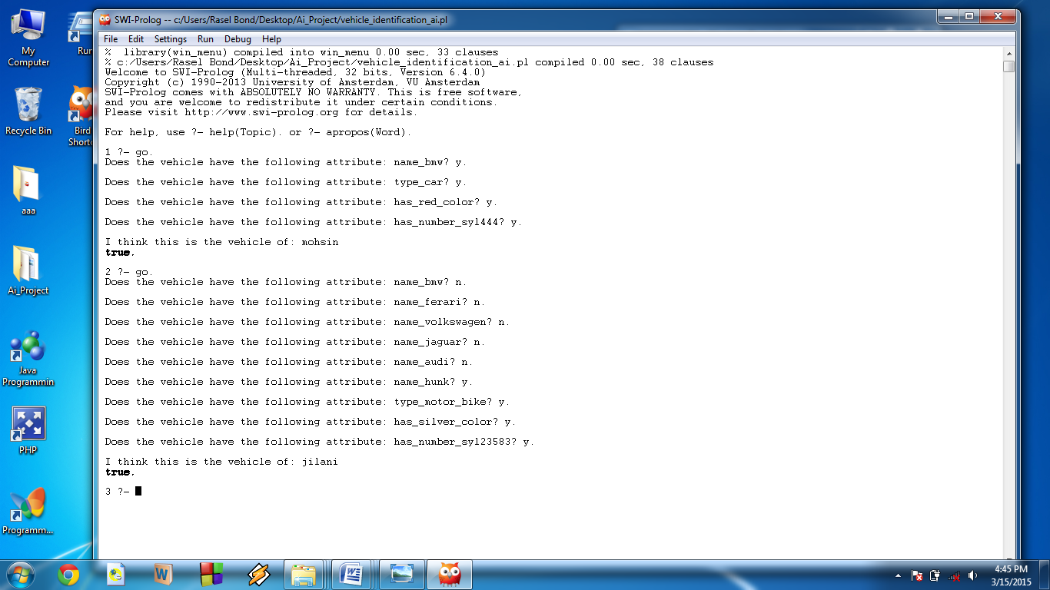

Fig 1: Figure of output

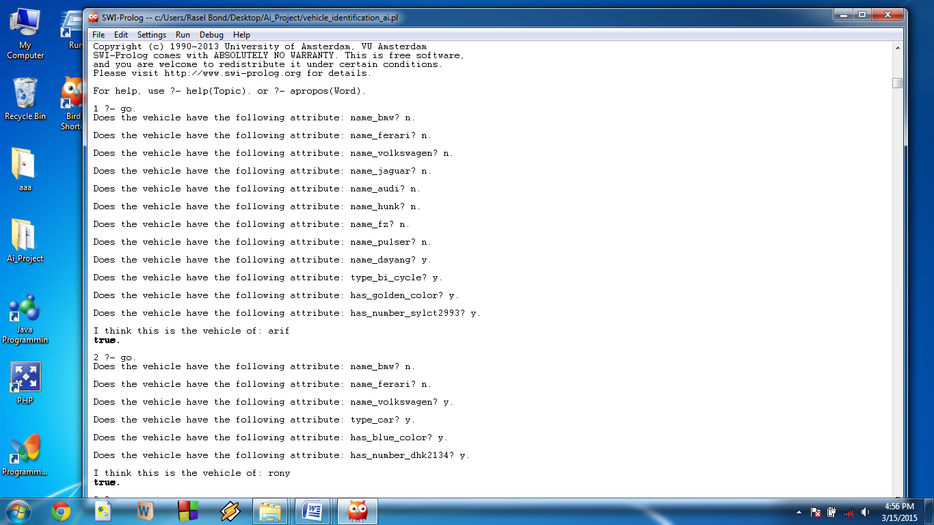

Fig 2: Figure of output

1.10 **Codes:**

/*

vehicle identification ai.

start with ?- go. */

go :- hypothesize(Vehicle),

write('I think this is the vehicle of: '),

write(Vehicle),

nl,

undo.

/* hypotheses to be tested */

hypothesize(mohsin) :- mohsin, !.

hypothesize(shuvo) :- shuvo, !.

hypothesize(rony) :- rony, !.

hypothesize(sultan) :- sultan, !.

hypothesize(asif) :- asif, !.

hypothesize(jilani) :- jilani, !.

hypothesize(sujon) :- sujon, !.

hypothesize(roni) :- roni , !.

hypothesize(arif) :- arif , !.

hypothesize(ruman) :- ruman , !.

hypothesize(unknown). /* no diagnosis */

/* vehicle identification rules */

mohsin :- bmw,

verify(type_car),

verify(has_red_color),

verify(has_number_syl444).

shuvo :- ferari,

verify(type_car),

verify(has_black_color),

verify(has_number_dhk1234).

rony :- volkswagen,

verify(type_car),

verify(has_blue_color),

verify(has_number_dhk2134).

sultan :- jaguar,

verify(type_car),

verify(has_white_color),

verify(has_number_sy6543).

asif :- audi,

verify(type_car),

verify(has_red_color),

verify(has_number_la6843).

jilani :- hunk,

verify(type_motor_bike),

verify(has_silver_color),

verify(has_number_syl23583).

sujon :- fz,

verify(type_motor_bike),

verify(has_sky_color),

verify(has_number_syl23783).

roni :- pulser,

verify(type_motor_bike),

verify(has_black_color),

verify(has_number_syl29983).

arif :- dayang,

verify(type_bi_cycle),

verify(has_golden_color),

verify(has_number_sylct2993).

ruman :- phoenix,

verify(type_bi_cycle),

verify(has_sky_color),

verify(has_number_sylct2963).

/* classification rules */

bmw :- verify(name_bmw), !.

ferari :- verify(name_ferari), !.

volkswagen :-verify(name_volkswagen), !.

jaguar :-verify(name_jaguar), !.

audi :-verify(name_audi), !.

hunk :-verify(name_hunk), !.

fz :-verify(name_fz), !.

pulser :-verify(name_pulser), !.

dayang :-verify(name_dayang), !.

phoenix :-verify(name_phoenix), !.

/* how to ask questions */

ask(Question) :-

write('Does the vehicle have the following attribute: '),

write(Question),

write('? '),

read(Response),

nl,

( (Response == yes ; Response == y)

->

assert(yes(Question)) ;

assert(no(Question)), fail).

:- dynamic yes/1,no/1.

/* How to verify something */

verify(S) :-

(yes(S)

->

true ;

(no(S)

->

fail ;

ask(S))).

/* undo all yes/no assertions */

undo :- retract(yes(_)),fail.

undo :- retract(no(_)),fail.

undo.

1.11 **Limitation:** Working with this project we have faced lot of problems. The resource of this language was very limited and it was hard to understand some of the built in function of the prolog programming language.

1.12 **Future Works and Expansion:** In this project we just works but without creating any interface. In future we will try to develop this software with the proper interfacing. And we are highly eager to interface this software with a hardware or hardware devices.

1.13 **Conclusion:** The project we developed about the vehicle identification. By developing that project we learned how the artificial intelligent system works with the programming language prolog. We enjoyed the project and highly expected to learn more and work in future with this expert system .

References: [www.wikipedia.com](http://www.wikipedia.com)

<http://www.luontoportti.com/suomi/eng>

More from Books.