
DEPARTMENT OF SOFTWARE ENGINEERING
Web Engineering Lab
Lab No. 02
Name | Mohsin Ali
Student ID | BSE-24S-052
Section | SE-6B
Department | Department of Software Engineering
Course Instructor | Sir Hassan Raza
Submission Date | 10-October-2026

Department of Software Engineering

HTML Code:
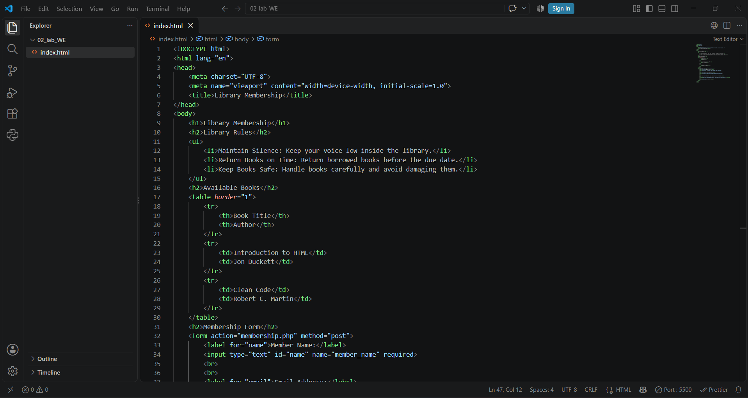
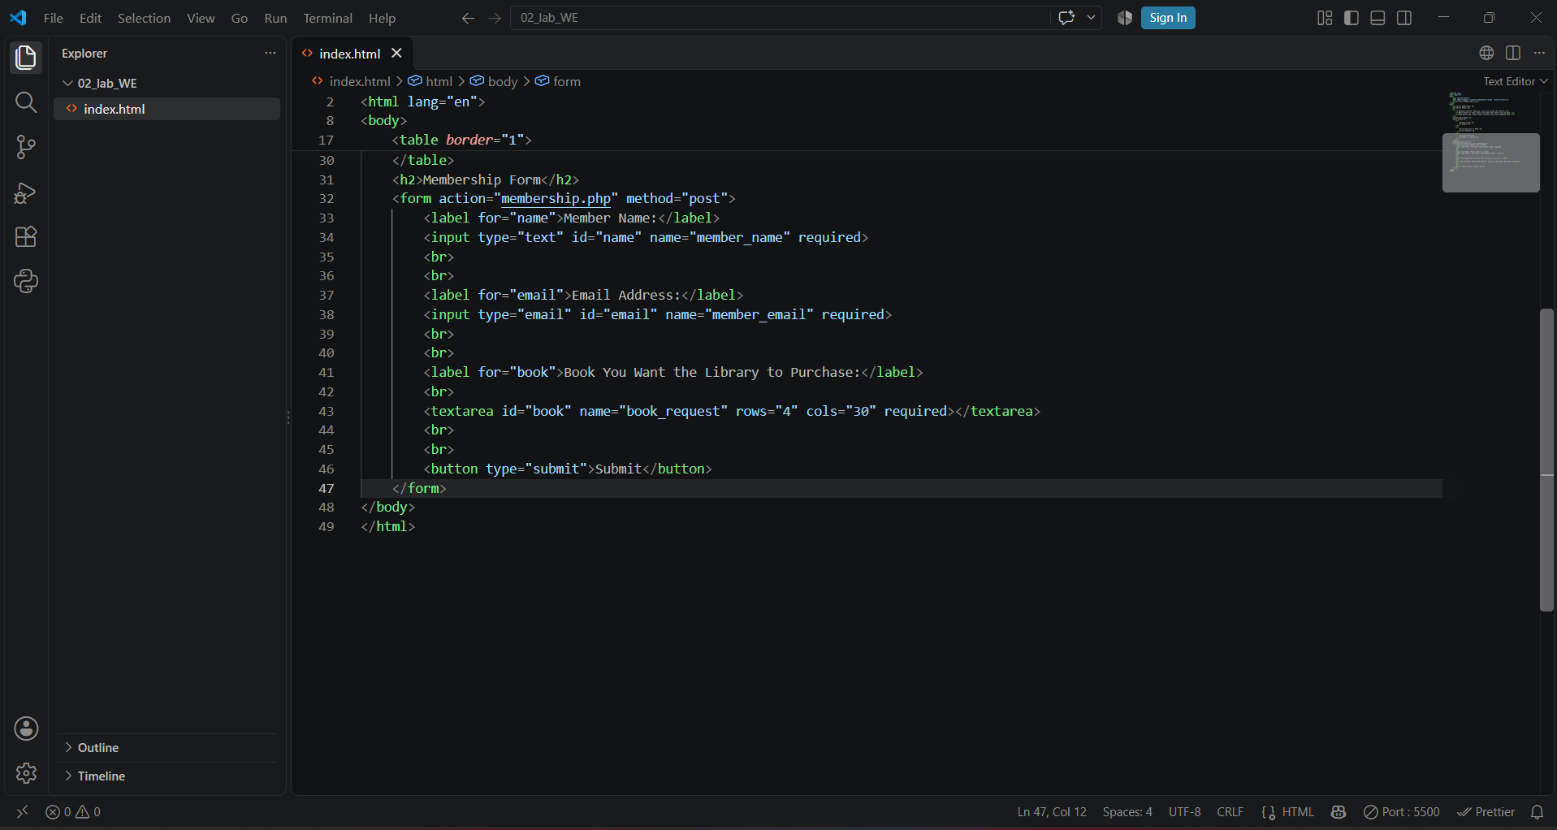

Output Preview:
