
DEPARTMENT OF SOFTWARE ENGINEERING
Web Engineering Lab
Lab No. 03
Name | Mohsin Ali
Student ID | BSE-24S-052
Section | SE-6B
Department | Department of Software Engineering
Course Instructor | Sir Hassan Raza
Submission Date | 10-October-2026

Department of Software Engineering

Task 01
HTML Code:
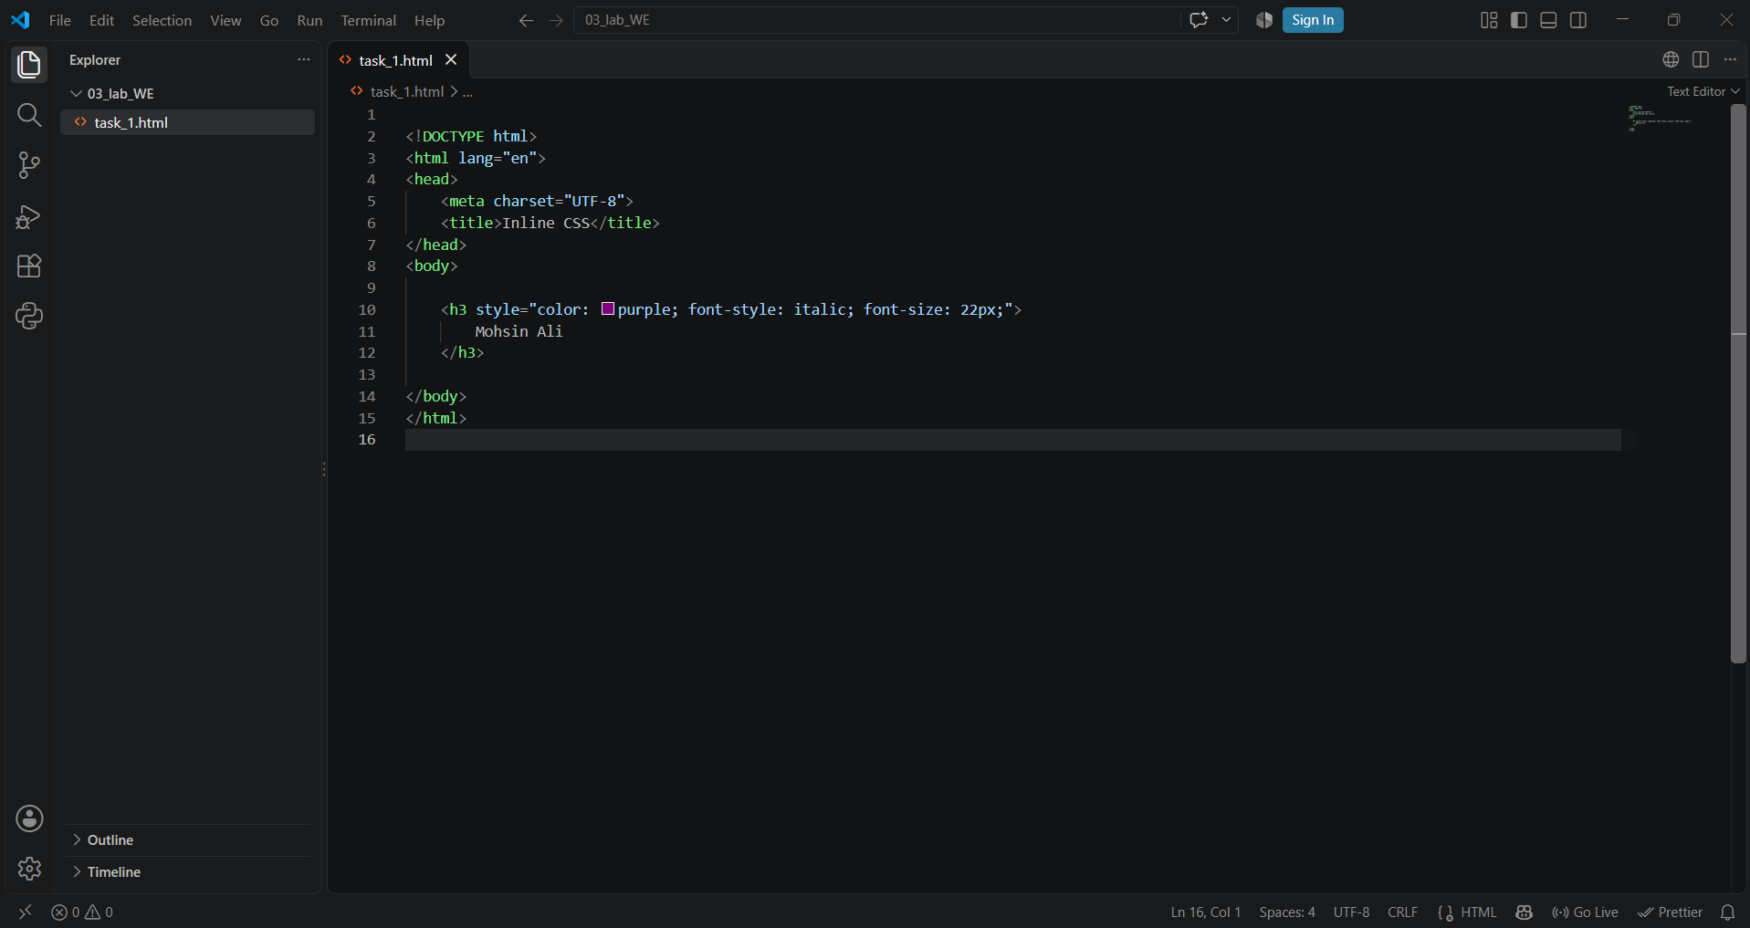
Code Preview:
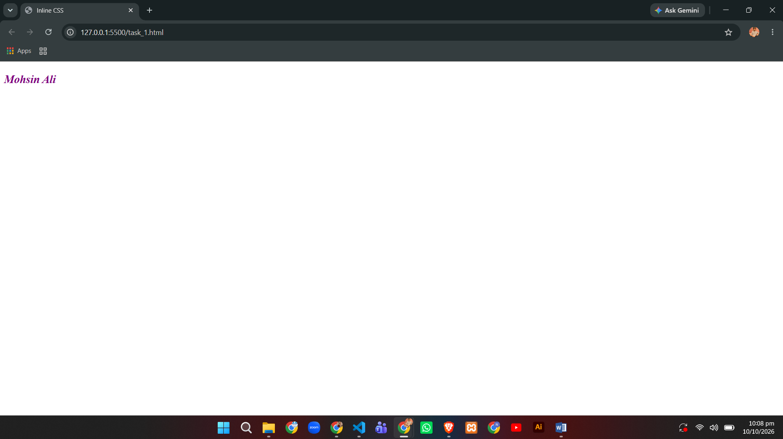

TASK 02
HTML Code:
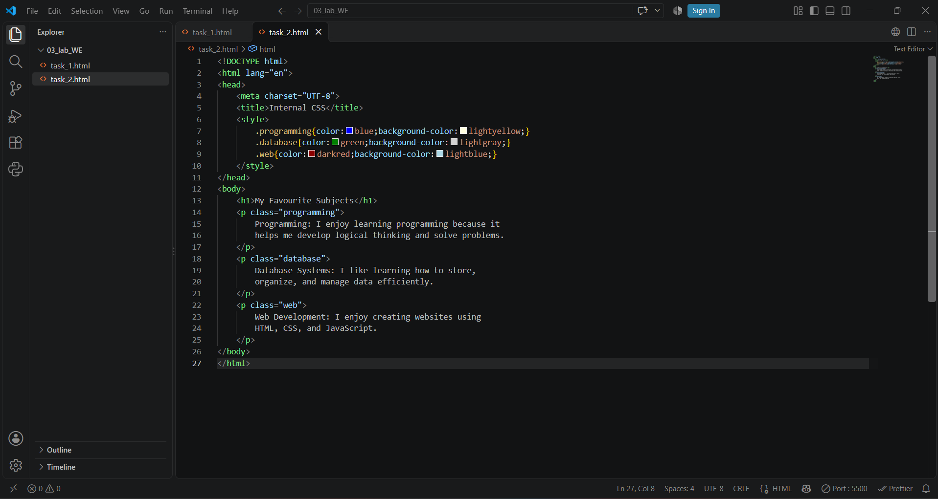
Code Preview:
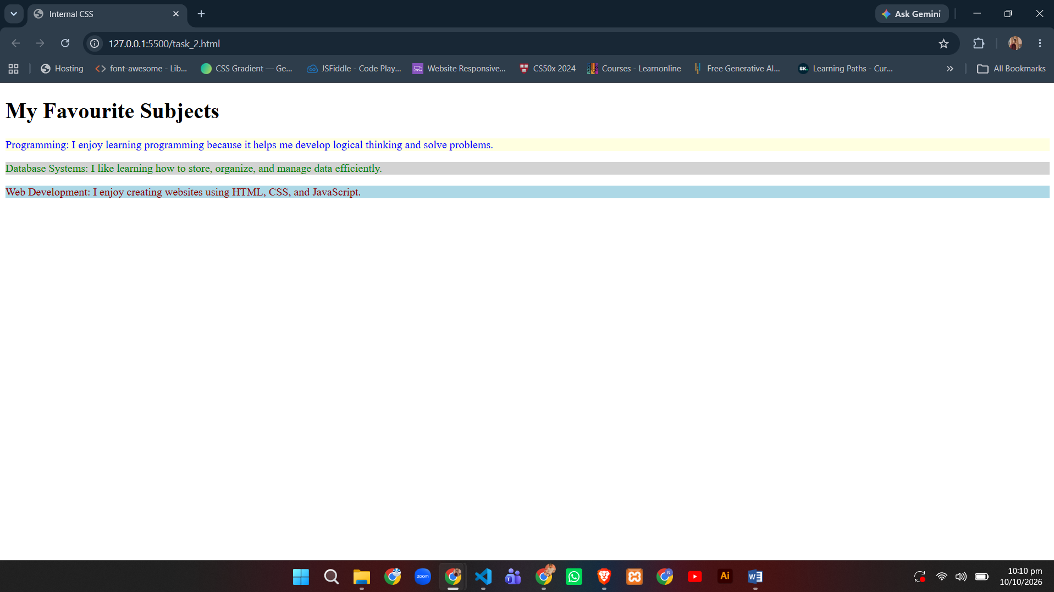

TASK 03
HTML Code:
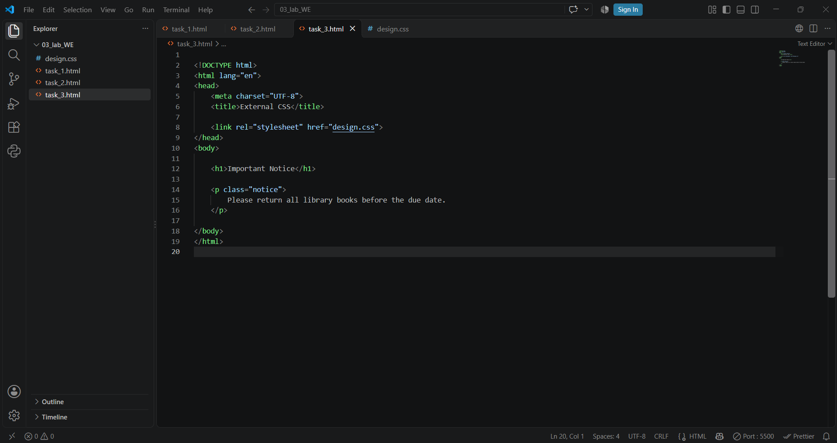
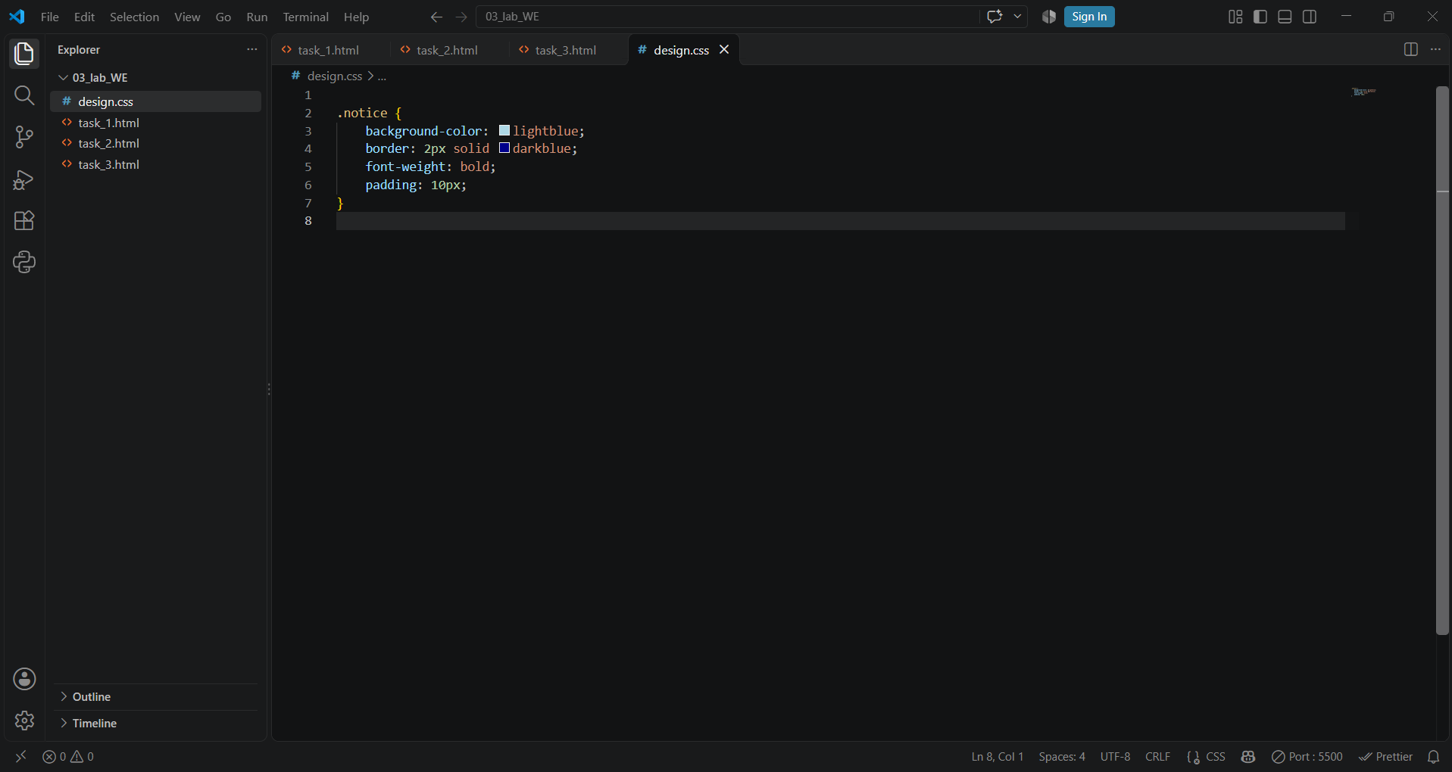

Code Preview:
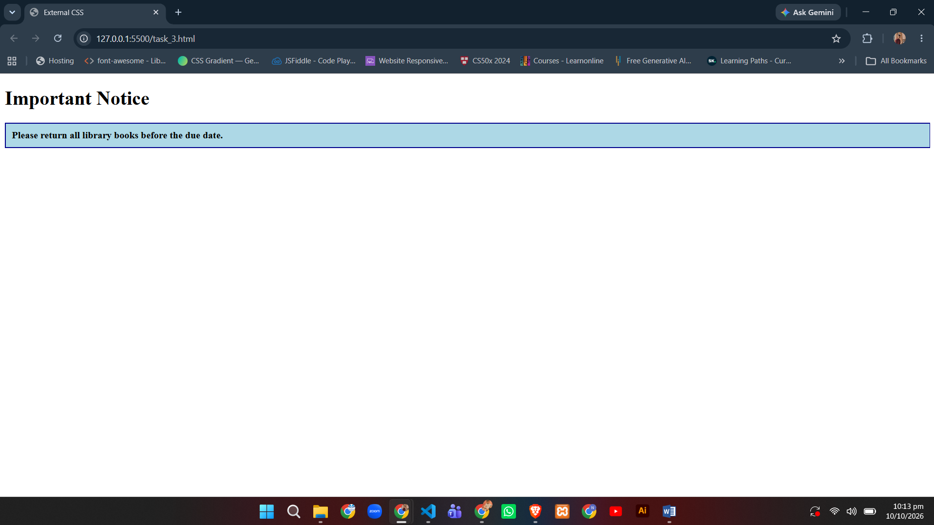

TASK 04
HTML Code:
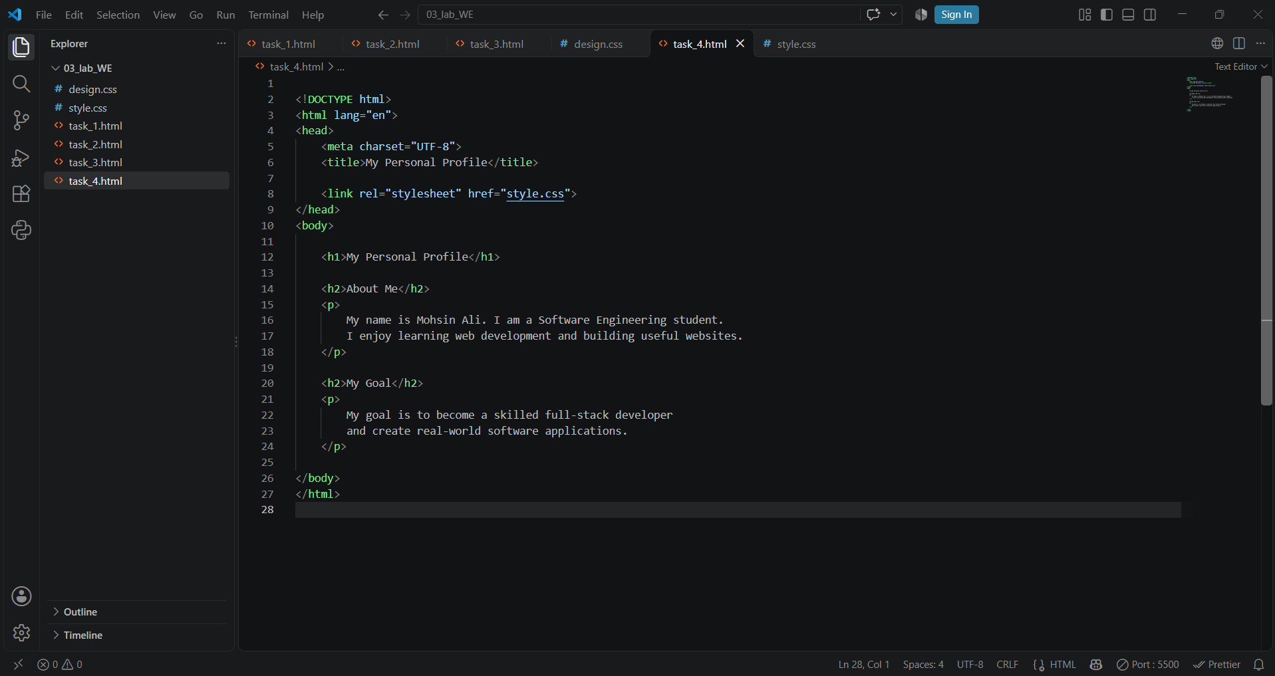
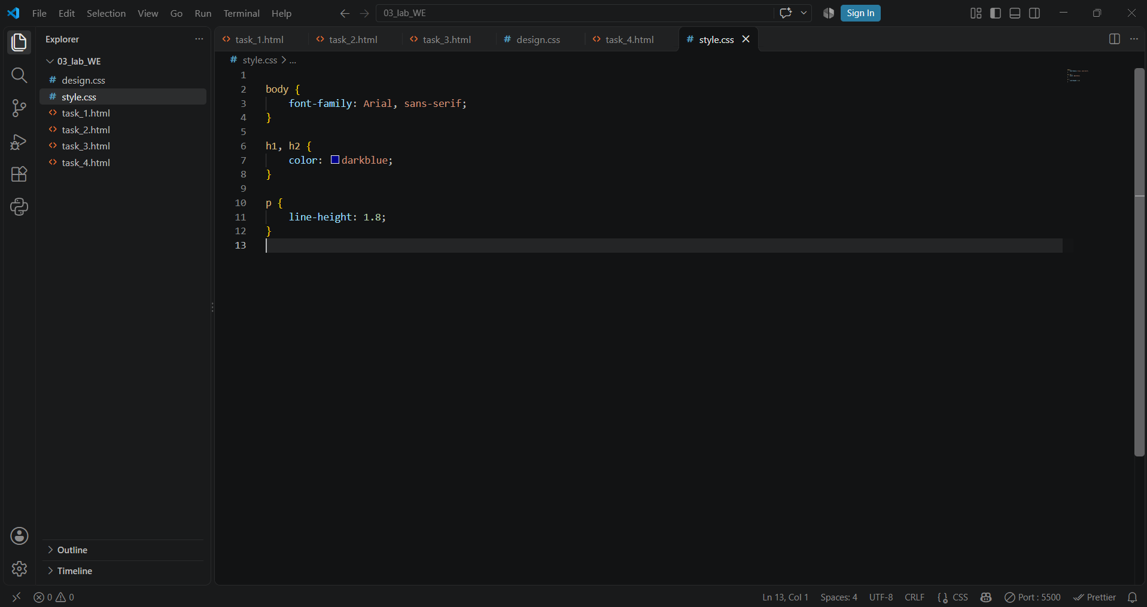
Code Preview:
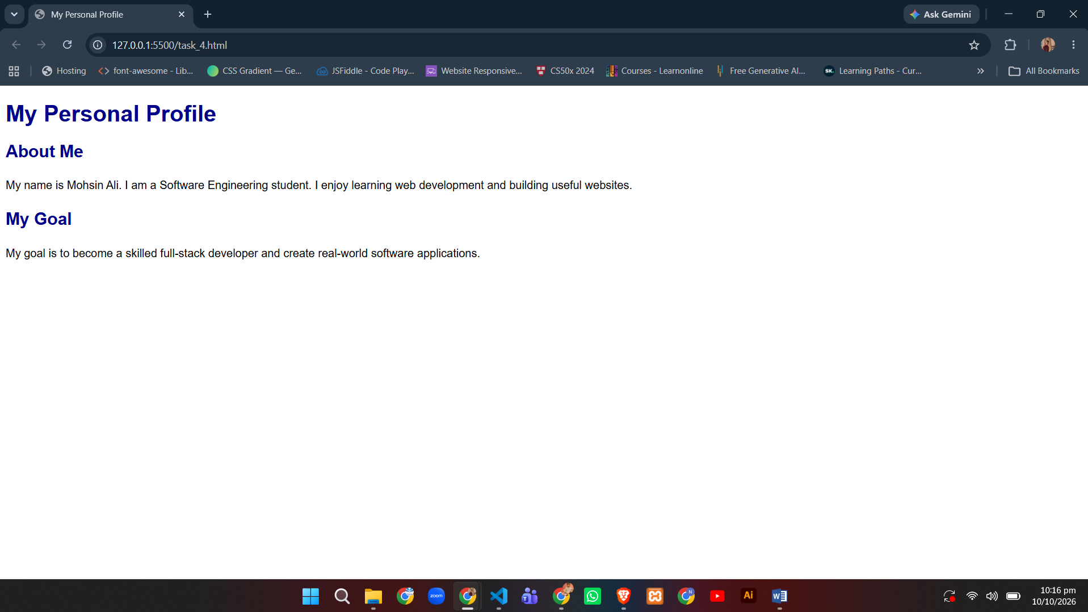

TASK 05
HTML Code:
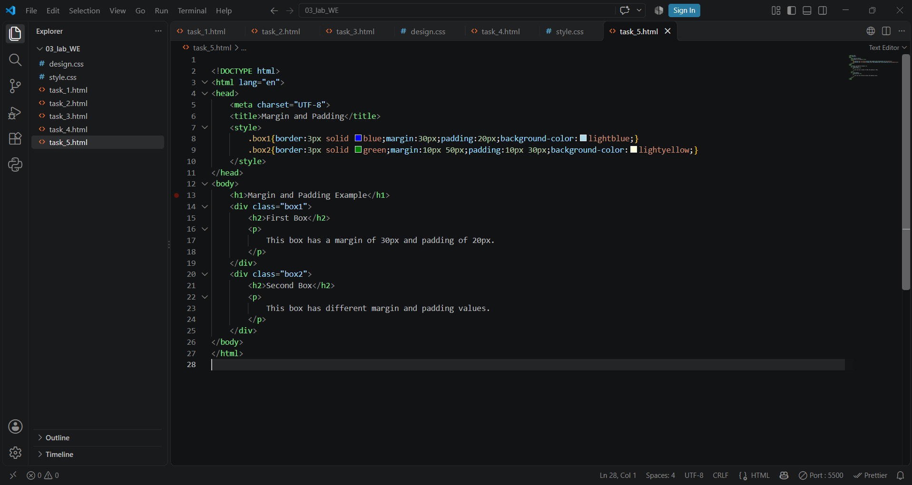
Code Preview:
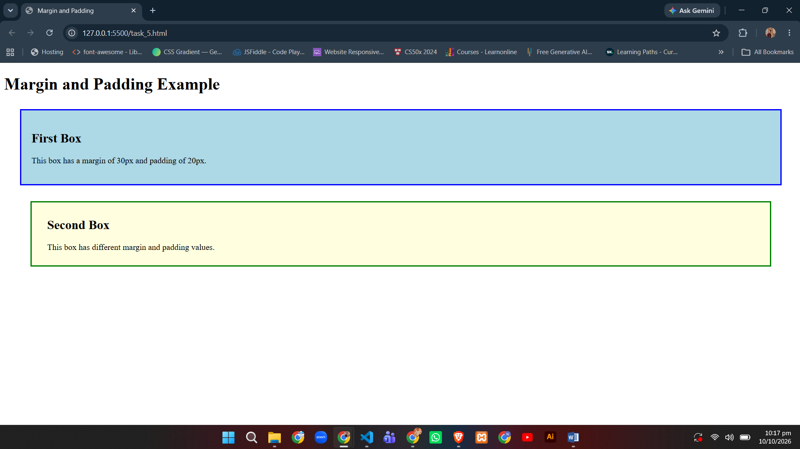

TASK 06
HTML Code:
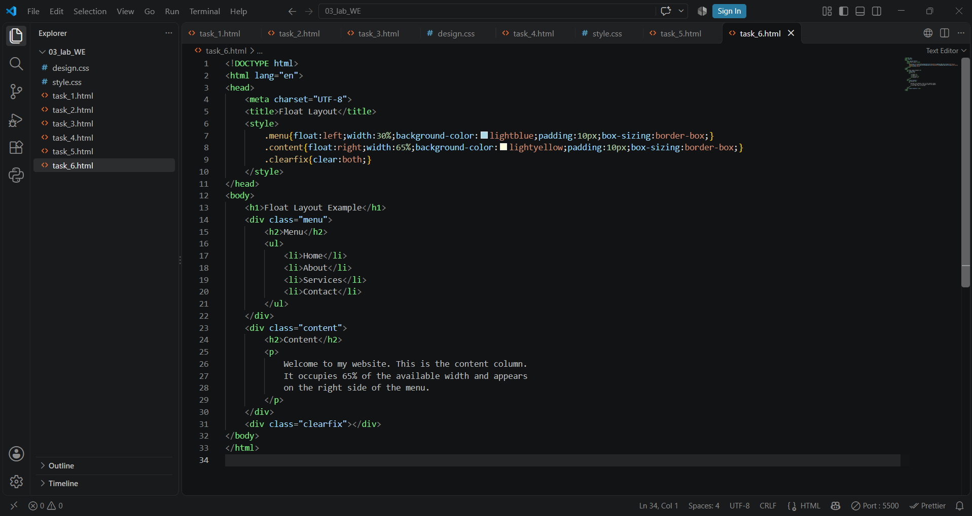
Code Preview:
