Lab #04
Objective:
To PRACTICE the use of different CSS terms such as Box Model, Clear, and Overflow, along with applying Box-Shadow, Linear-Gradient, and creating a Dropdown Navigation menu.
CSS 3: Box Model
Every element that a browser draws on a web page is treated as a rectangular box. The CSS3 Box Model explains how this box is built from four layers: the content in the centre, the padding around the content, the border around the padding, and the margin outside the border. Knowing how these layers add up is essential, because the space an element actually takes on the screen is not just its width and height, but the sum of all four layers. The following examples show the Box Model in code.
index.html:
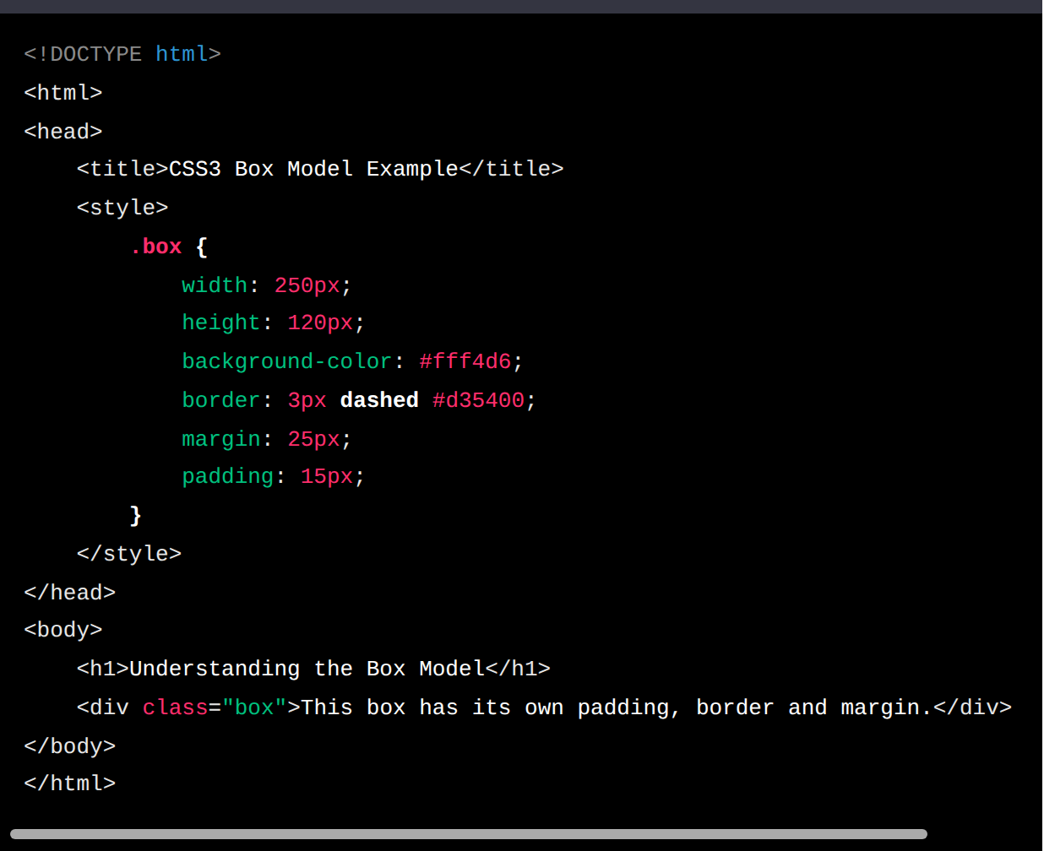
- In this example, an internal style sheet creates a class called .box, which is applied to a <div> element.
- The .box class sets the following properties:
- width: 250px; sets the width of the content area to 250 pixels.
- height: 120px; sets the height of the content area to 120 pixels.
- background-color: #fff4d6; fills the box with a light cream colour. The background also covers the padding area.
- border: 3px dashed #d35400; draws a 3-pixel dashed orange border around the padding.
- margin: 25px; adds 25 pixels of empty space outside the border on all four sides, keeping other elements away from the box.
- padding: 15px; adds 15 pixels of space inside the border, so the text does not touch the edges of the box.
CSS File (styles.css):
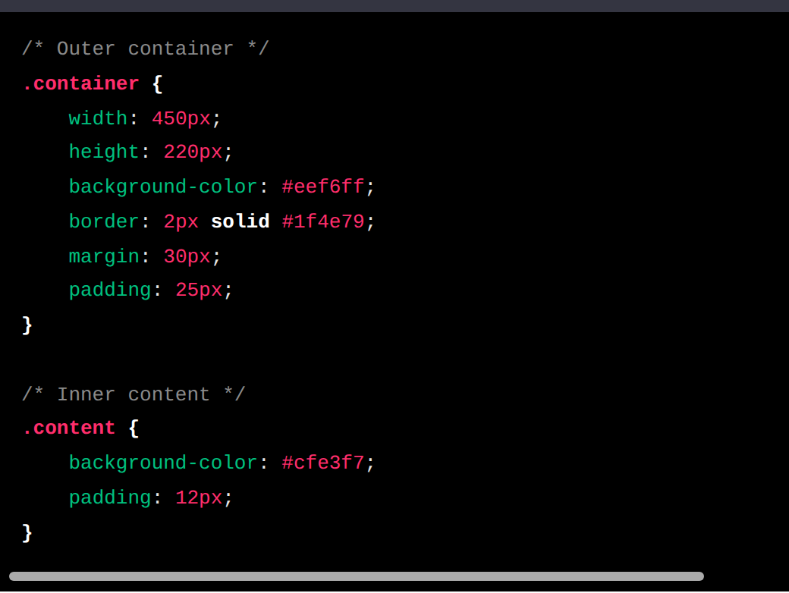
- The HTML file (index.html) connects to the external file styles.css with a <link rel="stylesheet" href="styles.css"> element inside the <head> section, so all the rules written in styles.css are applied to the page.
- The HTML file contains an outer <div> with the class "container" and, inside it, a second <div> with the class "content". The container has a light-blue background, a solid dark-blue border, 30px margin and 25px padding, while the inner content box has its own darker background and 12px padding. Placing one box inside another makes it easy to see how padding pushes the inner box away from the outer border.
The Box Model can be visualised as four boxes nested inside each other:
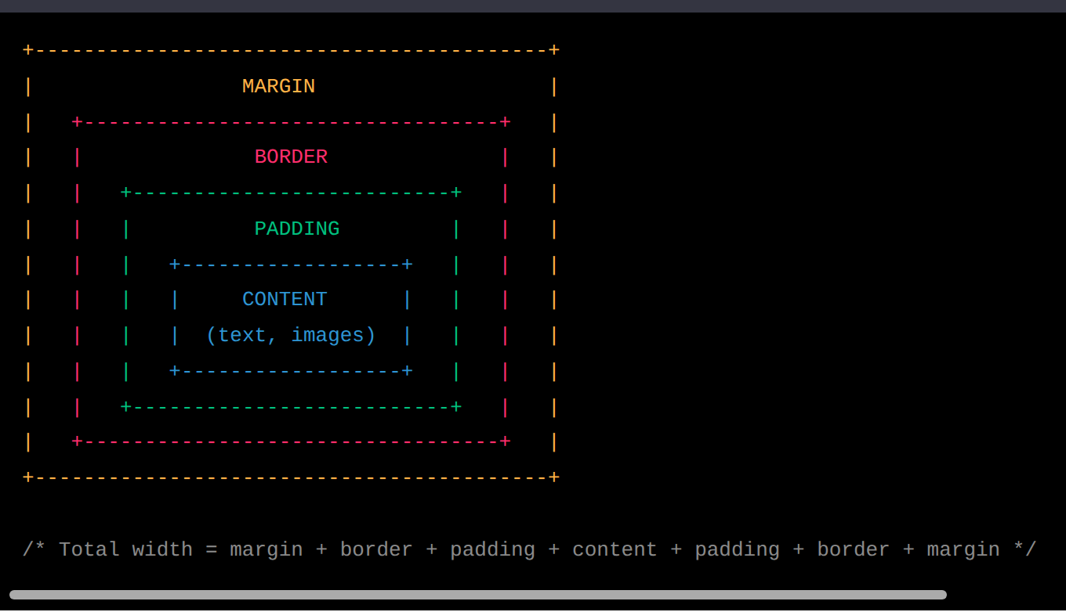
Example: for the .box above, the total width taken on the screen is 25 + 3 + 15 + 250 + 15 + 3 + 25 = 336 pixels, even though its width property is only 250px. Adding box-sizing: border-box; changes this behaviour so that the width includes the padding and border.
CSS 3: Box-Shadow, Linear-Gradient, Dropdown Navigation
HTML File (index.html): Box-Shadow
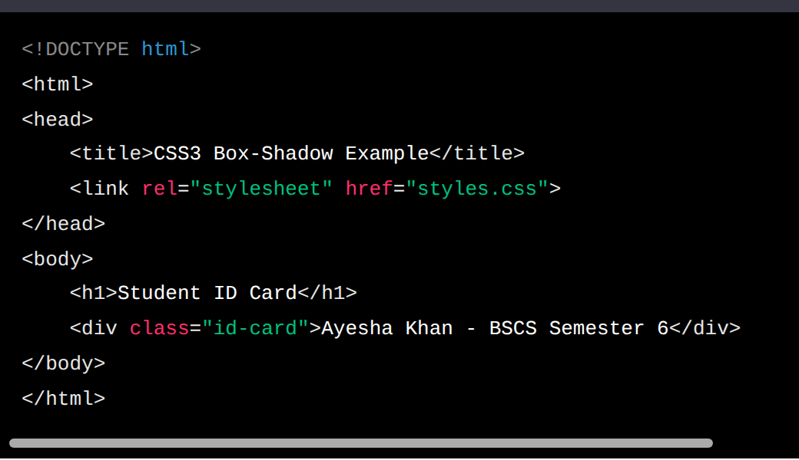
CSS File (styles.css): Box-Shadow
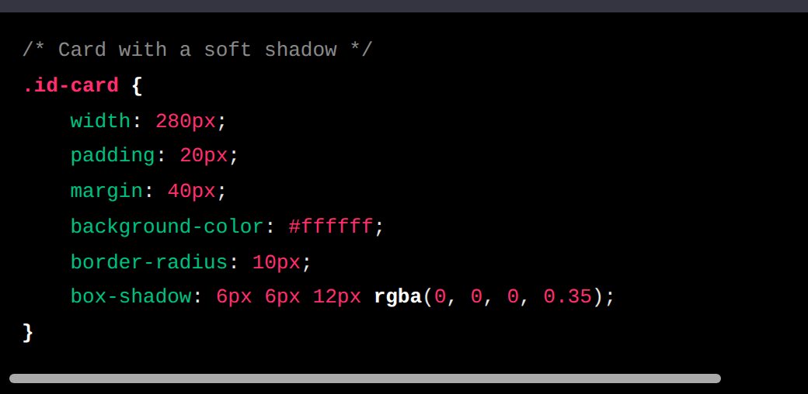
Description:
- The HTML file (index.html) links the external file styles.css using the <link> element inside the <head> section, so the shadow style written in the CSS file is applied to the page.
- The HTML file contains a <div> with the class "id-card", which looks like a student ID card. In styles.css, the box-shadow: 6px 6px 12px rgba(0, 0, 0, 0.35); property draws a shadow 6px to the right and 6px below the card, blurred over 12px. The rgba colour is black at 35% opacity, which gives a soft, realistic shadow, and border-radius: 10px; rounds the corners of the card.
HTML File (index.html): Linear-Gradient
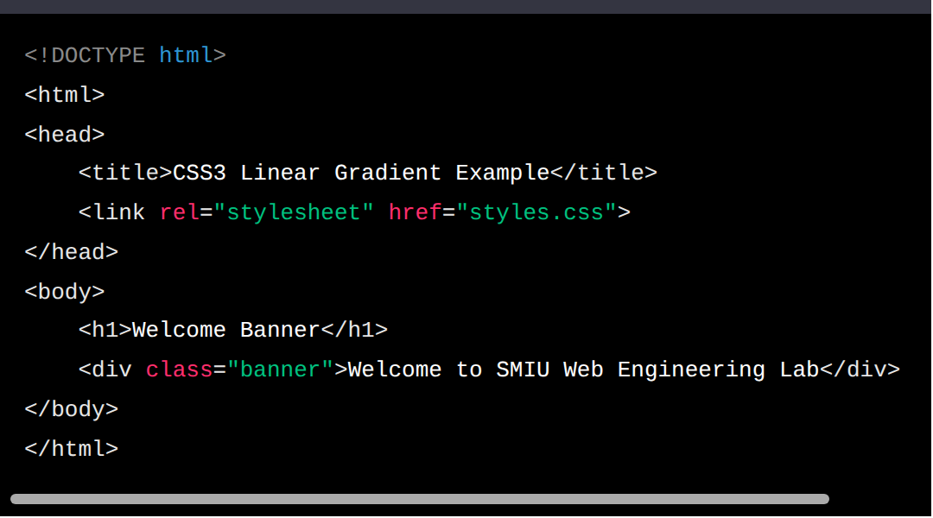
CSS File (styles.css): Linear-Gradient
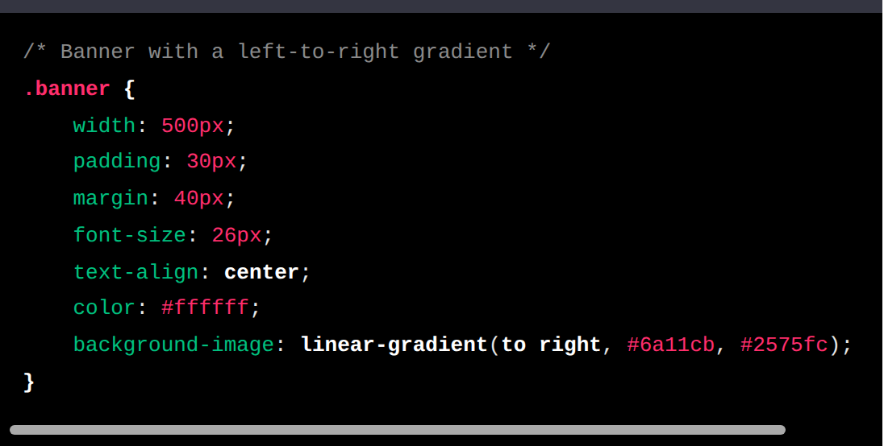
Description:
- The HTML file (index.html) links the external file styles.css using the <link> element inside the <head> section, so the gradient style is applied to the page.
- The HTML file contains a <div> with the class "banner". In styles.css, background-image: linear-gradient(to right, #6a11cb, #2575fc); fills the banner with a smooth blend that starts purple on the left and changes to blue on the right. The direction can also be written as an angle, such as 45deg, and more than two colours can be added. White text and centred alignment keep the welcome message readable on top of the gradient.
HTML File (index.html): Dropdown Navigation
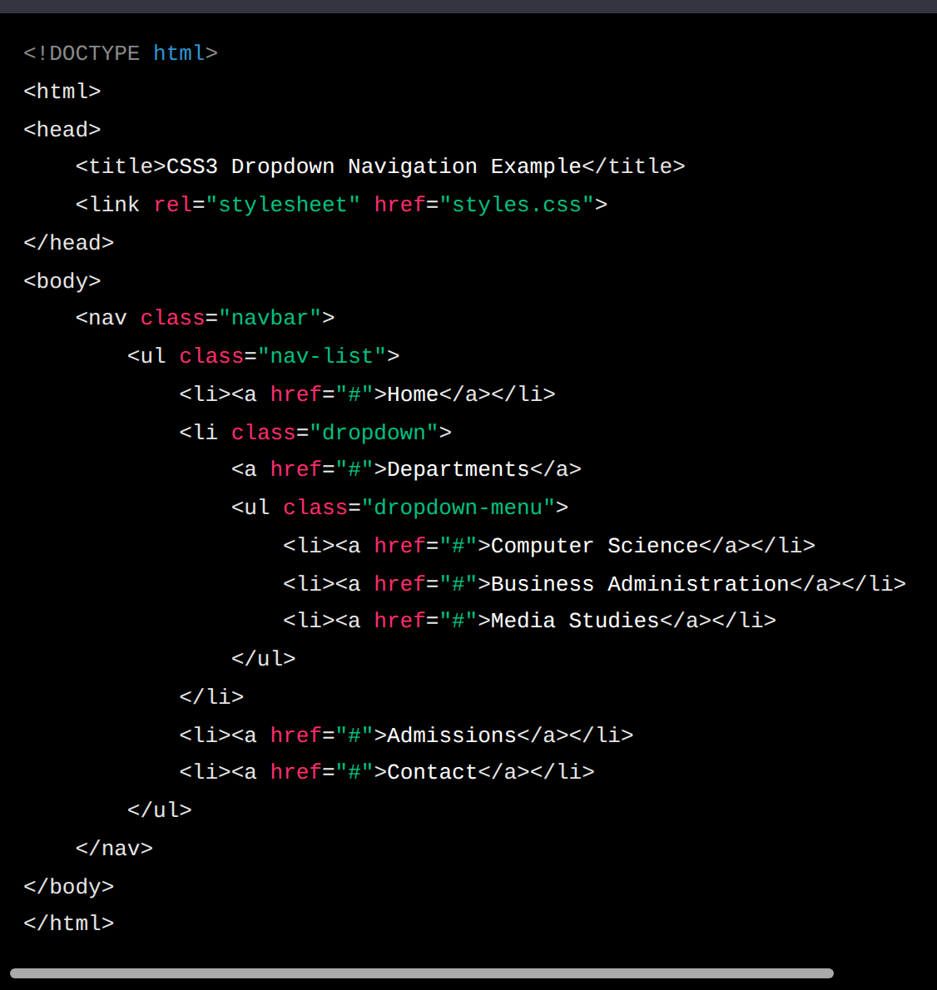
CSS File (styles.css): Dropdown Navigation
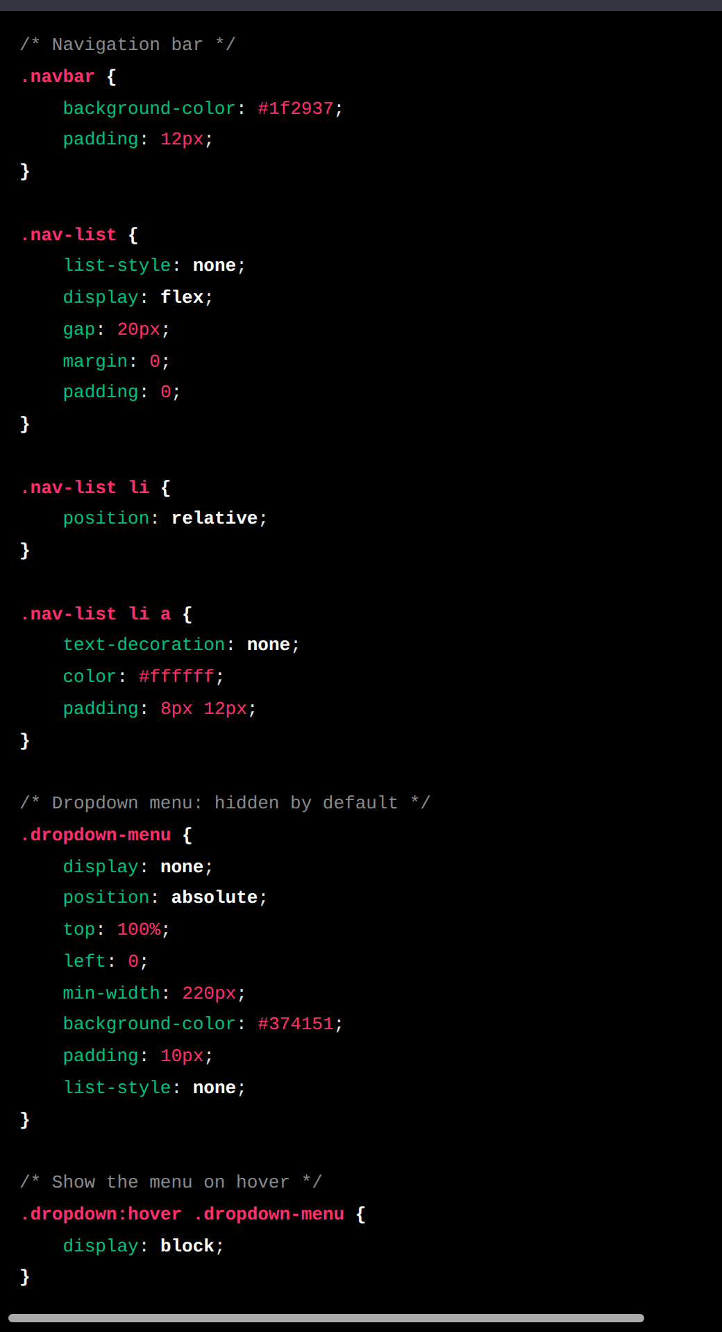
Description:
The HTML file (index.html) links the external file styles.css using the <link> element inside the <head> section, which connects all the navigation styles to the page.
The HTML file contains a <nav> element with the class "navbar", which represents the navigation bar of a university website. Inside it, an unordered list with the class "nav-list" holds the menu items: Home, Departments, Admissions and Contact. The Departments item has the class "dropdown" and contains a second, nested list with the class "dropdown-menu", which lists the departments.
In styles.css, display: flex; places the menu items in one horizontal row, and list-style: none; removes the bullets. The dropdown menu is hidden with display: none; and positioned with position: absolute; top: 100%; so that it appears directly below its parent item. Its parent uses position: relative; so the menu is placed relative to it. Finally, the rule .dropdown:hover .dropdown-menu { display: block; } shows the sub-menu only while the mouse is over Departments.
Tasks:
Create CSS3 and HTML5 program following.
CSS3: Box Model
- Create a <div> with the class "profile-box" and give it a 3px solid green border, a width of 320px, a height of 180px, padding of 25px and a margin of 35px.
- Inside the "profile-box" div, add a paragraph introducing yourself. Give the paragraph a light-yellow background (#fff9c4) and a font size of 18px. Then calculate and write, in a CSS comment, the total width the box takes on the screen.
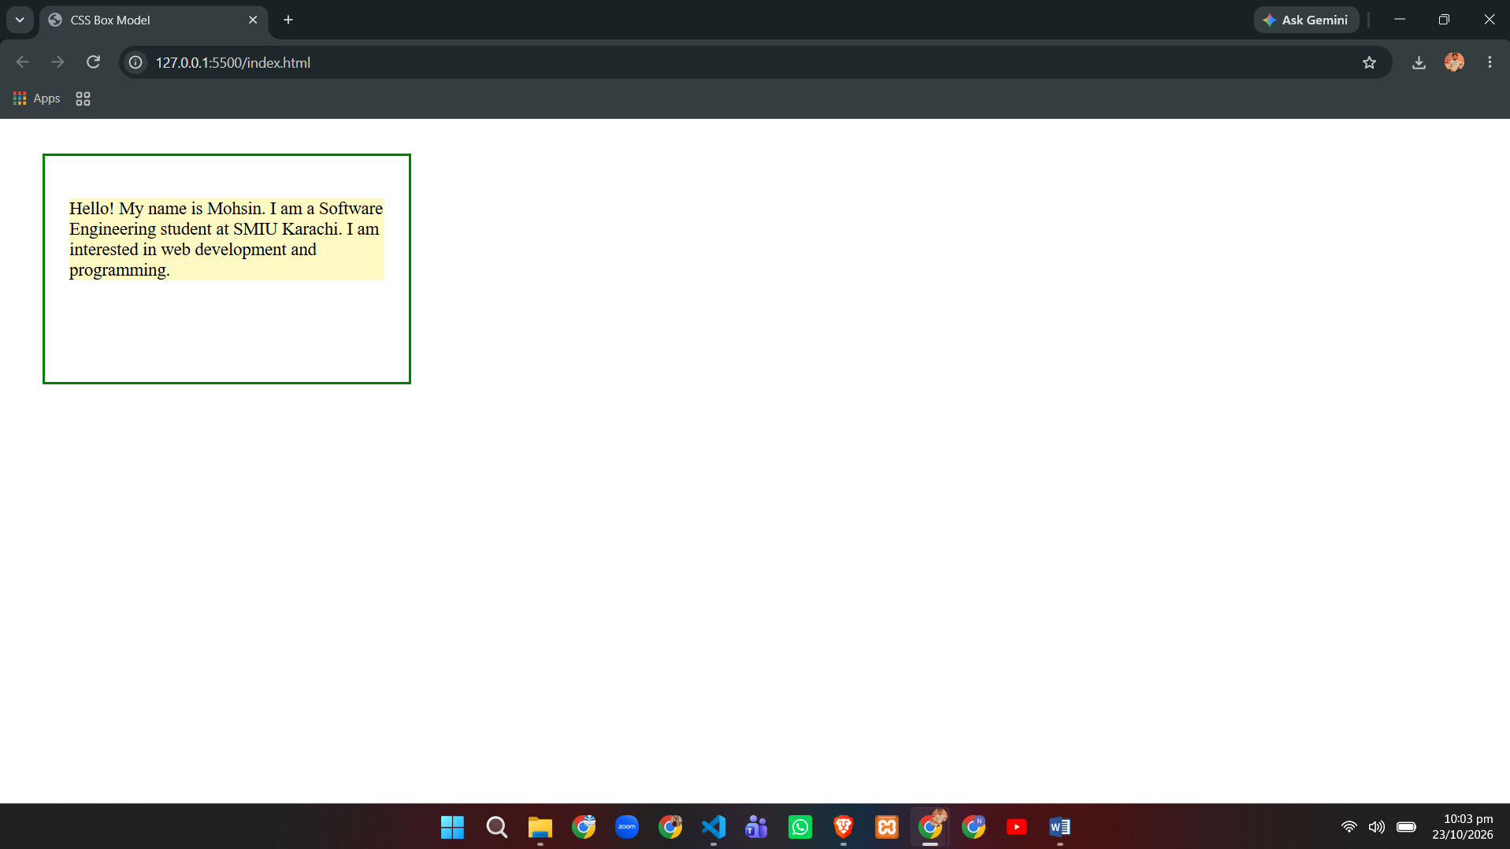
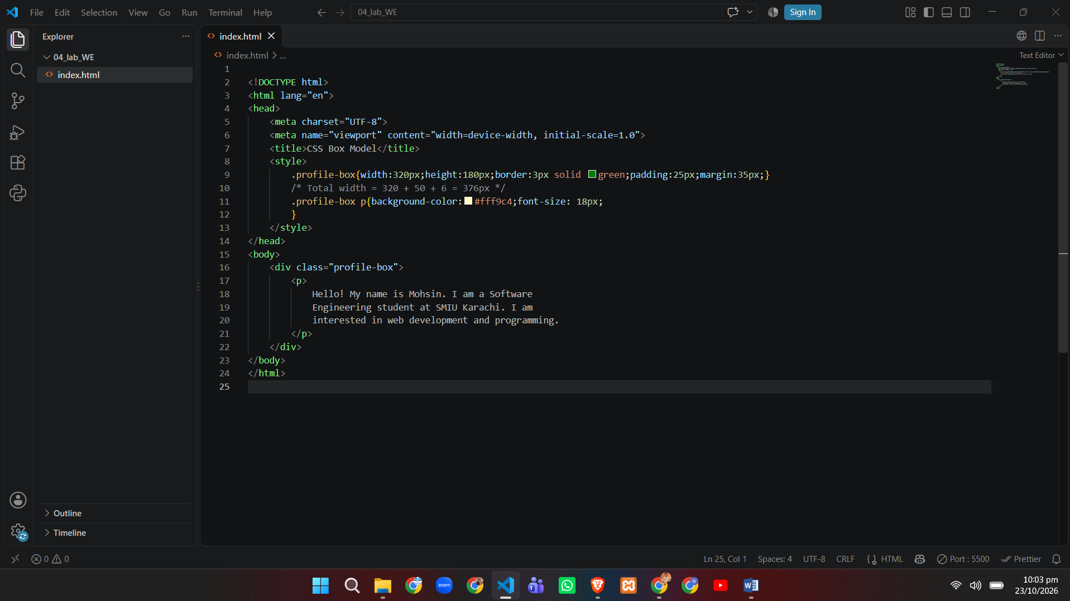
CSS3: Box-Shadow, Linear-Gradient, Dropdown Navigation
- Create a navigation bar with the class "menu-bar" for a restaurant website. Give it a linear-gradient background from #ff512f to #dd2476, white text and padding of 12px.
- Inside the "menu-bar", create an unordered list with the class "menu-list". Display the list items in one row and separate them with some margin.
- Apply a box-shadow to the "menu-bar" with a 4px horizontal offset, a 4px vertical offset and a blur radius of 8px.
- Style the links inside "menu-list" with no underline, white text colour and a font size of 17px.
- Create a dropdown menu for the "Menu" list item that shows Starters, Main Course and Desserts. When the mouse hovers over "Menu", display a sub-menu with the class "dropdown-menu", with a background colour of #4a4a4a and padding of 10px, appearing directly below the "Menu" item.
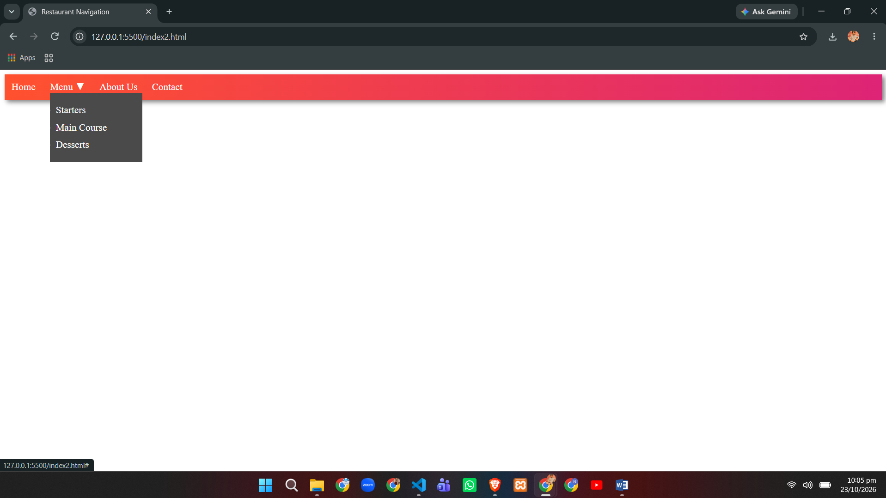

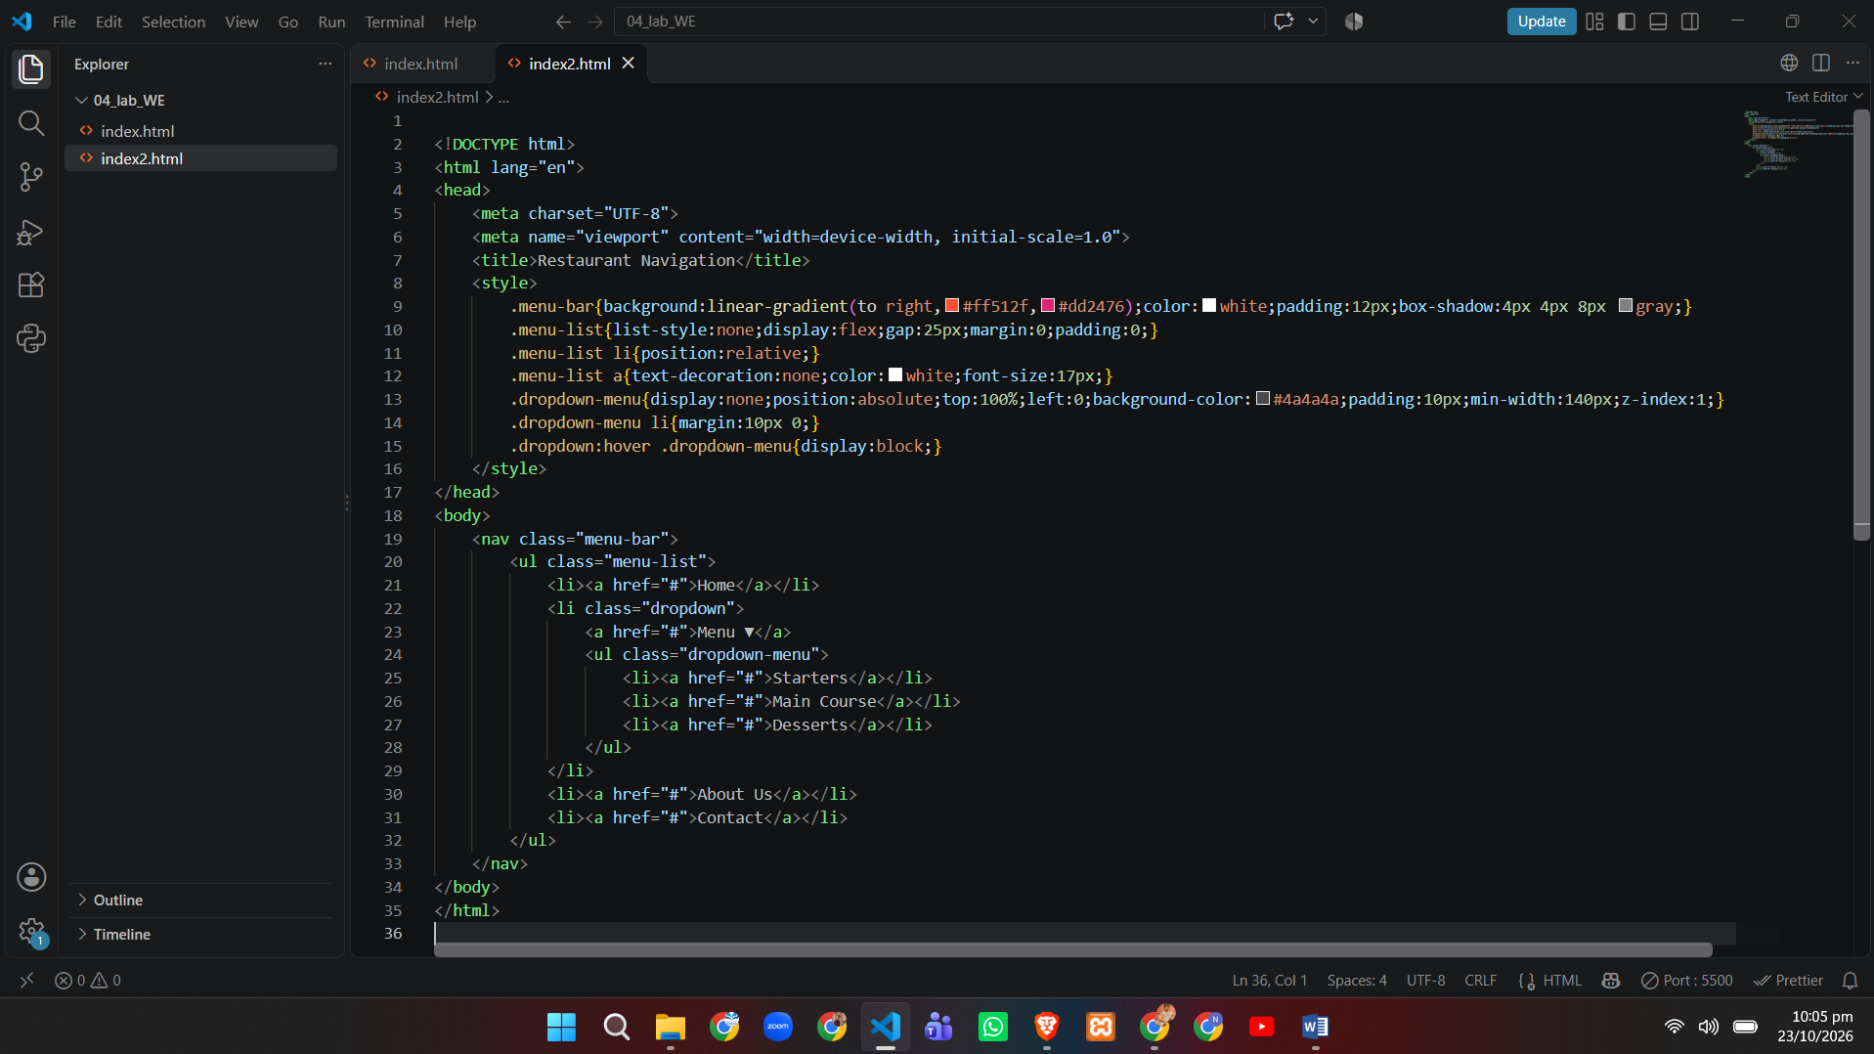
Record Notes

