CHRIST (Deemed to be University)
Department of Computer Science
4MCA- Artificial Intelligence & Machine Learning (MCA475)
CIA-3
DATE: 25-08-2025 Time: 9.45 To 11.45 AM Max Marks: 35

Program-1 CO:1,2,4 L4 – Analyzing L5 – Evaluating L6 – Creating
You are designing a perceptron to replicate the logical AND function using two binary inputs. How will you set the weights and threshold manually to achieve this?
- Write a python script to create a perceptron and demonstrate AND operation use two input neurons and one output neurons initialize the random weights for two input neurons between 0.2 to 0.8 and display the error function (3 M)

- Write a python script to create a perceptron and demonstrate OR operation use two input neurons and one output neurons initialize the random weights for two input neurons between 0.4 to 0.7 and display the error function. (3 M)

- Input: One binary input, X. and describe the neural network structure that could perform the NOT operation.
3.1 What values should the weights and biases take, and why?
3.2 Assume you are provided with the correct input-output pairs for each gate. Describe the process of training the neural network to learn the correct weights and biases using a neural network approach (4 M)
4. Interpret and visualize the results (2 M)
Program-2 CO:1,3,4 L3 – Applying, L4 – Analyzing
You are a data scientist working for an educational analytics company. Your team has collected a dataset of students' performance in various subjects, their demographics, and socio-economic factors. The dataset includes various features.
The goal is to use LDA to classify students into different performance levels such as (low and high) based on the attributes VisITedResources, Discussion. This classification will help in identifying students who might need additional support or advanced learning opportunities.
- Compute the class mean value for the classes L & H (0.5 M)

- Compute co-variance matrix for both the classes (0.5 M)

- Calculate Within-class scatter matrix using the formula SW=S1+S2 (S1 & S2 are the covariance matrix for the classes L & H respectively) (0.5 M)

- Find the Between-class scatter matrix using the formula (0.5 M)
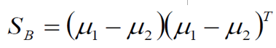
- Perform the LDA projection using the formula (1 M)
- compute eigen vector W using the formula (1 M)
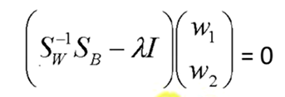
- Multiply every two-dimensional input sample with the largest eigen vector (1 M)

- Interpret & visualize the data in the reduced two-dimensional space (1 M)
Assume we have the below dataset which has 4 features and a total of 5 training examples.
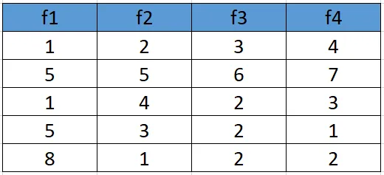
- standardize the dataset use the following formula (0.5 M)
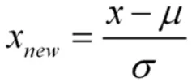
- Calculate the covariance matrix (Without using built in function) for the whole dataset (0.5 M)
- Calculate eigenvalues and eigen vectors (Without using built in function) (1 M)
- Sort eigenvalues and their corresponding eigenvectors (1 M)
- Pick k eigenvalues and form a matrix of eigenvectors (1 M)
- Transform the original matrix. (1 M)
- Visualize and interpret the result (1 M)

Note:
Students are required to complete the corresponding code for each scenario and submit their completed code as ipynb file & Pdf File.
It is expected that students provide comprehensive descriptions in their code (Syntax of the function used), specifying the purpose and usage of each function or package.
Evaluation rubrics:
Coding Proficiency (20 Marks)
Program-1 : 10 Marks
Program-2 : 10 Marks

Usage of packages and functions (6 Marks)
Program-1 : 3 Marks
Program-2 : 3 Marks

Interpretation and visualization of results appropriately (4 Marks)
Program-1 : 2 Marks
Program-2 : 2 Marks
WriteUp-5

