Department of Computer Science
MCA575 / Neural Networks and Deep Learning
Program 2: Activation Functions

- Create a perceptron to demonstrate the following
  - AND operation
  - OR operation
  - XOR operation
- Build Activation Function from scratch to display the range values as shown in the figure (Refer Unit-1 Slides)
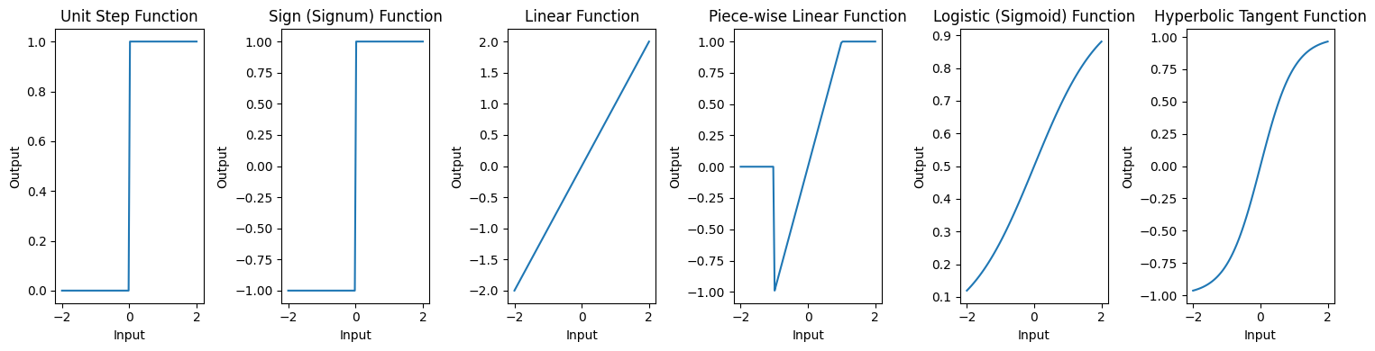
For example,
- Complete the `sigmoid(x)` function to compute the sigmoid activation.
- Complete the `tanh(x)` function to compute the hyperbolic tangent
  - For example: x_values = np.linspace(-1, 1, 50)
- Plot both functions.
- Answer the analysis question below.
  - What are the output ranges for Sigmoid and Tanh? How are they similar and different?
3. Use the dataset from the link below
archive.ics.uci.edu/dataset/267/banknote+authentication
4. Train the network on the banknote data and compare the performance of `sigmoid`
vs. `relu` activation functions

