1. S3 Bucket creation.

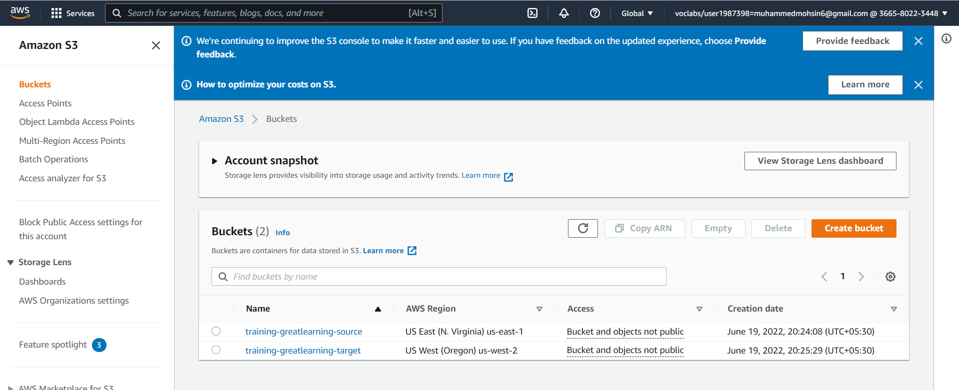

1. Login into AWS Cloudshell

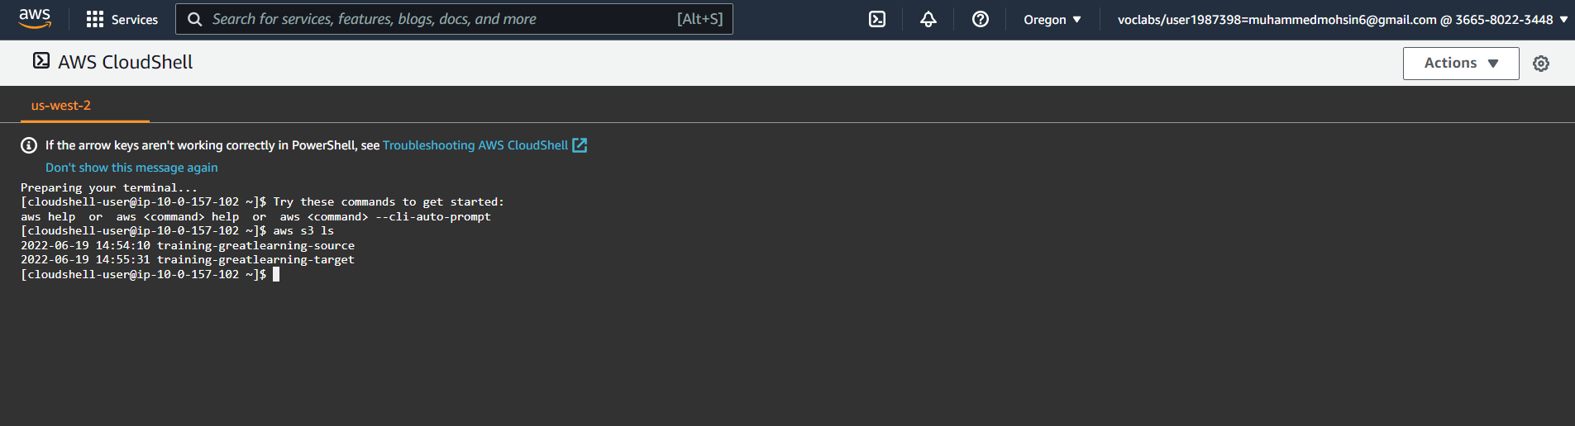

1. Listing and creating S3 Buckets. Also, file uploaded to source

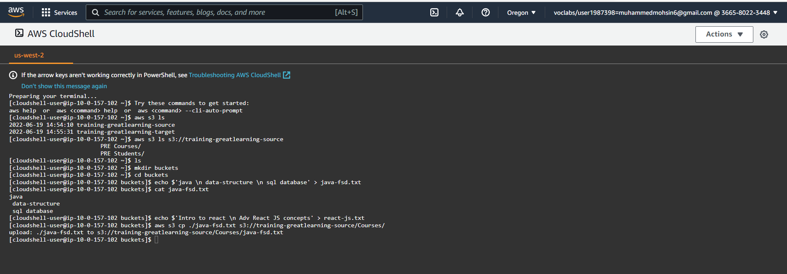

1. Source S3 bucket.

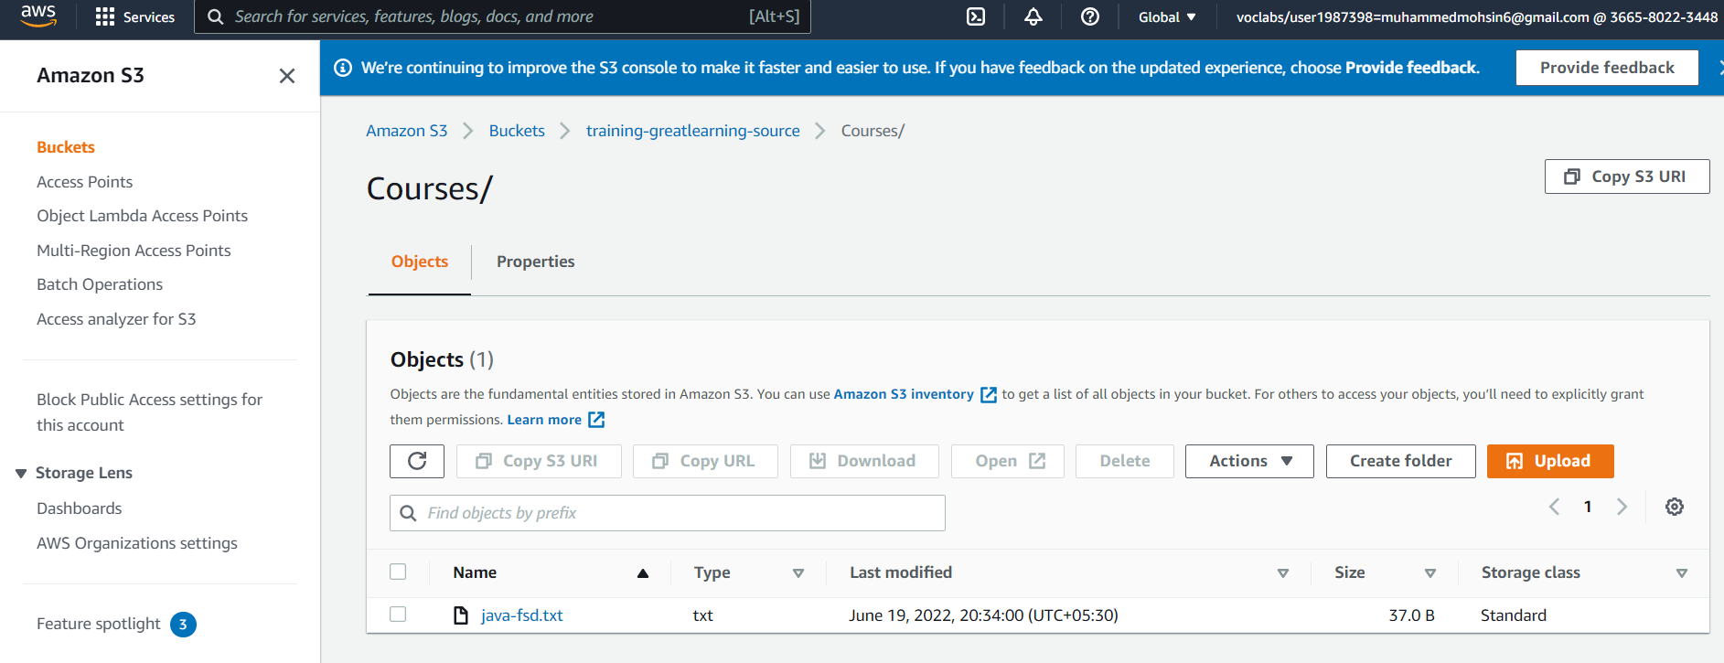

1. Creating Replication Rule.

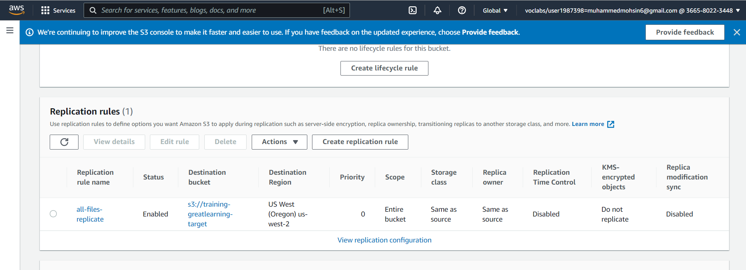

1. Uploading Files after applying replication rules.

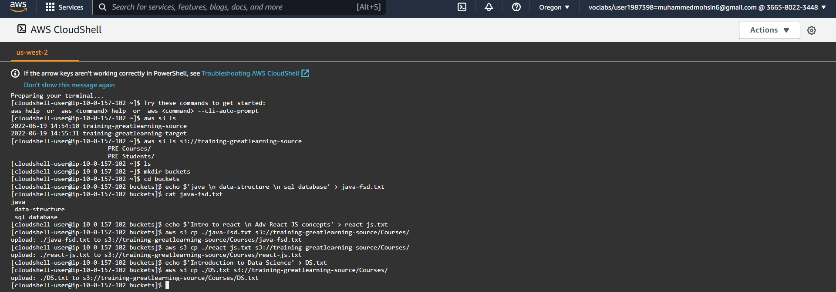

1. Replication of file at target S3 bucket.

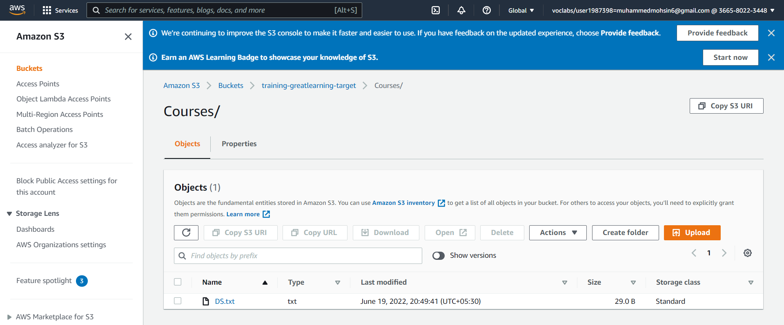

1. Uploading more files.

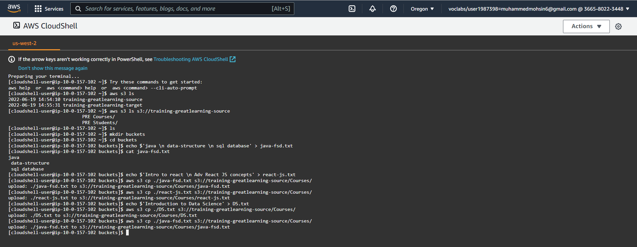

1. Target S3 bucket.

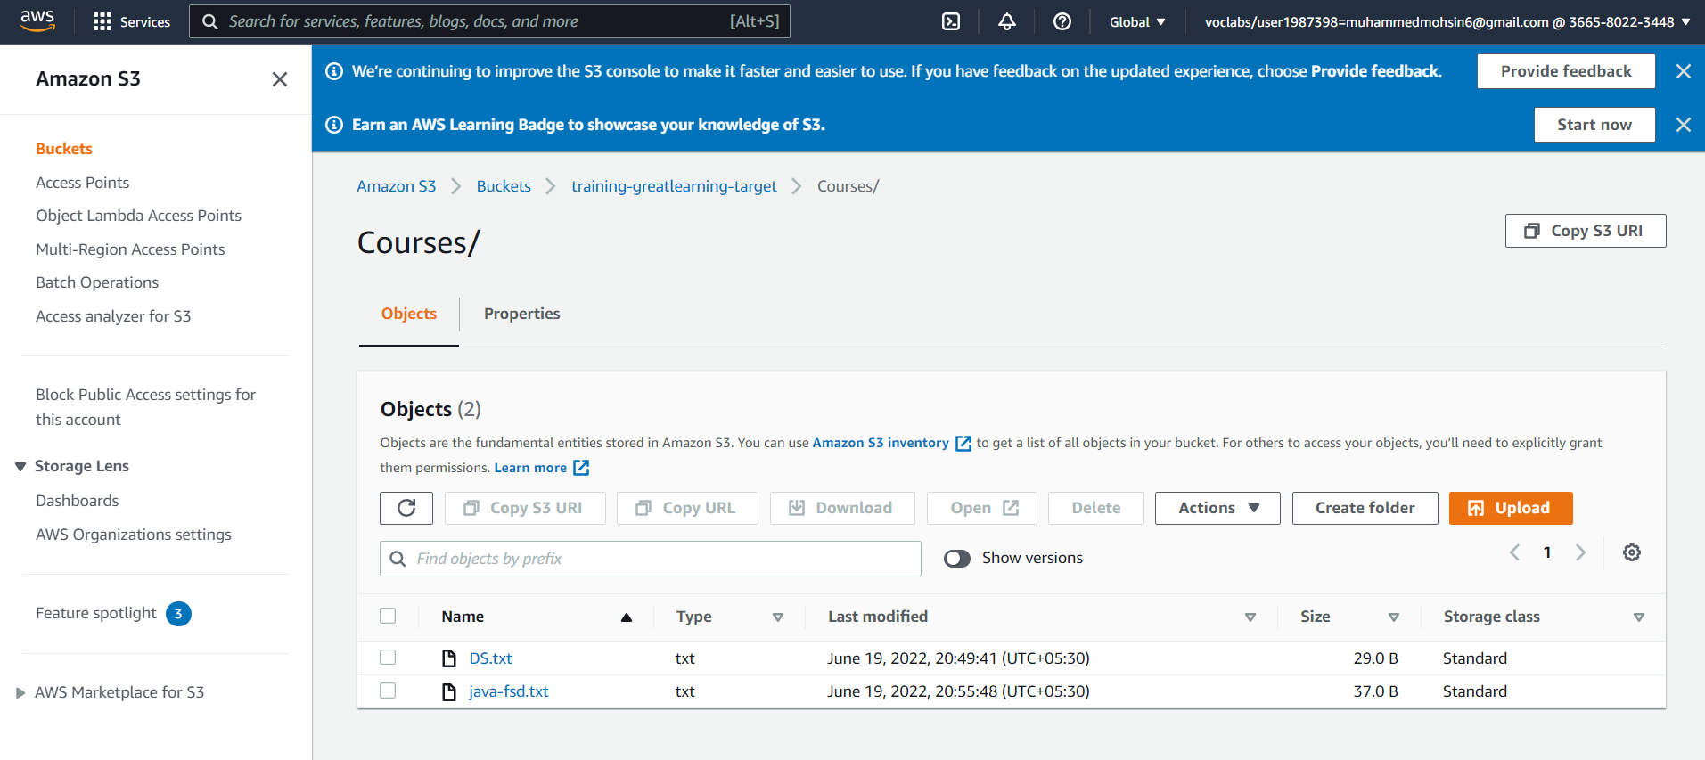

1. Versioning at source S3 bucket as the file was uploaded twice at source S3.

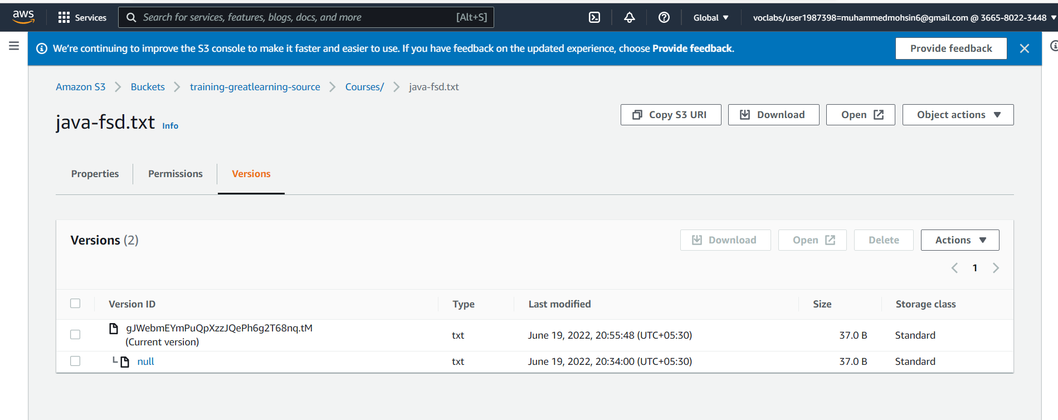

1. Creating new Replication rule.

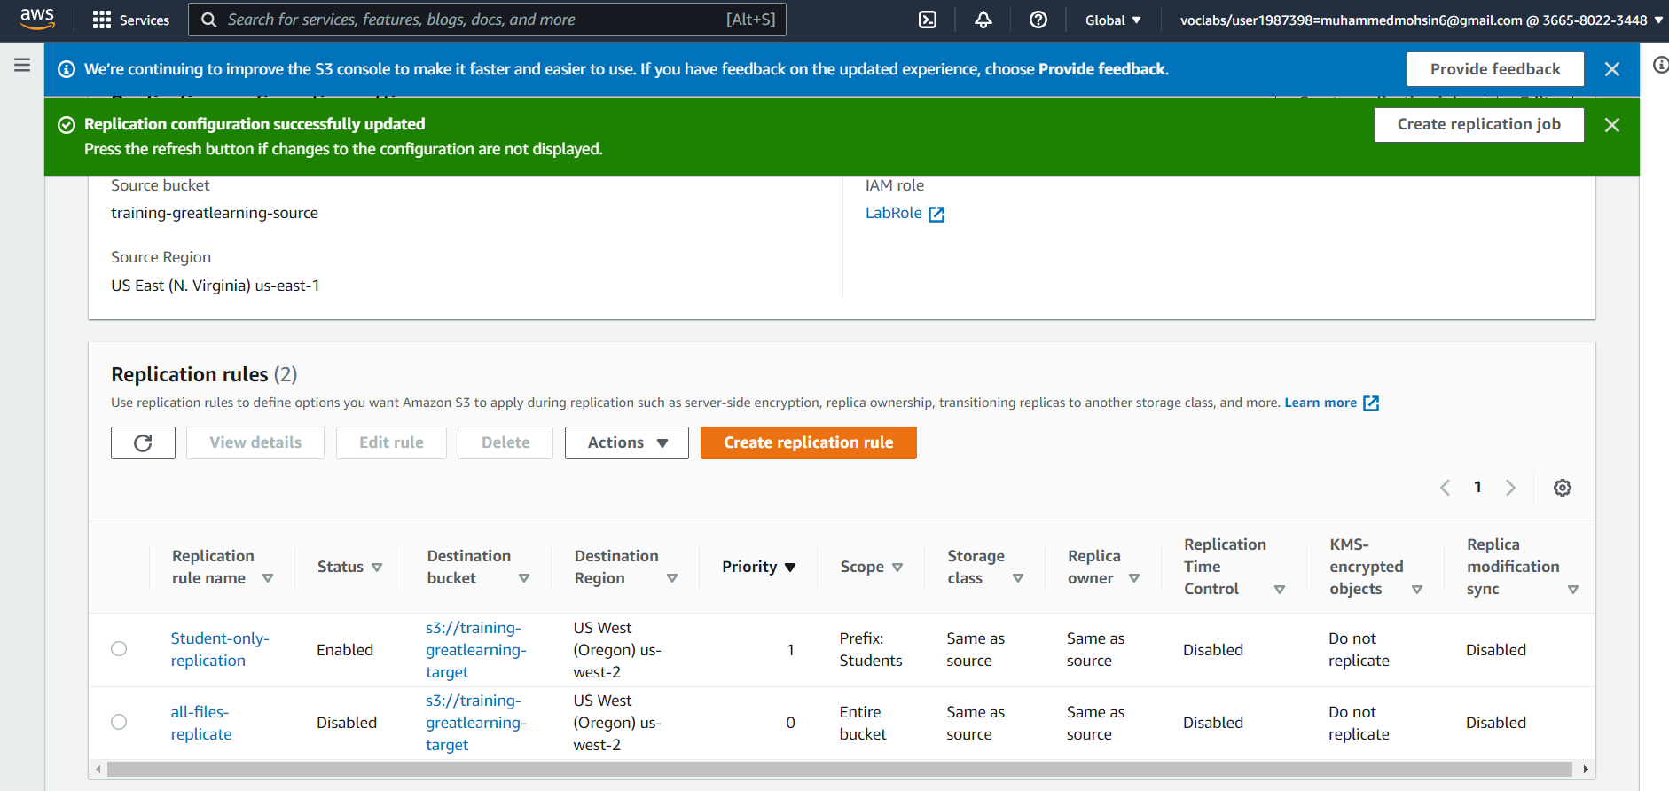

1. Uploading Files.

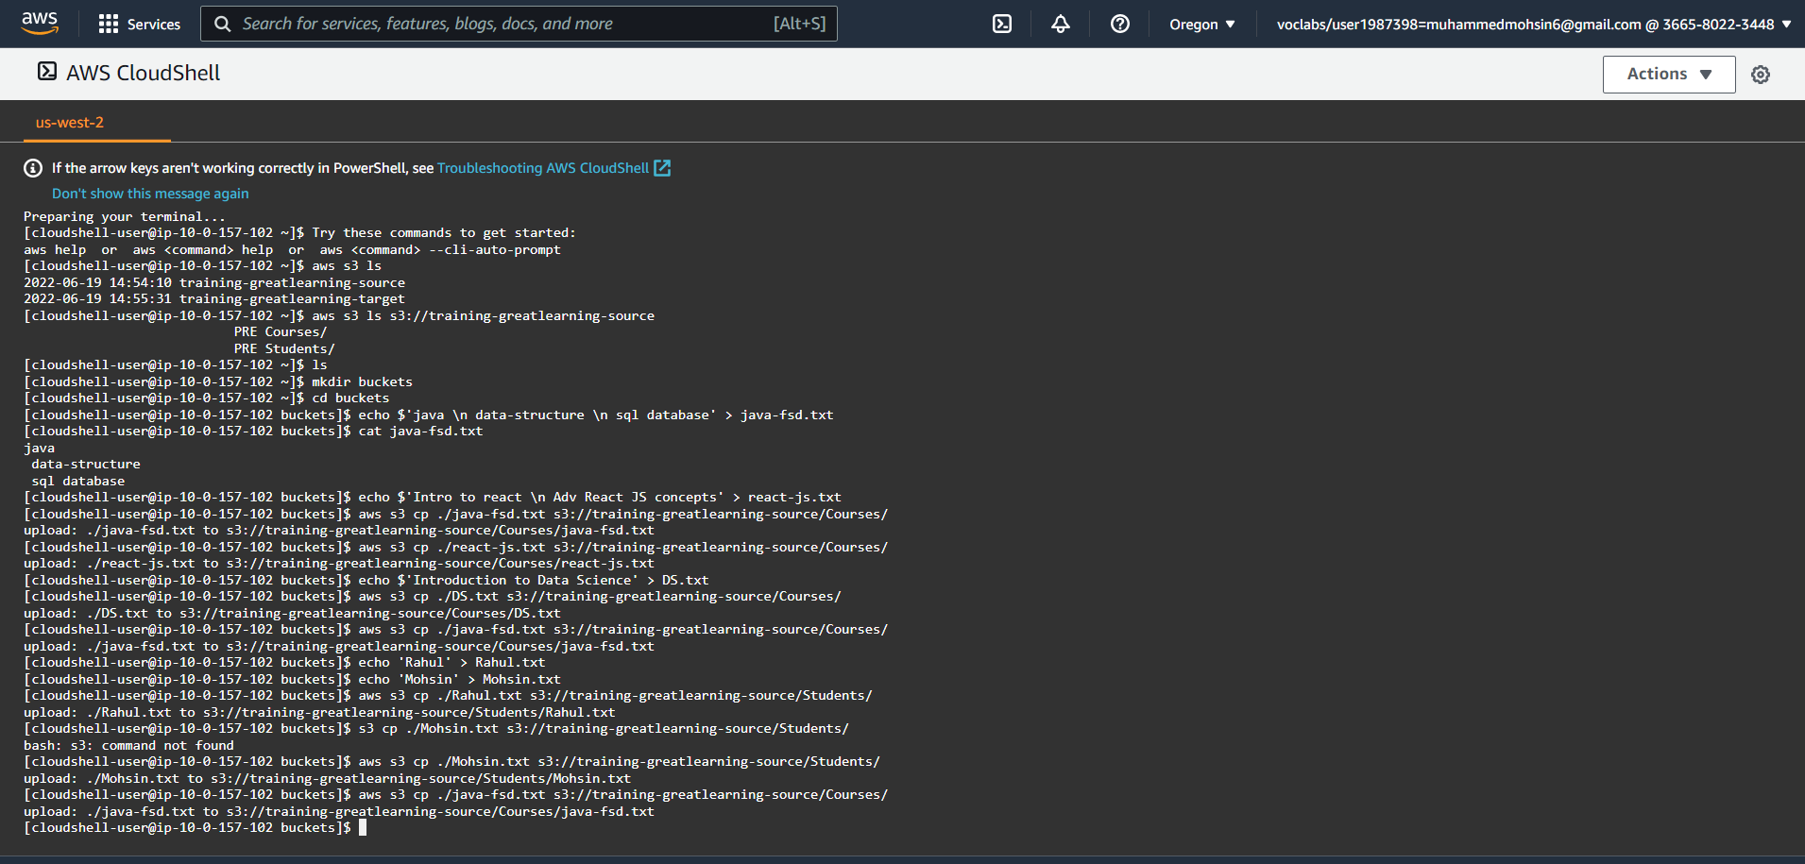

1. Replication done at target bucket for students folder.

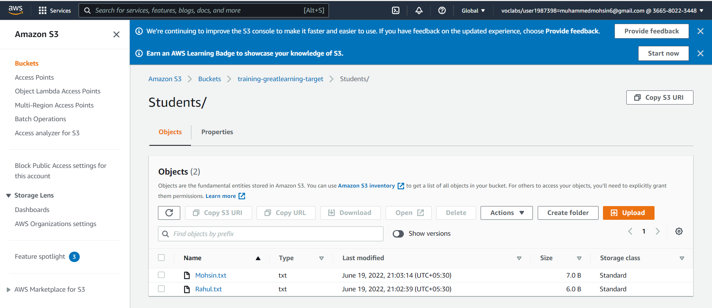

1. No versioning for FSD.txt on target as the replication rule is for Students folder only :

