SQL

show databases;

* CREATE DATABASE CUSTOMERS;
* Show tables

create table student(

-> student_id int auto_increment primary key,

-> firstname varchar(100)

-> lastname varchar(100)

-> );

Show tables

insert into student(firstname,lastname) values("ready","vv");

select firstname from student

alter table student add age int(11);

alter table student drop column province

**delete update**

alter table stude drop column class;



**Primary Key**

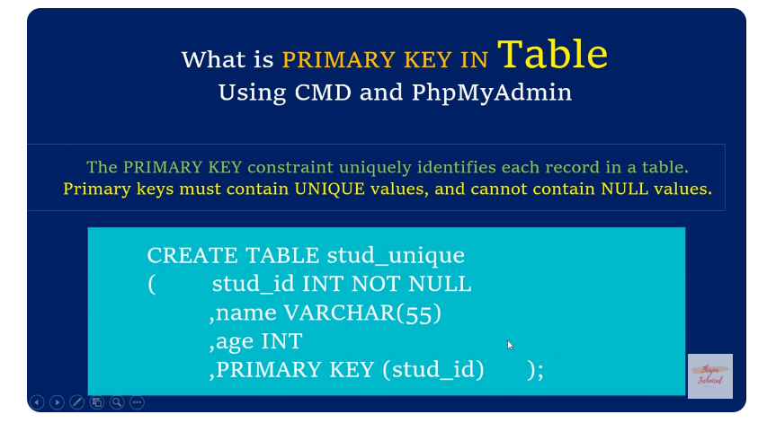

**Add data in table**

**+----+---------+-------+------+**

**| id | fname | lname | age |**

**+----+---------+-------+------+**

**| 1 | ali | khan | 15 |**

**| 2 | asim | khan | 50 |**

**| 3 | khurram | khan | 23 |**

**| 4 | zainab | khan | 23 |**

**| 5 | nomi | shah | 20 |**

**+----+---------+-------+------+**

**Update**

update student set age =50 where fname ='asim';

delete



**Distinct**



select distinct age from student;

**orderBy**

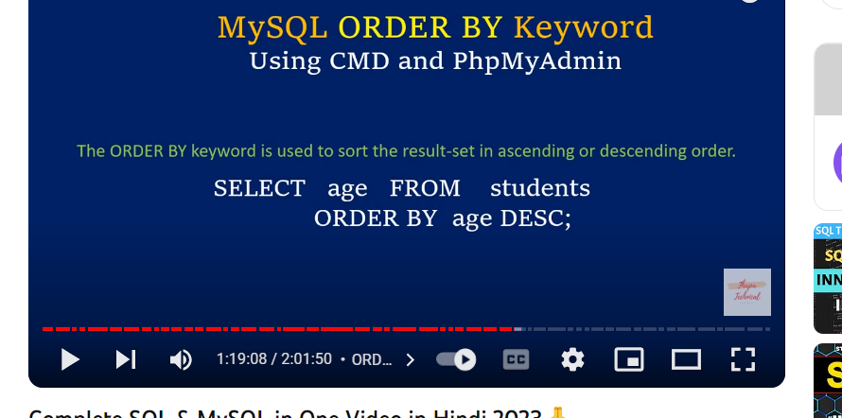

select age from student order by age;

Aggregates



Aggrigates

select avg(age) from student;

select sum(age) from student;

select min(age) from student;

select max(age) from student;

LOGICAL OPERATOR

select * from student where age !=25;

select * from student where age >25;

select * from student where age >=25;

select * from student where age <=25;

select * from student where age between 22 and 25;

select * from student where age <= 25 && age >= 10;

select * from student where age not between 22 and 25;

select * from student where fname ='asim' or fname='shah' ;

select * from student where fname in('ali','nomi');



CONCAT

select concat('ali',' ','asim') as fname;

palindrome reverse

select concat('asim',reverse('asim')) as palindrom;

**UPPERCASE**

select upper(concat('asim',reverse('asim'))) as palindrom;

**DATETIME:**

create table dateOfstu(

-> name varchar(55),

-> dob date,

-> dot time,

-> bt datetime);

**insert into dateOfstu values('vinod','1994-1-05','05:05:05', '1994-1-05 05:05:05');**

**YY-MM_DD**

**HH-MM_SS**



**Predefined dateTime FUNCTION**

insert into dateOfstu values('vonid', curdate(),

-> curtime() , now() );

**FORIGN KEY**

**//customer table**

**create table customers(cid int not null auto_inc**

**rement primary key, cname varchar(55),email varchar(100));**

insert into customers(cid,cname,email) values(3,'ali','ali@g.com');

**//order table**

**create table orders(oid int not null auto_increment primary key ,orderdate date , cid int , foreign key(cid) references customers(cid));**

insert into orders(oid,orderdate,amount,cid) values(2,'2019/05/05',55,2);

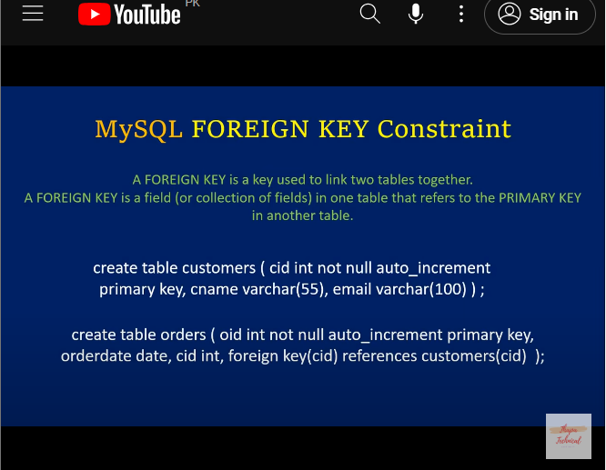

**join**

select * from customers ,orders

-> where customers.cid =orders.cid;

**INNER JOIN**

select * from customers

-> join orders

**-> on customers.cid = orders.cid;**

**select cname, orderdate, amount fro**

**m customers**

**-> join orders**

**-> on customers.cid = orders.cid;**

**Left**

select * from customers left join orders

-> on customers.cid=orders.cid;

RIGHT joim

select * from customers right join orders

-> on customers.cid=orders.cid;