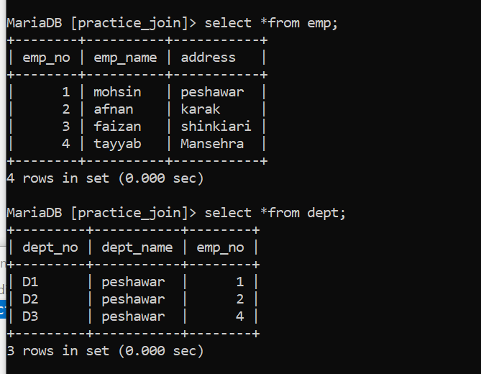

**Natural join:**

1. select emp_name from emp,dept where emp.emp_no=dept.emp_no;
2. select emp_name from emp natural join dept;

**Inner Join:**

select emp.emp_no, emp_name from emp inner join dept on emp.emp_no = dept.emp_no;

**equi join:**

select emp.emp_name,dept.emp_no from emp inner join dept on emp.emp_no = dept.emp_no;

**NOTE**  
inner join, natural join and equi join are exactly the same but syntax different in inner join just primary equal to foreign key equality condition must be include.

**Left outer join:**

select emp.emp_no, emp_name from emp left outer join dept on emp.emp_no = dept.emp_no;

**union join:**

select emp.emp_no, emp_name from emp left outer join dept on emp.emp_no = dept.emp_no union select emp.emp_no, emp_name from emp right outer join dept on emp.emp_no = dept.emp_no;

**left join but the missing primary key will show:**

select emp.emp_no, emp_name from emp left outer join dept on emp.emp_no = dept.emp_no where dept.emp_no is null;

**left join but the missing foreign key will show:**

select emp.emp_no, emp_name from emp right outer join dept on emp.emp_no = dept.emp_no where dept.emp_no is null;

**subquires:**

select emp_no from emp where emp_no in(select distinct emp_no from dept);

This query returns the emp_no values from the emp table that **also exist in the dept table**.

