# **Key Milestone 1: Conceptual Schema**

**Group Members:**

1. **Mohsin Sajjad (22PWCSE2149)**
2. **Muhammad Hassan (22PWCSE2105)**
3. **Muhammad Afnan Khan (22PWCSE2155)**

**1. Entity Descriptions:**

Below is a summary of the core entities, their primary keys, and main attributes:

|  |  |  |  |
| --- | --- | --- | --- |
| **Entity** | **Primary Key** | **Key Attributes** | **Description** |
| **User** | UserID | Name, Email, Password, UserType | Stores common account data for both JobSeekers and Employers. |
| **JobSeeker** | SeekerID | UserID (FK), DateOfBirth, Address, ProfileSummary | Subtype of User; holds seeker-specific profile details. |
| **Employer** | EmployerID | UserID (FK), CompanyName, CompanyDescription, CompanyWebsite, VerifiedStatus | Subtype of User; holds employer-specific company details. |
| **Resume** | ResumeID | SeekerID (FK), FilePath, UploadDate, LastUpdated | Stores uploaded resumes for JobSeekers. |
| **Job** | JobID | EmployerID (FK), Title, Description, Requirements, Location, SalaryRange, PostedDate | Represents job listings posted by Employers. |
| **Application** | ApplicationID | JobID (FK), SeekerID (FK), ResumeID (FK), AppliedDate, Status | Captures a JobSeeker’s application to a specific Job with one resume. |

**2. Detailed Business Rules:**

1. **User registration**: Every account must register as either a JobSeeker or an Employer; the UserType attribute enforces this.
2. **Unique email**: The Email in **User** must be unique and validated before account activation.
3. **Email verification**: Only Employers with *VerifiedStatus = TRUE* may post Job listings.
4. **Job postings**: An Employer may post zero or more Jobs; each Job must reference exactly one Employer.
5. **Resume upload**: A JobSeeker may upload multiple Resumes, but only one active Resume may be associated per Application.
6. **Profile completeness**: JobSeekers must complete mandatory fields (*DateOfBirth, Address, Profile Summary*) before applying to any Job.
7. **Application constraint**: A JobSeeker may apply to the same Job at most once; duplicate applications are disallowed.
8. **Application status**: Each Application’s Status must be one of: Pending, Reviewed, Interview, Offered, Rejected.
9. **Posting requirements**: Each Job must include at minimum: Title, Description, Requirements, Location, and Posted Date.
10. **Automatic timestamps**: Applied Date (*Application*) and Posted Date (*Job*) default to the current system date when the record is created.
11. **Resume updates**: When a JobSeeker updates a Resume, the old version may be retained for audit but only the latest may be linked to new Applications.
12. **Deletion rules**: Deleting a User cascades to delete associated JobSeeker/Employer sub-records; deleting an Employer prevents deletion if open Job listings exist.

**3. Entity–Relationship Diagram (ERD):**

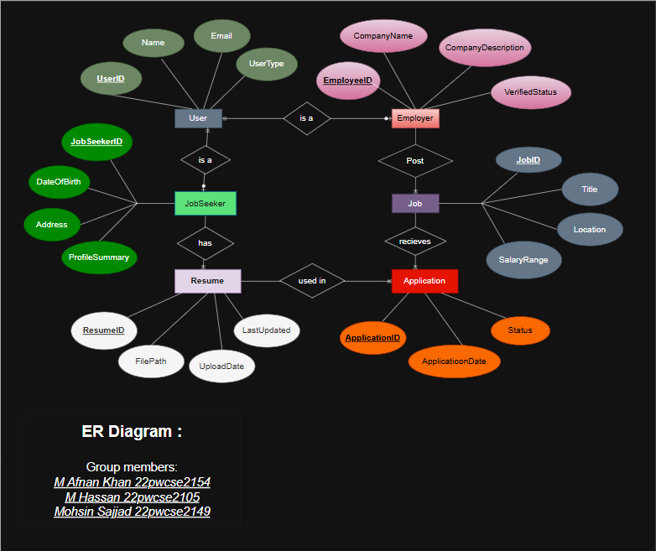

**4. Enhanced ER Diagram (EERD):**

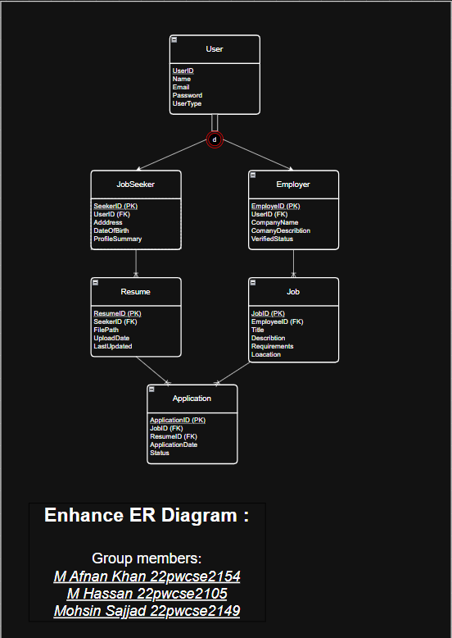

**REFRENCES:**1) google.com

2) chatgpt