# **Key Milestone 2:**

# **DBMS Lab Project Normalized Relational Schema**

**Group Members:**

1. **Mohsin Sajjad (22PWCSE2149)**
2. **Muhammad Hassan (22PWCSE2105)**
3. **Muhammad Afnan Khan (22PWCSE2155)**

**1: Convert your project conceptual schema into relational schema. Show converted relational schema.**

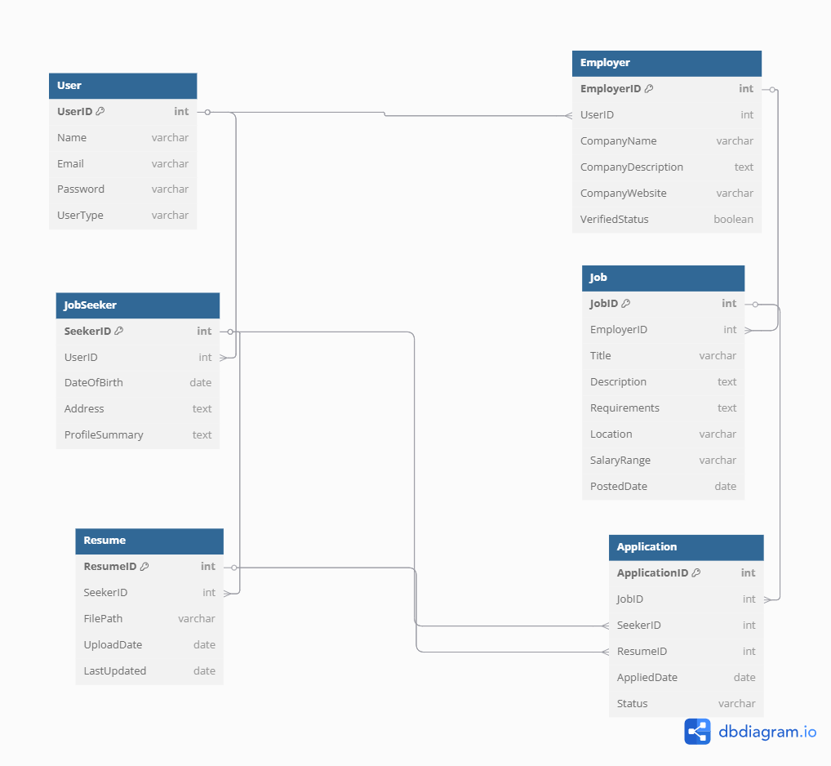

**2: Normalize the relational schema step-wise into 3NF relations (i.e. third normal form).**

**1NF (First Normal Form)**

1NF requires:

* Atomic values (no multivalued or composite attributes)
* Unique rows

All relations already use atomic attributes. So, the schema is in **1NF**.

**2NF (Second Normal Form)**

2NF requires:

* Be in 1NF
* No partial dependency (non-key attributes depend on whole primary key)

All relations have simple (single-attribute) primary keys:

* UserID, SeekerID, EmployerID, etc.

Thus, **no partial dependencies exist**, and schema is in **2NF**.

**3NF (Third Normal Form)**

3NF requires:

* Be in 2NF
* No transitive dependency (non-prime attribute depends only on the key)

Thus, all relations satisfy **3NF**.

**USER**

|  |  |  |  |  |
| --- | --- | --- | --- | --- |
| User_ID | Name | Email | Password | UserType |

**Employer**

|  |  |  |  |  |  |
| --- | --- | --- | --- | --- | --- |
| Employe_ID | User_ID | Company_Name | Company_Discription | Company_website | Verified_status |

**Jobseekers**

|  |  |  |  |  |
| --- | --- | --- | --- | --- |
| Seeker_ID | User_ID | Date_Of_birth | Address | Profile_Summary |

**Job**

|  |  |  |  |  |  |  |  |
| --- | --- | --- | --- | --- | --- | --- | --- |
| Job_ID | Employe_ID | Title | Description | Requirement | Location | Salary_range | Posted_Date |

**Resume**

|  |  |  |  |  |
| --- | --- | --- | --- | --- |
| Resume_ID | Seeker_ID | File_Path | Upload_Date | Last_Updated |

**Application**

|  |  |  |  |  |  |
| --- | --- | --- | --- | --- | --- |
| Application_ID | Job_ID | Seeker_ID | Resume_ID | Applied_Date | Status |