# Job Portal Database Project:

# Key Milestone 3:

**Group Members:**

M Afnan Khan 22pwcse2155

Mohsin Sajjad 22pwcse2149

M Hassan 22pwcse2105

**TABLES AND METADATA:**

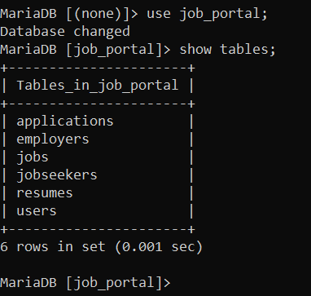

**USERS**

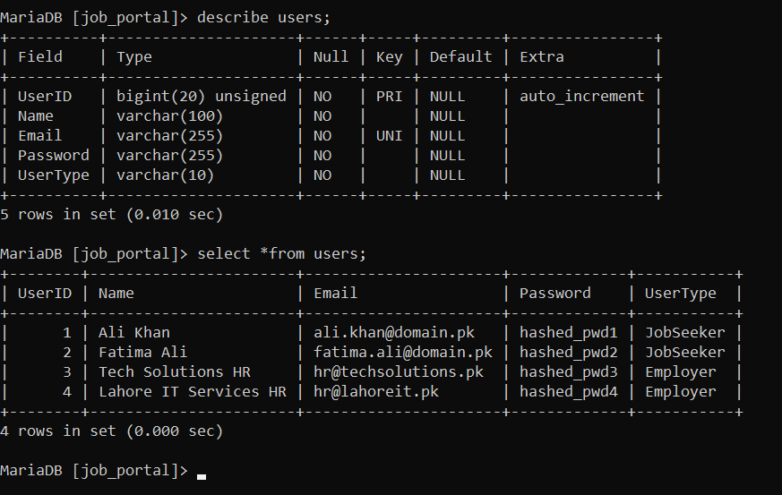**Jobseeker**

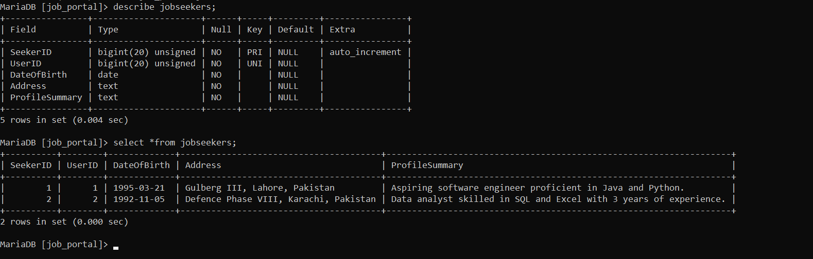

**APPLICATIONS**

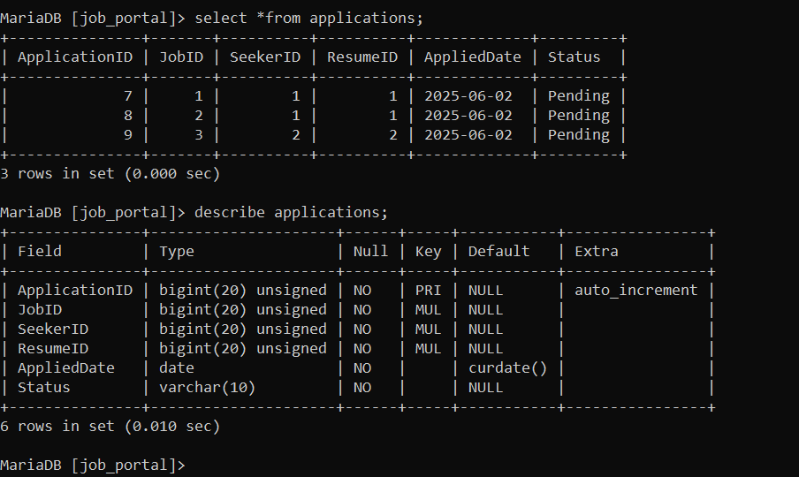

**EMPLOYERS  
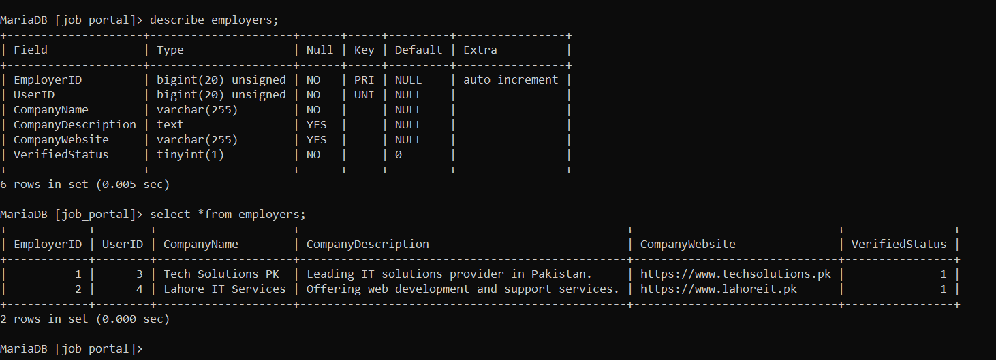**

**JOBS:**

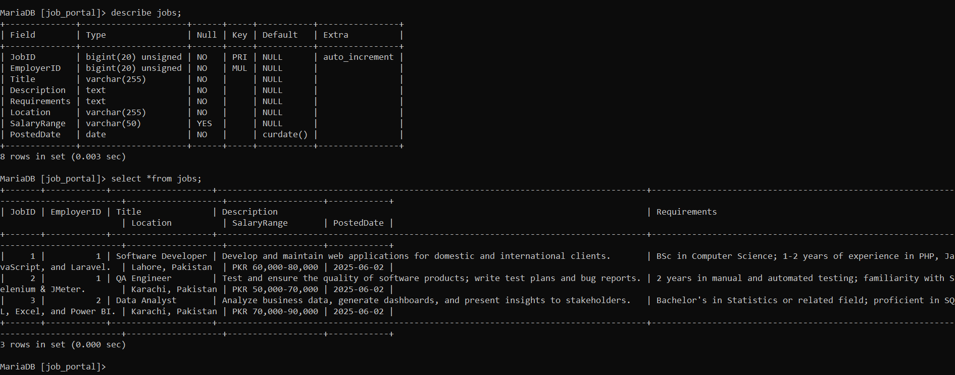

**RESUMES**

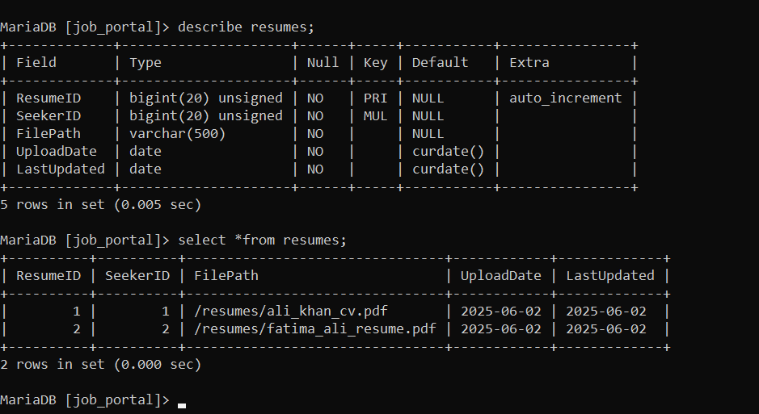

# SQL Queries

-- List all jobs posted by a specific employer

SELECT j.JobID, j.JobTitle, j.Location, j.PostedDate FROM Jobs j JOIN Employers e ON j.EmployerID = e.EmployerID WHERE e.CompanyName = 'XYZ Technologies';

-- List all applications for a specific jobseeker

SELECT a.ApplicationID, j.JobTitle, a.ApplicationDate, a.Status FROM Applications a JOIN Jobs j ON a.JobID = j.JobID WHERE a.JobseekerID = 1;

-- Retrieve jobseeker details along with their resume

SELECT js.FirstName, js.LastName, r.ResumeFilePath FROM Jobseekers js JOIN Resumes r ON js.ResumeID = r.ResumeID WHERE js.JobseekerID = 1;

-- Count number of applications per job

SELECT j.JobTitle, COUNT(a.ApplicationID) AS ApplicationCount FROM Jobs j LEFT JOIN Applications a ON j.JobID = a.JobID GROUP BY j.JobID;

-- List employers and the number of jobs they have posted

SELECT e.CompanyName, COUNT(j.JobID) AS JobCount FROM Employers e LEFT JOIN Jobs j ON e.EmployerID = j.EmployerID GROUP BY e.EmployerID;