# DataBase System Project

Name: Ahmad Mujahid, Mohsin Ramzan

RollNumber: 20i-0849, 20i-2354

Section: CS(C)

Contents

DataBase System Project 1

Detailed Functional Requirements of Each Module 2

TA/LD Module 2

Faculty Member Module 2

Admin Module 2

ERD 2

EERD 3

Relational Schema 3

UserGuideLines: 3

Login and Registration UserProfile 3

Task Assignment FeedBack Evaluation 3

## Detailed Functional Requirements of Each Module

TA/LD Module

* User Profile(Edit,View)
* Task Assignment
* Feedback and Evaluation

### Faculty Member Module

* userprofile
* Task Assignment
* Feedback and Evaluation

### Admin Module

* Delete Account
* Update Account
* Register
* System Operations
* Task Management
* View Task
* View Profile

## ERD

## EERD

## Relational Schema

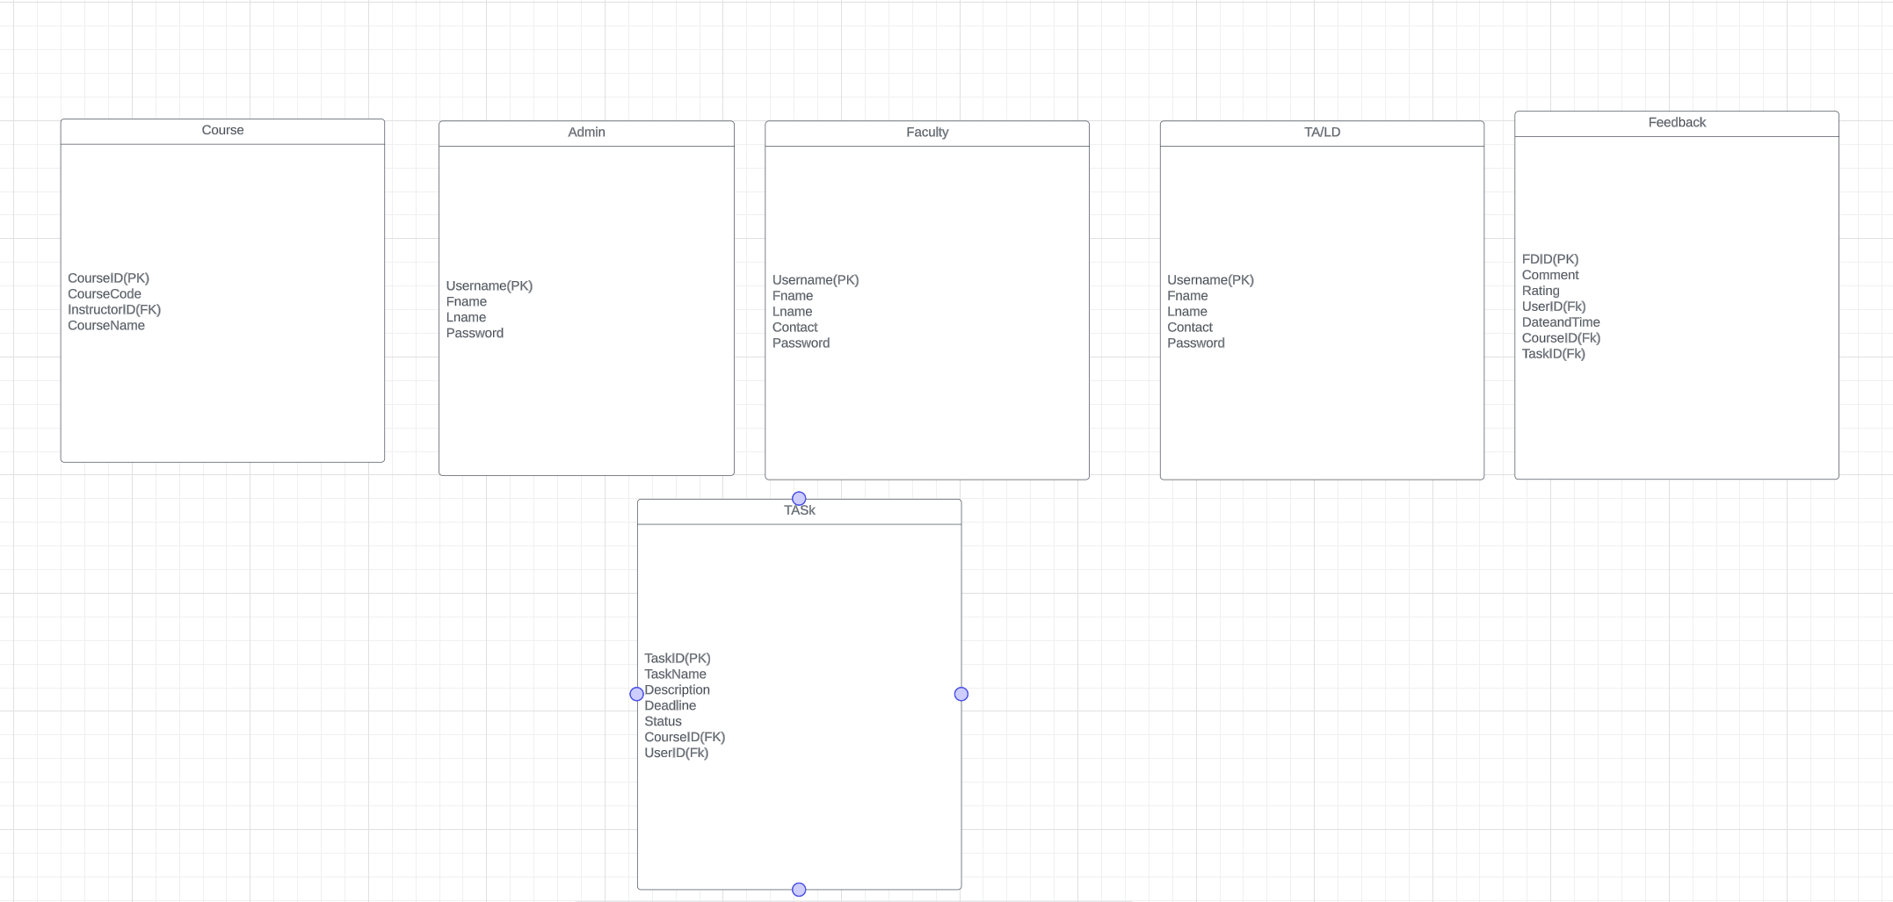

## UserGuideLines:

## Login and Registration UserProfile

Task Assignment  
FeedBack Evaluation

## ScreenShot of Forms:



