Table of Contents
SEMESTER PROJECT 1
Software Requirements Specification (SRS) for University Event Management System 2
Introduction: 2
2. Problem Statement: 2
3. Objectives: 2
4. Scope: 2
5. Existing System Analysis: 3
6. Stakeholder Identification: 3
7. Requirements Elicitation Techniques: 3
8. Interview Findings (Real Data): 3
Stackeholders Register: 4
10. Student Survey Analysis 4
11. Functional Requirements: 4
12. Non-Functional Requirements: 5
13. System Constraints: 5
14. Feasibility Study: 5
15. UML / DFD / ERD Section: 5
16. Conclusion: 6
17. Future Enhancements: 6

Table of figures
Figure 1:faculty survay piegraph 7
Figure 2:problems identified by faculty 7
Figure 3: students survay analysis 9
Figure 4: students survay problems identified 9

Software Requirements Specification (SRS)
for University Event Management System

1. Introduction:

University events such as seminars, workshops, competitions, sports activities, and society programs play an important role in student development. However, many universities still manage events using scattered communication channels, manual registration methods, delayed approvals, and poor attendance tracking.
The proposed University Event Management System is a centralized digital platform designed to streamline event creation, approvals, registrations, attendance management, notifications, certificates, and reporting.

2. Problem Statement:

The current university event management process relies on scattered communication channels, manual registrations, slow approvals, poor attendance tracking, and delayed certificate issuance. Students often miss opportunities due to late announcements, while administration lacks centralized monitoring and reporting. Therefore, a digital University Event Management System is required to improve efficiency, transparency, and coordination.

3. Objectives:

The objectives of the proposed system are:

- Centralize all university event announcements.
- Provide online registration facilities.
- Improve approval workflow efficiency.
- Manage attendance digitally.
- Generate certificates automatically.
- Provide notifications and reminders.
- Ensure fairness and transparency.
- Provide reports for management and faculty.

4. Scope:
The system will serve students, faculty, coordinators, societies, and administration. It will manage the complete lifecycle of university events from proposal submission to post-event reporting.

5. Existing System Analysis:

Currently, event announcements are made through mixed methods such as LMS, social media platforms, office notices, and society channels. Registration is sometimes done through LMS, but mostly through manual desks with physical fee collection. Attendance and certificates are manually handled, resulting in delays and inefficiencies.

6. Stakeholder Identification:

Primary Stakeholders:
- Students
- Faculty Members
- Coordinators
- Society Heads
- SLC Office
- HOD
- IT Department
- Creative Team
Secondary Stakeholders:
- Sponsors
- Security Staff
- Visitors

7. Requirements Elicitation Techniques:

The following elicitation techniques were used:
- Interviews with HOD, SLC representatives, IT staff, creative lead, CR, and students.
- Online surveys for students and faculty.
- Observation of existing registration and communication methods.
- Informal discussions with stakeholders.

8. Interview Findings (Real Data):

Key findings from stakeholder interviews:
- SLC highlighted scattered announcements and manual desk registrations.
- HOD emphasized attendance and certificate issues and noted some manual processes may still be useful.
- IT Department highlighted changing requirements and need for flexible design.
- Creative Lead highlighted approval delays, funding issues, and unauthorized entries.
- Students highlighted missed events and poor communication.

9. Stakeholders Register:

Stakeholder | Role in System | Influence | Interest
Student | Register and attend events | High | High
Faculty | Supervise / approve / reports | High | High
HOD | Oversight and decisions | High | Medium
SLC Office | Manage university events | High | High
IT Department | Technical support / maintenance | Medium | High
Society Heads | Organize events | Medium | High
Creative Team | Media / promotion | Low | Medium
Security Staff | Crowd control / access | Low | Medium

10. Faculty Survey Analysis:

A separate stakeholder survey was conducted to gather the perspectives of faculty members and coordinators regarding the current university event management process and the need for an improved digital solution. A total of 5 responses were collected.
Respondent Roles
- Faculty Members: 4
- Coordinator: 1
This indicates that the majority of responses came from academic stakeholders directly involved in student communication and event supervision.
Current Event Management Method
Most respondents stated that the current event management process uses a mixed approach, including manual coordination, office communication, and informal digital channels.
- Mixed Method: 4
- Through Office Coordination: 1
This suggests the absence of a single centralized system.
Major Challenges Identified
The most common issues highlighted were:
- Registration Issues: 3
- Late Communication: 2
- Scheduling Conflicts: 2
- Certificate Delays: 1
These findings indicate operational inefficiencies and communication gaps.
Need for a Digital Event Management System
Faculty stakeholders strongly supported the development of a digital system.
- Yes: 4
- Maybe: 1
No respondent rejected the idea.
Most Needed Features
The most requested features were:
- Reports / Analytics: 4
- Event Calendar: 3
- Approval Workflow: 3
- Notifications / Reminders: 3
This shows a need for better management visibility and coordination tools.
Reporting Requirements
All respondents agreed that department heads or coordinators should receive event reports.
- Yes: 5
This indicates the importance of monitoring and accountability.
Faculty Access Preferences
Respondents suggested faculty should be able to:
- Approve Events: 4
- View Events: 3
- Manage Attendance: 3
- View Reports: 3
- Manage Certificates: 2
This supports role-based access control in the proposed system.
Security Expectations
The most important security requirements identified were:
- Data Privacy: 5
- Backup Records: 4
- Secure Login: 3
- Role-based Access: 3
This confirms that security must be a major component of the system.
Expected Impact
All respondents believed that the proposed system would improve student participation in events.
- Yes: 5
Suggestions Received
Respondents recommended:
- Clear planning and defined responsibilities
- Structured timelines
- Use of digital tools for registration and communication
- Feedback collection mechanisms
Conclusion
The faculty survey clearly demonstrates support for a centralized University Event Management System. Key priorities include secure access, reporting features, approvals, communication efficiency, and attendance management.

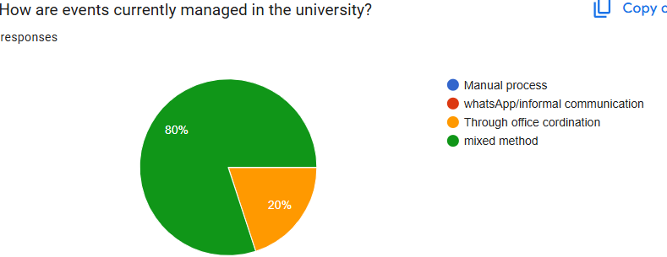
Figure 1: Faculty Survey Response Distribution

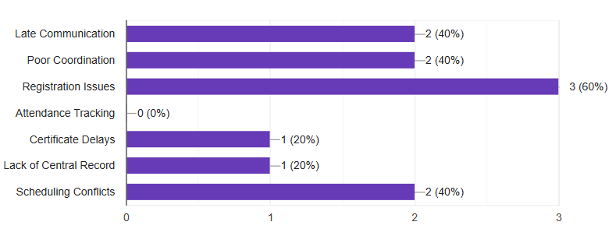
Figure 2: Faculty Challenges Analysis

11. Student Survey Analysis:

A student survey was conducted using Google Forms to understand student experiences with the current university event management process and to identify the need for a centralized digital solution. A total of 20 student responses were collected.
Participation Level
Most respondents stated that they had attended university events before. This indicates that student interest and participation in events is generally positive.
Current Communication Channels
Students reported receiving event information through multiple informal sources such as:
- Friends
- Social Media
- Notice Boards
- Student Groups
This shows that event communication is currently scattered and lacks a centralized official platform.
Missed Events Due to Late Information
A significant number of students reported that they had missed events because they received information too late. This highlights a major communication gap in the existing system.
Registration Process Feedback
Many students rated the current registration process as average or difficult. This suggests that the current process is not fully user-friendly and requires improvement.
Reminder System
Most respondents stated that they rarely or never receive reminders before events. This negatively affects participation and attendance rates.
Need for Online Event Management System
Almost all respondents preferred the idea of an online event management system. This demonstrates strong student demand for a digital solution.
Major Problems Identified
Students highlighted the following issues:
- Late event information
- Poor communication
- Lack of organization
- Difficult registration process
- Weak reminder system
Most Requested Features
Students suggested that the proposed system should include:
- Event Notifications
- Online Registration
- Event Calendar
- Certificate Download System
- Easy Event Search
- Centralized Event Dashboard
Conclusion
The student survey clearly indicates that while student interest in events is high, the current management process has weaknesses in communication, registration, and reminders. A centralized University Event Management System would improve efficiency, participation, and overall student experience.

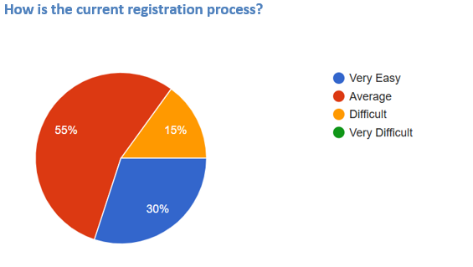
Figure 3: Student Survey Response Summary
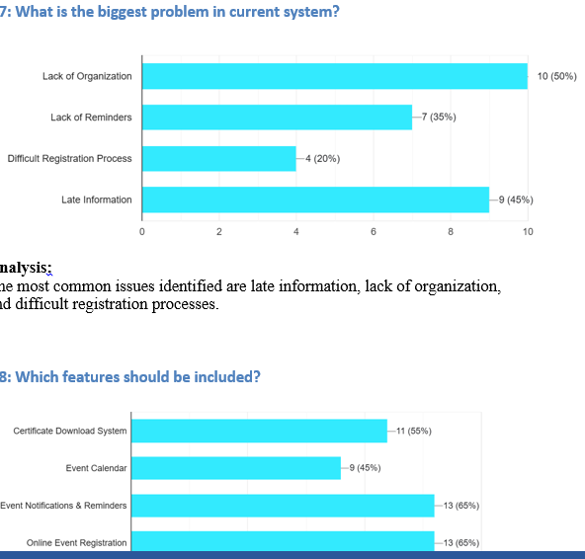
Figure 4: Student Problems Identified

12. Functional Requirements:

- User registration and login.
- Role-based dashboards.
- Event creation and approval.
- Event browsing and search.
- Online registration.
- Attendance marking.
- Certificate generation.
- Notifications and reminders.
- Report generation.
- Feedback collection.

13. Non-Functional Requirements:

- Secure login system.
- Data privacy protection.
- Fast response time.
- User-friendly interface.
- System availability.
- Backup and recovery.
- Scalability for future events.

14. System Constraints:

- Budget limitations.
- Changing requirements.
- Internet dependency.
- User resistance to change.
- Limited development time.

15. Feasibility Study:

- Technical Feasibility: Possible using web/mobile technologies.

- Economic Feasibility: Reduces manual costs over time.

- Operational Feasibility: Beneficial for students and management.

- Schedule Feasibility: Can be developed in phases.

16. UML / DFD / ERD Section:
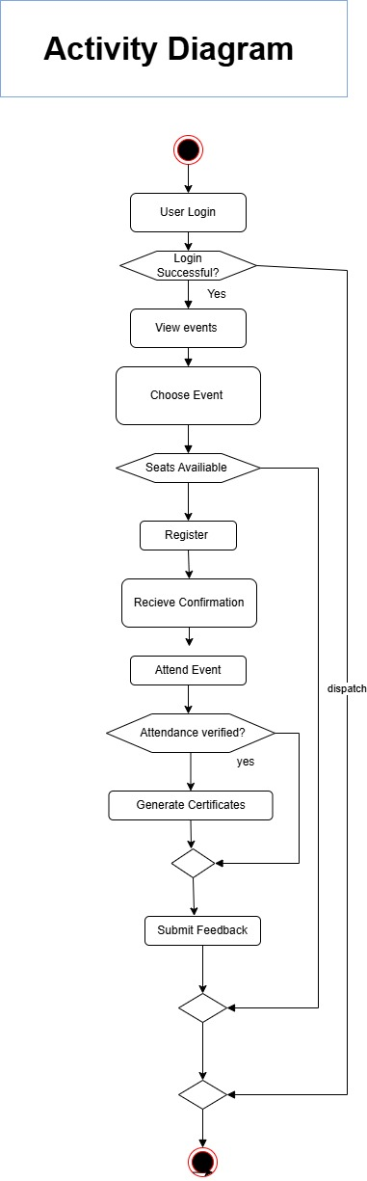
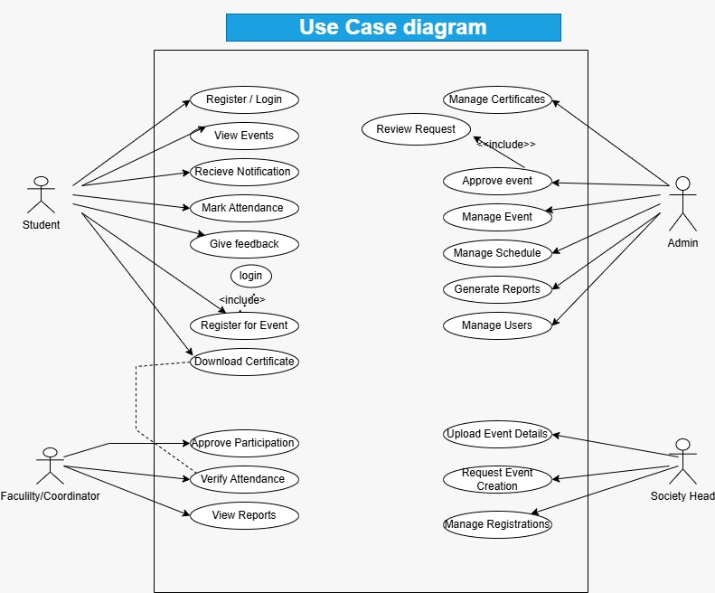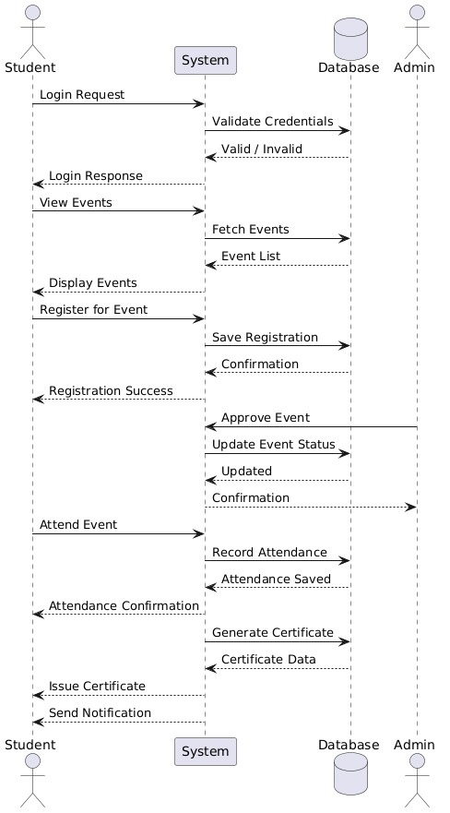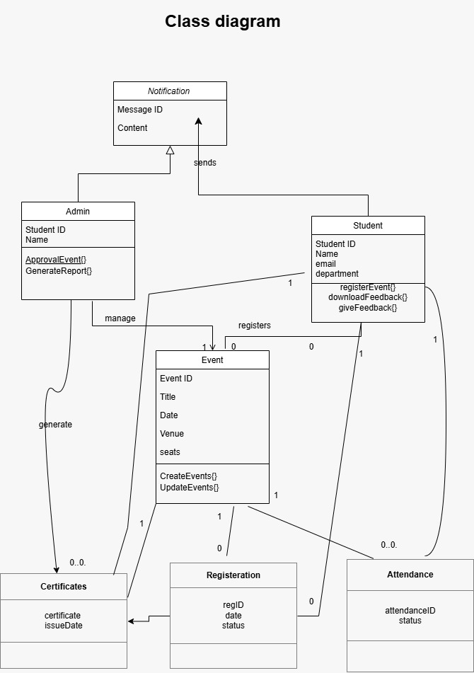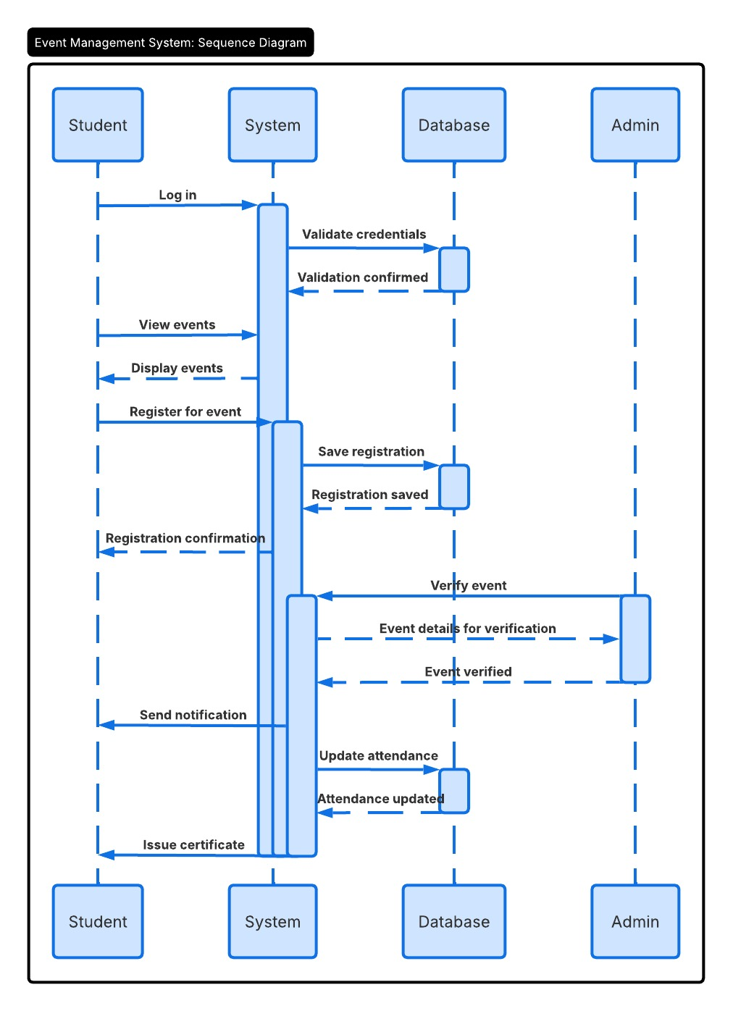

17. Conclusion:

The proposed University Event Management System will solve major problems identified in the current manual and scattered system. It will improve communication, fairness, registration efficiency, attendance management, and reporting.

18. Future Enhancements:

- Mobile application.
- Online payments.
- Face recognition for event photos.
- AI-based event recommendations.
- Sponsor management module.

