Name: Mohsin Ali Irfan

Reg no: L1F19BSCS0171

create table 1st_lab(std_id int, std_name varchar(15), std_sem int);

desc 1st_lab;

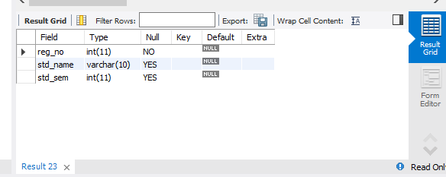

alter table 1st_lab drop std_name;

desc 1st_lab;

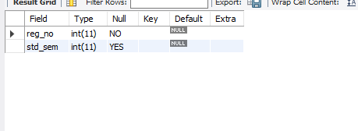

alter table 1st_lab add std_name varchar(15);

show columns from 1st_lab;

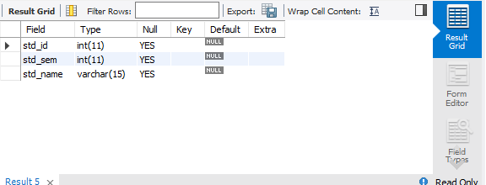

alter table 1st_lab drop std_name;

desc 1st_lab;

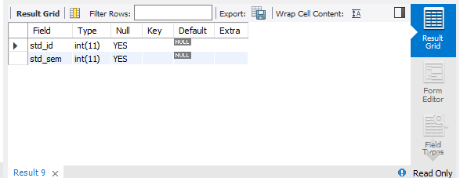

alter table 1st_lab add std_name varchar(15) first;

desc 1st_lab;

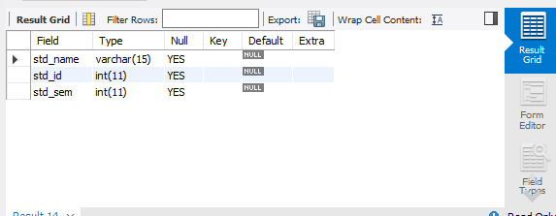

alter table 1st_lab drop std_name;

desc 1st_lab;



alter table 1st_lab add std_name varchar(15) after std_id;

desc 1st_lab;

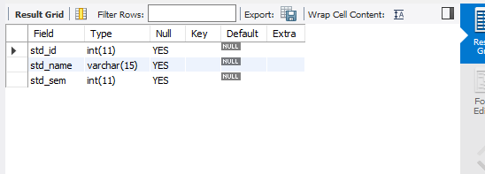

alter table 1st_lab modify std_name varchar(10);

desc 1st_lab;

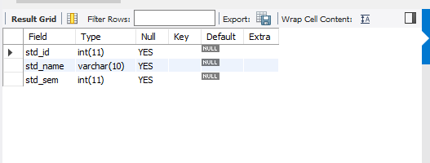

alter table 1st_lab change std_id reg_no bigint;

desc 1st_lab;

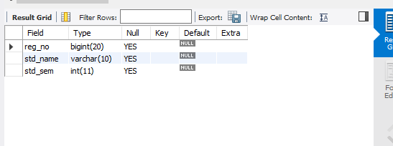

alter table 1st_lab change reg_no reg_no int;

desc 1st_lab;

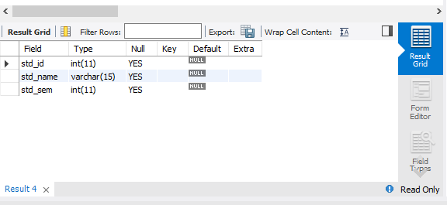

alter table 1st_lab modify reg_no int not null default 100;

desc 1st_lab;

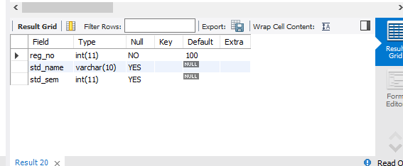

alter table 1st_lab alter reg_no drop default;

desc 1st_lab;

