Name: Mohsin Ali Irfan

Reg no: L1F19BSCS0171

create database bloodcollectionrecord;

use bloodcollectionrecord;

create table bloodcollectionrecord(

Record varchar (15),

CampaignID varchar (15),

DonationTime date,

DonorStatus varchar (15),

DonorID varchar (15)

);

desc bloodcollectionrecord;

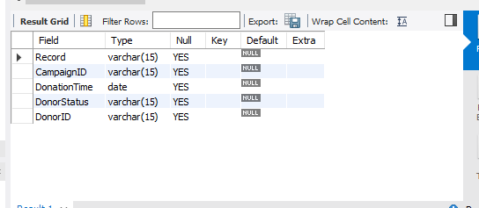

alter table bloodcollectionrecord add column unitdonated varchar(15);

desc bloodcollectionrecord;

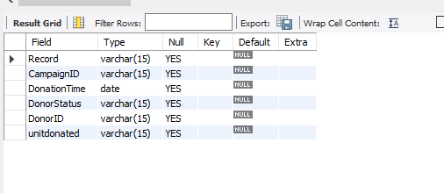

alter table bloodcollectionrecord modify DonationTime time;

desc bloodcollectionrecord;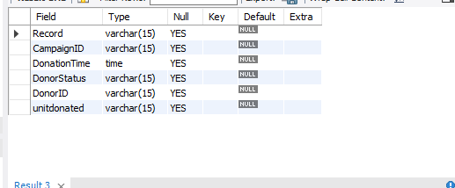

create database notificationdetails;

use notificationdetails;

create table notificationdetails (

NotificationID varchar (15),

CampaignID varchar (15),

DonorID varchar (15),

NotificationMsg varchar (15),

ReplyMsg varchar (15),

NoticationSentTime date

);

desc notificationdetails;

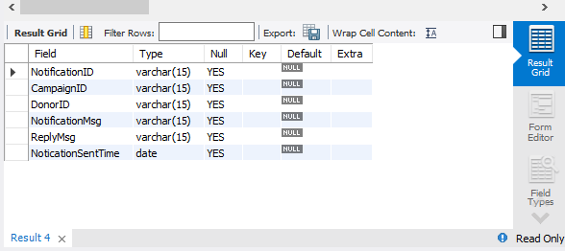

alter table notificationdetails add column notificationdetailtime time;

desc notificationdetails;

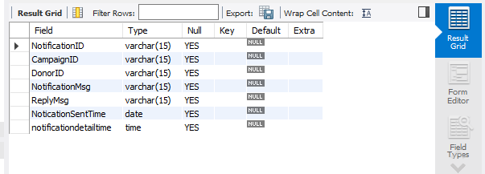

alter table notificationdetails modify NoticationSentTime time;

desc notificationdetails;

