Domain-Specialized Deep-Learning Framework for Promoter Prediction
Complete modeling flow and finalized fixed-configuration ensemble results

Executive summary
This report documents the implemented leakage-aware promoter classification workflow and the finalized results of fixed-configuration, three-seed domain specialists. The bacterial and archaeal systems use Multi-scale CNN ensembles; the eukaryotic system uses a Residual CNN ensemble. Ensemble probabilities are averaged across seeds, with decision thresholds chosen solely from validation predictions before one-time evaluation on untouched test partitions.
The strongest result was obtained for Archaea (test MCC 0.842), followed by Eukaryota (0.708) and Bacteria (0.617). These results are finalized for the current fixed configurations. They are not evidence that these architectures outperform all five implemented candidates because the full architecture comparison, unified-model study, interpretability suite, and ablations remain incomplete.

1. Dataset and leakage controls
Only FASTA files in data/3) finalized were used. All bacterial sequences were 81 nt, archaeal sequences 100 nt, and eukaryotic sequences 251 nt. Exact sequences and their reverse complements share a deterministic group identifier so they cannot cross partitions. Six archaeal promoter/non-promoter reverse-complement conflict pairs (12 records) were quarantined. No exact cross-label sequence overlaps were detected. One isolated N base was represented by an all-zero nucleotide vector with a separate validity mask.
Table 1. Leakage-controlled dataset composition
Domain | Promoter | Non-promoter | Train | Validation | Test | Total
Bacteria | 3,572 | 4,234 | 5,466 | 1,171 | 1,169 | 7,806
Archaea | 3,618 | 6,986 | 7,424 | 1,591 | 1,589 | 10,604
Eukaryota | 41,591 | 39,100 | 56,487 | 12,104 | 12,100 | 80,691

2. Modeling flow
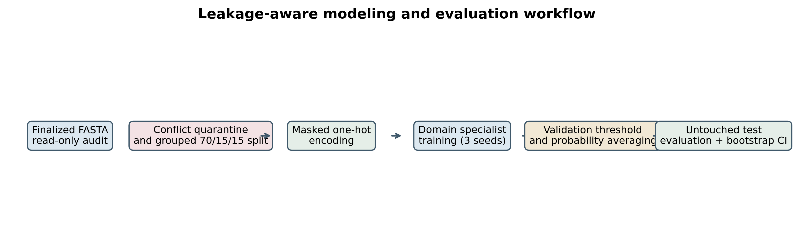
Figure 1. End-to-end data, training, threshold-selection, and evaluation workflow.
Audit and metadata: Parse finalized FASTA files, preserve original headers, assign stable internal identifiers, compute hashes and sequence-level metadata.
Grouped splitting: Create deterministic 70/15/15 train, validation, and test partitions stratified by domain, organism, and class while grouping exact/reverse-complement sequences.
Encoding: Encode A/C/G/T as four-channel one-hot vectors. N and padding remain all-zero; explicit masks prevent padding from affecting recurrence, attention, or pooling.
Specialist architectures: Use Multi-scale CNNs for Bacteria and Archaea to capture motifs at multiple widths, and a compact Residual CNN for the much larger 251-nt eukaryotic dataset.
Training: Train each fixed architecture with seeds 2025, 2026, and 2027 using weighted BCE, organism/class-aware sampling, AdamW, gradient clipping, deterministic seeds, checkpointing, and early stopping.
Selection and ensemble: Restore each seed's best validation-MCC checkpoint, average seed probabilities, and select the ensemble threshold by maximum validation MCC.
Final evaluation: Apply the frozen ensemble and threshold once to the untouched test set; calculate discrimination, classification, calibration, confusion matrices, and 1,000-resample bootstrap intervals.

3. Finalized ensemble results
Table 2. Final untouched-test performance
Domain | Architecture | Threshold | Accuracy | Sensitivity | Specificity | MCC | PR-AUC | ROC-AUC
Bacteria | Multi-scale CNN | 0.876 | 0.808 | 0.692 | 0.905 | 0.617 | 0.860 | 0.875
Archaea | Multi-scale CNN | 0.598 | 0.930 | 0.871 | 0.960 | 0.842 | 0.954 | 0.971
Eukaryota | Residual CNN | 0.560 | 0.847 | 0.761 | 0.939 | 0.708 | 0.932 | 0.911
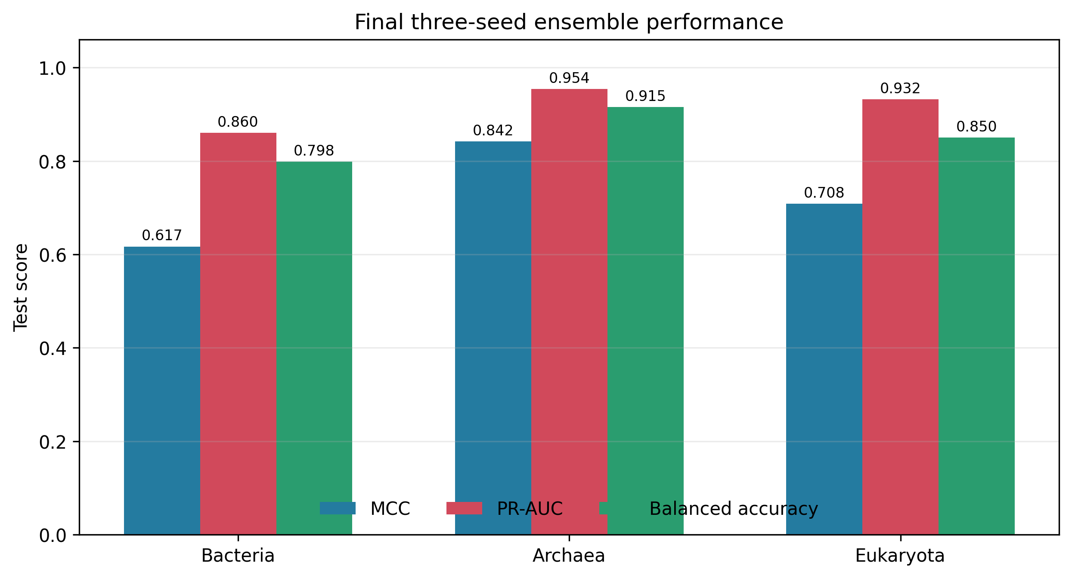
Figure 2. Principal test metrics for the finalized three-seed ensembles.
Table 3. Bootstrap 95% confidence intervals (1,000 resamples)
Domain | MCC 95% CI | PR-AUC 95% CI | ROC-AUC 95% CI
Bacteria | 0.574-0.658 | 0.831-0.887 | 0.856-0.895
Archaea | 0.814-0.870 | 0.940-0.966 | 0.961-0.978
Eukaryota | 0.697-0.721 | 0.927-0.936 | 0.906-0.916
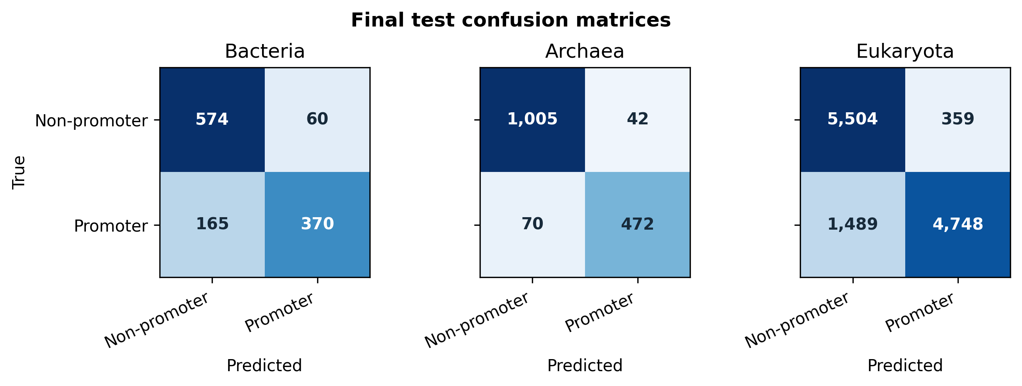
Figure 3. Confusion matrices using validation-selected ensemble thresholds.

4. Interpretation of finalized results
Archaea achieved the highest discrimination and classification balance (MCC 0.842; PR-AUC 0.954), with both false-positive and false-negative rates controlled. Eukaryota achieved high specificity and precision but lower sensitivity, indicating a conservative promoter decision boundary. Bacterial performance was weaker and less certain, consistent with a smaller, organism-heterogeneous dataset and greater validation-to-test variation.
Relative to the corresponding single-seed models, the three-seed ensembles improved test MCC by 0.056 for Bacteria, 0.032 for Archaea, and 0.013 for Eukaryota. The consistent direction of change supports variance reduction through probability averaging, although paired statistical testing is still needed before claiming significance.

5. Reproducibility and saved artifacts
- Data manifest: data/splits/split_manifest.csv
- Per-seed checkpoints and predictions: results/checkpoints/<domain>/<model>/<config>/seed_<seed>/
- Ensemble metrics: results/main_tables/multiseed_ensemble.json
- Ensemble predictions: results/predictions/<domain>_multiseed_ensemble_test.csv
- Random seeds: 2025, 2026, and 2027

6. Publication-readiness statement
The dataset audit, leakage-controlled split, fixed-configuration specialist training, three-seed ensembling, untouched-test evaluation, and bootstrap uncertainty estimates are complete and reproducible. These results can be reported as finalized specialist-ensemble experiments. The broader proposed publication is not yet complete because it still requires the planned five-architecture comparison, unified domain-aware model, group-aware cross-validation, biological controls, interpretability analyses, ablations, paired statistical tests, and final model exports.

