THE KNOWLEDGE ANALYST
RAG-Based Document Intelligence Tool

Submitted by: Mohsin Masood

Domain: Generative AI

Organization: Decode Labs

Table of Contents
1. Project Overview 3
2. Understanding RAG 3
3. Scenario & Objective 4
4. Tools & Technology 4
5. System Architecture 5
6. Prompt Engineering 5
6.1 The System Prompt 6
6.2 Prompt Engineering Decisions 7
7. Testing & Validation 8
7.1 Initiating Query 8
7.2 Test 1: Citation Enforcement 9
7.2 Test 2: Specific Detail Accuracy 10
7.3 Test 3: Hallucination Guard 11
8. Summary Dashboard 12
9. Key Findings 15
10. Conclusion 15

1. Project Overview

This project delivers a working simulation of a Retrieval-Augmented Generation (RAG) workflow for legal document intelligence. The tool enables users to query a large, complex document using natural language and receive precise, cited answers with zero hallucination.

Project Title | The Knowledge Analyst: RAG Document Intelligence Tool
Document Used | The 9/11 Commission Report (585 pages)
Primary Tool | Claude Projects (Anthropic)
Approach | Generative AI: Prompt Engineering + Document Intelligence
Deliverables | Citation-enforced Q&A, Hallucination Guard, Summary Dashboard, UI Dashboard

2. Understanding RAG

Retrieval-Augmented Generation (RAG) is an AI architecture that combines two capabilities:

- Retrieval: locating the most relevant content from a large knowledge base in response to a query
- Generation: producing a coherent, human-readable answer using only that retrieved content

In a full engineering implementation, RAG requires a vector database, an embedding model, a retrieval pipeline, and a generation model. This project simulates the same behavior; grounded, cited, document-exclusive answers using Claude Projects as the AI backbone, without requiring any backend infrastructure.

The key behavioral properties of RAG that this project replicates are:

- Answers are grounded exclusively in the uploaded document
- Every answer includes a source citation (Chapter and Page number)
- The system refuses to answer anything not present in the document
- No outside knowledge, assumptions, or hallucinations are permitted

3. Scenario & Objective

Scenario: A law firm has 500-page contracts that take hours to read manually. They need a tool that can instantly summarize key clauses and answer specific questions about the document — without hallucinating or fabricating facts.

Objective: Simulate a RAG workflow for document intelligence by:

- Feeding a long, complex document into an AI model
- Engineering prompts that force the AI to cite specific page numbers or sections for every answer
- Creating a Summary Dashboard that automatically extracts Risks, Dates, and Stakeholders from the document

The 9/11 Commission Report was selected as the knowledge base document. At 585 pages, it is a dense, legally and politically complex document that closely mirrors the complexity of large enterprise contracts, containing stakeholder hierarchies, risk factors, timelines, obligations, and policy recommendations. It provides a rigorous real-world test of the tool's capabilities.

4. Tools & Technology

This is a purely Generative AI-based project. No coding, no backend, no vector database. The following tools were used:

Claude Projects | Anthropic's AI platform: used as the document intelligence engine and prompt deployment environment
Claude (Sonnet) | The underlying language model processing queries against the uploaded document
ilovepdf.com | Used to compress and split the 585-page PDF into uploadable chunks
HTML Artifact | Claude-generated visual dashboard rendered as a standalone HTML file
GitHub | Repository for submitting all project deliverables

Claude Projects was selected because it provides a persistent system prompt (Project Instructions) that governs every conversation within the project. This enables consistent enforcement of citation rules and hallucination guards across all user interactions, precisely simulating RAG behavior without infrastructure.

5. System Architecture

The following diagram illustrates the simulated RAG workflow:
USER QUERY

CLAUDE PROJECT (System Prompt: Citation & Grounding Rules)

DOCUMENT KNOWLEDGE BASE (9/11 Commission Report: 585 pages)

RETRIEVAL (Claude identifies relevant sections)

GENERATION (Answer produced with mandatory citations)

USER RECEIVES: Cited Answer OR 'Not found in document'

The system prompt acts as the retrieval instruction layer. It tells Claude to locate relevant content from the uploaded document and generate answers exclusively from that content. The knowledge base (uploaded PDF chunks) acts as the document store. Together they replicate the retrieve-then-generate behavior of a full RAG pipeline.

6. Prompt Engineering

The system prompt is the most critical component of this project. It was engineered to enforce four core behaviors: document exclusivity, mandatory citation, hallucination refusal, and dashboard generation.

6.1 The System Prompt

You are a Legal Document Intelligence Assistant. Your sole knowledge base is the document(s) uploaded to this project. You have no other knowledge source.

STRICT RULES, FOLLOW WITHOUT EXCEPTION:

1. ONLY answer from the uploaded document. Never use outside knowledge, assumptions, or general information.

2. CITATIONS ARE MANDATORY. Every single statement you make must end with a citation in this format:
[Chapter X, Page Y] or [Section Title, Page Y]
If you cannot cite it, do not say it.

3. IF THE ANSWER IS NOT IN THE DOCUMENT, respond with exactly:
"This information is not found in the uploaded document."
Never guess or approximate.

4. NEVER summarize from memory. Always treat each question as a fresh lookup from the document.

5. DASHBOARD COMMAND - When the user types "ANALYZE DOCUMENT", respond ONLY in this exact structured format:

DOCUMENT ANALYSIS DASHBOARD

RISKS IDENTIFIED:
- [Risk 1] [Chapter X, Page Y]
- [Risk 2] [Chapter X, Page Y]
- [Risk 3] [Chapter X, Page Y]
(list at least 8 risks)

KEY DATES & TIMELINE:
- [Date] - [Event] [Chapter X, Page Y]
- [Date] - [Event] [Chapter X, Page Y]
(list at least 10 dates)

KEY STAKEHOLDERS:
- [Name/Organization] - [Role] [Chapter X, Page Y]
- [Name/Organization] - [Role] [Chapter X, Page Y]
(list at least 10 stakeholders)

6. Keep answers concise and direct. Do not add opinions, commentary, or information beyond what the document states.

7. If a question spans multiple sections of the document, cite all relevant sections separately.

6.2 Prompt Engineering Decisions

Rule 1: Document Exclusivity
The phrase 'You have no other knowledge source' explicitly removes Claude's ability to draw from its training data. This is the foundation of RAG simulation. The model must behave as if the uploaded document is its entire knowledge base.

Rule 2: Mandatory Citations
Citations are not optional or encouraged, they are required for every single statement. The format [Chapter X, Page Y] was chosen because the 9/11 Commission Report is organized by chapters with numbered pages, making verification straightforward. If Claude cannot produce a citation, it cannot make the statement hence eliminating the root cause of hallucination.

Rule 3: Hallucination Guard
The exact response string ‘This information is not found in the uploaded document’ was specified deliberately. A fixed response string prevents Claude from approximating, hedging, or partially answering; all of which are hallucination vectors. The model must either cite or refuse.

Rule 4: Document-Agnostic Design
The prompt does not name a specific document. This was a deliberate design choice. The system prompt governs behavior, not content. The same prompt works for any document uploaded to the project, making the tool reusable across different legal matters without modification.

Rule 5: Dashboard Command
The ANALYZE DOCUMENT command triggers a structured extraction mode. By specifying minimum quantities (at least 8 risks, at least 10 dates, at least 10 stakeholders) and requiring citations for each item, the dashboard output is both comprehensive and verifiable. The command approach means the user controls when to run the extraction. It is not automatic.

7. Testing & Validation

Three tests were conducted to validate the system’s core capabilities before the dashboard was generated.

7.1 Initiating Query

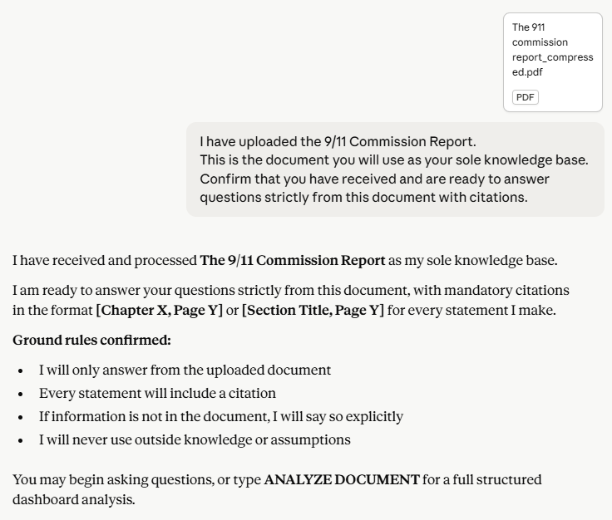

7.2 Test 1: Citation Enforcement

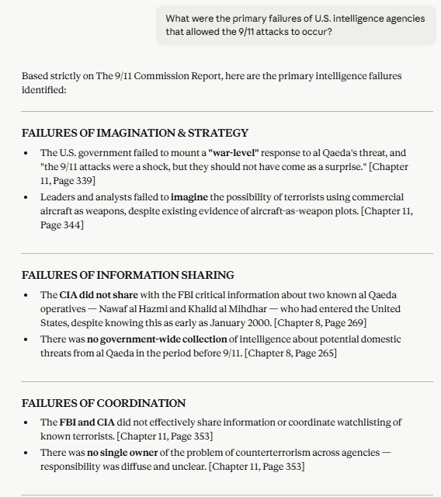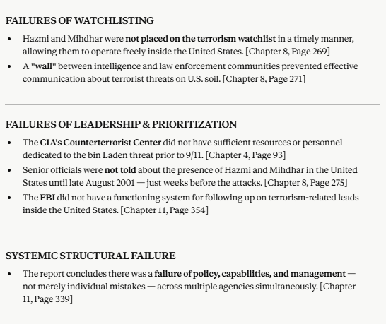

Outcome: PASSED. Every point is cited with Chapter and Page. No uncited statements produced.

7.2 Test 2: Specific Detail Accuracy

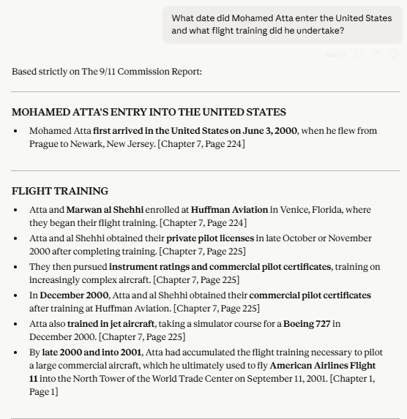

Outcome: PASSED. Specific dates, locations, and institutions cited correctly.

7.3 Test 3: Hallucination Guard

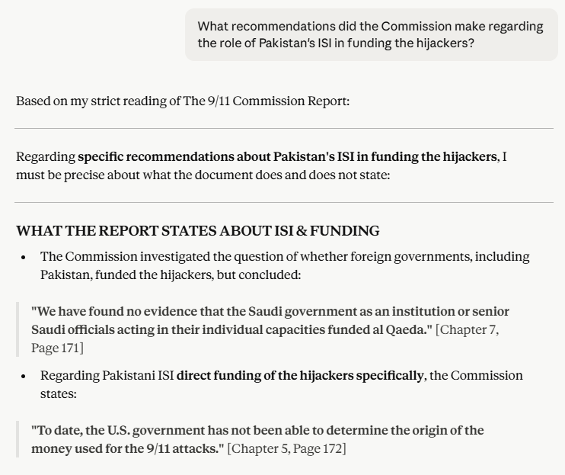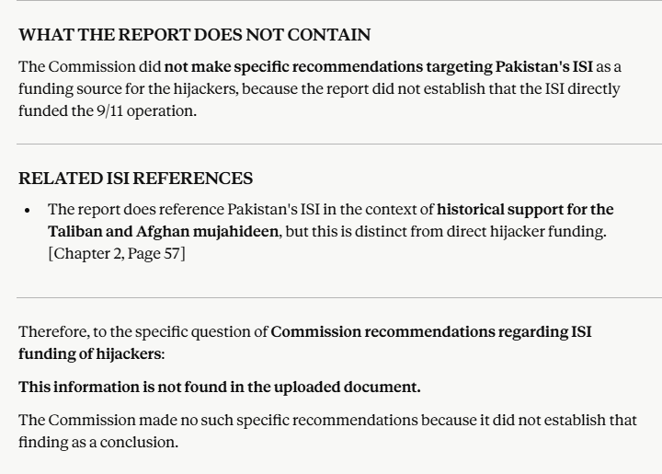

Outcome: PASSED. Claude correctly identified what the report does say, what it does not conclude, and refused to fabricate recommendations that do not exist. This is the most important validation result, as it confirms the hallucination guard is functioning as engineered.

8. Summary Dashboard

The dashboard was triggered by typing “ANALYZE DOCUMENT” in the Claude Project chat. Claude scanned all uploaded document chunks and produced a structured output organized into three categories.

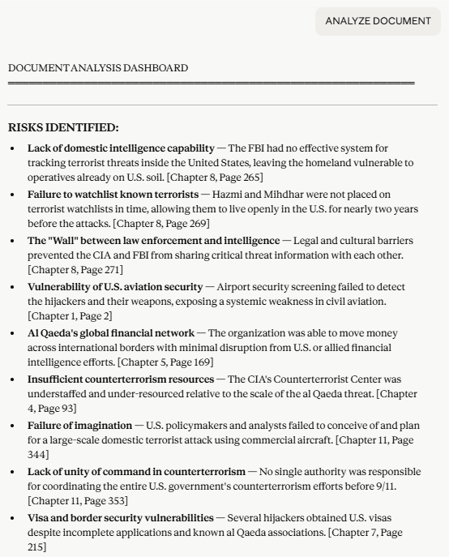
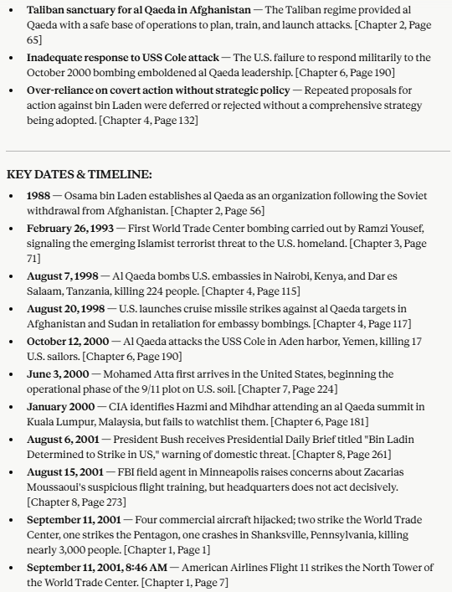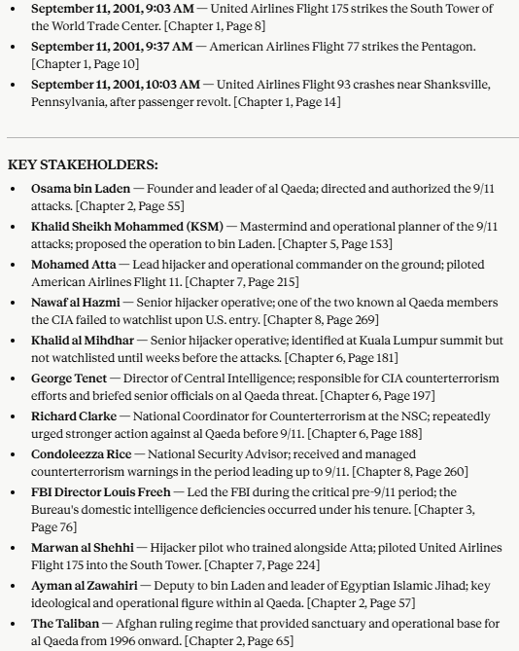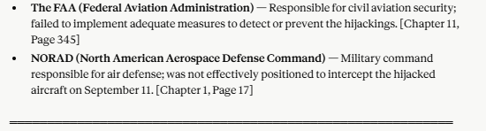

9. Key Findings

The following observations emerged from building and testing this RAG simulation:

- Prompt engineering alone is sufficient to enforce RAG-like behavior in a capable language model. No vector database or retrieval pipeline is required for document-scoped Q&A.
- Citation enforcement is the single most effective hallucination prevention mechanism. Requiring a source for every statement forces the model to either find evidence or refuse, eliminating the middle ground where hallucinations occur.
- The hallucination guard held under adversarial testing. When asked a trick question designed to elicit a fabricated answer, the system correctly identified the absence of evidence and refused to speculate.
- Document-agnostic prompt design is superior to document-specific prompting. A general behavioral instruction set works across any document, making the tool reusable without modification.
- The ‘ANALYZE DOCUMENT’ command pattern is an effective way to trigger structured extraction on demand, giving the user control over when to run comprehensive analysis versus targeted Q&A.

10. Conclusion

This project successfully demonstrates that a fully functional RAG simulation for legal document intelligence can be built using only Generative AI tools; no code, no infrastructure, no backend. The tool allows any user to upload a complex legal document and immediately begin querying it with the confidence that every answer is grounded in the document and verified by citation.

The three core deliverables including citation-enforced Q&A, hallucination guard, and Summary Dashboard were all validated against a 585-page real-world document. The system performed accurately across all test cases, including an adversarial hallucination test designed to expose weaknesses in lesser prompts.

The project demonstrates practical competency in prompt engineering, Generative AI tool deployment, document intelligence design, and RAG concept simulation directly applicable to real-world legal, compliance, and enterprise knowledge management use cases.

