GITHUB URL:

<https://github.com/MohsinMinhas/Projects.git>

POSTMAN TASK:

# GET REQUEST:

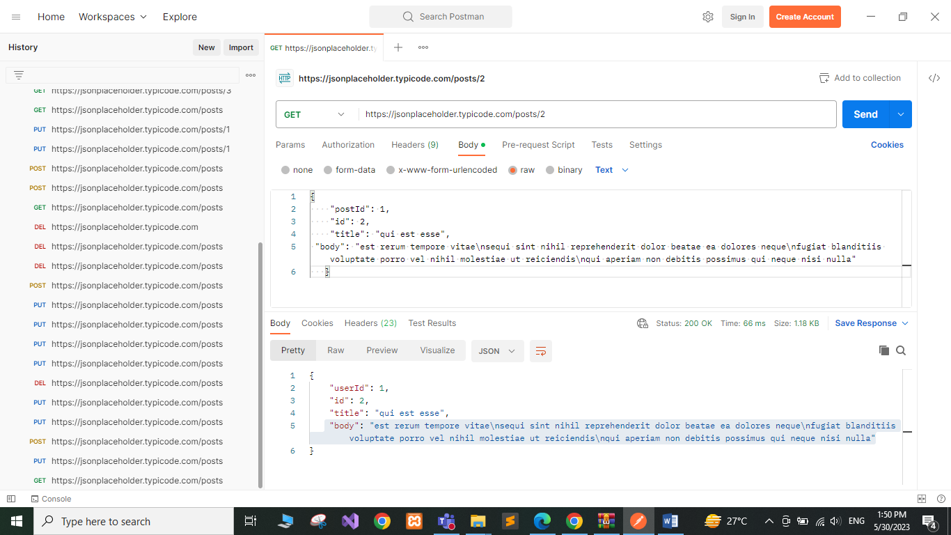

# PUT REQUEST:

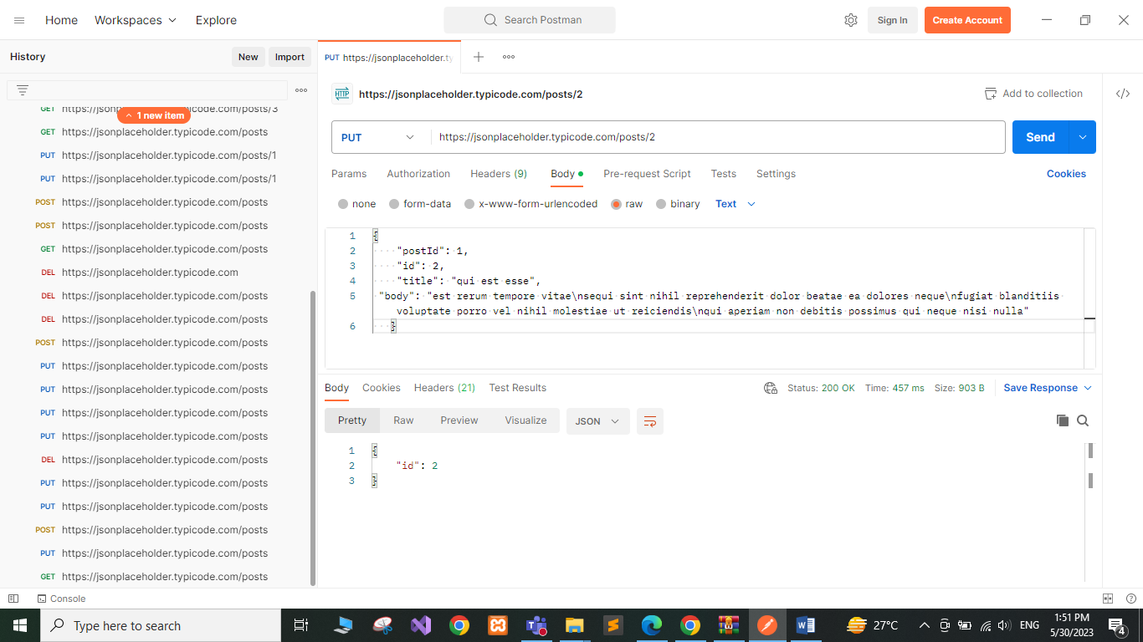

# DELETE REQUEST:

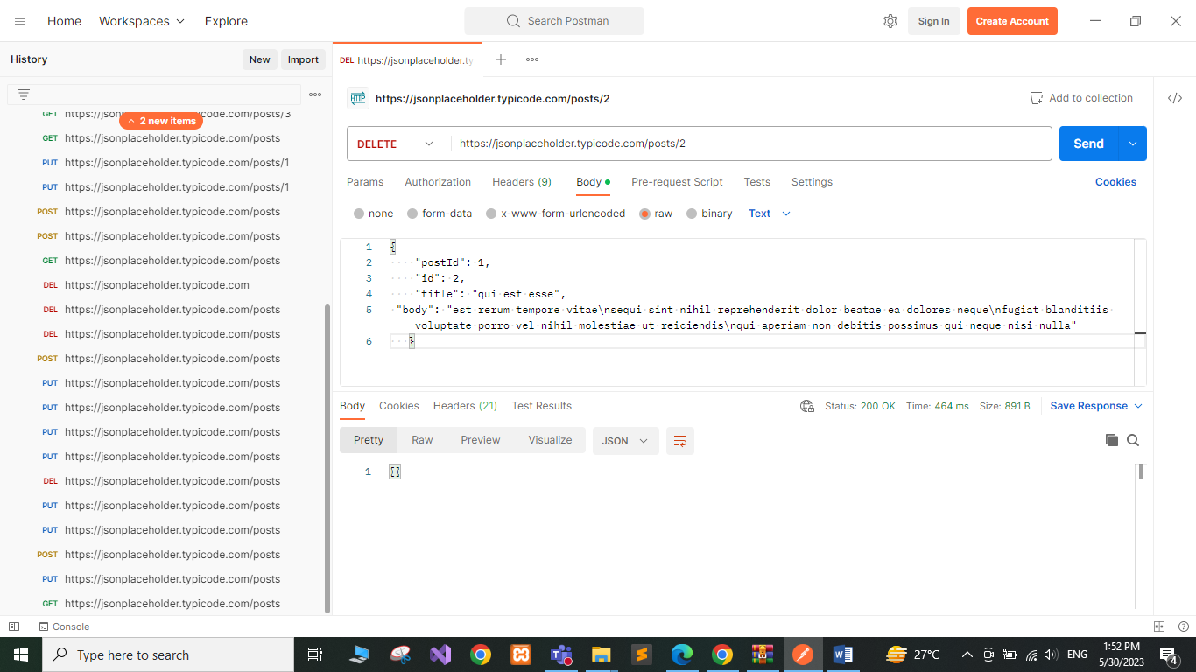

# POST REQUEST:

