ASYNC RUST
(Written by Mohsin Muhammad Ali)

Introduction
- Async(or asynchronous) Rust programming is a technique to do multiple task by using single thread.
- We use async programming to achieve maximum utilization

Async Rust:
Async rust allow to do multiple task on single Operatind system thread.But in many application if you download two web pages at same time then it use two threads (that is Multithreading) The example are give follow

Example no 1:
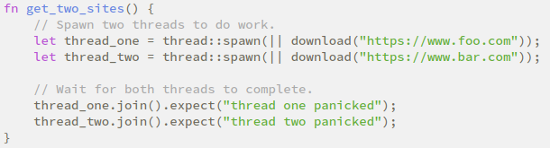

This would fine for many application but there is limitation of using the above technique.By using this one issue is an overhead in switching between thread and other issue is of sharing data between them (due to a lot of thread it would be difficult to assigning task to each thread)

