Difference Between Multitasking and Multithreading
(written by Mohsin Muhammad Ali)
Contents:

- Introduction
  - What is mutitasking and multithreading
- What is Multitasking Operating System
  - Understanding working of multitasking operating system
- What is Multithreading Operating System
  - Example of multithreading
  - Advantage of multithreading
- Summary

Introduction

- In this article, we will discuss the differences between Multitasking and Multithreading.

- The basic difference between Multitasking and multithreading is that

    - Multitasking allows CPU to perform multiple tasks (program, process, task, threads) simultaneously whereas,

    - Multithreading allows multiple threads of the same process to execute simultaneously

What is Multitasking Operating System?

When any program is running it is referred to as a task. In a Multitasking Operating System, two or more tasks are active simultaneously.
For example:
In modern operating systems, we can play MP3 music, edit documents in Microsoft Word, surfing the Google Chrome all are simultaneous.

Understanding working of multitasking operating system

In a time-sharing system, each process is assigned some specific amount of time for this time slice a process can be executed.Suppose there are four processes
- word processor
- Email
- Web browser
- Antivirus
Let assume this four processes is ready to execute by our processor.Note one thing here is that processor assigned some time to each process (let assume 5 sec for each process)
When one process begins execution (say Web browser), it executes for that quantum of time (5 second). After 5 second the CPU starts the execution of the other process (say Word processor) for the specified quantum of time and so on procedure is goin until all processes will be end
Note: The time mentioned here is different from real world. The purpose of this time is for better understanding. In real world this time is in nano second or smaller then nano seconds
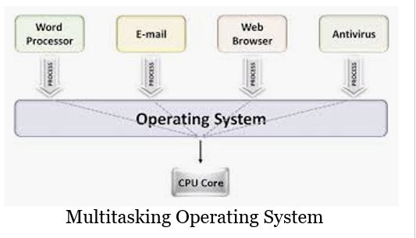
Here also basically a context switch is occurring but it is occurring so fast that the user is able to interact with each program separately while it is running.
This way, the user is given the illusion that multiple tasks are executing simultaneously. But actually only one process/ task is executing at a particular instant of time.
In multitasking, time sharing is best manifested because each running process takes only a fair quantum of the CPU time.

What is Multithreading Operating System?

A thread is a basic unit of CPU utilization.
Multi threading is an execution model that allows a single process to have multiple code segments (i.e., threads) running concurrently within the “context” of that process.
For Example 1:
VLC media player, where one thread is used for opening the VLC media player, one thread for playing a particular song and another thread for adding new songs to the playlist.
Example 2:
In a word processor, one thread (t1) is for displaying graphics, second thread (t2) for reading keystrokes from the user and a third thread (t3) for performing spelling and grammar checking in the background.

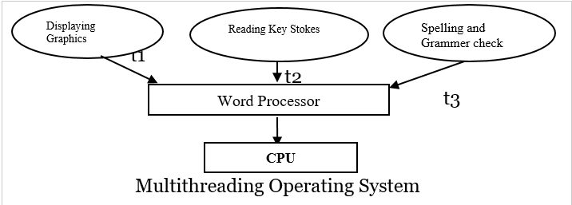
Example 3:
- Say there is a web server which processes client requests. Now if it executes as a single threaded process, then it will not be able to process multiple requests at a time. Firstly one client will make its request and finish its execution and only then, the server will be able to process another client request. This is really costly, time consuming and tiring task. To avoid this, multi threading can be made use of.
- Now, whenever a new client request comes in, the web server simply creates a new thread for processing this request and resumes its execution to hear more client requests. So the web server has the task of listening to new client requests and creating threads for each individual request. Each newly created thread processes one client request, thus reducing the burden on web server.
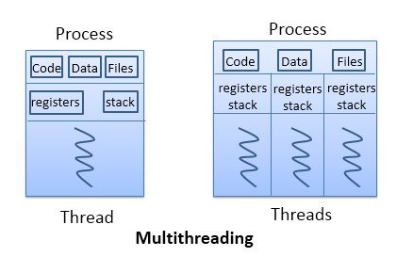

Advantages of Multithreading Operating System

- Responsiveness
Benefits of Multi threading include increased responsiveness. Since there are multiple threads in a program, so if one thread is taking too long to execute or if it gets blocked, the rest of the threads keep executing without any problem. Thus the whole program remains responsive to the user by means of remaining threads.

- Less Costly
Another advantage of multi threading is that it is less costly. Creating brand new processes and allocating resources is a time consuming task, but since threads share resources of the parent process, creating threads and switching between them is comparatively easy. Hence multi threading is the need of modern Operating Systems.

Summary

The basic difference between multitasking and multithreading is that in multitasking, the system allows executing multiple programs and tasks at the same time, whereas, in multithreading, the system executes multiple threads of the same or different processes at the same time.
- In multitasking, CPU has to switch between multiple programs so that it appears that multiple programs are running simultaneously. On other hands, in multithreading CPU has to switch between multiple threads to make it appear that all threads are running simultaneously.
- Multitasking allocates separate memory and resources for each process/program whereas, in multithreading threads belonging to the same process shares the same memory and resources as that of the process
- Multithreading helps when more than one client uses it. For instance, In DB. While I'm typing something, there would be someone else, doing the same type of job. not more than one person will be able to do the same kind of job If DB is not having a multithread option.
- It is time-consuming to create and manage processes than threads.

