Benchmark: application of a pore pressure traction

Boundary conditions
A pressure traction of -10kPa is applied at the top surface. Load is applied at the NODES.
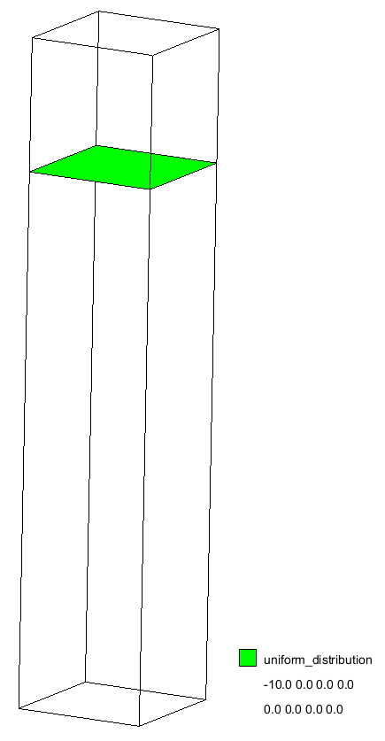  Figure 1 pressure traction | 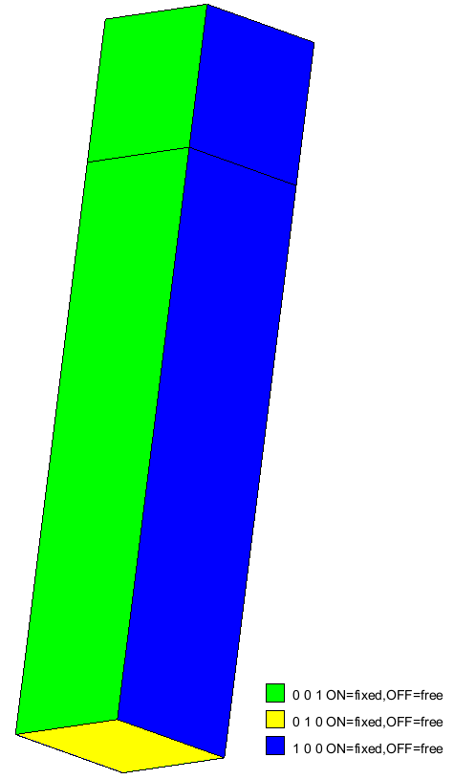  Figure 2 Solid fixity | 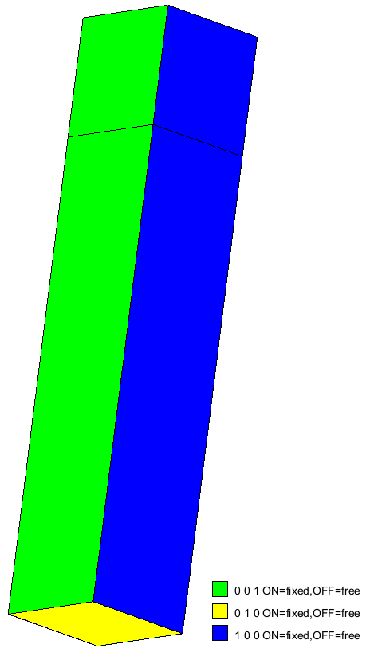Figure 3 Liquid fixity

Material parameters
$$MATERIAL_NAME
Soil
$$MATERIAL_TYPE
2-phase
$$POROSITY_SOLID
0.40
$$DENSITY_SOLID
2650
$$K0_VALUE_SOLID
0.5
$$INTRINSIC_PERMEABILITY_LIQUID
1e-10
$$DENSITY_LIQUID
1000
$$BULK_MODULUS_LIQUID
20000.0
$$DYNAMIC_VISCOSITY_LIQUID
1e-6
$$MATERIAL_MODEL_SOLID
linear_elasticity
$$YOUNG_MODULUS
1000
$$POISSON_RATIO
0.3

Discretization
4MP per elements are used. The mesh counts 30 tetrahedral elements.
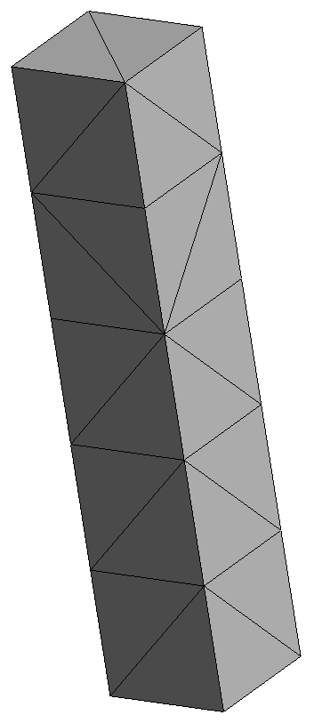

Load phases
- Load phase 1: gravity loading, apply quasi-static convergence. Multiplier liquid = 0, damping factor 0.75
- Load phase 2-5: pressure loading. Multiplier liquid = 1, damping factor=0, total time=2s:
$$NUMBER_OF_LOADSTEPS
11
$$TIME_PER_LOADSTEP
2.000000000000000E-001
$$COURANT_NUMBER
0.900000000000000
$$COMPUTATION_METHOD
MPM-MIXED
$$NUMBER_OF_PHASES
2
$$NUMBER_OF_POINTS
1
$$GRAVITY_VECTOR
0.000000000000000E+000 -1.00000000000000 0.000000000000000E+000
$$MULTIPLIER_GRAVITY
1.00000000000000 1.00000000000000
$$MULTIPLIER_LIQUID
1.000000000000000E+000 1.000000000000000E+000
$$LOAD_TYPE
STEP

Results
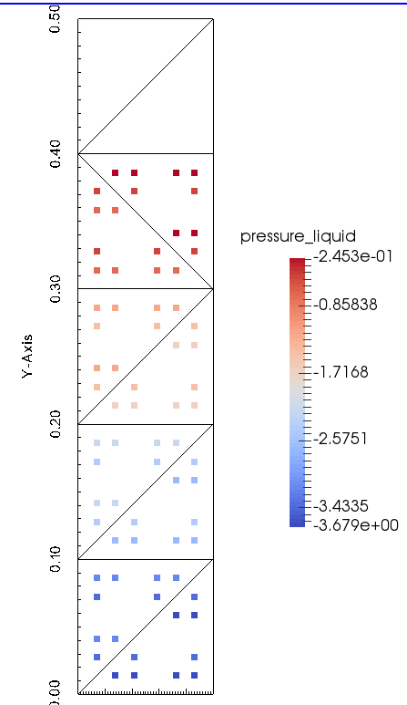  Figure 4 pore pressure at load step 1 (hydrostatic distribution) | 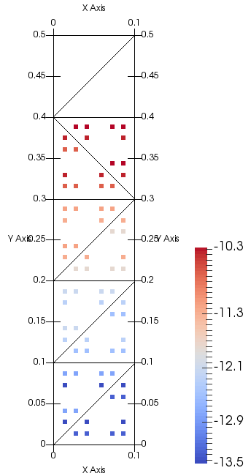  Figure 5 pore pressure at load step 10

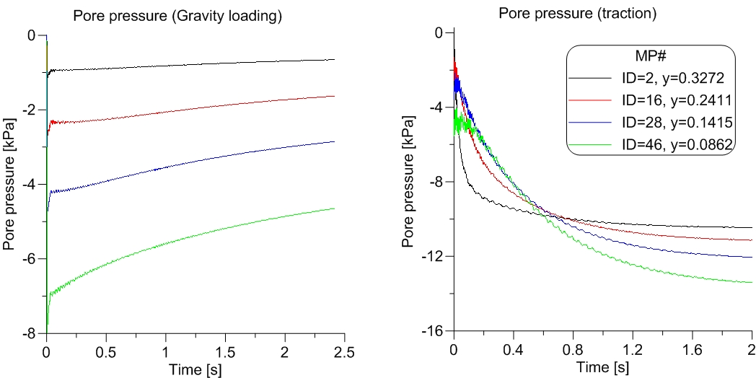
Figure 6 Pressure at material points during load step 1 (left) and load steps 2-11 (right).

Conclusions
The pore pressure increases with time as expected.

Modifications conducted on 11 August, 2021:
In order to reproduce this benchmark using the opensource (version 2021), a new GiD file was created. This subsequently changed the material point (MP) numbers. Table 1 provides the new MP ID corresponding to the Y coordinate in the old MP. Figure 6 and 7 show the reproduced results using the opensource for the dynamic and quasi-static portions of the simulation.
Table 1: Reference MP ID numbers for the newly benchmark for the same problem
Y-Coordinate (m) | Old MP ID | New MP ID
0.33 | 2 | 51
0.24 | 16 | 11
0.14 | 28 | 8
0.0862 | 46 | 2

Figure 6: Pore pressure result obtained for the dynamic part
Figure 7: Pore pressure result obtained for the quasi-static part

