Oedometer_QS_MPMMIXED_1Phase_NormalStress_LowDampingFactor
written by Gaia Di Carluccio, 21-10-2021

General description
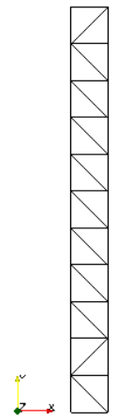
In this benchmark a 2D column of soil of 1m height is loaded at the top with a vertical load of 20kPa. MPM-MIXED computational method and quasi-static calculation is used. The soil consists of 1-phase (solid) with a linear-elastic model. Compared with test-1007, a lower value of damping factor is used.
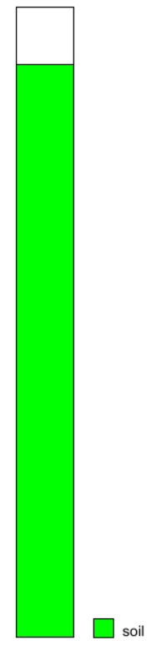
Mesh
The initial column is 0.1 m x 1 m.
Type of element: triangular-3 nodes
Number of element: 22
Size of element: 0.1
Number of nodes: 24

Material properties
$$MATERIAL_TYPE
dry_material
$$POROSITY_SOLID
0.3
$$DENSITY_SOLID
2600
$$K0_VALUE_SOLID
0.0
$$MATERIAL_MODEL_SOLID
linear_elasticity
$$YOUNG_MODULUS
100
$$POISSON_RATIO
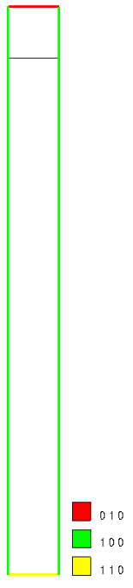
0.2
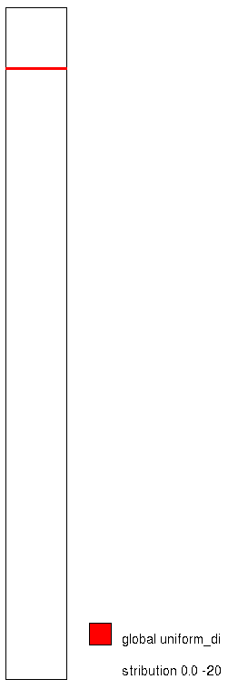
Boundary conditions
The top of the column is fixed in y direction, the bottom is fixed in x and y directions and the sides of the column are fixed in lateral direction.
A vertical load of -20 kPa is applied at the top line of the soil column (on MPs).

Gravity
Gravity is not applied.
Calculation data
### Anura3D_2021 ###
$$NUMBER_OF_LOADSTEPS
1
$$TIME_PER_LOADSTEP
0.1
$$TOTAL_TIME
0.0
$$COURANT_NUMBER
0.8
$$COMPUTATION_METHOD
MPM-MIXED
$$GRAVITY_ACCELERATION
9.81
$$GRAVITY_VECTOR
0.0 -1.0 0.0
$$GRAVITY_LOAD
off 0.0 1.0
$$SOLID_TRACTION
step 0.0 1.0
$$LIQUID_PRESSURE
off 0.0 1.0
$$PRESCRIBED_VELOCITY
off 0.0 1.0
$$QUASISTATIC_CONVERGENCE
1
$$TOLERATED_ERROR_SOLID
0.001 0.001
$$TOLERATED_ERROR_LIQUID
0.001 0.001
$$MAXIMUM_TIME_STEPS
10000
$$HOMOGENEOUS_LOCAL_DAMPING
1 0.55
$$OUTPUT_NUMBER_OF_MATERIAL_POINTS
10
$$OUTPUT_MATERIAL_POINTS
2
9
11
20
24
32
36
45
53
57
$$END

Analytical solution
The results correspond to the point with material point ID equal to 2. The graph shows the stress-strain curve and the comparison with the theoretical oedometric modulus: $E_{oed}= \frac{1-ν}{(1+ν)(1-2ν)}E$
