Benchmark Test: Gravitation_QS_MPMMIXED_2Phase_Gravity_Damping_2D:
written by Luis A. Aviles, 02/07/2021
General description
A 2D dry soil column, with elastic behaviour, is loaded using gravity load apply instantly from first time step. Quasistatic (QS) calculation is used together with a homogeneous damping of 0.75. Bottom is fixed and the sample can only deform in vertical direction.
Mesh
Size of mesh: 0,1 m x 1,1 m x 0,1 m
Type of element: triangular_3-noded
Number of elements: 22
Size of elements: 0.1
Number of nodes: 24
Number of MPs per element: 3 SMPs

Material properties
$$MATERIAL_NAME
Elastic
$$MATERIAL_TYPE
saturated_material_coupled
$$POROSITY_SOLID
0.25
$$DENSITY_SOLID
2650
$$DENSITY_LIQUID
1000
$$INTRINSIC_PERMEABILITY_LIQUID
1e-9
$$BULK_MODULUS_LIQUID
10000
$$DYNAMIC_VISCOSITY_LIQUID
1e-6
$$K0_VALUE_SOLID
0.0
$$MATERIAL_MODEL_SOLID
linear_elasticity
$$YOUNG_MODULUS
10000
$$POISSON_RATIO
0.3
Boundary conditions
The displacement for solid and liquid at the boundaries will be ﬁxed in normal direction and free in the tangential directions
Initial conditions
No initial conditions
Gravity
Gravity load is applied in the first-time step.
Numerical Solution:
### Anura3D_2021 ###
$$NUMBER_OF_LOADSTEPS
10
$$TIME_PER_LOADSTEP
0.2
$$COURANT_NUMBER
0.98
$$COMPUTATION_METHOD
MPM-MIXED
$$GRAVITY_LOAD
step 1.0 1.0
$$SOLID_TRACTION
off 0.0 1.0
$$LIQUID_PRESSURE
off 0.0 0.0
$$QUASISTATIC_CONVERGENCE
1
$$TOLERATED_ERROR_SOLID
0.01 0.01
$$TOLERATED_ERROR_LIQUID
0.01 0.01
$$MAXIMUM_TIME_STEPS
10000
$$MASS_SCALING
0 1.0
$$HOMOGENEOUS_LOCAL_DAMPING
1 0.75
$$FIX_SOLID_SKELETON
0
$$STRAIN_SMOOTHING
0
$$APPLY_OBJECTIVE_STRESS
0
$$DEGREE_OF_FILLING
0.9
$$OUTPUT_NUMBER_OF_MATERIAL_POINTS
6
$$OUTPUT_MATERIAL_POINTS
1
10
22
34
46
58
$$END

The output is given for 6 material point. From the .PAR file it is possible to plot time steps (or time) versus load multiplier.

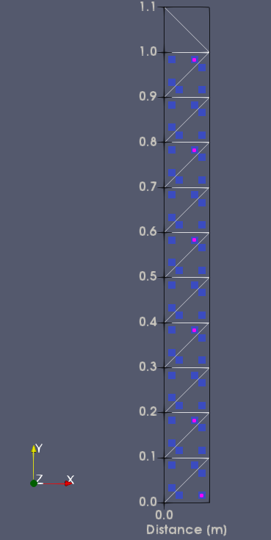
58
46
34
22
10
1
Analytical Solution
No analytical solution

